**1DFJ PPI Contact Map**

<https://www.rcsb.org/structure/1dfj>

This shows contact between the I and E chains of the complex, ie where the proteins are in contact with each other. I don’t know if it shows anything, but it is a nice structure.

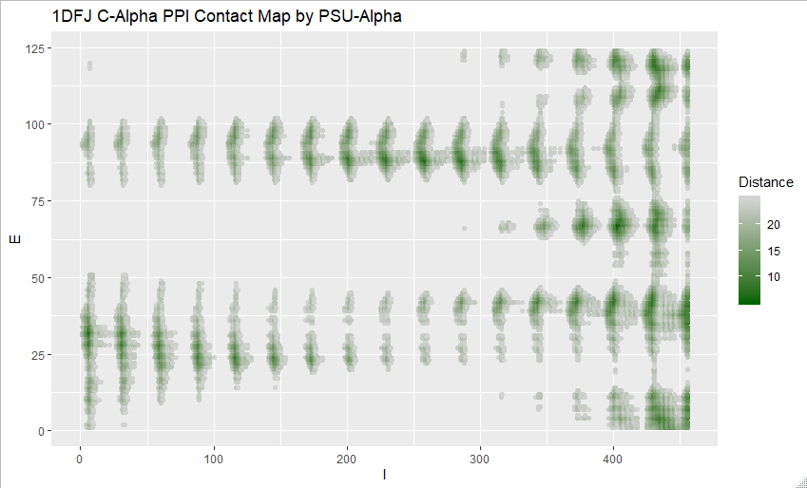

Image of complex from UCSF Chimera

