CSC348 Assignment 2
Peer reviews
Table of Contents
Harry Boyce - 2011556 2
Ashish Kozhuvanmakkal Vijayamohandas - 2211806 4
Emily Willcox-Beney - 985283 6
Sandesh Adhikari - 2035469 8
Liju Raju – 2149106 10

Harry Boyce - 2011556
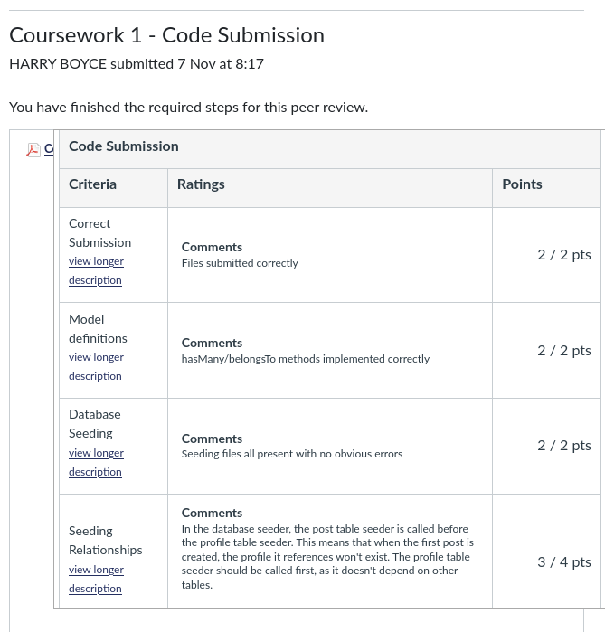
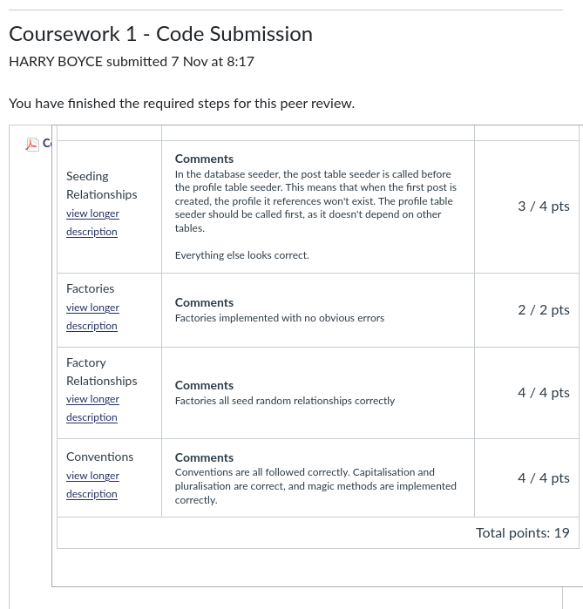

Ashish Kozhuvanmakkal Vijayamohandas - 2211806
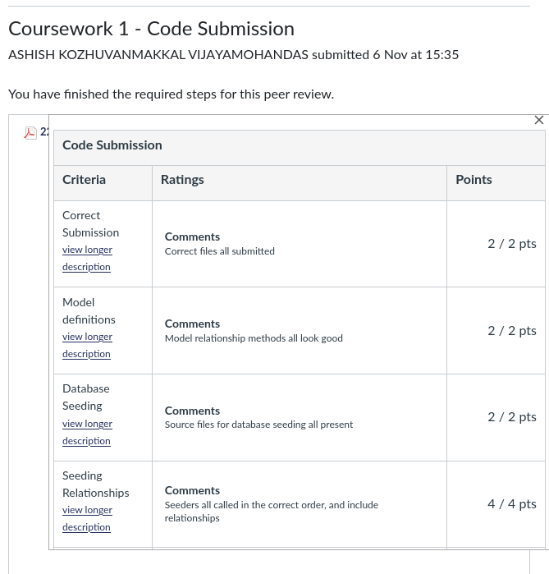

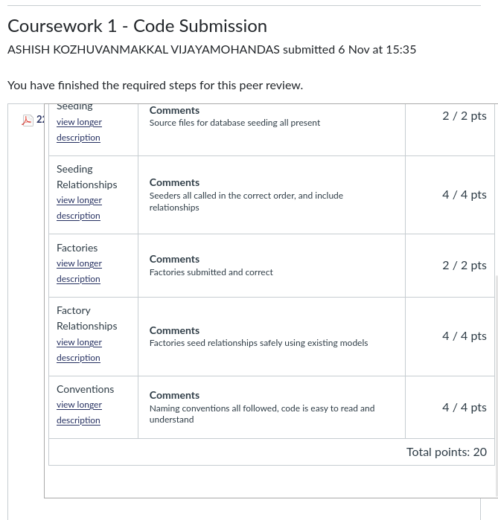

Emily Willcox-Beney - 985283
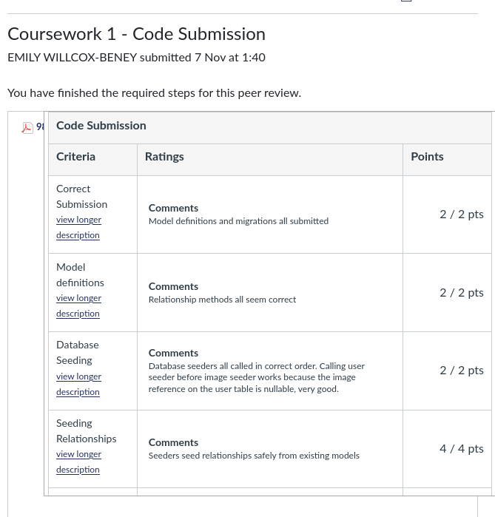

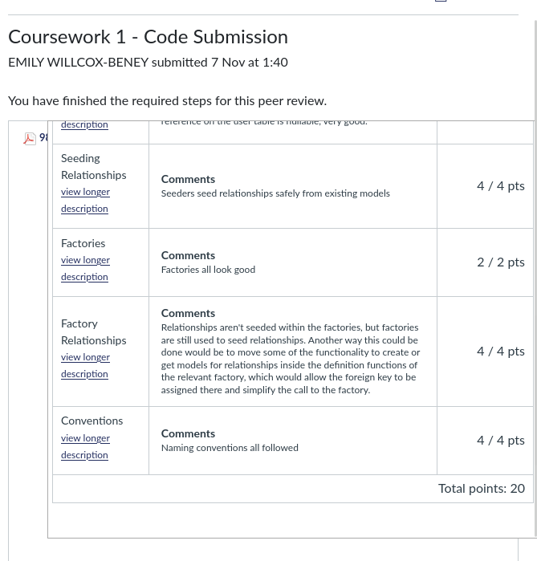

Sandesh Adhikari - 2035469
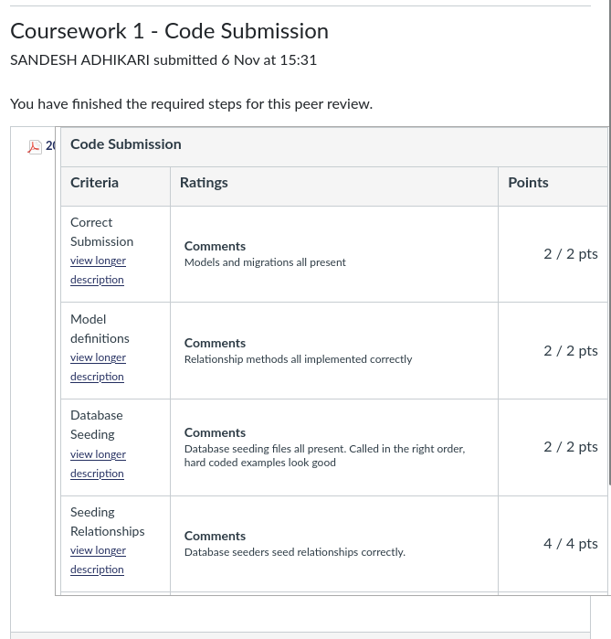

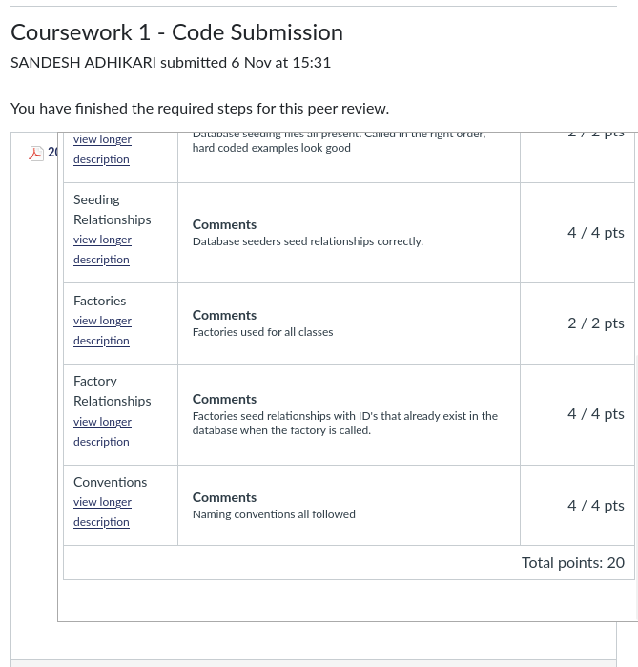

Liju Raju – 2149106
