1. Code I have implemented

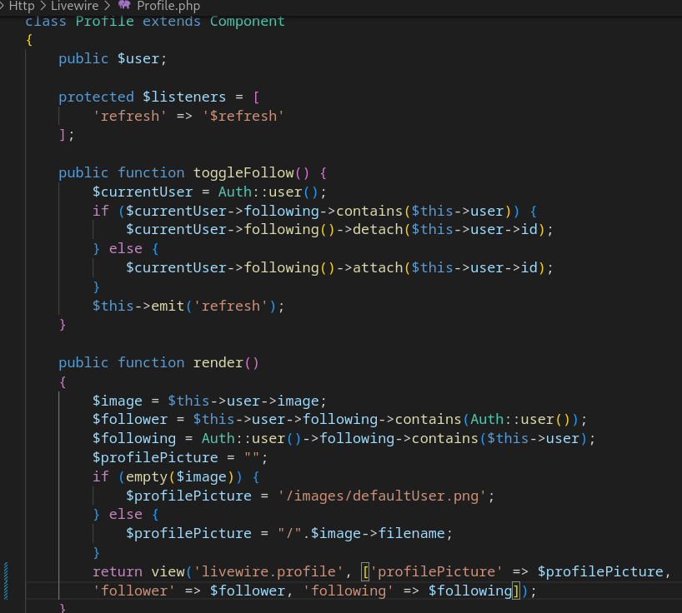
This is the controller for a livewire component that shows a user’s profile, containing their picture or the default picture if they don’t have one, name, username and bio, along with a follow/unfollow button and a notification if they are following you.

2. Screenshots of git commit history

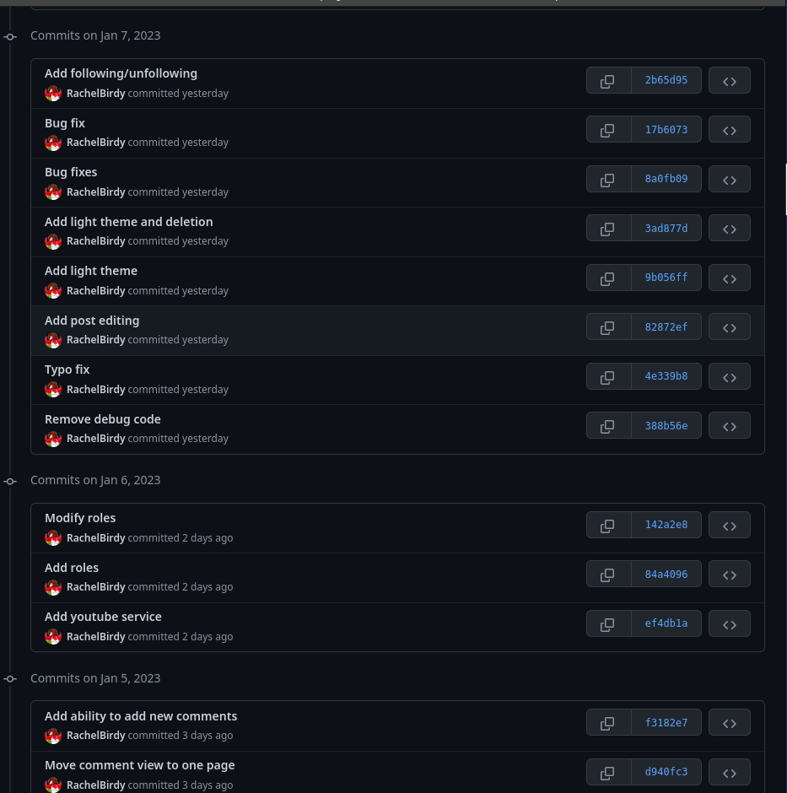
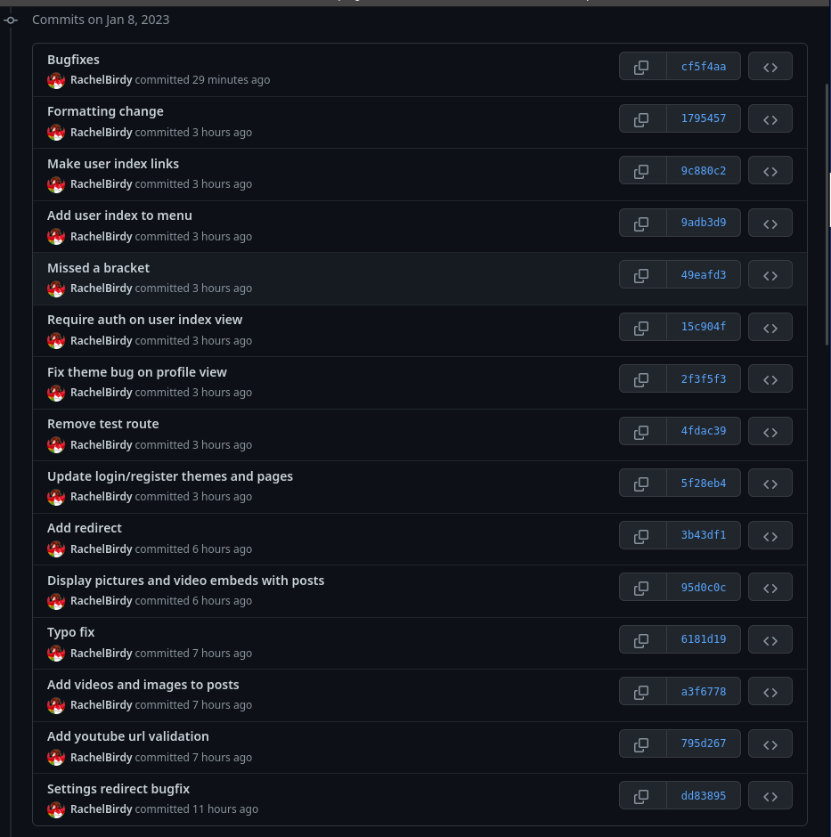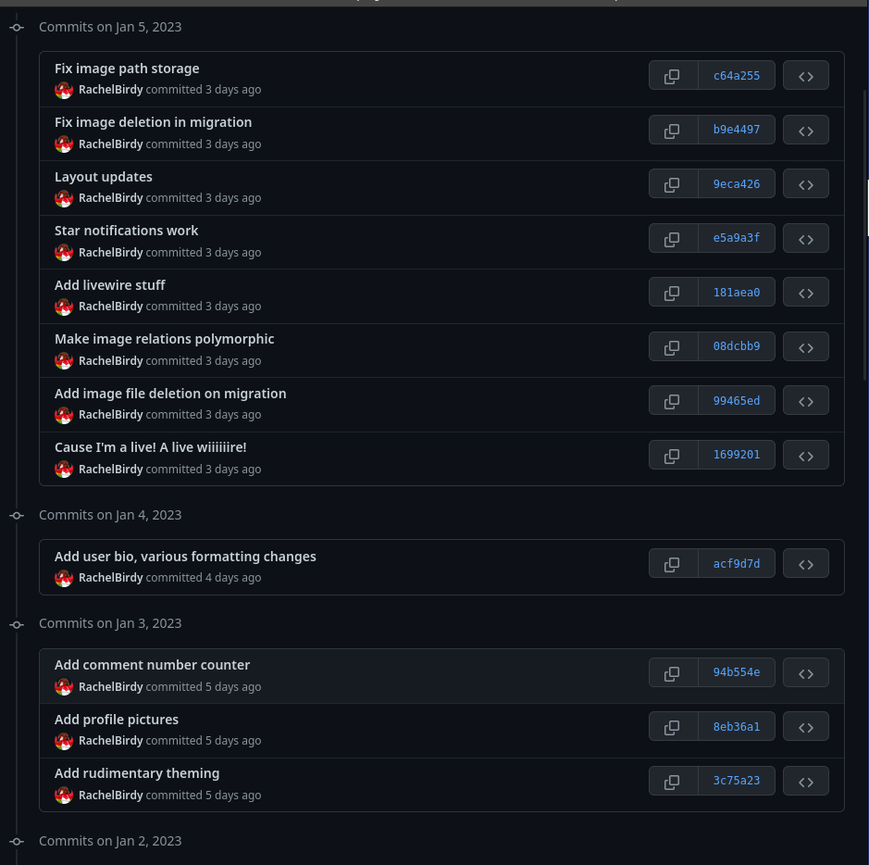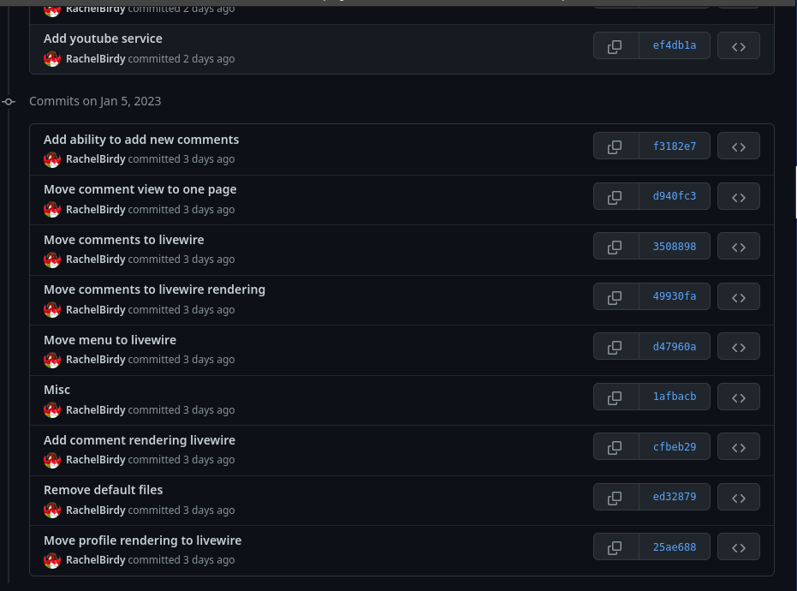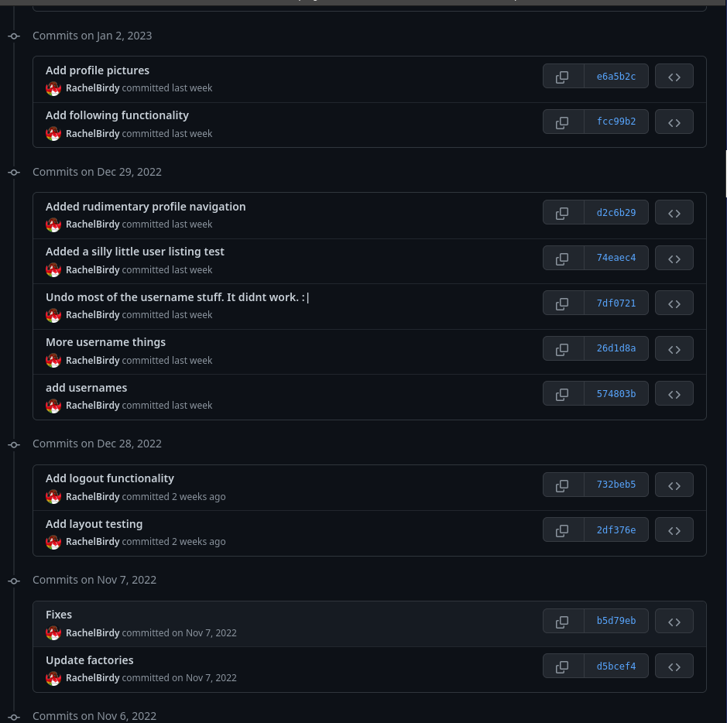

3. MVC

The model-view-controller pattern is a form of design that broadly splits applications and their UI into three components:
1. Models, which are used to store data on an object. As well as the attributes of the object being accessible via them, they also provide access to the relations that object has with another object.
2. Views, which are the pages displayed to the user. These typically contain minimal if any logic themselves, acting purely as HTML/PHP pages, with certain locations marked for data from a variable to be inserted and for additional sections to be added in.
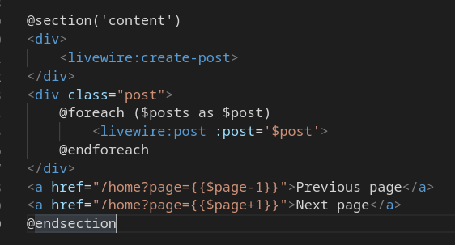
This is a section being rendered. The posts to be displayed have already been retrieved, processed and ordered before being passed into the view by the controller.
3. Controllers, which perform any logic operations and perform actions such as creating, updating retrieving or destroying models.

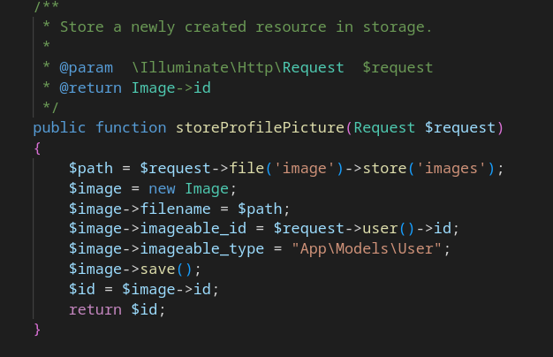
This is a typical function in a controller. When accessed via a post request defined in the routes file, it saves an uploaded picture, creates an Image object, assigns the path of the saved image to the Image object, and saves the object to the database.
In an MVC system, the user sends a request to a particular function on a controller. The controller, interacts with and collates data from any models that it needs, or updates or performs any other operations on a model depending on the request. The model then returns a view to the user, with any data it’s collected passed into it and slotted into the marked locations.

4. WCAG2 reflection
The site meets a very limited number of WCAG2 guidelines

1 Perceivable

Text alternatives
There are no text alternatives to images and no ability to add it to user uploaded images.

Time based media
The only time-based media on the side is embedded youtube videos, and youtube provides automated and manual captioning which carries over to embedded videos and streams.

Adaptability
Labelling though present in places is inconsistent. The tables used to present the app should linearize correctly, data is presented in a meaningful sequence, but no explicit indicators of sequence or ordering have been provided.
Instructions for operating content do not make any reference to the visual layout/sensory characteristics of the page (i.e. there is no “Type in the box below” or “Click the red button” that would become meaningless if the page were interpreted differently)
Content is constrained in it’s presentation to a narrow, portrait view.

Distinguishably
Colour is not used to convey information, prompt actions or distinguish visual elements
There is no audio which automatically plays.
The site layout is high contrast, contrasting white text against dark backgrounds or vice versa depending on the theme in use. It does not, however, have an explicit high contrast mode that ensures that all elements meet the 4.5:1 and 7:1 contrast requirements of the guidelines.
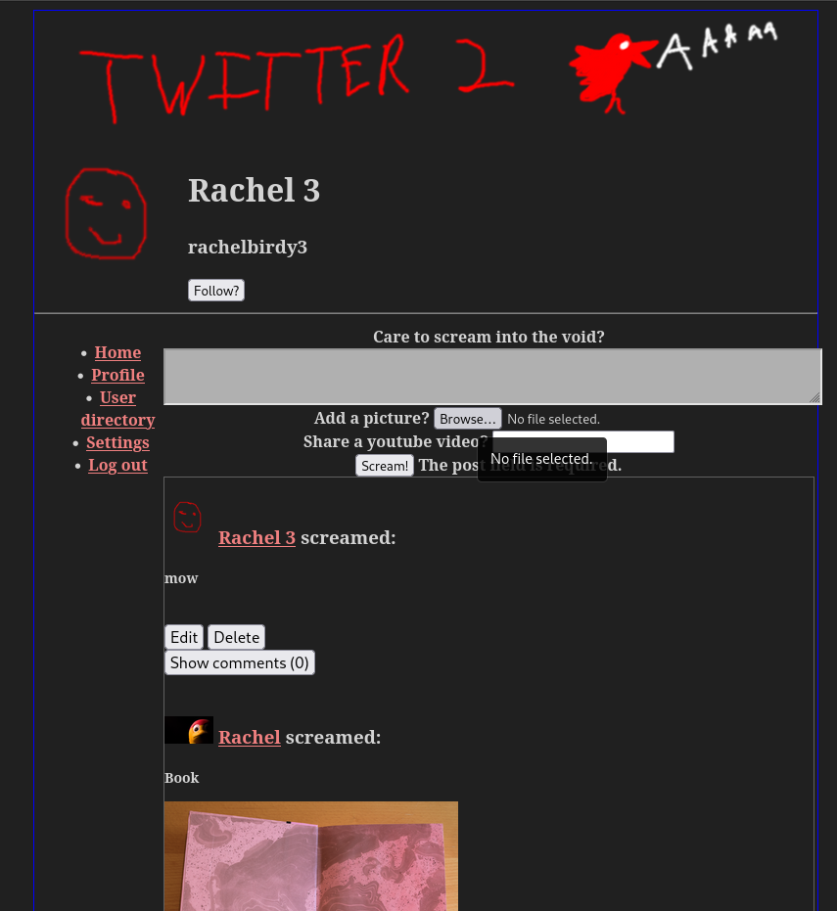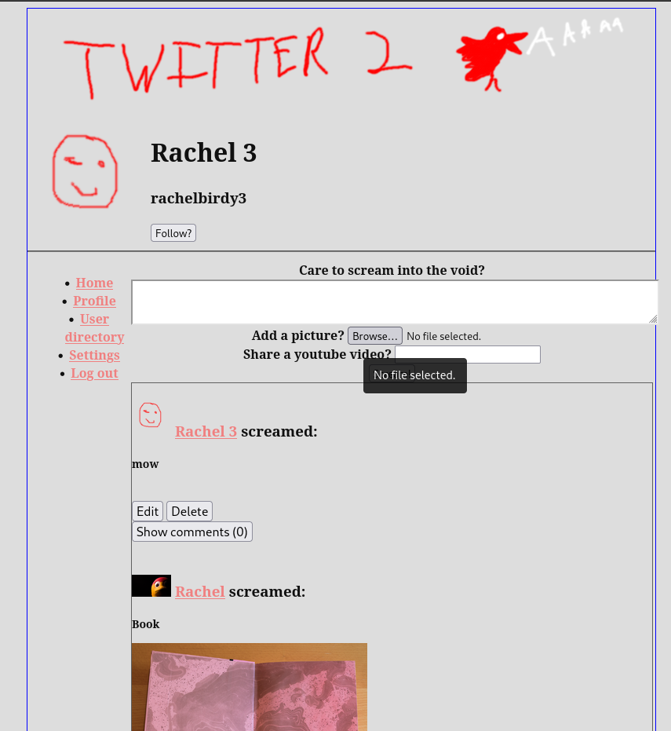
Resizing text has no negative impact on the site’s functionality, as shown in this screenshot of the site at 200% magnification in browser.
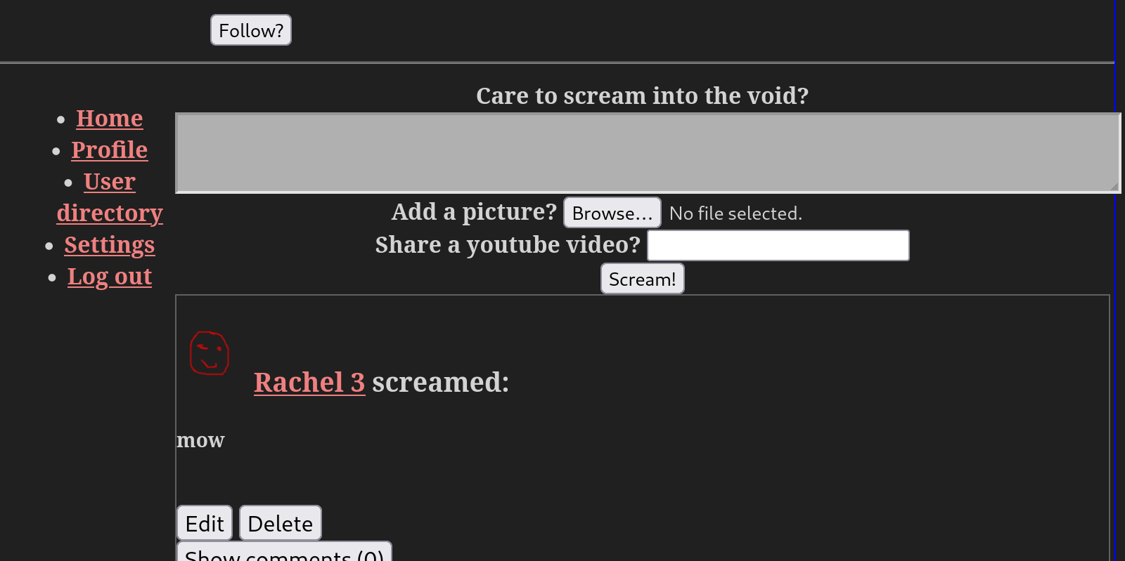
All text on the site outside of the logo is conveyed using text rather than images of text
Foreground and background colours can be selected in a limited capacity by the user – there are multiple themes available that change this, but they cannot be selected as a free choice.

2 Operable

Keyboard accessible
All functionality of the site can be accessed using only a keyboard, there are no traps which pull and keep focus and require non-standard ways to navigate away from, and there are no character key shortcuts on the side

Enough time
There are no timing dependant elements to the site. There are no auto-updating elements, interruptions, or any other elements to the frontend which are time dependant. However, if a user’s authentication expires and they have to reauthenticate, any data stored in forms that was not saved will be lost. There is no warning that this will happen.

Seizures and physical reactions
The site does not contain any flashing content, and user interactions do not trigger any animations

Navigable
Though repeated content between pages is minimal, there is no functionality to skip it.
Page titles are present but inconsistent
The order that elements are focussed on when tabbing through is logical, with different sections of the site grouped together.
All links purposes are clearly signposted by the text they are assigned to.
There are not multiple ways to get to some pages on the site. For instance, the only way to get to the settings page, is by clicking the settings link in the menu on the left, there is no alternate route. However, user profiles and content can be navigated to by clicking usernames anywhere they appear, in posts, comments, or in the user directory.
Headings and labels are inconsistent and unreliable.
The keyboard focus indicator is visible on almost all elements when tabbing through the site. The only elements it is not visible on are embedded youtube videos.
There is little information about the users location within a set of webpages available. Some pages, but not all, have titles which indicate this.

Input modalities
There are no gesture based controls in the interface.
All pointer functions are completed on the mouse up event, the down event is not used.
Input mechanisms are not limited by the applications

3 Understandable

Readable
Because the site relies on user generated content, there is no way to assess the reading ability required for the content, nor to programatically determine the language of the content. There is also no ability to identify specific definitions or pronunciations of words in context.

Predictable
An element receiving focus never changes context. User input does not change context until the user actively submits the form using the submit button or enter key. Navigation is consistent across the site, with the left hand menu always being present. Changes of context are only ever user initiated.

Input assistance
Validation is present and input errors are presented to the user.
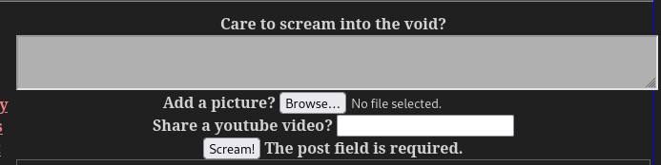
Labels and instructions for user input are lacking on the post form, and the comment box has no instruction on how to submit a comment. There is no suggestion of corrections for errors, and there is no context sensitive help.

4 Robust

Compatibility
Not all elements have complete start and end tags, the table on the main view is left open without an end tag. Element ID’s are unique and anywhere a shared identifier is needed for css styling a class is used rather than an ID.
All form elements and links are standard HTML controls
The site does not present status messages to the user except for in limited situations.

5. Service container
I designed a service which communicates with google’s api to retrieve the embedding HTML for a youtube video based on a provided video ID. It is initially constructed with an API key from google, and contains a function that when called with a video id makes a call to the api for data on that video, parses the response and returns a string of HTML for embedding that specific video that can be inserted into a view.
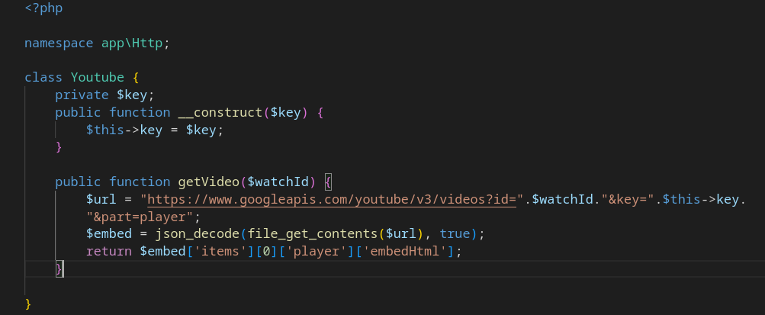

The service container contains all of the applications bindings, which allow functions and objects to be accessed universally without being explicitly passed in to methods from the methods calling them.
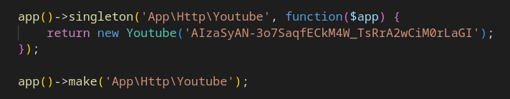
Binding “App\Http\Youtube” to a function that returns an instance of the class means that if this class is referenced from anywhere in the application where an explicit instance of the class has not already been passed in, this function will be called to return one. Binding it as a singleton specifically means that this function will only ever be run once, and any subsequent calls will return the same object generated by that first run.

An instance of the class can then be called inside functions without being passed in. Every time this render function is called, the function that the Youtube class is bound to will be called to get an instance of it.
This is useful for communicating with external API’s because it lets all of the configuration for those API’s be done in one place. Rather than having API keys scattered throughout various controllers it can all be set in one place, and the behaviour of the service across the application can be changed in one place. For instance, if I decided I don’t like youtube anymore and want to use tiktok videos instead, I can change the code in the service and everywhere else it’ll just work.

