Rachel, 234342T, IT2151-02

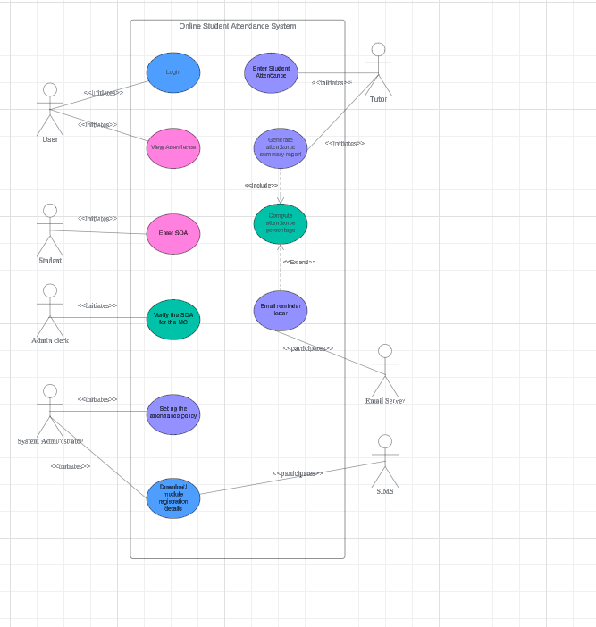

The non-functional requirements mentioned in the case study are as follows:

1. Allow 50 concurrent users to access the system without degrading the system performance
2. Response time of 30 seconds
3. Use Oracle database due to campus license
4. Accessible from web campus wide
5. Support major browser (e.g. chrome, safari)

Reflections

Use case is a model to capture functional requirements of proposed system for user with little technical background

The use case model focus in the following:

1. Who are the users of the system? (Actors)
2. What goal the system is expected to achieve? (The Use Case)
3. What is the environment that the system is required to operate in Secondary School? (the Secondary Actors)

While it is sufficient to show to non-technical users, use case model is not detailed enough for developer to proceed with the development work. Hence for each use case, a use case description would be needed to supplement the details (e.g.: the possible scenarios that each use case may go through) needed for development.