IT2164/IT2561 Operating Systems

# Tutorial 5

**Process Management**

Attempt the following questions before you attend tutorial.

1. What is a process?

Binary program in execution

1. In a multi-threaded process, threads share certain information in the same process whilst not sharing others. In your own words, briefly explain why this is so.

In a multi-threaded process, information that is related to the process state as a whole can and must be shared by all the threads in the same process

This is so, because to the user, the process is still one process, even though it has multiple threads, all executing at the same time

On the other hand, information that is related to a particular thread of execution cannot be shared as there are multiple execution engines, each represented by a thread. This information cannot be shared

1. Given that the states of a process are :
   * Running : Currently using the CPU
   * Ready : Waiting for the CPU
   * Blocked for Interrupt : Waiting for an interrupt handler to finish, then resume running.
   * Blocked for reusable resource : Waiting for a reusable resource to be allocated, then will become ready.
   * Blocked for consumable resource : Waiting for a consumable resource to be allocated, then will become ready.

What is a possible state diagram for the process? Show the relationship in terms of the transitions between each of these states.

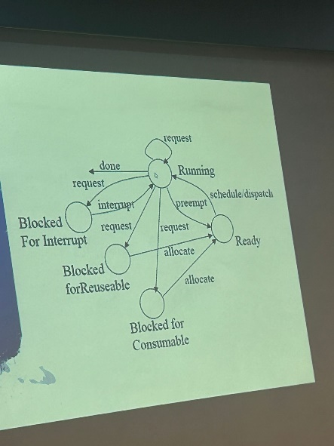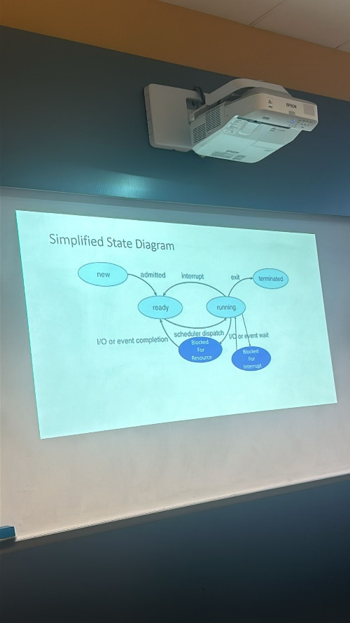

1. What data structure is used to store the information regarding each process in the OS? How are they organized?

The process control block (PCB) or process descriptor is used to store information about each process. They are usually organized as a queue in the memory.

Tutorial 5 Page 1 of 1