Submission:
Summarize what you have done on a Word Doc.
- Add a screen shot of your page with all the changes that you made.

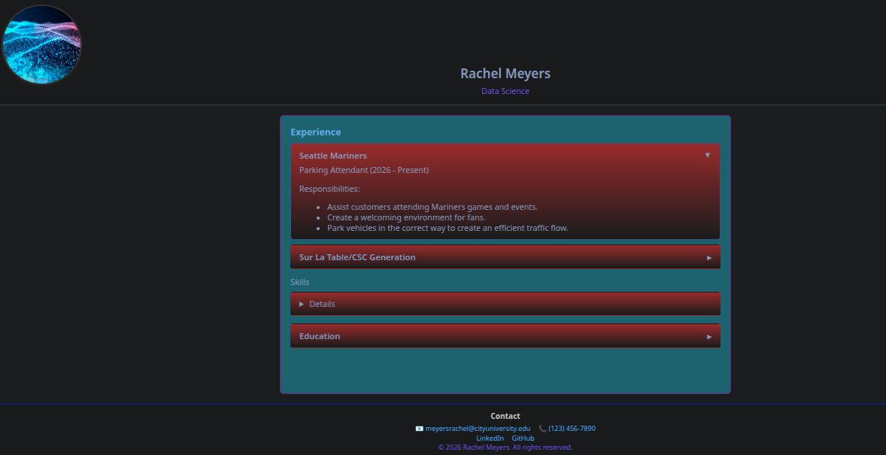

- Answer the following:
  - How did you decide to implement your color scheme

I went into the CSS file and played around with different colors that would help the web page stand out a little more.

  - What challenges did you run into styling the skills table.

The Styling skills table has a more defined and refined list style, where the categories allow the user to click on a list and it will show more details about the heading information.

