

Mitigating AI Bias Recognition to Enhance Accuracy for South East Asian Features in Immigration Sector

RACHEL MARVIN WAN

Bachelor of Computer Science with Honours
(Multimedia Computing)
2026

Mitigating AI Bias Recognition to Enhance Accuracy for South East Asian Features in Immigration Sector

RACHEL MARVIN WAN

This project is submitted in partial fulfillment of the
requirements for the degree of
Bachelor of Computer Science and Information Technology

Faculty of Computer Science and Information Technology
UNIVERSITI MALAYSIA SARAWAK
2026

Mengurangkan Bias Pengecaman AI untuk Meningkatkan Ketepatan Ciri Wajah Asia Tenggara dalam Sektor Imigresen

RACHEL MARVIN WAN

Projek ini merupakan salah satu keperluan untuk
Ijazah Sarjana Muda Sains Komputer dan Teknologi Maklumat

Faculty of Computer Science and Information Technology
UNIVERSITI MALAYSIA SARAWAK
2026
Acknowledgement

First and foremost, I would like to thank God Almighty for granting me the strength and perseverance in completing this project. I would also like to express gratitude to my supervisor, Dr. Jacey Lynn-Minoi, for guiding me and providing feedback, and also Dr. Tan Chong Eng, my examiner, for his encouragement throughout the journey in completing this project. Also, I would like to thank Mr. Lavindar, my employer and supervisor during my internship for his unwavering support throughout my studies in final year. Lastly, I would like to thank my friends and family, for their unwavering support and prayers especially through tough times. I am blessed to have all of you by my side.

Abstract

Facial recognition systems used in immigration sectors often exhibit lower performance on under-represented populations, particularly individuals from Southeast Asia. This project presents a prototype facial recognition pipeline tailored to Southeast Asian faces with the aim of mitigating demographic bias and improving identification reliability for this region. The system integrates Multi-Task Cascaded Convolutional Neural Network (MTCNN) for face detection and alignment, an InceptionResnetV1 (FaceNet) model for deep embedding extraction, and a supervised classifier for four nationality classes: Bruneian, Indonesian, Malaysian and Thai. A curated dataset of Southeast Asian facial images was organised using a structured directory layout and augmented through controlled transformations such as rotation, brightness and saturation adjustment to increase variability while preserving key facial characteristics. A standardised preprocessing pipeline ensured consistent cropping, resizing and normalisation across training and validation stages. The prototype was evaluated using conventional classification metrics and confusion matrices, with additional per-class analysis to examine disparities between nationalities. The results demonstrate the feasibility of building an end-to-end facial recognition system specifically focused on Southeast Asian populations and highlight persistent challenges related to data limitations and unequal performance across demographic groups. This study provides a practical foundation and methodological baseline for future work on fairness-aware facial recognition in regional immigration applications.

Abstrak

Sistem pengecaman wajah yang digunakan dalam sektor imigresen sering menunjukkan prestasi yang lebih rendah terhadap populasi yang kurang diwakili, khususnya individu dari Asia Tenggara. Projek ini membentangkan satu prototaip rangkaian pengecaman wajah yang direka khas untuk wajah Asia Tenggara dengan tujuan mengurangkan bias demografi dan meningkatkan kebolehpercayaan pengecaman bagi rantau ini. Sistem yang dicadangkan menggabungkan Multi-Task Cascaded Convolutional Neural Network (MTCNN) untuk pengesanan dan penjajaran wajah, model InceptionResnetV1 (FaceNet) untuk pengekstrakan embedding mendalam, serta pengelas terselia bagi empat kelas kewarganegaraan: Brunei, Indonesia, Malaysia dan Thailand. Set data wajah Asia Tenggara yang ditapis disusun menggunakan susun atur struktur direktori dan melalui transformasi terkawal seperti putaran, pelarasan kecerahan dan ketepuan bagi menambah kepelbagaian tanpa menjejaskan ciri utama wajah. Satu rangkaian prapemprosesan berpiawai digunakan untuk memastikan proses pemotongan, penukaran saiz dan penormalan yang konsisten antara fasa latihan dan validasi. Prototaip dinilai menggunakan metrik pengelasan konvensional dan matriks kekeliruan, dengan analisis setiap kelas untuk meneliti perbezaan prestasi antara kebangsaan. Dapatan kajian menunjukkan kebolehlaksanaan pembinaan sistem pengecaman wajah hujung ke hujung yang memfokuskan populasi Asia Tenggara serta menonjolkan cabaran berterusan berkaitan kekangan data dan ketidakseimbangan prestasi merentas kumpulan demografi. Kajian ini menyediakan asas praktikal dan garis panduan metodologi untuk kerja masa hadapan mengenai pengecaman wajah yang peka keadilan dalam aplikasi imigresen serantau.
Table of Content
Acknowledgement 4
Abstract 5
Abstrak 6
1.0 Project Title 10
1.1 Background 10
1.2 Problem Statement 11
1.3 Objectives 11
1.4 Methodology 12
1.5 Scope 13
1.6 Significance of Project 14
1.7 Project Schedule 15
1.8 Expected Outcome 15
Chapter 2 16
2.1 Introduction 16
2.2 Bias 16
2.2.1 Types of Bias 16
2.3 Related Works 18
2.4 Deep Learning 24
2.5 Discussion on Convolutional Neural Networks(CNN) 25
2.5.1 CNN Architecture: Applications in Facial Recognition 26
2.5.2 Performance Analysis and Optimization Factors 27
2.5.3 Multi-Task CNN Approaches to Bias Mitigation 27
2.5.4 Computational Considerations and Optimization 28
2.5.5 Training Methodologies and Implementation 29
2.5.6 Current research gaps and limitations. 29
2.6 Summary 30
Chapter 3 33
3.1 Introduction 33
3.2 Data Curation and Pre-processing 35
3.2.1 Dataset Selection and Aggregation 35
3.2.2 Data Processing Pipeline 36
3.2.2 Dataset Versioning 36
3.3 Model Selection and Architecture Design 38
3.3.1 Multi- Task CNN Architecture Selection 38
3.3.2 Loss Function Design and Optimization Strategy 39
3.4 Implementation and Training 40
3.4.1 Technology Stack Selection 40
3.4.2 Training Pipeline Implementation 40
3.4.3 Transfer Learning Implementation 41
3.5 Evaluation and Optimization 42
3.5.1 Evaluation Metrics Framework 42
3.5.2 Evaluation Protocol 45
3.6 Deployment 46
3.6.1 Prototype System Architecture 46
3.6.2 Performance Optimization 47
3.7 Summary 47
Chapter 4 49
4.1 Introduction 49
4.2 System Implementation 50
4.2.1 Overall System Architecture 50
4.2.2 Development Environment 51
4.3 Dataset Preparation and Preprocessing 52
4.3.1 Dataset Preparation 52
4.3.2 Embedding Extraction Process 54
4.3.3 Model Training Process 55
4.3.4 Evaluation metrics and Test Setup 55
4.4 Model Training and Fine-Tuning 56
4.5 Experimental Result and Analysis 57
4.5.1 Overall Performance 57
4.5.2 Confusion Matrix and Per- Class Results 58
4.5.3 Qualitative Analysis. 60
4.6 Chapter Summary 61
Chapter 5 62
5.1 Introduction 62
5.2 Summary of Findings 62
5.3 Discussion and Evaluation 64
5.4 Contribution and Significance 65
5.5 Limitations and Recommendations / Future Work 66
5.5 Conclusion 67

Chapter 1

Introduction

1.0 Project Title
Mitigating AI Bias Recognition to Enhance Accuracy South East Asian features in Immigration Sector

1.1 Background
Artificial Intelligence (AI) has been evolving over the years in various sectors, especially in immigration. Under AI itself, several technologies have been developed, and to date, they continue to evolve to ease the process in our daily life activities and continuously improve the lifestyle of our current society. Facial Recognition or Facial Recognition Technology (FRT) are among the widely used AI- based technology in today’s life. Implemented in verification systems, surveillance cameras and health-monitoring, it is an AI–based biometric technology that utilizes computer vision to analyze facial images and identify individuals based on their unique facial features (Christian, 2024). Despite it’s various use, however the technology itself is found to be bias. Bias could be in terms of gender, age, ethnics, skin colors. In this context, this project focuses on ethnic groups, focusing on South East Asians and other underrepresented group. Studies has found that most facial recognition system are biased against certain ethnic groups (Khalil et al.,2020). This resulted with complications such as high rates of misidentification, inefficient delays and wrongful denial of entrance during the immigration process. Thus, developing bias aware facial recognition system is designed and developed to address these issues. This chapter highlights on the problem statement and briefly on the methodology that will be used for this project. Current research and methods of the project used will be explained in Chapter 2. In Chapter 3, the development of the project will be described in detail in this chapter.

1.2 Problem Statement
Facial recognition systems in immigration systems often exhibit bias against certain ethnic groups, particularly those from South East Asia. This bias leads to unfair treatment, longer processing times or wrongful denials of entry. The root causes of this bias include underrepresentation in training datasets, algorithmic limitations in recognizing diverse facial features, and a lack of consideration for ethnic diversity in system design and testing. Addressing this bias is crucial in ensuring equitable and efficient immigration processes. Furthering this issue would not only increase the current problems addressed but could also lead to unjust deportation across borders.

1.3 Objectives
The main objective of this project is to develop a facial recognition prototype system that could help enhance accuracy for South East Asian and other under-represented ethnic groups using deep learning technique. Other objectives includes:-
- To develop datasets consist of South East Asian and other under-represented ethnic groups features for training and testing purposes.
- To determine the most suitable deep learning techniques and implement them to increase the accuracy of the identification of the South East Asian individuals.
- Evaluate system’s performance using fairness and accuracy metrics.

1.4 Methodology
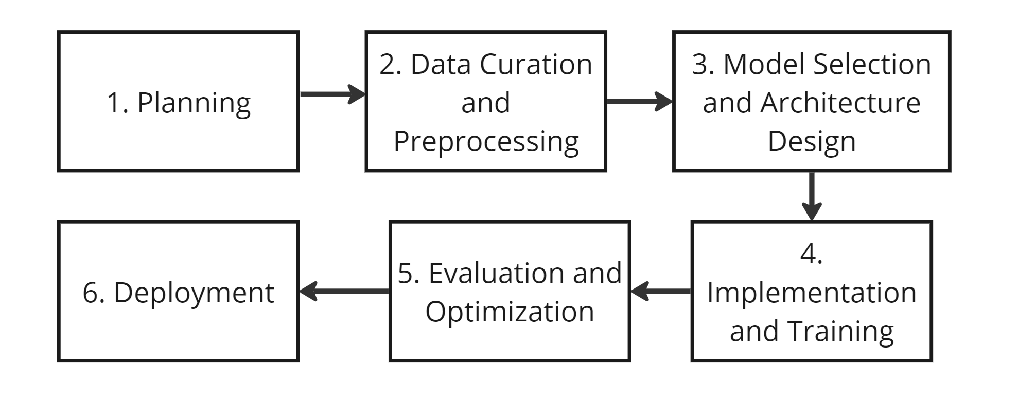
Figure 1.4(a): Research Methodology
As seen in Figure 1.4(a), the waterfall approach methodology will be used for this project. This approach is used to outline the steps necessary to guarantee that each process is carried out correctly. The primary goal of the planning stage will be to determine the resources required for this undertaking. This entails planning the entire system, defining the goals precisely, and locating the datasets from reliable open-source platforms like Kaggle. Prior to being trained on a dataset, datasets will be gathered from the designated sources and categorized by gender, age ranges, and ethnic groups utilizing preprocessing techniques, such as scaling and normalization as needed using Roboflow. The planning phase's prototype system will then be developed and detailed as necessary. Following this phase, the prototype will be put into use and tested to replicate various immigration circumstances. Fairness and correctness will then be assessed.

1.5 Scope
The scope of this project will focus on developing a prototype facial recognition system designed to address biases against Southeast Asian facial features in immigration settings. Details are as follows:-
1. Algorithm Improvement - Implement bias mitigation techniques to improve accuracy in recognizing Southeast Asian features.
2. Dataset development - Create and use a diverse dataset representing Southeast Asian characteristics for training and testing, ensuring ethical data handling and privacy protection. A few existing datasets from reputable resources will be collected from reputable resources. This would enhance the accuracy and inclusivity of the system.
3. Prototype testing - Develop and conduct preliminary tests on a prototype to evaluate its effectiveness in reducing bias and enhancing performance for Southeast Asian individuals.
4. Limitations - The project focuses on Southeast Asian features and serves as a model for potential adaptation to other underrepresented groups in the future.

1.6 Significance of Project
The significance of this project lies in its potential to lessen racial bias in AI applications, especially in the face recognition systems used within the immigration industry. Currently, the accuracy of AI systems for members of under-represented groups, such as Southeast Asians, traits accurately. This project aims to bridge that gap by creating a prototype specifically designed to recognize accurately recognized Southeast Asian features .

The suggested model helps to develop fair and ethical AI by fostering inclusivity in an area where bias can have serious effects, such as delays, increased scrutiny, or wrong denials in immigration processes. This effort may have an impact on the creation of future systems that cater to multicultural populations by highlighting the significance of data variety and algorithmic adaptation. Furthermore, this prototype could serve as a foundational example for other sectors using facial recognition technology, such as security, healthcare, and employment, offering a pathway to develop fairer AI-driven systems.

1.7 Project Schedule

Figure 1.7(a): Project Schedule

1.8 Expected Outcome
The expected outcome of this project include:-
1. Increase of accuracy and fairness - Significant improvement of a facial recognition system designed to recognize Southeast Asian traits with better accuracy and fairness compared to traditional facial recognition models.
2. Data diversity insights - A curated and representative datasets highlighting the importance of diversity in training data for AI system.
3. Development of prototype system - A working prototype of a facial recognition system that would recognize Southeast Asian facial features with reduced bias.

Chapter 2
Literature Review

2.1 Introduction
The incorporation of facial recognition technology in the existing immigration systems has becoming more widespread, promising higher security, faster processing and increased of efficiency at global border checkpoints. These systems utilize advanced algorithms to identify and authenticate individuals by assessing their facial traits and matching them with images saved in the existing database. Nonetheless, despite technical progress, considerable hurdles remain regarding the precise identification of individual of South East Asian heritage.
In this chapter, types of bias that is tackled for this project were outlined and explained. Review on several machine learning techniques that has been implemented for bias mitigation are compared to understand its implementation made by other researchers, followed by the detailed explanation on the deep learning that will be implemented in this project.

2.2 Bias

2.2.1 Types of Bias
Several studies had its own focus on the type of bias that they want to tackle. For this project, the bias that is focused is as follows:-

Ethnic bias
Facial recognition systems perform worst on Southeast Asian faces compared to Western. A study found by Buntoun and Kuok(2023) found that systems rained on Western datasets showed significant performance drops when tested on Southeast Asian faces. The systems frequently confused different Southeast Asian ethnicities, misclassifying Cambodian individuals as Vietnamese and vice versa. This ethnic bias creates real problems in immigration. Southeast Asian travelers experience higher rates of false rejections, requiring manual verification that causes delays and increased scrutiny. In worst cases, this leads to wrongful denial of entry.

Data Training Bias
Most facial recognition datasets severely underrepresent Southeast Asian faces. 13 major face databases are reviewed and found they primarily contain Western and East Asian faces, with Southeast Asian faces either missing or minimally represented(Khalil et al.,2020)

The largest training datasets like MS-Celeb-1M (10 million images) and VGGFace2 (3.3 million images) come from celebrity databases that reflect Western entertainment demographics. When these datasets include "Asian" categories, they typically mean East Asian, not Southeast Asian faces. This data gap means algorithms never properly learn Southeast Asian facial features, creating systems that work well for some populations but fail for Southeast Asians.

Cross-race Bias
Facial recognition algorithms work better on faces similar to their training data. Phillips et al. (2011) showed that Western-developed algorithms perform better on Western faces, while East Asian-developed algorithms perform better on East Asian faces. Southeast Asians get caught in the middle - they're not well-represented in either Western or East Asian training datasets. This creates a "double disadvantage" where no existing systems are optimized for Southeast Asian facial characteristics.

System Bias
Recognition systems employ universal decision thresholds to ascertain matches; nevertheless, these thresholds function variably among different ethnic groups. Using the same threshold for everyone creates unequal error rates across different populations (Robinson et al., 2020). For Southeast Asians, this implies that the system may be excessively stringent (resulting in erroneous rejections) or overly permissive (leading to security vulnerabilities). In immigration circumstances where precision and security are paramount, these threshold issues pose significant operational challenges.

2.3 Related Works
Several research work that developed this solution are increasing drastically and different methods are implemented in mitigating this issue. One of the fundamental techniques in facial recognition is Principal Component Analysis, also referred to as the "Eigenfaces" method (Hu et al., 2017). PCA preserves the most significant variance in the data while reducing high-dimensional face image data to a lower-dimensional space. The technique converts photos of faces into eigenfaces, which are basic elements that represent the main differences between various faces. Studies that exhibit significant feature dimension reductions while preserving discriminative power attest to PCA's efficacy in dimension reduction (Islam et al., 2018). One approach maintained a 99% variance ratio while achieving a 99.72% dimension reduction, lowering features from 69,240 to just 191. PCA's inability to handle changes in illumination and its emphasis on global rather than local facial traits, however, can affect recognition accuracy in difficult situations (Majumder & Bhowmik, 2015). PCA's key flaw is that it optimizes for variance rather than class separability, despite the fact that it is still theoretically beautiful and computationally efficient. This implies that when within-class differences outweigh between-class differences, it might not be able to differentiate between people efficiently. Using Linear Discriminant Analysis or LDA is another solution that is developed in mitigating this issue. Sometimes being referred to as “Fisherface”, it very useful for recognition tasks when differentiating between identities is essential since it looks for projection axes that maximize between-class variance while minimizing within-class variance. This is specially good especially it optimized class separability rather than just just variance, which overcomes some of PCA’s drawbacks (Hu et al., 2017). By establishing feature spaces where photos of the same person cluster closely together but images of different people stay well apart, the study demonstrates the utility of LDA in improving feature discrimination (Santhosh & Rajashekararadhya, 2023). Because of this characteristic, LDA is particularly helpful for verification tasks in immigration contexts where the algorithm has to decide if two photos depict the same individual. When feature dimensions are greater than training samples, LDA's primary drawback is revealed by limited sample sizes, necessitating regularization techniques for stability. Notwithstanding these limitations, LDA is still useful when paired with other techniques to improve system performance. Encouragement For facial categorization tasks, vector machines have proven to be incredibly effective; several research have shown that they perform better than conventional techniques (Islam et al., 2018; Majumder & Bhowmik, 2015). SVM is especially well-suited for high-dimensional facial recognition problems because it finds the best hyperplane in feature space that optimizes the margin between classes. When paired with suitable feature extraction techniques, research by Islam et al. (2018) showed that SVM is successful in facial expression recognition, attaining accuracies of above 95%. According to the study, SVM performs well in high-dimensional spaces and manages scenarios when feature counts are more than sample counts, which is a typical occurrence in facial recognition. In comparison to more sophisticated kernels, Majumder & Bhowmik (2015) demonstrated the computational efficiency of linear kernel SVM with thermal facial recognition by achieving recognition rates above 99%. SVM's mathematical underpinnings and capacity to manage intricate decision boundaries are its main advantages. However, because the method is binary, it must be modified for multi-class situations using strategies like One-Versus-One or One-Versus-Rest, which might make computation more difficult. Additionally, parameter tweaking and kernel selection have a significant impact on SVM performance. A conceptually straightforward method for classifying faces is the k-Nearest Neighbors algorithm, which uses the majority class of the k nearest training samples in feature space (Islam et al., 2018). Research shows that k-NN has practical limits when compared to other classifiers, especially with regard to memory needs and computational efficiency, even though it can reach good recognition results. Since the method needs to keep all training data for classification, k-NN's memory requirements are its primary drawback. This storage need becomes unaffordable for large-scale immigration systems with thousands of enrolled persons. Furthermore, the choice of k and distance measure has a significant impact on performance, therefore choosing the right parameters is essential for best results. Majumder & Bhowmik (2015) introduced a novel hybrid method that combines Fast Independent Component Analysis (FastICA) for dimensionality reduction with Gabor filters for feature extraction. By utilizing the complementing advantages of both approaches, this strategy was able to attain recognition rates on thermal face photos that were higher than 96%. Gabor filters produce 40 filtered versions of each input image in five scales and eight orientations, demonstrating their exceptional ability to capture local texture information at various scales and orientations. But doing so produces high-dimensional data (276,960 features per image), which would be too expensive to process for straightforward classification. In contrast to PCA's variance-based method, FastICA provides more discriminative representations by removing statistically independent components. The Gabor-FastICA method shows how strong recognition systems may be produced by fusing cutting-edge statistical methods with conventional feature extraction. The method's resilience is demonstrated by its performance with difficult thermal images, but real-time applications may be limited by the computing burden of creating and processing many Gabor filters. According to several research, a particularly successful hybrid strategy is the combination of SVM for classification and PCA for dimensionality reduction (Islam et al., 2018). This technique takes advantage of SVM's strong classification skills while utilizing PCA's effectiveness in compressing facial data. According to research, this hybrid approach achieved a 95.7% accuracy rate in facial expression recognition, indicating its efficacy for real-time applications where dimensionality reduction increases computational efficiency and allows for faster processing without sacrificing recognition accuracy. This hybrid approach demonstrates the benefits of using complementary techniques to tackle the intricate problems of facial recognition. These techniques frequently outperform single-method systems by combining the advantages of conventional feature extraction with those of contemporary classifiers, especially when handling varied populations or difficult imaging scenarios. According to the study, facial recognition systems can benefit greatly from both hybrid and classic machine learning techniques. While hybrid approaches frequently offer the optimum mix between performance and processing requirements by combining different techniques, traditional methods like as PCA and LDA continue to be relevant because to their computing efficiency and interpretability. The best ways to mitigate demographic bias in Southeast Asia may be hybrid strategies that combine many feature extraction techniques with adaptive classification algorithms. Hybrid approaches are especially well-suited for enhancing recognition accuracy across underrepresented populations, such as Southeast Asians, because they may implement bias-aware classification algorithms and capture a variety of facial traits using several feature extraction methods. Evaluation frameworks that specifically measure performance across various ethnic groups are necessary, especially for disadvantaged populations in immigration scenarios, as the majority of research concentrates on overall accuracy rather than demographic fairness.
Method | Type | Key Characteristics | Strengths | Limitations | Reported Accuracy/Impact | Relevance to SE Asian Bias Mitigation
PCA (Eigenfaces) | Traditional | Variance-based dimensionality reduction | Efficient, retains major image variance | Poor at local features, sensitive to lighting | Reduced features by 99.72%, retained 99% variance | Limited; does not address demographic variations
LDA (Fisherfaces) | Traditional | Maximizes class separability | Better identity separation than PCA | Small sample size issues, needs regularization | Effective in verification tasks | Moderate; stronger than PCA but limited by data size
SVM | Traditional | Margin-based classifier with kernel trick | High accuracy, good in high dimensions | Needs kernel tuning, binary-class base | >95% accuracy; >99% in thermal face recognition | High; robust classifier adaptable with bias-aware training
k-NN | Traditional | Distance-based voting classifier | Simple, interpretable | Memory-intensive, slow for large datasets | Good accuracy, less than SVM | Low; not scalable for immigration use cases
Gabor-FastICA | Hybrid | Texture + Independent components | Handles local features, good for thermal | Computationally expensive | >96% accuracy on thermal images | High; resilient to non-ideal imagery common in border checks
PCA + SVM | Hybrid | Combines compression + classification | Efficient & accurate, balances trade-offs | Requires careful tuning of both parts | 95.7% accuracy in expression recognition | High; well-suited for balancing fairness & efficiency
Table 1: Summary on Current Bias Mitigation Techniques

2.4 Deep Learning
Deep learning is a machine learning concept that uses artificial neural networks to learn levels of representation and abstraction by creating high-level features (Hu et al., 2017). Deep neural networks are often composed of more than one hidden layer in deeply layered designs, with complex operations like as convolutions replacing simple activation functions (Janiesch et al., 2021). Deep learning's primary advantage is its capacity to automatically discover representations from raw input data without requiring manual feature engineering, removing the requirement for human experts to identify and extract relevant features (Janiesch et al., 2021).

Convolutional neural networks (CNNs), a popular deep learning model, use local pooling and filters to extract complicated features from raw images. CNNs have performed well in facial recognition applications, with accuracies of 96.2% on the ORL dataset (400 2D photos of 40 people), 96.0% on the LFW dataset, and 97.45% on real-world unconstrained faces (Hu et al., 2017). CNNs' hierarchical feature learning capabilities allows them to detect fundamental features such as edges and corners in early layers, which are then incrementally aggregated into more sophisticated features in later layers, resulting in complete facial representations suited for recognition tasks.

Deep learning's automatic feature learning is a considerable improvement over older methods. These networks use complicated multi-layered structures with millions of parameters to represent highly nuanced relationships, automatically learning from raw data without the need for manual feature extraction procedures (Janiesch et al., 2021; Hu et al., 2017). However, deep learning often necessitates larger datasets and significant computational resources, and it frequently benefits from specialist hardware such as GPUs to successfully train the multiple parameters and attain optimal performance (Hu et al., 2017).

2.5 Discussion on Convolutional Neural Networks(CNN)
Building on the previously described deep learning foundations, Convolutional Neural Networks have emerged as the most popular deep learning architecture for facial recognition applications. This section looks at how CNNs have been explicitly applied and optimized for facial recognition applications, including architectural innovations, performance successes, and implementation methodologies.

2.5.1 CNN Architecture: Applications in Facial Recognition

Research regularly shows that CNN architectures tailored specifically for facial recognition outperform typical machine learning approaches. Hu et al. (2017) conducted extensive research comparing two CNN architectures - CNN-1 with two convolutional layers and CNN-2 with one convolutional layer - for 2D and 3D facial recognition tasks. Their findings demonstrated that simpler architecture frequently performs better, with CNN-2 achieving 95% accuracy in 2D face recognition and 85.15% accuracy in 3D depth picture recognition.

From basic CNN implementations to more advanced designs. Lawrence et al. (2007) developed an early hybrid neural network system that included self-organizing neural networks and CNNs, attaining 96.2% accuracy on the ORL dataset. Recent studies have shown a trend toward deeper and more complex architectures, with Yi Sun et al. (2023) developing CNNs with stacked convolution and inception layers and achieving 96.0% accuracy on the LFW dataset, and Jun-Cheng Chen et al. (2024) achieving 97.45% accuracy on real-world unconstrained faces (Hu et al., 2017).

2.5.2 Performance Analysis and Optimization Factors

The literature has considerable examination of the elements that influence CNN performance in facial recognition applications. Hu et al. (2017) found that CNN effectiveness is strongly dependent on preprocessing approaches and hyperparameter adjustment. Their investigations revealed that Local Binary Pattern (LBP) preprocessing greatly improved CNN performance, with CNN-1 obtaining 91.25% accuracy with LBP images versus 88.75% with raw images.

Activation function selection has been found as an important performance aspect. According to literature study, ideal activation function combinations differ by architecture: CNN-1 performed best with tanh activation functions in both convolutional layers, but CNN-2 produced optimal results with tanh activation in a single convolutional layer (Hu et al., 2017). Another important element is learning rate optimization, as research has shown that optimal learning rates vary greatly depending on architecture and input preprocessing methods.

2.5.3 Multi-Task CNN Approaches to Bias Mitigation

Recent research has focused on Multi-Task CNN architectures, which solve numerous facial analysis issues at once. Das et al. (2018) introduced a complex Multi-Task CNN technique that simultaneously learns face recognition, gender classification, age estimation, and race classification. Their approach enhances FaceNet with ResNet V1 inception modules, dividing the network at the fully connected layer into three distinct branches for various categorization tasks.

According to the research, multi-task CNNs handle bias reduction difficulties via dynamic loss weighting algorithms. Das et al. (2018) used joint dynamic weighting schemes to automatically assign loss weights to each task during training, allowing the network to learn task correlations directly from the data. This approach outperformed single-task networks by providing bias awareness capabilities via 128-dimensional face embeddings and triplet loss functions.

2.5.4 Computational Considerations and Optimization

Research has widely highlighted the computational constraints involved with CNN deployment in facial recognition systems. According to studies, typical convolutional procedures involve large processing resources, with parameter counts based on mathematical correlations between kernel dimensions and input/output channels (Teacher and Student Facial Expression Recognition, 2024).

The literature describes advanced optimization approaches for addressing these computational problems. Depth separable convolution algorithms have been presented to dramatically reduce parameter counts while preserving recognition performance. The study also discusses bottleneck module topologies that execute channel expansion before depth-wise convolution, followed by channel compression, resulting in more efficient information flow via networks.

2.5.5 Training Methodologies and Implementation

The literature contains detailed documentation on CNN training approaches for facial recognition. Mini-batch gradient descent with backpropagation is widely used in network optimization research, with datasets typically split 80% for training and 20% for testing (Hu et al., 2017). Advanced training tactics include sophisticated optimization algorithms like the Adam optimizer, which has precisely calibrated hyperparameters, as well as regularization techniques like dropout to prevent overfitting.

The literature stresses the value of data augmentation strategies in increasing CNN generalization. Rotation, flipping, and masking approaches have been used in research to broaden training datasets and improve model robustness in a variety of facial recognition contexts.

2.5.6 Current research gaps and limitations.

Despite its proven effectiveness in mitigating bias risk, there are also numerous drawbacks in existing CNN techniques to facial recognition. According to research, while CNN designs outperform standard machine learning methods, they frequently operate as "black boxes" with poor interpretability. This constraint presents issues for applications that require explainable conclusions, particularly in sensitive sectors such as immigration processing.

Studies also show that computational intensity remains a chronic barrier, with training requirements frequently exceeding ordinary hardware capabilities. Recent research trends show a rising interest in tackling bias and fairness issues in CNN-based facial recognition systems, while this is still an active subject that requires additional development to achieve equal performance across varied demographic groups.

2.6 Summary
With an emphasis on Southeast Asian communities in immigration scenarios, this literature review has thoroughly investigated the complex issues of bias in facial recognition systems. According to the review, bias in facial recognition is a complex interaction of various factors that cumulatively disadvantage underrepresented ethnic groups rather than being a single problem. Due to the severe underrepresentation of Southeast Asian faces in major training datasets such as MS-Celeb-1M and VGGFace2, the analysis identified four critical forms of bias that affect Southeast Asian populations: cross-race bias, which causes a "double disadvantage" for Southeast Asians who are underrepresented in both East Asian and Western training data; system bias, which manifests as universal decision thresholds that operate unfairly across different ethnic groups; and ethnic bias, where systems trained primarily on Western datasets show significant performance degradation on Southeast Asian faces.

The review looked at a variety of bias mitigation strategies, from hybrid approaches that combine many strategies to more conventional approaches like PCA (Eigenfaces), LDA (Fisherfaces), and SVM. Conventional techniques such as PCA showed minimal efficacy in addressing demographic changes, although achieving excellent dimensional reduction (99.72% feature reduction while keeping 99% variance). More promise for bias mitigation was shown by hybrid approaches, especially the coupling of PCA with SVM and Gabor-FastICA algorithms, the latter of which achieved over 96% accuracy on difficult thermal pictures and showed robustness to less-than-ideal imaging conditions typical of border crossings. The most promising method for mitigating bias was found to be Convolutional Neural Networks, since research on real-world unconstrained faces showed accuracies of above 97%. Through dynamic loss weighting schemes, advanced CNN architectures—such as Multi-Task CNN approaches, which simultaneously handle face recognition, gender classification, age estimation, and race classification—offer sophisticated bias-aware capabilities. These architectures hold particular promise for immigration applications, which require the simultaneous consideration of multiple demographic factors.

The assessment found that attaining demographic fairness remains difficult despite major technical advancements. Evaluation frameworks that particularly measure performance across ethnic groups are necessary because the majority of current research concentrates on overall accuracy rather than demographic equity. For delicate applications like immigration processing, where defensible conclusions are essential, the computational complexity of deep learning algorithms and their "black box" nature pose extra difficulties. The results indicate that a multifaceted strategy combining a variety of training datasets, sophisticated CNN architectures with bias-aware training methods, and customized evaluation metrics that place equal weight on fairness and accuracy is necessary for effective bias mitigation for Southeast Asian populations. The success of hybrid approaches suggests that integrating several complementing tactics rather than depending solely on one is probably the best course of action. The development of the bias-aware facial recognition prototype suggested in this research, which attempts to solve the unique difficulties Southeast Asian people encounter in immigration processes, is based on this thorough understanding.

Chapter 3
Research Methodology

3.1 Introduction
This chapter describes the research methodology used to develop a facial recognition prototype designed to counteract discrimination against Southeast Asian populations in contexts pertaining to immigration. The three primary objectives described in Chapter 1 are to develop representative datasets for Southeast Asian traits, enhance the prototype system, and apply algorithmic enhancements. The theoretical foundations and practical framework that guided the execution of this research endeavor are provided by the approach that is being given here. The research methodology, which is founded on applied research principles, prioritizes empirical validation and methodical investigation to address practical issues. This specific strategy was developed to address the practical issue of bias in facial recognition systems and the need for solutions that might demonstrate measurable advantages in immigration scenarios. The methodology integrates experimental design, comparative evaluation, and quantitative analysis to offer a comprehensive basis for research on bias mitigation.

This study's applied aspect, which seeks to develop facial recognition technology practically rather than only conceptually, is reflected in the methods selected. This study demonstrates how existing bias mitigation techniques may be effectively adapted and applied to address the challenges of Southeast Asian facial recognition in immigration scenarios through the careful compilation of datasets, algorithmic execution, and comprehensive prototype development. The comprehensive evaluation methodology ensures that bias reduction efficacy is measured at every stage of development rather than as a separate analytical objective.

Applied system development and empirical evaluation using a quantitative experimental technique are combined in the study design framework. The study's experimental component is demonstrated by the development and testing of a novel facial recognition approach that aims to reduce demographic bias through deliberate algorithmic adjustments. The quantitative framework enables accurate evaluation of bias reduction and performance enhancements through the use of established measurements and statistical analysis. The study design might be categorized as applied research because it emphasizes practical application and real-world validation. This design choice was chosen to ensure that theoretical insights lead to measurable improvements that can benefit Southeast Asians who use immigration services. The applied focus informs all methodological decisions, including dataset selection and assessment techniques, ensuring that the study is still applicable to real-world deployment settings and providing comprehensive bias monitoring capabilities.

3.2 Data Curation and Pre-processing

3.2.1 Dataset Selection and Aggregation
By merging several pre-existing datasets, the data gathering process uses a deliberate aggregation approach to produce a thorough and representative training corpus for facial recognition across Southeast Asia. Because it allows access to larger and more diverse populations than would be possible through primary data collection, allows comparison with prior research using the same baseline datasets, and ensures ethical compliance through the exclusive use of publicly available datasets with appropriate academic licenses, this approach was chosen over primary data collection for a number of methodological reasons.
The primary datasets used in this project are UTKFace, BEFA, CelebA, AFAD and LFW. UTKFace is a large‑scale face dataset with over 20,000 images annotated for age, gender and ethnicity, and was used by Das et al. (2018) for training and validation, making it important for comparative analysis and reproducibility. BEFA (Bias Estimation in Face Analytics), the ECCV 2018 challenge dataset where Das et al.’s MTCNN method placed first, provides detailed demographic annotations for 56 attribute combinations (for example “male, young, Indian”) and serves as a baseline for bias assessment. CelebA contributes more than 200,000 celebrity images with 40 attribute annotations; although it is largely Western‑focused, it includes Asian celebrities and supplies high‑quality images for comparison. AFAD contains over 160,000 images that focus specifically on Asian facial traits and is therefore critical for improving the representation of Asian faces. Finally, LFW (Labeled Faces in the Wild), used by Das et al. (2018) for pre‑training validation and comprising approximately 77.5% male and 83.5% Caucasian subjects, illustrates the demographic imbalance that motivates bias‑mitigation research.

3.2.2 Data Processing Pipeline
The preprocessing methodology uses a multi-stage pipeline to normalize image quality, improve feature visibility, and prepare data for efficient model training. The pipeline is built using OpenCV for computer vision operations and Roboflow for sophisticated augmentation techniques. The preprocessing pipeline consists of four main stages that standardise image quality, enhance facial features and prepare the data for efficient model training. In the first stage, face detection and extraction, Zhang et al.’s MTCNN is used for robust face detection, alignment and landmark estimation. This implementation relates to Zhang et al.’s Multi‑task Cascaded Convolutional Networks for face detection, rather than Das et al.’s classification‑oriented Multi‑Task CNN. Faces are cropped with suitable margins to retain contextual information, and images with detection confidence below 0.95 are flagged for manual review or removal.
In the second stage, image standardisation, all facial images are resized to 224×224 pixels to match the input requirements of the pre‑trained models. Intelligent cropping is applied to preserve aspect ratios while maintaining facial proportions, and colour space normalisation is performed using ImageNet statistics (mean [0.485, 0.456, 0.406] and standard deviation [0.229, 0.224, 0.225]).
The third stage, quality enhancement, improves feature visibility through histogram equalisation, Gaussian noise reduction and selective sharpening. These operations reduce artefacts and emphasise edges and local structures that are important for recognition.
In the final stage, data augmentation, Roboflow’s advanced preprocessing tools are used to extend the dataset while preserving demographic representativeness. Geometric transformations include rotations up to ±15 degrees, horizontal flips on a subset of images and small zoom variations between 90% and 110% to simulate changes in camera distance. Photometric augmentations adjust brightness (±20%), contrast (±15%) and saturation (±10%) to mimic different lighting conditions and camera characteristics. Additional robustness is introduced through blur on a subset of images, Gaussian noise with σ = 0.02 and Cutout masking of approximately 5% of the image area.
3.2.3 Dataset Versioning
The dataset for this project is planned to be developed in multiple versions to enable iterative improvement of data quality and preprocessing. The initial version aggregates Southeast Asian face images from public repositories, reflecting the raw conditions of available data, including variations in file formats, resolution, and labelling quality. Subsequent versions apply stricter filtering of image formats, manual checking of labels, and refined preprocessing in Roboflow, such as consistent resizing and controlled augmentation, before export to the training pipeline. This versioning strategy is designed to support later comparison of how incremental improvements in dataset quality influence model performance and bias, with detailed explanations on the outcomes in the next chapter.
The curated and pre-processed dataset produced in this pipeline forms the input to the model selection and architecture design that is described in Section 3.3

3.3 Model Selection and Architecture Design

3.3.1 Multi- Task CNN Architecture Selection
The architecture selection methodology is based on the extensive literature review provided in Chapter 2, with the Multi-Task Convolutional Neural Network (MTCNN) approach from Das et al. (2018) chosen for several critical considerations that are consistent with the research objectives and specific challenges of Southeast Asian recognition of facial bias.

Theoretical Foundation and Proven Effectiveness: The multi-task learning paradigm solves the basic drawback of traditional single-task techniques, which focus primarily on identification accuracy and ignore demographic fairness. Das et al. (2018) showed that their MTCNN methodology outperformed baseline methods, with considerable gains in accuracy: -
- Race classification: 90.1% (compared to 85.1% for the FaceNet baseline).
- Gender classification: 98.23% (compared to 91.2% for the FaceNet baseline).
- Age classification: 70.1% (compared to 56.9% for the FaceNet baseline).
The developed architecture feature representations that are explicitly aware of demographic characteristics through joint dynamic loss weight adjustment, making it particularly suited to addressing Southeast Asian bias challenges.

3.3.2 Loss Function Design and Optimization Strategy
Multi-task Loss Formulation: The loss function combines numerous objectives to balance accuracy and fairness.
where:-
- L_identity: Cross-entropy loss for identity recognition
- L_gender: Binary cross-entropy for gender classification
- L_age: Mean squared error for age regression
- L_ethnicity: Cross-entropy for ethnicity classification
- L_fairness: Custom fairness constraint promoting demographic parity
Dynamic Loss Weighting: During training, a fairness-aware algorithm adjusts weights (α₁ to α₅) based on performance across demographic groupings, emphasizing underperforming populations.
Optimization Strategy: -
Optimizer: Adam optimizes learning rate scheduling.
Learning Rate: Initial rate of 10⁻³ with cosine annealing.
Batch Size: 32 photos each batch to balance memory constraints with gradient stability.
Regularization: L2 weight decay (10⁻⁴) and dropout (0.5) in fully connected layers.

3.4 Implementation and Training

3.4.1 Technology Stack Selection
The prototype was implemented using a Python‑based deep learning stack centred on PyTorch 1.12.0 and CUDA 11.6. PyTorch was selected for its dynamic computation graph, extensive research‑community support and flexibility in implementing custom architectures and loss functions, while CUDA enables GPU‑accelerated training and inference. All experiments were developed in Python 3.8 to ensure compatibility with the required libraries.
For computer‑vision operations, the implementation relied on OpenCV 4.6.0 for image preprocessing, geometric transformations and quality‑enhancement filters, together with Torchvision 0.13.0 for access to pre‑trained models and standard augmentation utilities, and Pillow 9.2.0 for basic image I/O. Numerical computation and data management were handled using NumPy 1.21.0 and Pandas 1.4.0, while Scikit‑learn 1.1.0 provided additional evaluation metrics and preprocessing utilities. Several specialised libraries were also integrated. The MTCNN 0.1.1 package was used for face detection and alignment, Roboflow supported dataset annotation and advanced augmentation, and Weights & Biases was employed for experiment tracking and hyperparameter monitoring across training runs.

3.4.2 Training Pipeline Implementation
Training was performed on an NVIDIA GeForce RTX 3080 GPU with 10 GB of VRAM. Models were trained for up to 100 epochs with early stopping based on validation‑set fairness metrics, using an 80/20 train–validation split with stratified sampling by ethnicity to preserve class proportions. Model checkpoints were saved periodically and whenever validation fairness improved so that the best performing configuration could be recovered.
The multi‑task training schedule was organised in three phases. In Phase 1 (epochs 1–30), all tasks were trained jointly with equal loss weighting to establish a stable shared representation. In Phase 2 (epochs 31–70), dynamic loss re‑weighting was introduced to emphasise demographic groups and tasks that were underperforming. In Phase 3 (epochs 71–100), the network was fine‑tuned with a stronger focus on fairness optimisation while maintaining overall accuracy.

3.4.3 Transfer Learning Implementation
Pre-Training Strategy: The implementation begins with ResNet-50 weights pre-trained on ImageNet, providing a solid founfdation for general feature extraction. The lower-level features learned from natural images (edges, textures, basic shapes) transfer effectively to facial recognition tasks, enabling efficient adaptation to Southeast Asian facial characteristics.

Fine-Tuning Methodology:-
    - Layer-wise Learning Rates: Different learning rates for different network layers
      - Backbone layers: 10⁻⁵ (slow adaptation to preserve pre-trained features)
      - Task-specific heads: 10⁻³ (faster adaptation for specialized tasks)
    - Gradual Unfreezing: Progressive unfreezing of backbone layers during training
    - Discriminative Fine-tuning: Different optimization strategies for different network components

3.5 Evaluation and Optimization

3.5.1 Evaluation Metrics Framework
Classification Performance Metrics:
    - True Positive Rate (TPR/Sensitivity/Recall): TP/(TP+FN) - Correctly identified matches
    - True Negative Rate (TNR/Specificity): TN/(TN+FP) - Correctly rejected non-matches
    - False Positive Rate (FPR): FP/(FP+TN) - Incorrectly identified as matches (Type I Error)
    - False Negative Rate (FNR): FN/(TP+FN) - Incorrectly rejected as non-matches (Type II Error)
    - Precision: TP/(TP+FP) - Accuracy of positive predictions
    - Recall: TP/(TP+FN) - Coverage of actual positive cases
    - F1-Score: 2×(Precision×Recall)/(Precision+Recall) - Harmonic mean of precision and recall
    - Equal Error Rate (EER): Point where FPR = FNR, threshold-independent measure

Face Recognition Specific Metrics:
    - True Match Rate (TMR): TP/(TP+FN) - Ratio of correctly verified match pairs
    - True Non-Match Rate (TNMR): TN/(TN+FP) - Ratio of correctly rejected non-match pairs
    - False Match Rate (FMR): FP/(FP+TN) - Incorrectly accepted non-match pairs
    - False Non-Match Rate (FNMR): FN/(FN+TP) - Incorrectly rejected match pairs
    - ROC Curve: Plots TMR against FMR at different thresholds
    - Area Under ROC Curve (AUC): Summary measure of ROC performance across all thresholds

Accuracy Metrics:
    - Top-1 Accuracy: Primary identification accuracy measure
    - Top-5 Accuracy: Recognition within top 5 candidates
    - Mean Classification Accuracy: Following Das et al.'s evaluation protocol for direct comparison
    - Overall Accuracy: (TP+TN)/(TP+TN+FP+FN) - Total correct predictions
    - Correct Recognition Rate (CRR): Percentage of correctly classified samples

Advanced Evaluation Metrics:
    - Confusion Matrix Analysis: Detailed breakdown of classification errors across demographic groups
    - Cross-Validation Performance: K-fold (K=5,10) validation following established protocols
    - A0 Estimate: Non-parametric version of d' approximating AUC for human performance comparison
Bias and Fairness Assessment Metrics:
    - Demographic Parity: P(ŷ=1|A=a) consistency across groups
    - Equalized Odds: TPR and FPR equality across demographic groups
    - Equalized Opportunity: TPR equality across protected groups
    - Inequity Ratios (IR): NIST standard for measuring max/min ratios of FMR and FNMR across groups
    - Fairness Discrepancy Rate (FDR): Weighted combination of FMR and FNMR differentials
    - GARBE (Gini Aggregation Rate for Biometric Equitability): Statistical dispersion measure
    - Standard Deviation of Error Rates: Measuring variation in FMR, FNMR, and TMR across demographics
    - Skewed Error Ratio (SER): Comparing worst-case error rates across demographic groups
    - Differential Performance: Variations in score distributions independent of thresholds
    - Differential Outcome: Threshold-dependent differences in FMR/FNMR between groups
Statistical Validation Metrics:
    - Bootstrap Confidence Intervals: Uncertainty estimation for bias metrics
    - Effect Size Analysis: Practical significance assessment using Cohen's d
    - Statistical Hypothesis Testing: Bootstrap-based tests for demographic differences
    - Sample Standard Deviation: For measuring performance variation across racial groups
Baseline Comparison Strategy:
    - FaceNet Baseline: Direct comparison with Das et al.'s baseline (85.1% race, 91.2% gender, 56.9% age accuracy)
    - Fine-tuned FaceNet (FFNet): Intermediate baseline showing transfer learning benefits
    - State-of-the-art CNN approaches: Including Wang & Deng (2020) RL-RBN approach
    - Traditional methods: PCA, LDA, SVM for comprehensive comparison
    - Commercial systems: When evaluation licenses permit, following Robinson et al.'s BFW evaluation approach

3.5.2 Evaluation Protocol
Cross-Validation Strategy:
- Stratified K-Fold (K=5): Ensures representative demographic distribution in each fold
- Leave-One-Group-Out: Tests generalization to unseen ethnic subgroups
- Temporal Validation: Evaluation on data collected at different time periods
Baseline Comparison:
- Standard ResNet-50: Traditional single-task approach without bias mitigation
- FaceNet: Industry-standard face recognition system
- ArcFace: State-of-the-art margin-based approach
- Previous Bias Mitigation Methods: Comparison with existing fairness-aware approaches
Statistical Testing:-
    - McNemar's Test: Paired comparison of classification results
    - Bootstrap Confidence Intervals: Uncertainty estimation for bias metrics
    - Effect Size Analysis: Practical significance assessment using Cohen's d

3.6 Deployment

3.6.1 Prototype System Architecture
The prototype system architecture comprises several interconnected components. A face‑detection module based on YOLOv8 performs real‑time detection of faces in incoming images or video streams. A preprocessing pipeline then standardises and enhances the detected face regions before they are passed to the recognition engine, which runs the trained multi‑task CNN and associated bias‑monitoring routines. A database layer manages the secure storage and retrieval of facial templates, while a web‑based user interface exposes the system to immigration officers. In addition, a monitoring dashboard presents real‑time performance and bias metrics to support operational oversight.
To approximate real deployment conditions, the prototype simulates typical immigration scenarios such as document verification, where live camera feeds are compared against passport photos; batch processing of large numbers of travellers during peak periods; and continuous monitoring of model outputs with alerts when bias thresholds are exceeded.

3.6.3 Performance Optimization

Several optimisation strategies were applied to make the prototype suitable for near real‑time use. Inference was accelerated through 8‑bit quantisation of model weights, integration with NVIDIA’s TensorRT framework and careful tuning of batch sizes to maximise throughput on the available GPU. To support scalability, the system design assumes containerised deployment using Docker, load balancing across multiple GPU instances and caching of frequently accessed facial templates. Real‑time constraints were addressed by targeting sub‑second response times and a minimum throughput of approximately 100 faces per minute, with dynamic resource allocation based on current processing demand.

3.7 Summary
This comprehensive technique provides a methodical framework for achieving three key goals: developing Southeast Asian datasets, improving bias-aware algorithms, and building prototype systems for immigration contexts. The methodology integrates theoretical insights from bias mitigation research with practical system development approaches to deliver measurable improvements in fairness while maintaining operational effectiveness. The multi-layered method handles the three objectives in a synergistic manner: strategic data collection for representation, algorithmic advancement via multi-task learning and attention mechanisms, and system integration via extensive monitoring and assessment. This integrated technique acknowledges that effective bias mitigation necessitates a coordinated approach to all aspects of the facial recognition pipeline, from data preparation to final prototype deployment. The process ensures that research is both scientifically rigorous and useful. The findings have significant implications for both theoretical understanding and practical advancements in facial recognition fairness. This methodology provides a solid foundation for advancing equity in facial recognition technology for Southeast Asian populations in immigration contexts by employing systematic application of proven bias mitigation techniques, comprehensive evaluation using established metrics, and transparent acknowledgement of limitations, which guide the prototype developed in the next chapter and the future extension of this work. Only a few of this framework could be still be implemented within the project scope, and the detailed implementation will be shown after that.

Chapter 4
Implementation and Testing

4.1 Introduction

This chapter presents the final implementation and testing of the proposed prototype facial recognition system, focusing on how it was realized in practice to address bias for Southeast Asian faces. This translates the methodology that has been outlined in Chapter 3 into a concrete system components by describing the overall system architecture, the development environment used, and the entire process of preparing and organizing facial datasets for training and evaluation. The chapter then explains how facial embeddings are extracted, how model is trained and appropriate evaluation metrics and test setups are defined to measure both recognition performance and fairness across different demographic groups. Finally, it reports the experimental results of the prototype, including overall accuracy and group-wise performance for Southeast Asian subjects, and highlights additional observations that emerged during testing, thereby providing the empirical basis for the discussion in the next chapter.

4.2 System Implementation

4.2.1 Overall System Architecture
The prototype is a facial recognition pipeline that detects faces, extract embeddings and classifies them into demographic/nationality groups, with a focus on Southeast Asian faces. The system follows a modular architecture in which each stage is responsible for specific functions, from image acquisition up until final decisions, which allows the implementation to be tested and refined step by step based on our requirement.
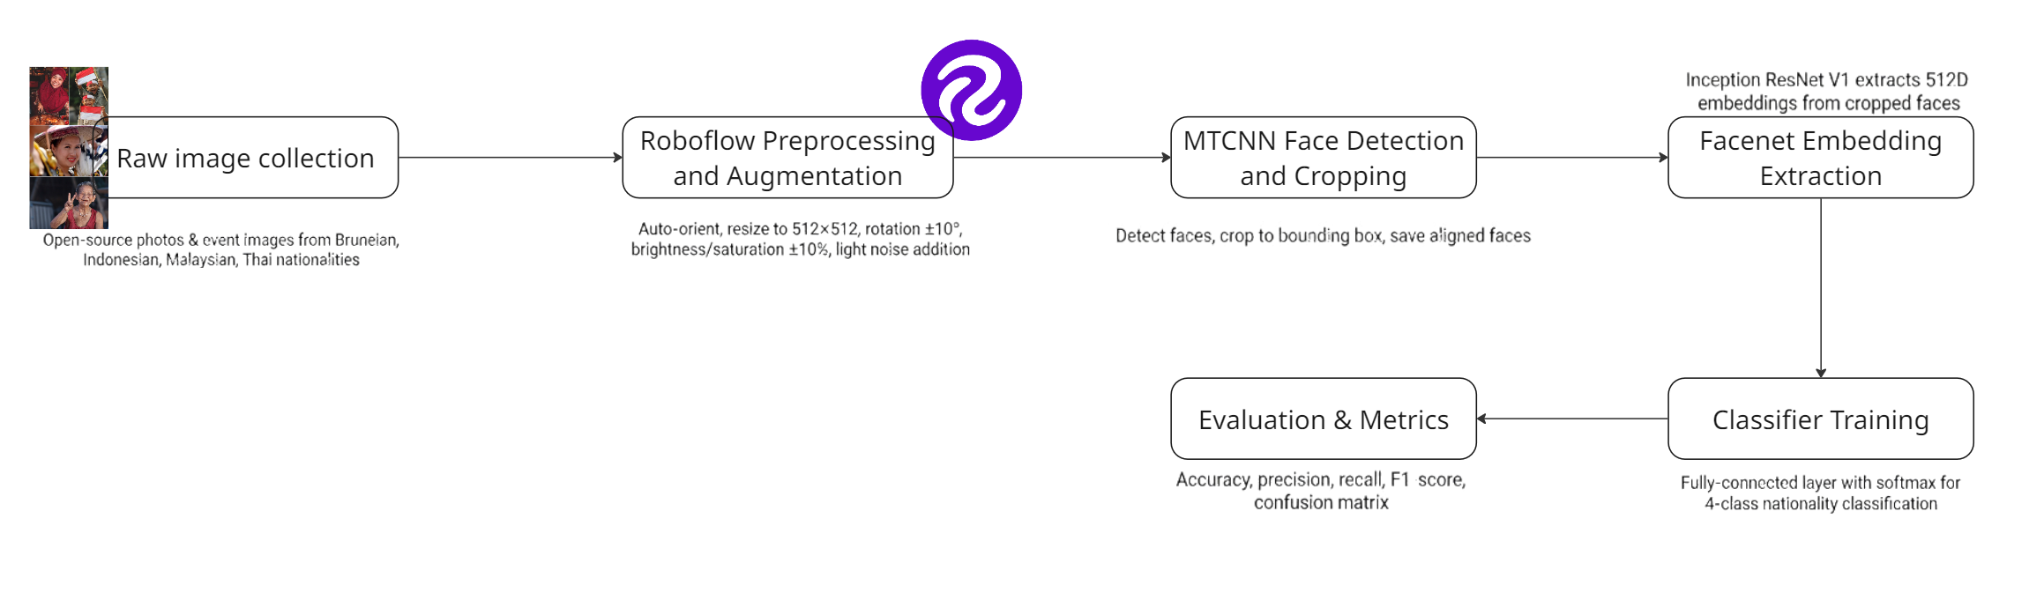Figure 4.2.1(a): End-to-end system pipeline from raw image collection through Roboflow preprocessing, MTCNN face detection, FaceNet embedding extraction, classifier training, to final evaluation with accuracy, precision, recall, F1-score, and confusion matrix.

As shown in Figure 4.2.1(a), the implemented system follows a modular pipeline where each stage transforms the input progressively from raw Southeast Asian nationality images to final classification predictions and performance metrics. While preparing datasets, raw facial images are organized into training and validation splits following a Yolov8-style directory structure. With separate folders for each class. During the preprocessing stage, the Multi-Task Cascaded Convolutional Neural Network(MTCNN) model detects and aligns faces within these images, and the cropped face regions are saved into dedicated folders named ‘train_cropped’ and ‘valid_cropped’. A pretrained InceptionResnetV1(Facenet) model is applied to each cropped face at the feature extraction stage to generate a fixed-length embedding vector that captures the identity-related features. Lastly, a classification layer is trained on these embeddings to predict the target demographic or nationality class, and the same pipeline is reused during inference to produce predictions in which performance is evaluated using accuracy, confusion matrices and group-wise metrics.

4.2.2 Development Environment
The prototype was implemented and tested entirely in the Google Colab environment, using a hosted runtime with NVIDIA T4 GPU and the latest stable Python 3 runtime in the platform, which is Python 3.12.12. All code editing, execution and experiment tracking were performed directly in Colab notebooks, which integrated both the data preprocessing pipeline and the Facenet-based training and evaluation scripts. The deep learning stack was built on Pytorch, together with torchvision and facenet-pytorch libraries for MTCNN face detection and InceptionResnetV1(Facenet) embedding extraction, while common scientific Python packages, which are numPy and Matpotlib were used for data handling and visualization of training curves and Confusion Matrices.
The use of Google Colab with GPU acceleration made it feasible to process the augmented dataset, perform batch-based embedding extraction and fine-tune the classifier within reasonable training times, despite the limited local hardware resources available on the student’s personal machine. Batch sizes and memory-saving practices such as running the embedding model in evaluation mode with gradients disabled and periodically clearing unused tensors were adopted to ensure that the experiments ran reliably within the memory limits of the T4 GPU.

4.3 Dataset Preparation and Preprocessing

4.3.1 Dataset Preparation
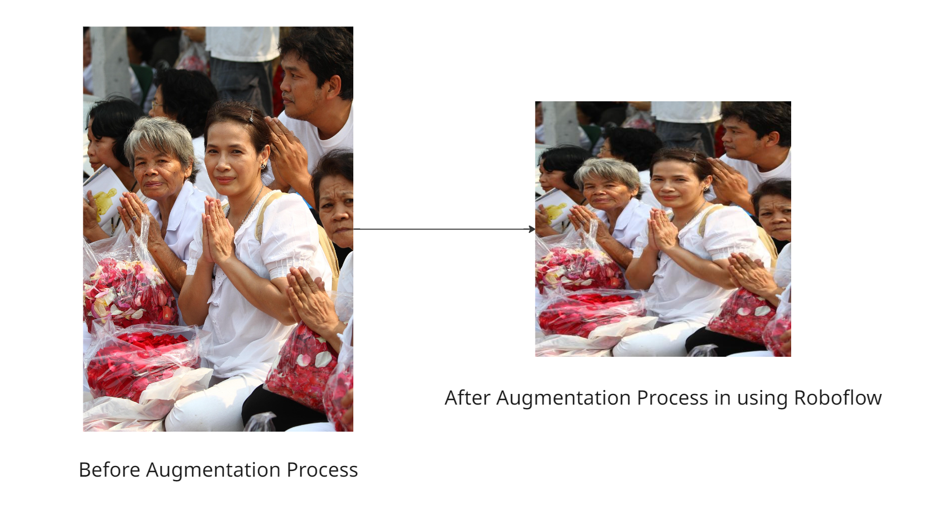
Figure 4.3.1(a): Face image of one of the ckass nationalities after Roboflow augmentation
The dataset used in this project consists of facial images collected from open-source platforms and from freelance photographers that joined multiple cultural events. The facial images then is organized into multiple nationality classes, with a particular emphasis on Southeast Asian subjects. These images are arranged into separate training and validation splits using a Yolov8-style directory structure, where each class has its own sub-folder containing the face images. Before it is turned into a dataset, data augmentation was applied using Roboflow to increase the effective size and diversity of the dataset. Transformation which are rotation, saturation, brightness variation and cutout are implemented to help increase the quality of the dataset.After augmentation process, the final dataset statistics(number of images per class and per split) we computed to verify that there was no severe imbalance that could bias the classifier towards particular groups. 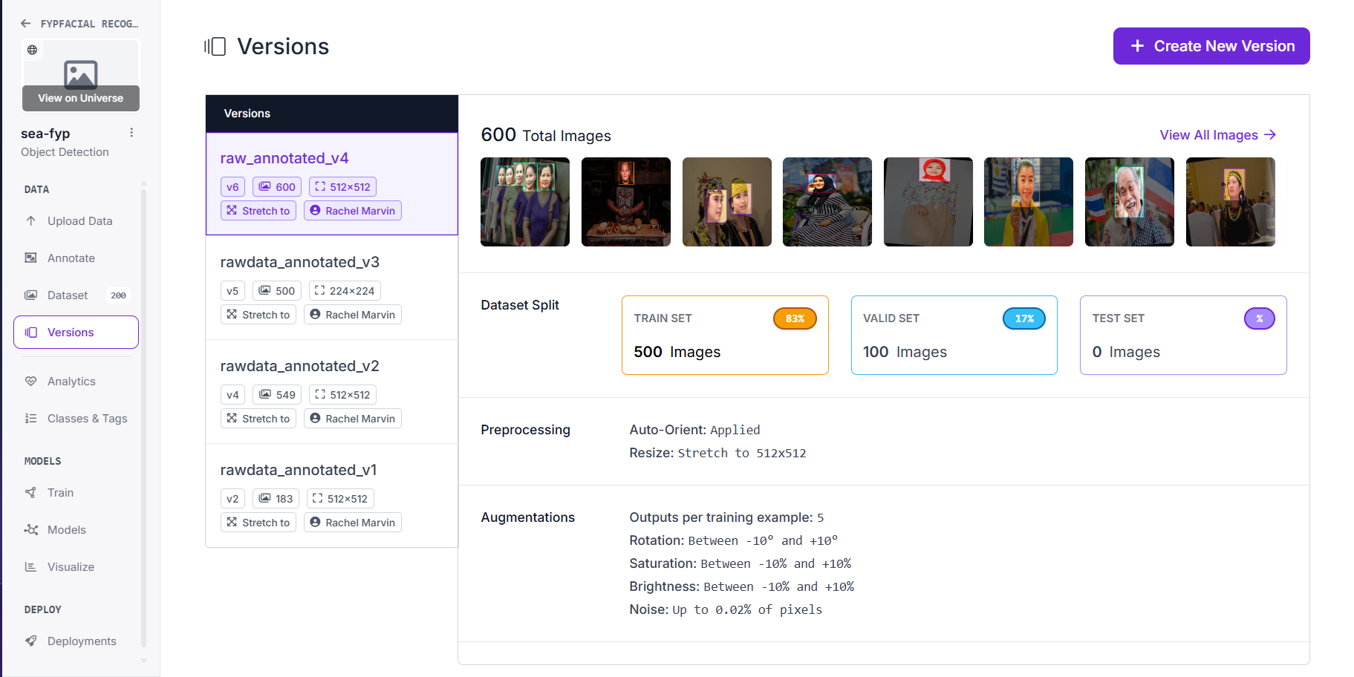
Figure 4.3.1(b): Dataset Configuration for the Final Version, containing 600 images split into 500 images(83%) and 100 validation images (17%).

4.3.2 Embedding Extraction Process
Prior to training the classifier, all facial images were converted into compact numerical representations using a FaceNet-based embedding model. First, the MTCNN face detector was applied to each image in the training and validation sets to locate and align the primary face region, which was then cropped and resized to a fixed resolution suitable for the embedding network; the cropped faces were stored in dedicated ‘train_cropped’ and ‘valid_cropped’ folders for reuse. Next, a pretrained InceptionResnetV1 model from the facenet-pytorch library was loaded in evaluation mode and used to process batches of cropped faces, generating a fixed-length embedding vector for each face. To ensure efficient use of GPU memory, embeddings were extracted in mini-batches under a no-gradient context, and intermediate tensors were periodically cleared from memory once they were concatenated into the final embedding matrix.
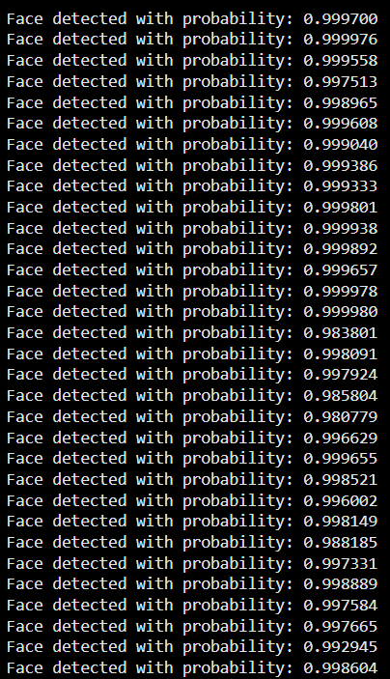
Figure 4.3.2(a):Example MTCNN face-detection probabilities during preprocessing.

4.3.3 Model Training Process
After embedding extraction, the training process treated each face as a pair of (embedding, label) suitable for supervised classification. The cropped training and validation images were loaded using PyTorch’s ImageFolder datasets with a transform pipeline that converts images to tensors and applies fixed image standardization, and the resulting datasets were wrapped in DataLoader objects to provide mini-batches for training and evaluation. A classification head was attached to the FaceNet backbone, and the combined model parameters were optimized using the Adam optimizer with an appropriate initial learning rate, while a MultiStepLR scheduler was used to reduce the learning rate at predefined epochs in order to stabilize convergence. The model was trained for a fixed number of epochs, and after each epoch, the performance on the validation set was recorded so that the best-performing checkpoint could be selected for subsequent testing and analysis.

4.3.4 Evaluation metrics and Test Setup
The performance of the facial recognition prototype was evaluated using standard classification metrics computed on the held-out validation or test set. Overall accuracy was used as a primary indicator of how often the model correctly predicted the target demographic or nationality class, while the confusion matrix provided a more detailed view of which classes were frequently confused with each other. In addition, per-class accuracy and group-wise metrics were calculated in order to examine potential biases, for example whether the system performed consistently across different Southeast Asian nationalities or demographic groups. The test setup ensured that images used for evaluation were not seen during training, and that the same preprocessing and embedding extraction pipeline was applied at both training and testing time to maintain consistency. These procedures ensure that the experimental evaluation follows standard practices in facial recognition research, using held-out validation data, consistent preprocessing between training and testing, and widely accepted metrics such as accuracy, confusion matrices, and per-class precision, recall, and F1-score.

4.4 Model Training and Fine-Tuning
The FaceNet-based classifier was fine-tuned on the prepared Southeast Asian facial dataset to adapt the pretrained embeddings to the specific demographic or nationality classes defined in this study. Training was carried out using mini-batches of cropped and standardised face images loaded through PyTorch DataLoader objects, with each batch passed through the InceptionResnetV1 backbone followed by a classification layer to produce class logits. The model parameters were optimised using the Adam optimiser with a fixed initial learning rate, while a MultiStepLR scheduler was employed to reduce the learning rate at selected epochs, thereby encouraging stable convergence as training progressed. The cross-entropy loss function was used to measure the discrepancy between the predicted class probabilities and the ground-truth labels, and gradients were backpropagated through both the embedding and classification layers.
During each epoch, the model was trained on the training split and subsequently evaluated on the validation split to monitor its generalization performance. Key statistics, including training and validation loss as well as validation accuracy, were recorded for every epoch to observe learning trends and detect potential overfitting. The final model used in the subsequent experimental analysis was selected as the checkpoint that achieved the best validation performance, providing a reasonable balance between fitting the training data and maintaining robust performance on unseen faces.

4.5 Experimental Result and Analysis

4.5.1 Overall Performance
A held-out validation set including 100 facial photos in total, drawn from the four nationality classes—Bruneian, Indonesian, Malaysian, and Thai—was used to assess the refined model. On this set, the model’s overall classification accuracy was 36% meaning that 36 out of 100 faces had their nationality correctly predicted. Given the small dataset size and the strong visual resemblance between Southeast Asian faces, this relatively low accuracy highlights the difficulty of the task and indicates that the current prototype should be viewed as an experimental proof-of-concept rather than a deployable system.
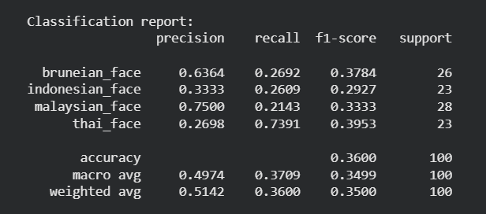
Figure 4.5.1(a): Summary of per-class precision, recall, F1-score and support for the four nationality classes on the 100-image validation set.

4.5.2 Baseline Comparison
The earlier experiment was conducted with a less curated version of the dataset and more aggressive augmentation settings, following most of the requirements in methodology, which produced a validation accuracy of 29% for the four-classjm nationality task. After configuration is improved and quality of images is analysed, which now has the cleaned-600 image dataset with controlled augmentations and same MTCNN-Facenet architecture, the best model achieves 36% validation on the held-out validation set. This 7 percentage-point improvement shows that dataset redevelopment and safer augmentation choices by data scarcity and the difficulty of the differences among Southeast Asian nationalities.

4.5.3 Confusion Matrix and Per- Class Results
A confusion matrix and a complete classification report were calculated on the validation set to provide a more thorough understanding of the model's behavior. Although the highest recall (0.7391) and F1-score (0.3953) are achieved by Thai faces, followed by Bruneian faces (recall 0.2692, F1-score 0.3784) and Malaysian faces (recall 0.2143, F1-score 0.3333). Indonesian faces record a recall of 0.2609 and F1-score of 0.2927, indicating that none of the four nationalities is recognised particularly well, but Thai faces are favoured in terms of recall. These findings demonstrate that the model has a significant propensity to assign many faces to the Thai class while frequently failing to recognize Malaysian and Bruneian faces, indicating the need for more data and more balanced training to ensure equitable recognition for all populations.
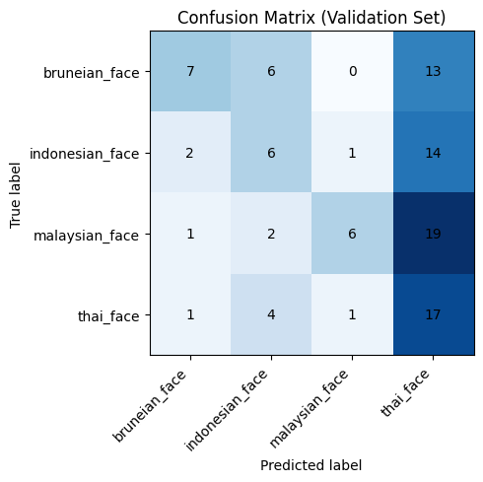
Figure 4.5.3(a): Confusion matrix for four-class nationality classification on the validation set.
The high recall but low precision for Thai faces shows that the classifier frequently assigns other nationalities to the Thai class, while the low recall for Malaysian and Bruneian faces indicates that these groups are systematically under-recognised. This imbalance suggests remaining demographic bias in the prototype and motivates further dataset balancing and model refinement.

4.5.4 Qualitative Analysis.
Beyond the numerical metrics, several qualitative patterns were observed when inspecting sample predictions. Correctly classified examples generally corresponded to frontal faces with sufficient lighting, moderate resolution and minimal occlusion, which are conditions that align well with the images seen during training. In contrast, many misclassifications occurred in images with challenging properties such as non-frontal pose, shadows, partial occlusion or lower image quality, and in cases where individuals from different nationalities exhibited very similar facial features. These observations suggest that the current model is sensitive to variations in pose and lighting and that the dataset does not yet capture enough diverse examples per class, motivating future work on collecting higher-quality and more varied images for each Southeast Asian nationality.
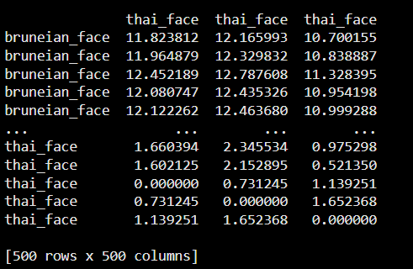
Figure 4.5.4(a): A part of embedding distance matrix, where lower values indicate more similar faces.

4.6 Chapter Summary
The implementation and testing of the suggested face recognition prototype for Southeast Asian nationality classification have been thoroughly covered in this chapter. It provided the FaceNet-based embedding extraction and model training workflow used to fine-tune a four-class classifier, described the system architecture and Colab-based development environment, and described how the facial dataset was prepared, enhanced, and preprocessed. With a 36% overall accuracy on a validation set of 100 images, the experimental evaluation revealed significant confusion between the nationalities and the effects of visual similarity and dataset limitations. The recall for Indonesian and Thai faces was significantly higher, while the recall for Malaysian and Bruneian faces was very low. These results serve as the empirical foundation for the following chapter, which summarizes the findings, discusses them in light of the project's goals and existing literature, and uses them to draw key conclusions, identify any limits, and offer suggestions for future works.

Chapter 5
Conclusion and Future Works

5.1 Introduction
This chapter presents the overall conclusions of the study based on the implementation and experimental results reported and relates them back to the research objectives and problem statement outlined in the earlier chapter. It summarises the main findings, discusses their implications for nationality-based facial recognition on Southeast Asian faces, highlights the contributions and significance of the prototype, and acknowledges the limitations of the work together with recommendations for future research and system improvement.

5.2 Summary of Findings
This project successfully implemented a prototype facial recognition pipeline for Southeast Asian faces, combining MTCNN for face detection and alignment, a pretrained InceptionResnetV1 (FaceNet) model for embedding extraction, and a supervised classifier for four nationality classes: Bruneian, Indonesian, Malaysian and Thai. On the curated dataset of 600 images, evaluated using a held-out validation set of 100 images, the prototype achieved an overall classification accuracy of 36%, indicating that slightly more than one-third of faces were assigned to the correct nationality. Per-class metrics and the confusion matrix showed that Indonesian and Thai faces obtained comparatively higher recall and F1-scores, while Malaysian and Bruneian faces were frequently misclassified, revealing uneven performance across nationalities.

5.3 Discussion and Evaluation
The experimental results demonstrate that nationality-based facial recognition on a small, regional dataset is a highly challenging task. The overall accuracy of 36% is much lower than the accuracies above 95% commonly reported on large, balanced face recognition benchmarks, and the confusion matrix indicates substantial misclassification between Southeast Asian nationalities. This performance gap can be attributed to several factors: the limited number of images per class, class imbalance, and the high visual similarity between neighbouring Southeast Asian populations, which makes nationality boundaries inherently fuzzy at the level of facial appearance. The uneven per-class metrics raise fairness concerns, as the model tends to recognise Indonesian and Thai faces more reliably while systematically under-recognising Malaysian and Bruneian faces. This pattern likely reflects differences in data quantity and quality between classes and overfitting to specific visual patterns, rather than genuine differences in recognisability, underscoring the need for larger, more balanced datasets and stronger regularisation in future work.

5.4 Contribution and Significance
Despite its limited accuracy, the project makes three main contributions. First, it delivers a complete, end-to-end implementation of a FaceNet-based facial recognition pipeline tailored to Southeast Asian nationalities, implemented in a reproducible Google Colab environment with clearly defined preprocessing, embedding extraction and classification steps. Second, it assembles and documents a curated dataset of Bruneian, Indonesian, Malaysian and Thai faces, including a practical workflow for augmentation, cropping and organisation that can serve as a baseline for future regional studies. Third, by reporting detailed per-class metrics and confusion patterns instead of only overall accuracy, the work highlights how performance can vary substantially across demographic groups and emphasises the importance of fairness-aware evaluation when applying facial recognition to under-represented populations in sensitive domains such as immigration.

5.5 Limitations and Recommendations / Future Work
This study has several important limitations that must be acknowledged. The most significant constraint is the limited size and balance of the dataset, with relatively few images per nationality and uneven representation of different conditions such as pose, lighting and occlusion, which restricts the ability of the model to generalise and contributes to the low overall accuracy and uneven per-class performance. In addition, the training process relied on a single model architecture and a single training configuration on the Google Colab T4 GPU, without extensive hyperparameter tuning or comparison to alternative classifiers, which limits the conclusions that can be drawn about the best possible performance for this task. Furthermore, nationality at the level of facial appearance is an inherently ambiguous label, and the use of visual nationality classification raises ethical questions regarding privacy, consent and potential misuse that are not fully addressed in this technical prototype.
Future work should therefore focus on expanding and rebalancing the dataset, for example by collecting more images per nationality and including additional Southeast Asian countries, as well as ensuring better coverage of variations in lighting, pose and age. It would also be valuable to explore alternative model architectures and training strategies, such as experimenting with different embedding networks, loss functions or metric-learning approaches, and to perform systematic hyperparameter tuning to seek improved performance. From an evaluation and ethics perspective, future studies should incorporate more rigorous fairness metrics, cross-dataset validation and clear guidelines on acceptable use, so that facial recognition systems developed for Southeast Asian populations can be assessed not only in terms of accuracy but also in terms of bias, transparency and societal impact.

5.5 Conclusion
In summary, this project implemented and evaluated a FaceNet-based facial recognition prototype for four Southeast Asian nationalities, demonstrating the feasibility of integrating modern face detection and embedding models into a complete pipeline while also exposing the challenges of applying such systems to limited and imbalanced regional datasets. The experimental results showed an overall validation accuracy of 36% with substantial confusion between nationalities and particularly poor recognition of Malaysian and Bruneian faces, highlighting the need for more extensive data collection, careful model design and fairness-aware evaluation before nationality classification could be considered for any practical deployment. Nevertheless, the work provides a useful foundation by clarifying the system architecture, data preparation steps and evaluation methodology for Southeast Asian facial recognition and by identifying specific directions for future research aimed at improving both performance and equity.

References
Esler, T. (2019). facenet-pytorch (Version 2.5.2) [Computer software]. GitHub. https://github.com/timesler/facenet-pytorc
Buntoun, M., & Kuok, F. (2023). Cross-race effect in face recognition: An observation on Southeast Asian. Proceedings of the 15th International Conference on Software, Knowledge, Information Management, and Applications (SKIMA), 75-80.
Buolamwini, J., & Gebru, T. (2018). Gender shades: Intersectional accuracy disparities in commercial gender classification. Conference on Fairness, Accountability and Transparency, 77-91.
Christian, G. (2024). The New Jim Crow: Unmasking racial bias in AI facial recognition technology within the Canadian immigration system. McGill Law Journal, 69(4), 441 - 466.
Das, A., Dantcheva, A., & Bremond, F. (2018). Mitigating bias in gender, age and ethnicity classification: A multi-task convolution neural network approach. European Conference on Computer Vision (ECCV) 2018 Workshops.
Gross, T. F. (2014). Own-ethnicity bias in the recognition of Black, East Asian, Hispanic, and White faces. Asian American Journal of Psychology, 5(3), 181-189.
Hu, H., Shah, S. A. A., Bennamoun, M., & Molton, M. (2017). 2D and 3D face recognition using convolutional neural network. 2017 IEEE Region 10 Conference (TENCON), 133-138.
Islam, B., Mahmud, F., & Hossain, A. (2018). Facial expression region segmentation based approach to emotion recognition using 2D Gabor filter and multiclass support vector machine. 2018 21st International Conference of Computer and Information Technology (ICCIT), 1-6.
Janiesch, C., Zschech, P., & Heinrich, K. (2021). Machine learning and deep learning. Electronic Markets, 31(3), 685-695.
Khalil, A., Ahmed, S. G., Khattak, A. M., & Al-Qirim, N. (2020). Investigating bias in facial analysis systems: A systematic review. IEEE Access, 8, 130751-130761.
Khan, N., & Efthymiou, M. (2021). The use of biometric technology at airports: The case of customs and border protection (CBP). International Journal of Information Management Data Insights, 1(2), 100049.
Klare, B. F., Burge, M. J., Klontz, J. C., Vorder Bruegge, R. W., & Jain, A. K. (2012). Face recognition performance: Role of demographic information. IEEE Transactions on Information Forensics and Security, 7(6), 1789-1801.
Majumder, G., & Bhowmik, M. K. (2015). Gabor-FastICA feature extraction for thermal face recognition using linear kernel support vector machine. 2015 International Conference on Computational Intelligence & Networks, 19-25.
Phillips, P. J., Jiang, F., Narvekar, A., Ayyad, J., & O'Toole, A. J. (2011). An other-race effect for face recognition algorithms. ACM Transactions on Applied Perception, 8(2), 1-11.
Pum, M., & Nguyen, E. (2023). Algorithmic bias in facial recognition: A global perspective.
Robinson, J. P., Livitz, G., Henon, Y., Qin, C., Fu, Y., & Timoner, S. (2020). Face recognition: Too bias, or not too bias? Proceedings of the IEEE/CVF Conference on Computer Vision and Pattern Recognition Workshops, 0-1.
Santhosh, P., & Rajashekararadhya, S. V. (2023). Face recognition using PCA and LDA algorithms. International Journal of Engineering Research & Technology, 12(5), 789 - 794.
Singh, R., Majumdar, P., Mittal, S., & Vatsa, M. (2022). Anatomizing bias in facial analysis. Proceedings of the AAAI Conference on Artificial Intelligence, 36(11), 12351 - 12358.
Vohra, A. (2023). Social order in the age of artificial intelligence: The use of technology in migration governance and decision-making [Master's thesis]. University of British Columbia.
Wang, M., & Deng, W. (2020). Mitigating bias in face recognition using skewness-aware reinforcement learning. Proceedings of the IEEE/CVF Conference on Computer Vision and Pattern Recognition, 9322-9331.
Yucer, S., Tektas, F., Al Moubayed, N., & Breckon, T. (2024). Racial bias within face recognition: A survey. ACM Computing Surveys, 57(4), 1-39.
Zucchetti Filho, P. (2023). Mark Andrejevic and Neil Selwyn (2022) Facial Recognition. Cambridge: Polity Press. Law, Technology and Humans, 5(1), 221-224.

