2014

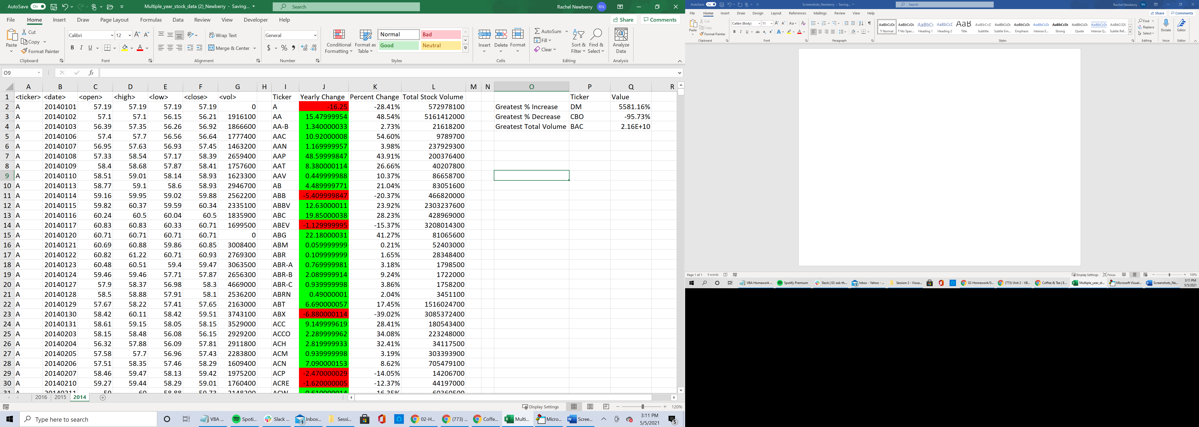

2015

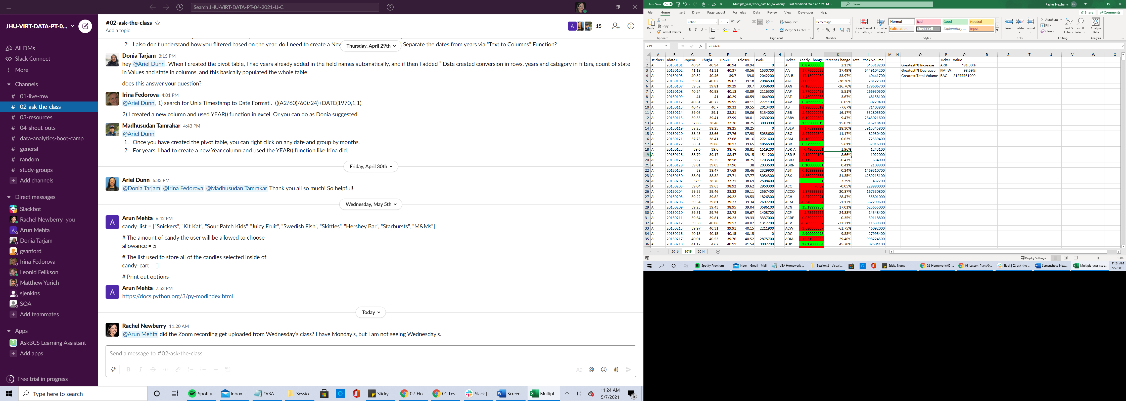

2016

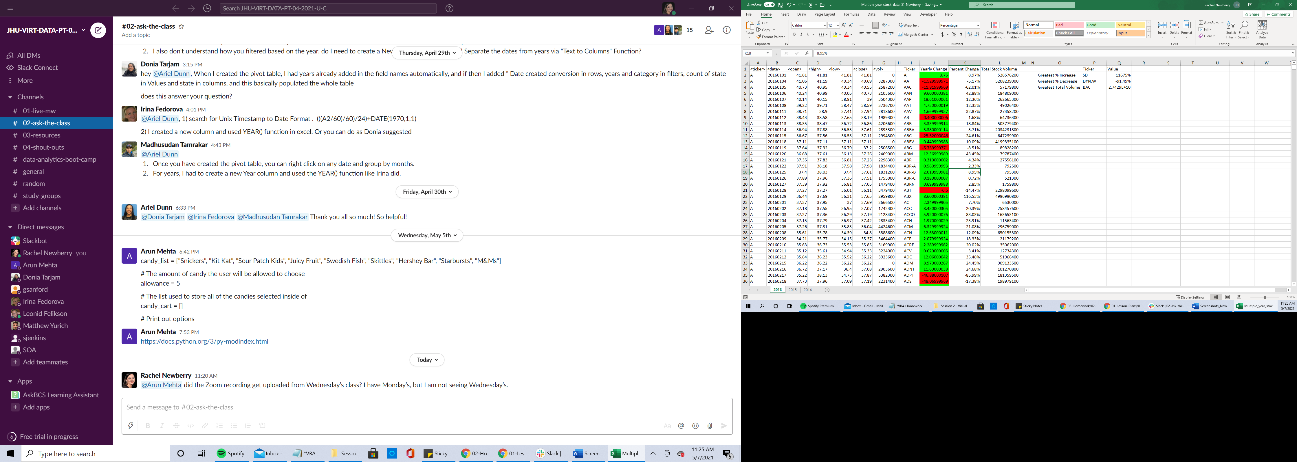

Sub Data()

Dim total As Double

Dim i As Long

Dim change As Single

Dim j As Integer

Dim start As Long

Dim rowCount As Long

Dim percentChange As Single

For Each ws In Worksheets

ws.Range("I1").Value = "Ticker"

ws.Range("J1").Value = "Yearly Change"

ws.Range("K1").Value = "Percent Change"

ws.Range("L1").Value = "Total Stock Volume"

ws.Range("P1").Value = "Ticker"

ws.Range("Q1").Value = "Value"

ws.Range("O2").Value = "Greatest % Increase"

ws.Range("O3").Value = "Greatest % Decrease"

ws.Range("O4").Value = "Greatest Total Volume"

j = 0

total = 0

change = 0

start = 2

rowCount = ws.Cells(Rows.Count, "A").End(xlUp).Row

For i = 2 To rowCount

If ws.Cells(i + 1, 1).Value <> ws.Cells(i, 1).Value Then

total = total + ws.Cells(i, 7).Value

If total = 0 Then

ws.Range("I" & 2 + j).Value = ws.Cells(i, 1).Value

ws.Range("J" & 2 + j).Value = 0

ws.Range("K" & 2 + j).Value = "%" & 0

ws.Range("L" & 2 + j).Value = 0

Else

If ws.Cells(start, 3) = 0 Then

For find_value = start To i

If ws.Cells(find_value, 3).Value <> 0 Then

start = find_value

Exit For

End If

Next find_value

End If

change = (ws.Cells(i, 6) - ws.Cells(start, 3))

percentChange = Round((change / ws.Cells(start, 3) * 100), 2)

start = i + 1

ws.Range("I" & 2 + j).Value = ws.Cells(i, 1).Value

ws.Range("J" & 2 + j).Value = Round(change, 2)

ws.Range("K" & 2 + j).Value = "%" & percentChange

ws.Range("L" & 2 + j).Value = total

Select Case change

Case Is > 0

ws.Range("j" & 2 + j).Interior.ColorIndex = 4

Case Is < 0

ws.Range("j" & 2 + j).Interior.ColorIndex = 3

Case Else

ws.Range("j" & 2 + j).Interior.ColorIndex = 0

End Select

End If

total = 0

change = 0

j = j + 1

Else

total = total + ws.Cells(i, 7).Value

End If

Next i

ws.Range("Q2") = "%" & WorksheetFunction.Max(ws.Range("K2:K" & rowCount)) * 100

ws.Range("Q3") = "%" & WorksheetFunction.Min(ws.Range("K2:K" & rowCount)) * 100

ws.Range("Q4") = WorksheetFunction.Max(ws.Range("L2:L" & rowCount))

increase_number = WorksheetFunction.Match(WorksheetFunction.Max(ws.Range("K2:K" & rowCount)), ws.Range("K2:K" & rowCount), 0)

decrease_number = WorksheetFunction.Match(WorksheetFunction.Min(ws.Range("K2:K" & rowCount)), ws.Range("K2:K" & rowCount), 0)

volume_number = WorksheetFunction.Match(WorksheetFunction.Max(ws.Range("L2:L" & rowCount)), ws.Range("L2:L" & rowCount), 0)

ws.Range("P2") = ws.Cells(increase_number + 1, 9)

ws.Range("P3") = ws.Cells(decrease_number + 1, 9)

ws.Range("P4") = ws.Cells(volume_number + 1, 9)

Next ws

End Sub