Building a Successful KickStarter Campaign

Rachel Nelson

8/1/2020

#Section 1 ###Introduction: How can I make my KickStarter campaign a success?

###Research questions * Are there certain types/category of campaigns that are more successful? * How much money should you ask for? * Is there a time period for the campaign that works better than others? * What is the average contribution of a backer? * Is there a better time of year to launch a campaign?

###Approach * I will be performing basic data analysis and correlation on the data set provided. I will review things like the mean, median and mode of some of the factors that are of interest.

####How your approach addresses (fully or partially) the problem. By finding out which metrics matter, we can use these elements to ensure your next kickstarter campaign ends in success.

####Data <https://www.kaggle.com/kemical/kickstarter-projects>

####Required Packages * dplyr * ggplot2 * plotly * lm.beta

####Plots and Table Needs * Scatter plots * data tables * correlation tables * box plots

####Questions for future steps * Should I look into neural networks?

# Section 2

### How to import and clean my data

I am importing the data by connecting the the CSV that was available for download on the Kaggle site. <https://www.kaggle.com/kemical/kickstarter-projects>

# load the data  
ks_df <- read.csv("D:/College/DSC520/dsc520/data/ks-projects-201801.csv")

I am cleaning the data set to prepare it for analysis. ####Check for missing columns

# Check for Missing Columns  
names(ks_df)

## [1] "ID" "name" "category" "main_category"   
## [5] "currency" "deadline" "goal" "launched"   
## [9] "pledged" "state" "backers" "country"   
## [13] "usd.pledged" "usd_pledged_real" "usd_goal_real"

ks_df$rowid <- paste(ks_df$ID, "-", ks_df$round)  
length(unique(ks_df$rowid))

## [1] 378661

length(ks_df$rowid)

## [1] 378661

Here I confirmed that all rows have a unique ID. I also reviewed the data to ensure all the data I needed was contained within the data set.

####Check variables names

# checks variable names and replace with new name  
library(dplyr)

##   
## Attaching package: 'dplyr'

## The following objects are masked from 'package:stats':  
##   
## filter, lag

## The following objects are masked from 'package:base':  
##   
## intersect, setdiff, setequal, union

ks_df <- rename(ks_df, usd_pledged = usd.pledged)

Here I renamed the variable usd.pledged to usd_pledged to align the naming conventions of all of my headers, since the rest of the headers uses underscores instead of periods for spaces.

####Check missing observations

# checks for missing values in observations  
colMeans(is.na(ks_df))

## ID name category main_category   
## 0.00000000 0.00000000 0.00000000 0.00000000   
## currency deadline goal launched   
## 0.00000000 0.00000000 0.00000000 0.00000000   
## pledged state backers country   
## 0.00000000 0.00000000 0.00000000 0.00000000   
## usd_pledged usd_pledged_real usd_goal_real rowid   
## 0.01002744 0.00000000 0.00000000 0.00000000

# removes column from data set  
ks_df = subset(ks_df, select = -c(usd_pledged) )

Here I am looking for missing values. There is a small amount of data in the usd_pledged with missing values. If I wanted to cleanse the data set, I could remove these values, but for now, I want to keep it in mind since there are zero missing values from usd_pledged_real, which is a column giving the same information, but the conversion to USD was done from the fixer.io api instead of done by kickstarter. Instead of removing the rows with the missing data, I am going to remove the column from the data set since it is a duplicate column.

usd_pledged: conversion in US dollars of the pledged column (conversion done by kickstarter). usd pledge real: conversion in US dollars of the pledged column (conversion from Fixer.io API).

####Check variable classification

# checks attributes of data frame  
str(ks_df)

## 'data.frame': 378661 obs. of 15 variables:  
## $ ID : int 1000002330 1000003930 1000004038 1000007540 1000011046 1000014025 1000023410 1000030581 1000034518 100004195 ...  
## $ name : chr "The Songs of Adelaide & Abullah" "Greeting From Earth: ZGAC Arts Capsule For ET" "Where is Hank?" "ToshiCapital Rekordz Needs Help to Complete Album" ...  
## $ category : chr "Poetry" "Narrative Film" "Narrative Film" "Music" ...  
## $ main_category : chr "Publishing" "Film & Video" "Film & Video" "Music" ...  
## $ currency : chr "GBP" "USD" "USD" "USD" ...  
## $ deadline : chr "2015-10-09" "2017-11-01" "2013-02-26" "2012-04-16" ...  
## $ goal : num 1000 30000 45000 5000 19500 50000 1000 25000 125000 65000 ...  
## $ launched : chr "2015-08-11 12:12:28" "2017-09-02 04:43:57" "2013-01-12 00:20:50" "2012-03-17 03:24:11" ...  
## $ pledged : num 0 2421 220 1 1283 ...  
## $ state : chr "failed" "failed" "failed" "failed" ...  
## $ backers : int 0 15 3 1 14 224 16 40 58 43 ...  
## $ country : chr "GB" "US" "US" "US" ...  
## $ usd_pledged_real: num 0 2421 220 1 1283 ...  
## $ usd_goal_real : num 1534 30000 45000 5000 19500 ...  
## $ rowid : chr "1000002330 - " "1000003930 - " "1000004038 - " "1000007540 - " ...

Checking the variable classification is the step used to make sure the data is the right datatype for analysis.

####Check duplicate rows

# Checking if one row is identical to another  
distinctdata <- distinct(ks_df)  
nrow(ks_df)

## [1] 378661

nrow(distinctdata)

## [1] 378661

Checking for duplicate rows within the data. None were found. If duplicate rows are found, the duplicate should be extracted from the dataset.

####Change dates from factors to date

ks_df <- transform(ks_df, deadline = as.Date(deadline), launched = as.Date(launched), backers = as.numeric(backers))

Changes the data type of deadline and launched to date.

### What does the final data set look like?

head(ks_df)

## ID name  
## 1 1000002330 The Songs of Adelaide & Abullah  
## 2 1000003930 Greeting From Earth: ZGAC Arts Capsule For ET  
## 3 1000004038 Where is Hank?  
## 4 1000007540 ToshiCapital Rekordz Needs Help to Complete Album  
## 5 1000011046 Community Film Project: The Art of Neighborhood Filmmaking  
## 6 1000014025 Monarch Espresso Bar  
## category main_category currency deadline goal launched pledged  
## 1 Poetry Publishing GBP 2015-10-09 1000 2015-08-11 0  
## 2 Narrative Film Film & Video USD 2017-11-01 30000 2017-09-02 2421  
## 3 Narrative Film Film & Video USD 2013-02-26 45000 2013-01-12 220  
## 4 Music Music USD 2012-04-16 5000 2012-03-17 1  
## 5 Film & Video Film & Video USD 2015-08-29 19500 2015-07-04 1283  
## 6 Restaurants Food USD 2016-04-01 50000 2016-02-26 52375  
## state backers country usd_pledged_real usd_goal_real rowid  
## 1 failed 0 GB 0 1533.95 1000002330 -   
## 2 failed 15 US 2421 30000.00 1000003930 -   
## 3 failed 3 US 220 45000.00 1000004038 -   
## 4 failed 1 US 1 5000.00 1000007540 -   
## 5 canceled 14 US 1283 19500.00 1000011046 -   
## 6 successful 224 US 52375 50000.00 1000014025 -

### Questions for future steps

I need to figure out if and how the factor/category data needs to be changed to numerical data. I also had to change dates from factors to date data types.

### What information is not self-evident?

I plan to run both correlation and unsupervised learning models on the data to see if I can uncover any new information that is not self-evident.

### What are different ways you could look at this data?

Yes, the questions I want to answer can be viewed though looking at bar charts, frequency plots and statistical models. * Are there certain types/category of campaigns that are more successful? * How much money should you ask for? * Is there a time period for the campaign that works better than others? * What is the average contribution of a backer? * Is there a better time of year to launch a campaign?

### How do you plan to slice and dice the data?.

Created a new variable for % successful by taking the pledged and dividing it by the goal. I also slided out the month for both deadline and launch dates.

# Adding new rows to slide and dice the data later  
ks_df <-  
 ks_df %>%  
 mutate(  
 pledged_to_goal = usd_pledged_real/usd_goal_real,  
 count = 1,  
 deadline_month = format(deadline,"%m"),  
 launched_month = format(launched,"%m"),  
 backers_per_pledge = usd_pledged_real/backers  
 )

### How could you summarize your data to answer key questions?

This ties into the different ways I can look at the data set. Charts and visualizations are a great way to summarize the data and answer key questions.

### What types of plots and tables will help you to illustrate the findings to your questions?

Bar charts, box plots and scatter charts will help illustrate findings to my questions.

### Do you plan on incorporating any machine learning techniques to answer your research questions? Explain.

Yes, I plan to see if there are any supervised (like decision tree or random forest) models and unsupervised (clustering) that can help make sense of what is funded verses unfunded.

### Questions for future steps

This still ties in to question #3, where I need to figure out if the factor/categyory data needs to be changed to numerical data and if so, how I go about doing that.

# Section 3

### Introduction

Kickstarter campaigns is a way to crowdsource funding to support projects, people or situations. It’s a way to raise money. In this analysis, I will be finding out if there are controllable factors which can lead to a successful campaign.

### The problem statement you addressed

Is there a way to design a kickstarter campaign to increase it’s likelihood to be successful?

### How you addressed this problem statement

I addressed this problem statement by looking into answering 5 questions: * Are there certain types/category of campaigns that are more successful? * How much money should you ask for? * Is there a time period for the campaign that works better than others? * What is the average contribution of a backer? * Is there a better time of year to launch a campaign?

I also performed correlation and applied machine learning techniques to see if there are ways to increase the likelihood of building successful campaigns.

### Analysis

#### Are there certain types/category of campaigns that are more successful?

# Filtering by one criterion  
ks_dff <- filter(ks_df, state == "successful")  
  
## Successful Launches based on Deadline Month  
counts <- table(ks_dff$main_category)  
barplot(counts, main="# of Successful Launches",  
 xlab="Main Category")

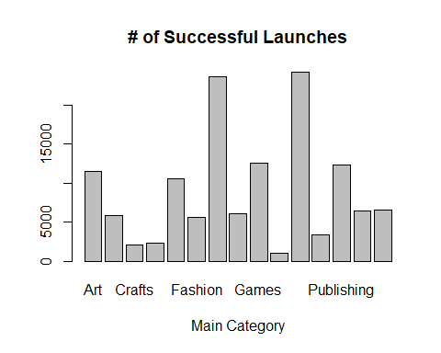 The top 5 categories with successful campaigns are: 1. Music 2. Film & Video 3. Games 4. Publishing 5. Art

#### How much money should you ask for?

library(ggplot2)  
## Create a scatterplot of all states  
ggplot(ks_df, aes(x=state, y=goal, col=state)) + ggtitle("State vs Goal Amount") + xlab("State") + ylab("Goal Amount") + geom_point(aes(colour = state))

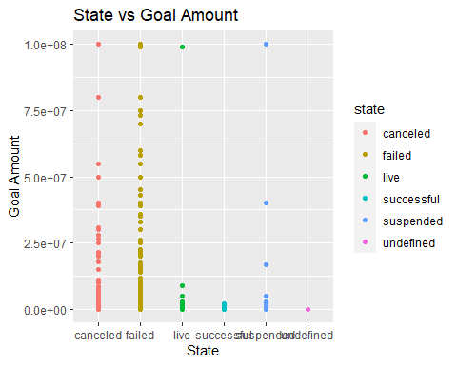

# Boxplot of only successful campaigns  
boxplot(goal~count,data=ks_dff, main="Successful Campaigns",  
 xlab="Goal", ylab="Campaign")

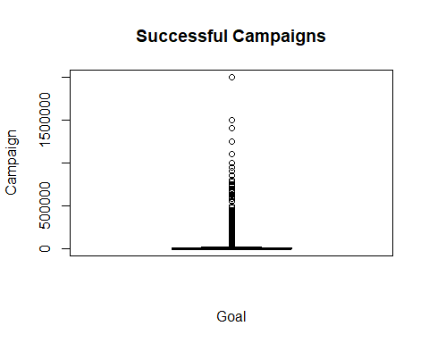

summary(ks_dff)

## ID name category main_category   
## Min. :2.111e+04 Length:133956 Length:133956 Length:133956   
## 1st Qu.:5.354e+08 Class :character Class :character Class :character   
## Median :1.077e+09 Mode :character Mode :character Mode :character   
## Mean :1.074e+09   
## 3rd Qu.:1.608e+09   
## Max. :2.147e+09   
## currency deadline goal launched   
## Length:133956 Min. :2009-05-03 Min. : 0 Min. :2009-04-24   
## Class :character 1st Qu.:2012-12-13 1st Qu.: 1250 1st Qu.:2012-11-13   
## Mode :character Median :2014-08-29 Median : 3923 Median :2014-07-29   
## Mean :2014-07-31 Mean : 10163 Mean :2014-06-29   
## 3rd Qu.:2016-04-13 3rd Qu.: 10000 3rd Qu.:2016-03-12   
## Max. :2018-01-02 Max. :2000000 Max. :2017-12-29   
## pledged state backers country   
## Min. : 1 Length:133956 Min. : 0.0 Length:133956   
## 1st Qu.: 1978 Class :character 1st Qu.: 33.0 Class :character   
## Median : 5117 Mode :character Median : 71.0 Mode :character   
## Mean : 24100 Mean : 263.9   
## 3rd Qu.: 13440 3rd Qu.: 167.0   
## Max. :20338986 Max. :219382.0   
## usd_pledged_real usd_goal_real rowid pledged_to_goal   
## Min. : 1 Min. : 0 Length:133956 Min. : 0.85   
## 1st Qu.: 2000 1st Qu.: 1302 Class :character 1st Qu.: 1.05   
## Median : 5107 Median : 3838 Mode :character Median : 1.17   
## Mean : 22671 Mean : 9533 Mean : 8.56   
## 3rd Qu.: 13232 3rd Qu.: 10000 3rd Qu.: 1.63   
## Max. :20338986 Max. :2015609 Max. :104277.89   
## count deadline_month launched_month backers_per_pledge  
## Min. :1 Length:133956 Length:133956 Min. : 0.7835   
## 1st Qu.:1 Class :character Class :character 1st Qu.: 41.1972   
## Median :1 Mode :character Mode :character Median : 63.3473   
## Mean :1 Mean : Inf   
## 3rd Qu.:1 3rd Qu.:102.3367   
## Max. :1 Max. : Inf

Successful campaigns have a smaller range then non-successful campaigns. The average successful campaign has a goal of around 10,000 with a median of around 4,000.

#### Is there a time period for the campaign that works better than others?

## Successful Launches based on Deadline Month  
counts <- table(ks_dff$deadline_month)  
barplot(counts, main="# of Successful Launches",  
 xlab="Deadline Month")

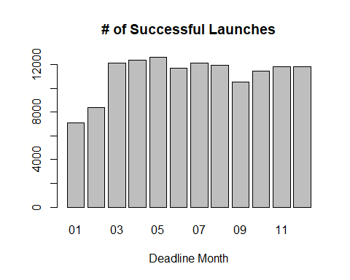 May has the highest number of campaigns that are successful.

#### What is the average contribution of a backer?

# Boxplot of only successful campaigns  
boxplot(usd_pledged_real~count,data=ks_dff, main="Pledged Per Backer",  
 xlab="Goal", ylab="Campaign")

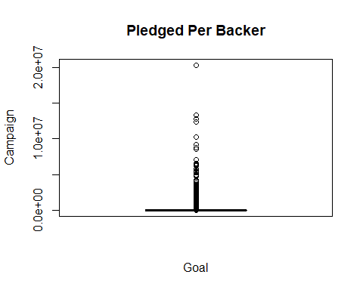

summary(ks_dff)

## ID name category main_category   
## Min. :2.111e+04 Length:133956 Length:133956 Length:133956   
## 1st Qu.:5.354e+08 Class :character Class :character Class :character   
## Median :1.077e+09 Mode :character Mode :character Mode :character   
## Mean :1.074e+09   
## 3rd Qu.:1.608e+09   
## Max. :2.147e+09   
## currency deadline goal launched   
## Length:133956 Min. :2009-05-03 Min. : 0 Min. :2009-04-24   
## Class :character 1st Qu.:2012-12-13 1st Qu.: 1250 1st Qu.:2012-11-13   
## Mode :character Median :2014-08-29 Median : 3923 Median :2014-07-29   
## Mean :2014-07-31 Mean : 10163 Mean :2014-06-29   
## 3rd Qu.:2016-04-13 3rd Qu.: 10000 3rd Qu.:2016-03-12   
## Max. :2018-01-02 Max. :2000000 Max. :2017-12-29   
## pledged state backers country   
## Min. : 1 Length:133956 Min. : 0.0 Length:133956   
## 1st Qu.: 1978 Class :character 1st Qu.: 33.0 Class :character   
## Median : 5117 Mode :character Median : 71.0 Mode :character   
## Mean : 24100 Mean : 263.9   
## 3rd Qu.: 13440 3rd Qu.: 167.0   
## Max. :20338986 Max. :219382.0   
## usd_pledged_real usd_goal_real rowid pledged_to_goal   
## Min. : 1 Min. : 0 Length:133956 Min. : 0.85   
## 1st Qu.: 2000 1st Qu.: 1302 Class :character 1st Qu.: 1.05   
## Median : 5107 Median : 3838 Mode :character Median : 1.17   
## Mean : 22671 Mean : 9533 Mean : 8.56   
## 3rd Qu.: 13232 3rd Qu.: 10000 3rd Qu.: 1.63   
## Max. :20338986 Max. :2015609 Max. :104277.89   
## count deadline_month launched_month backers_per_pledge  
## Min. :1 Length:133956 Length:133956 Min. : 0.7835   
## 1st Qu.:1 Class :character Class :character 1st Qu.: 41.1972   
## Median :1 Mode :character Mode :character Median : 63.3473   
## Mean :1 Mean : Inf   
## 3rd Qu.:1 3rd Qu.:102.3367   
## Max. :1 Max. : Inf

The median backer pledges 63 USD to projects.

#### Is there a better time of year to launch a campaign?

## Successful Launches  
counts <- table(ks_dff$launched_month)  
barplot(counts, main="# of Successful Launches",  
 xlab="Months")

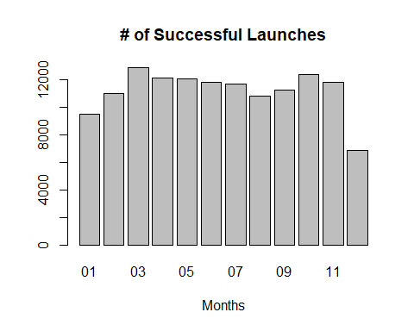 March and October has the most for count of successful launches. December has the least.

#### What are the factors that contribute to sucessful campaigns?

# Prepping the data for modelling:  
  
# Adding new rows to indicate successful campaigns  
ks_dff <-  
 ks_dff %>%  
 mutate(  
 successful = 1  
 )  
  
# Filtering by one criterion where campaigns not successful  
ks_dfn <- filter(ks_df, state != "successful")  
  
  
# Adding new rows to indicate unsuccessful campaigns  
ks_dfn <-  
 ks_dfn %>%  
 mutate(  
 successful = 0  
 )  
  
#combines successful and unsuccessful campaigns  
df_union1<-merge(ks_dff,ks_dfn,all=TRUE)  
  
df_union1 <- transform(df_union1, deadline_month = as.integer(deadline_month), launched_month = as.integer(launched_month))  
  
model_1 <- lm(successful ~ backers+usd_pledged_real,usd_goal_real,pledged_to_goal+deadline_month+launched_month, data = df_union1)  
summary(model_1)

##   
## Call:  
## lm(formula = successful ~ backers + usd_pledged_real, data = df_union1,   
## subset = usd_goal_real, weights = pledged_to_goal + deadline_month +   
## launched_month)  
##   
## Weighted Residuals:  
## Min 1Q Median 3Q Max   
## -46.295 -1.627 -1.223 2.021 94.783   
##   
## Coefficients:  
## Estimate Std. Error t value Pr(>|t|)   
## (Intercept) 4.044e-01 8.040e-04 502.957 <2e-16 ***  
## backers 1.562e-04 8.386e-07 186.275 <2e-16 ***  
## usd_pledged_real -6.924e-09 1.088e-08 -0.637 0.524   
## ---  
## Signif. codes: 0 '***' 0.001 '**' 0.01 '*' 0.05 '.' 0.1 ' ' 1  
##   
## Residual standard error: 1.939 on 375212 degrees of freedom  
## (3408 observations deleted due to missingness)  
## Multiple R-squared: 0.1211, Adjusted R-squared: 0.1211   
## F-statistic: 2.584e+04 on 2 and 375212 DF, p-value: < 2.2e-16

library(lm.beta)  
model_1.beta <- lm.beta(model_1)  
coef(model_1.beta)

## (Intercept) backers usd_pledged_real   
## 0.0000000000 0.1543442876 -0.0006805745

# linear regression on backers  
linearMod <- lm(successful ~ backers, data=df_union1)  
print(linearMod)

##   
## Call:  
## lm(formula = successful ~ backers, data = df_union1)  
##   
## Coefficients:  
## (Intercept) backers   
## 3.466e-01 6.805e-05

summary(linearMod)

##   
## Call:  
## lm(formula = successful ~ backers, data = df_union1)  
##   
## Residuals:  
## Min 1Q Median 3Q Max   
## -14.2750 -0.3470 -0.3466 0.6439 0.6534   
##   
## Coefficients:  
## Estimate Std. Error t value Pr(>|t|)   
## (Intercept) 3.466e-01 7.757e-04 446.78 <2e-16 ***  
## backers 6.805e-05 8.493e-07 80.12 <2e-16 ***  
## ---  
## Signif. codes: 0 '***' 0.001 '**' 0.01 '*' 0.05 '.' 0.1 ' ' 1  
##   
## Residual standard error: 0.4741 on 378659 degrees of freedom  
## Multiple R-squared: 0.01667, Adjusted R-squared: 0.01667   
## F-statistic: 6419 on 1 and 378659 DF, p-value: < 2.2e-16

The number of backers is a significant factor when predicting if the kickstarter will be a success.

### Conclusion

The best way to have a successful campaign is to increase the number of backers for that campaign. Would not recommend campaigning during the holiday season.