Transportation Frequency and Employment Status
Rachel Rapier
2025-10-15
Abstract
This manuscript discusses the relationship between public transportation and rideshare frequency based on employment status and whether the individual had access to a vehicle.
Table of contents

Introduction:
The type of transportation an individual chooses to use is influenced by a variety of factors, including employment status and access to a vehicle. Workers in America typically drive a personal vehicle to work (Yang et al. 2015).
A full-time employee working in the office will have to be in the office 20-22 days per month, while part-time employees, contract employees, and retirees will not need to commute as frequently. Because full time employees are required to be somewhere more days of the week than other types of employment, I hypothesize that the sum of their total public transportation days per month and rideshare days per month will be higher than those who are not full-time employed. I also hypothesize that access to a vehicle will decrease the total number of public transportaion and rideshare rides. I hypothesize that access to a vehicle will have a stronger effect on the number of public transportation and rideshare rides for individuals not employed full-time.
Transportation use and frequency varies based on num between full-time employed individuals and those who are not employed full-time. In this study, I examine public transportation and rideshare usage patterns between these two groups.
In addition, having access to a vehicle can impact transportation choices, and I hypothesize that access to a vehicle will decrease the # of days per month that individuals use public transportation or rideshare services.

Data and Methods
import pandas as pd
import numpy as np
import matplotlib.pyplot as plt
import seaborn as sns
from IPython.display import display, Markdown
import statsmodels.api as sm
from statsmodels.formula.api import ols
from collections import defaultdict
sns.set_context('talk')
dataA = pd.read_csv('data_orig/PRCAProlificExport_FileA.csv')
dataB = pd.read_csv('data_orig/PRCAProlificExport_FileB.csv')
dataC = pd.read_csv('data_orig/PRCAQualtricsExport_FileC.csv')
questions = pd.read_csv('data_dictionary.csv')
# rename the columns to variable_name and question
questions.rename(columns={questions.columns[0]: 'variable_name', questions.columns[1]: 'question'}, inplace=True)
# merge dataframes
data_all = pd.merge(dataA, dataB, how = 'outer')
# Then merge the result with dataC (Q0 in dataC contains Participant id that matches Participant id in dataA/dataB)
data_all = pd.merge(data_all, dataC, left_on='Participant id', right_on='Q0', how='right')
_{Source: Article Notebook}

Data Cleaning
_{Source: Article Notebook}
#create an indexing column because participant id a long string of numbers and we want to simplify it. This index will be used as the participant id. Then move it to the first column
data_all['p_id'] = data_all.index
data_all = data_all[['p_id'] + [col for col in data_all.columns if col != 'p_id']]
#drop columns that are not needed
df = data_all.drop(columns=['EndDate', 'StartDate', 'LocationLatitude', 'LocationLongitude', 'Started at', 'Completed at', 'ResponseId', 'Participant id', 'Submission id', 'Total approvals', 'Country of residence', 'Student status'])
#filter for participants that took more than 30 seconds to complete the survey
df = df[df['Duration (in seconds)']> 30]
df = df.drop(columns=['Duration (in seconds)', 'Time taken'])
_{Source: Article Notebook}
# Get unique values for each Q column (excluding Q0)
q_unique_vals = {}
for col in df.columns:
if col.startswith('Q') and not col.startswith('Q0'):
unique_vals = tuple(sorted(df[col].dropna().unique()))
q_unique_vals[col] = unique_vals
# Group columns by their unique values
value_groups = defaultdict(list)
for col, vals in q_unique_vals.items():
value_groups[vals].append(col)
group2_mapping = {
'0-1 days a month': 1,
'2-4 days a month': 2,
'4-8 days a month': 3,
'8 or more days a month': 4,
'Never': 0
}
group3_mapping = {
'1-2 rides in a typical day': 1,
'3-4 rides in a typical day': 2,
'5-6 rides in a typical day': 3,
'7 or more rides in a typical day': 4
}
for col in df.columns:
if col in value_groups[tuple(sorted(group3_mapping.keys()))]:
df[col + '_numeric'] = df[col].map(group3_mapping)
for col in df.columns:
if col in value_groups[tuple(sorted(group2_mapping.keys()))]:
df[col + '_numeric'] = df[col].map(group2_mapping)
#rename the new numeric columns something that makes more sense
df = df.rename(columns={
'Q26_numeric': 'public_trans_per_month',
'Q27_numeric': 'public_trans_reg_day',
'Q28_numeric': 'rideshare_per_month',
'Q29_numeric': 'rideshare_reg_day',
'Q21':'Car Access'})
#drop ALL Q columns
df = df.drop(columns=[col for col in df.columns if col.startswith('Q')])
#remove 1 participant that has 'Not Sure' as their car access response
df = df[df['Car Access'] != 'Not Sure']
# create a new column called Full-Time that combines Part-Time and Other into Other for Employment Status
df['Full-Time'] = df['Employment status'].apply(lambda x: 'Other' if x in ['Part-Time', 'Other'] else x)
# create my new outcome variable - total rides
df['total_rides'] = df['public_trans_per_month'] + df['rideshare_per_month']
df = df.drop(columns=['public_trans_reg_day', 'rideshare_reg_day'])
_{Source: Article Notebook}
num_rows = df.shape[0]
_{Source: Article Notebook}
I created a new particpant ID as an index that was simplified from the original dataset. This was done to make the data easier to work with and to avoid issues with the long string of numbers in the original participant ID.
I then dropped the columns in the data set that I was not using for my analysis.
There were 2 participants that completed the survey in less than 30 seconds, so I dropped them from the dataset because their values would not be accurate.
I converted the rideshare days per month and the public transportation days per month variables into numeric values (0-4) and renamed the columns to be more descriptive. One participant reported ‘Not Sure’ for acess to a vehicle, so I removed them from the data set. Employment status was simplified to a binary variable (full-time or other). I created my dependent variable total_rides by summing the rideshare days per month and public transportation days per month variables.
The final cleaned dataset contains 270.participants. Model assumptions were checked in the supplemental document.
_{Source: Article Notebook}
# export the data frame to a csv so I can load it in supplemental.qmd
df.to_csv('cleaned_data.csv', index=False)
_{Source: Article Notebook}

Descriptive Statistics
_{Source: Article Notebook}
# Check for any unreasonable values in the dataset
# Create a mapping of variable names to human-readable descriptions
variable_descriptions = {
'public_trans_per_month': 'Public Transportation Days per Month',
'rideshare_per_month': 'Rideshare Days per Month',
'total_rides': 'Total Ride Days per Month',
'Age': 'Age'
}
# Get the descriptive statistics and transpose
desc_stats = df.drop(columns = ['p_id']).describe().transpose().apply(lambda x: round(x, 2))
# Add human-readable descriptions as a new column
desc_stats['Variable'] = desc_stats.index.map(variable_descriptions)
# Drop the existing index and set the new column as the index
desc_stats = desc_stats.reset_index(drop=True).set_index('Variable').drop(columns = ['25%', '50%', '75%'])
desc_stats
Table 1: Descriptive statistics for the cleaned dataset
 | count | mean | std | min | max
Variable
Age | 251.0 | 39.32 | 13.38 | 17.0 | 77.0
Public Transportation Days per Month | 270.0 | 2.13 | 1.46 | 0.0 | 4.0
Rideshare Days per Month | 270.0 | 1.51 | 1.24 | 0.0 | 4.0
Total Ride Days per Month | 270.0 | 3.63 | 2.35 | 0.0 | 8.0

_{Source: Article Notebook}
# Drop p_id column
# df_plot = df.drop(columns=['p_id'])
# df_plot.hist(figsize=(8, 10))
sns.histplot(data=df,x='total_rides', bins=8)
plt.xlabel('Total Ride Days per Month')
plt.show()
Figure 1: Histogram of Total Ride Days Per Month
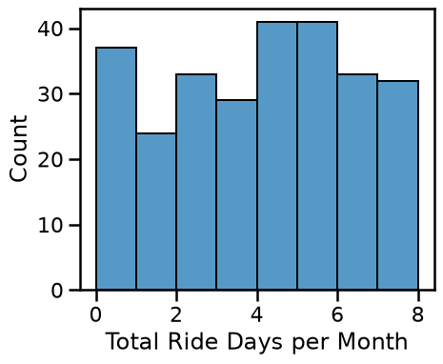
_{Source: Article Notebook}
# put value count for employmentstats and for car access in the same figure and make the y axis the same for each plot and don't show the y axis for the 2nd plot
fig, axes = plt.subplots(1, 2, sharey=True)
df['Full-Time'].value_counts().plot(kind='bar', ax=axes[0], rot=90)
df['Car Access'].value_counts().reindex(['Yes', 'No']).plot(
kind='bar',
ax=axes[1],
rot=90
)
plt.show()
Figure 2: Bar Plots of Employment Status and Vehicle Access
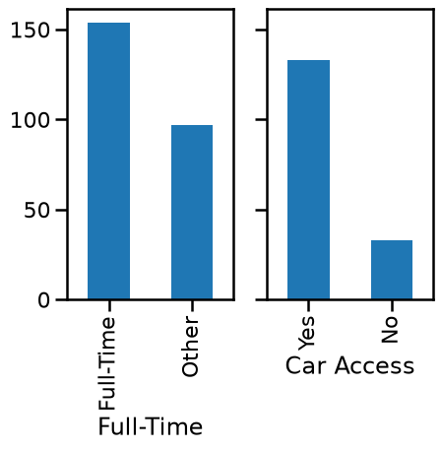
_{Source: Article Notebook}
I Cannot Figure Out How to rotate the bar labels in this graph and it is very frustration
_{Source: Article Notebook}
# Create a mapping of employment status values to human-readable descriptions
employment_descriptions = {
'Full-Time': 'Full-Time Employment',
'Other': 'Other Employment Status'
}
# Get the value counts
employ_counts = df['Full-Time'].value_counts()
# Create a DataFrame with the counts
employ_tbl = pd.DataFrame({'count': employ_counts})
# Add human-readable descriptions as a new column
employ_tbl['Employment'] = employ_tbl.index.map(employment_descriptions)
# Drop the existing index and set the new column as the index
employ_tbl = employ_tbl.reset_index(drop=True).set_index('Employment')
# Add total row
employ_tbl.loc['Total'] = employ_tbl['count'].sum()
# Create a mapping of car access values to human-readable descriptions
VehicleAccess = {
'Yes': 'Has Access to Vehicle',
'No': 'No Access to Vehicle'
}
# Get the value counts
car_counts = df['Car Access'].value_counts()
# Create a DataFrame with the counts
car_tbl = pd.DataFrame({'count': car_counts})
# Add human-readable descriptions as a new column
car_tbl['Vehicle Access'] = car_tbl.index.map(VehicleAccess)
# Drop the existing index and set the new column as the index
car_tbl = car_tbl.reset_index(drop=True).set_index('Vehicle Access')
# Add total row
car_tbl.loc['Total'] = car_tbl['count'].sum()
display(car_tbl)
display(employ_tbl)
 | count  Vehicle Access  Has Access to Vehicle 133  No Access to Vehicle 33  Total 166 |  |  | count  Employment  Full-Time Employment 154  Other Employment Status 97  Total 251
Table 2: Value Counts of Employment Status and Car Access
_{Source: Article Notebook}
This table is frustrating me because I want some space between the 2 tables and I want them to be side by side
Eventually I want Figure 2 and these tables to be in a tab set of some sort so you can click on it, but its just not working
_{Source: Article Notebook}
grouped = df.groupby(['Full-Time', 'Car Access'])['total_rides'].describe().drop(columns = ['25%', '50%', '75%']).round(2)
grouped
Table 3: Descriptive Statistics for Total Rides by Employment Status and Vehicle Access
 |  | count | mean | std | min | max
Full-Time | Car Access
Full-Time | No | 10.0 | 4.80 | 2.04 | 0.0 | 7.0
 | Yes | 75.0 | 3.49 | 2.16 | 0.0 | 8.0
Other | No | 16.0 | 4.31 | 1.58 | 2.0 | 8.0
 | Yes | 51.0 | 2.14 | 2.14 | 0.0 | 8.0

_{Source: Article Notebook}
# Create the ANOVA model (using Q() for column names with special characters)
df['full_time'] = df['Full-Time']
df['car_access'] = df['Car Access']
model = ols('total_rides ~ C(full_time) + C(car_access)', data=df).fit()
_{Source: Article Notebook}
# Get the ANOVA table
anova_table = sm.stats.anova_lm(model, typ=3).round(2)
# anova_table.index = ['Intercept','Full-Time', 'Car Access']
# Display the ANOVA tables
anova_table
Table 4: 2x2 ANOVA results for total rides by employment status and vehicle access
 | sum_sq | df | F | PR(>F)
Intercept | 563.22 | 1.0 | 128.38 | 0.0
C(full_time) | 53.43 | 1.0 | 12.18 | 0.0
C(car_access) | 68.83 | 1.0 | 15.69 | 0.0
Residual | 653.68 | 149.0 | NaN | NaN

_{Source: Article Notebook}

# Get the parameter estimates
params = model.params.round(2)
conf_int = model.conf_int().round(2)
pvalues = model.pvalues.round(3)
# Create a summary table
param_table = pd.DataFrame({
'Estimate': params,
'2.5%': conf_int[0],
'97.5%': conf_int[1],
'P-value': pvalues
})
#rename the indexes to better names
param_table.index = ['Intercept', 'Full-Time', 'Car Access']
param_table
Table 5: Parameter estimates for the ANOVA model
 | Estimate | 2.5% | 97.5% | P-value
Intercept | 5.24 | 4.33 | 6.16 | 0.000
Full-Time | -1.21 | -1.89 | -0.52 | 0.001
Car Access | -1.81 | -2.71 | -0.91 | 0.000

_{Source: Article Notebook}
I need to change the variable names for theoparameter estimates table and then I will REFER to the values created in the tables above
Table 1 give general descriptive statistics of the numeric values of the data.
Table 3 shows the descriptive statistics of my dependent variable ‘total_rides’ by employment status and vehicle access.
_{Source: Article Notebook}
#create a boxplot of total_rides by employment status and vehicle access
sns.boxplot(data=df, x='Full-Time', y='total_rides', hue='Car Access')
plt.title('Total Rides by Employment Status and Vehicle Access')
plt.xlabel('Employment Status')
plt.ylabel('Total Rides per Month')
plt.legend(title='Vehicle Access', bbox_to_anchor=(1.05, 1), loc='upper left')
plt.tight_layout()
plt.show()
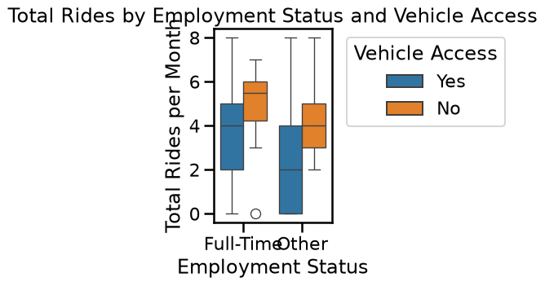
Figure 3: Boxplot of total rides by employment status and vehicle access
_{Source: Article Notebook}

Conclusion, Future Directions, & Limitations

Future Directions
Reviewing Figure 3, there appears to be an outlier that is a full-time employee without access to a car with very low ride share and public transportation usage days. It would be interesting to further examine this outlier; however, it seems to be this person may walk to work or work from home.

Limitations
The distributions of the variables(Figure 2, Figure 1) are not normal, which may impact the results of the ANOVA test.
The values of total_rides are calculated from categorical variables ride_share_per_month and public_trans_per_month that have unbalanced ranges: 0-1 days a month, 2-4 days a month, 4-8 days a month, 8 or more days a month, Never. Calculating total_rides as the sum of these ranges means that the value could represent a different range of actual ride counts. For example: if a participant has a total ride value of 4, they could have 4 ride share days and 0 public transportation days, or 3 ride share days and 1 public transportation day (visa versa), and 2 ride share days and 1 public transportation day. But, when calculating the actual number of days per month, the result could be 8+, 4-9, or 4-8. Therefore, the parameter estimates displayed in Table 5 are not informative values.
The main conclusion from this analysis is that there is
_{Source: Article Notebook}
Yang, Lin, J. Aaron Hipp, Deepti Adlakha, Christine M. Marx, Rachel G. Tabak, and Ross C. Brownson. 2015. “Choice of Commuting Mode Among Employees: Do Home Neighborhood Environment, Worksite Neighborhood Environment, and Worksite Policy and Supports Matter?” Journal of Transport & Health 2 (2): 212–18. https://doi.org/https://doi.org/10.1016/j.jth.2015.02.003.

