MTH4600 HW4

1. After running the program, we got the result as below:

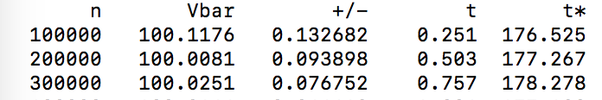

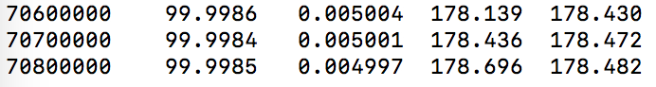

The program took 178.696s to achieve error tolerance 0.005 with 95% confidence. As we can see from the output, Vbar = 99.9985 is very close to S0 =100. So Vbar agrees with S0, illustrating that mu is correct.

1. The antithetic variance reduction method significantly improves the running time of the program, achieving error tolerance as of in program 1 with only 3.984 seconds.

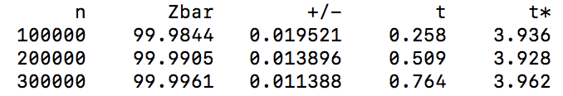

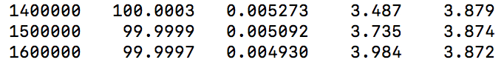

1. Given the call option struck at K = 110, we estimate the value of the call option at time T.

Note that, in problem 2, the 95% error tolerance is respect to the S statistic. Since here we estimate C statistic, the 95% error tolerance is respect to C. (N = 50)

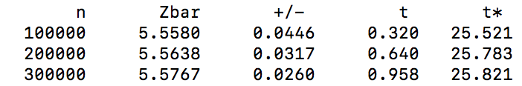

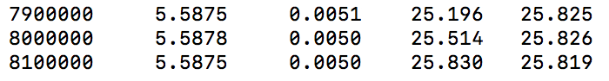

1. If using N = 1 instead of 50, we get the estimated values as below:

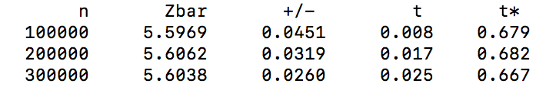

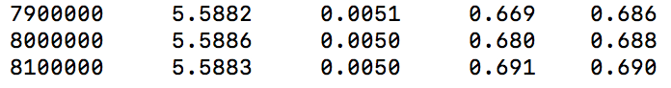

The outputs of C_star_bar are very close when N = 1 and N = 50. Since the time to expiration T=0.5 years is the same, according to the Black-Scholes formula, the difference in chopping the time period won’t change the value of the call option. Thus, the call price in both scenarios should be the same (or at least very close due to errors from simulations).

1. Using N=50, we compare the call option value with the price computed by the Black-Scholes formula:

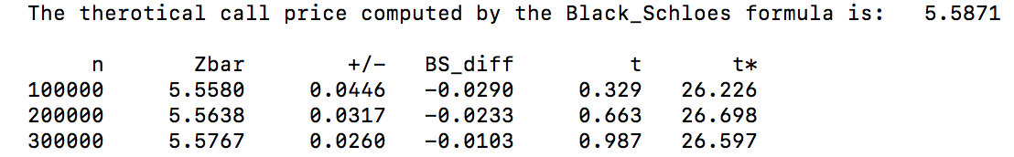

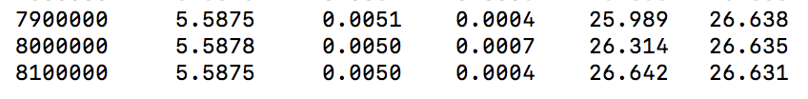

1. Using N = 50, keeping the antithetic reduction, we implement another control variable to further improve the running time of the program:

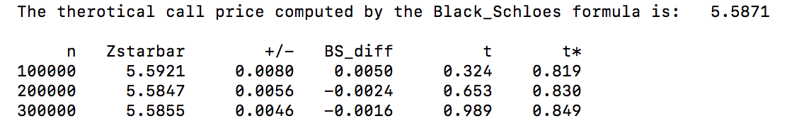

1. Keeping all variance reduction, we value the look-back option and obtain the following output:

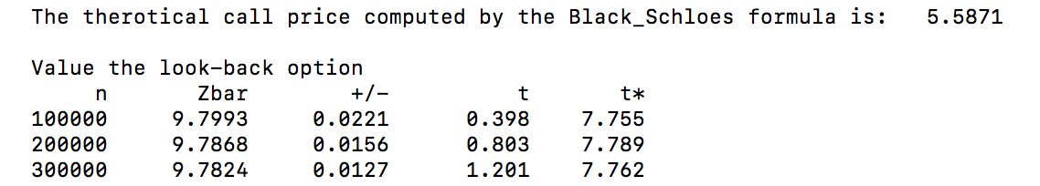

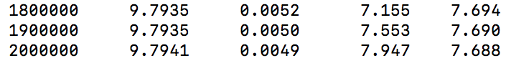

As the we can see, the look-back option yields a higher option value, which aligns with its construction.

1. The