OUTPUTS:

Exercise 1

Scenario 1:

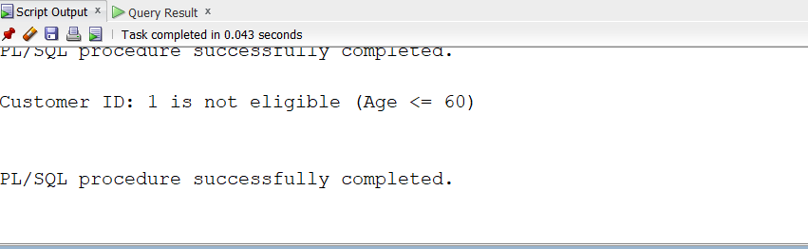

Scenario 2:

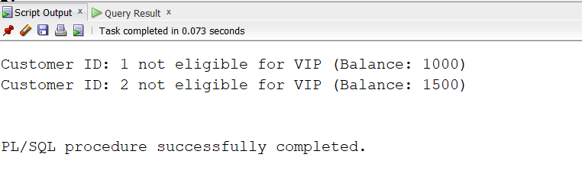

Scenario 3:

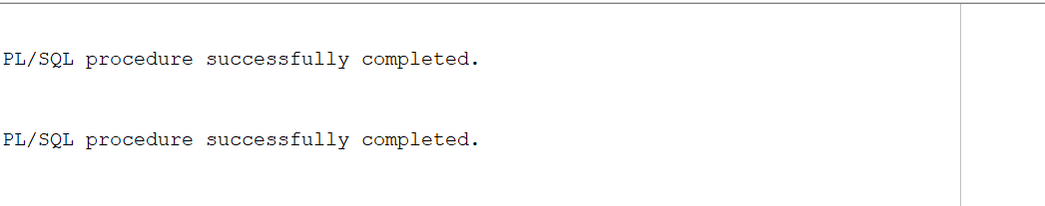

**Exercise 2:**

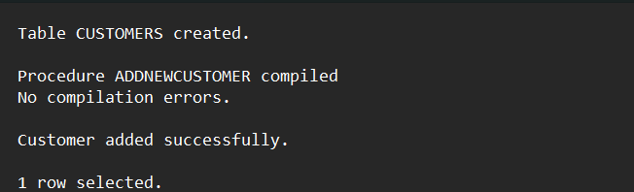

**Exercise 3:**

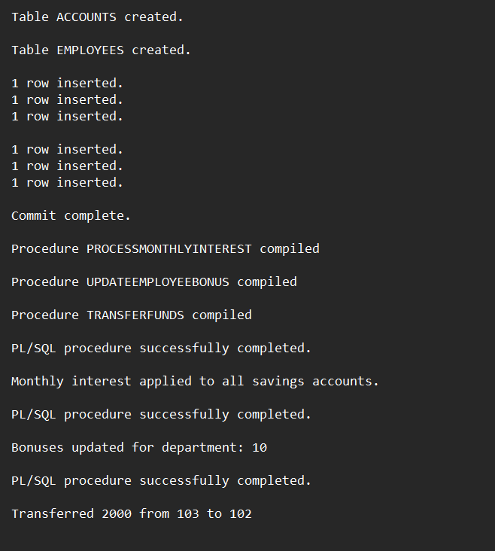

**Exercise 4:**

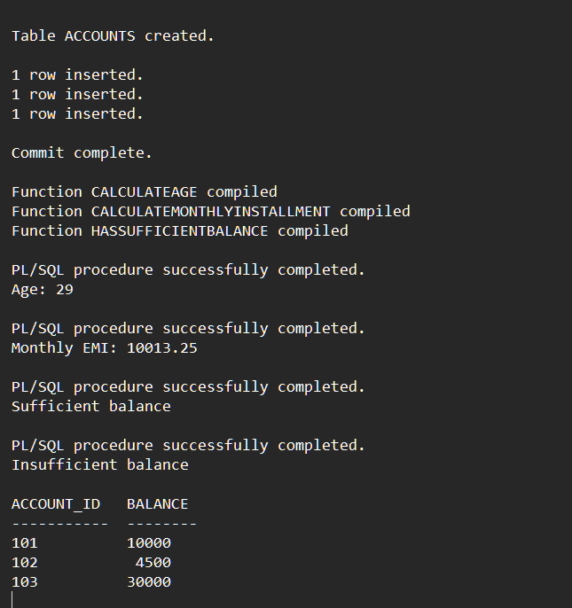

**Exercise 5:**

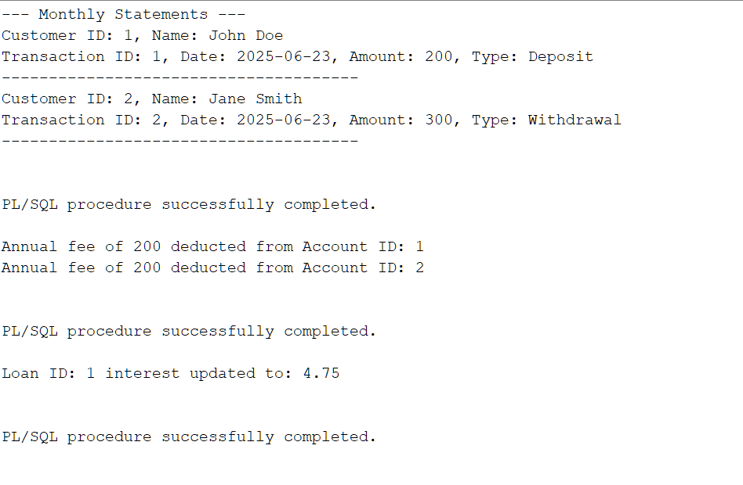

**Exercise 6:**

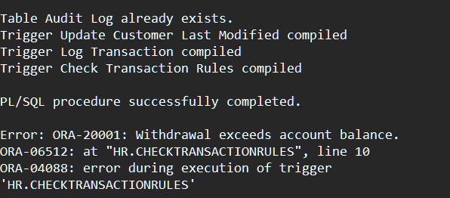

**Exercise 7:**

