Rachel Lane

7.2

test_cities.py

Population added to city_functions

Fail

Optional population

Test_cities again

Failed again with language added

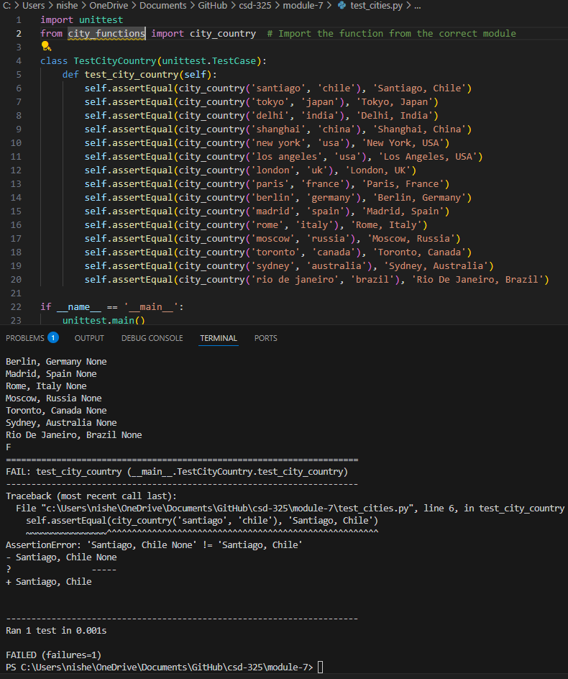

Test_cities again

