*IT Training, IT Staffing and Solution Services*

**Website**: [WWW.itexps.com](http://www.itexps.com/) | **Email**: [info@itexps.com](mailto:info@itexps.com) | **Phone**: 847-350-9034

**Note**: Exam is Open Book, you are allowed to refer a book or search in Google **Time: 2 Hours**

1. Create an ERD diagram using **draw.io**

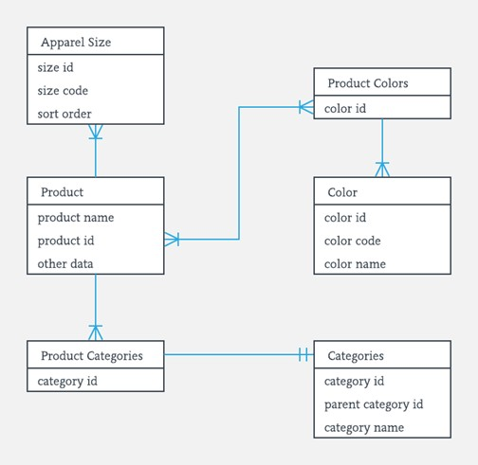

1. Create the following: **emp** table in **Oracle** live SQL and Enter records

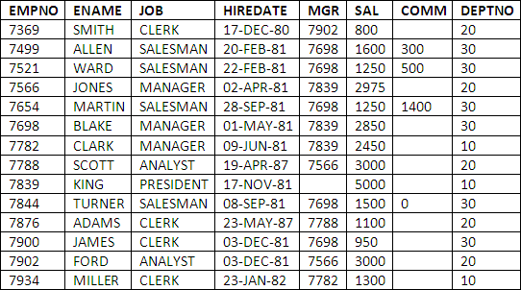

1. List the **emps** in the **asc** order of their Salaries
2. List the emps who joined before 1981.
3. List the emps who are either ‘CLERK’ or ‘ANALYST’ in the Desc order.
4. Display all the details of the emps whose Comm. Is more than Salary
5. List the emp who are working for the Deptno 10 or20.
6. List the Five-character names starting with ‘S’ and ending with ‘H’
7. List the emps Who Annual sal ranging from 22000 and 45000.
8. List all the Clerks of Deptno 20

.

1. Find the highest sal of EMP table.
2. Display the average salaries of all the clerks.
3. List the emps whose names contains ‘A’
4. Print the details of all the emps who are sub-ordinates to Blake.
5. List the no. of emps in each department
6. List the employee names and his average salary department wise