1. **Briefly describe the artifact. What is it? When was it created?**

This artifact is a game written in C++ called Left Center Right. It was created for IT312: Software Development With C++.NET that I enrolled in to learn the .NET platform and practice a C language because that is what the company I worked for at the time did their web development in. The game is a simply game of rolling dice and passing chips. The last player with chips left wins.

1. **Justify the inclusion of the artifact in your ePortfolio. Why did you select this item? What specific components of the artifact showcase your skills and abilities in software development? How was the artifact improved?**

I selected this item because it is something I wrote from scratch so it really showcases my abilities to not only write code, but plan a project. It shows my coding style, my use of best practices as well as my knowledge of the language and the platform. In particular, this game shows by knowledge of good code comments, use of the DRY (don’t repeat yourself) principle, encapsulation and object oriented programming.

1. **Did you meet the course objectives you planned to meet with this enhancement in Module One? Do you have any updates to your outcome-coverage plans?**

Requirements from module one:

|  |  |
| --- | --- |
| **Requirement** | **Met and Tested?** |
| Create a database to hold names and scores of winners | Complete |
| Insert row for each game winner and time to game completion | Complete |
| Ensure leaderboard is always up to date at beginning and end of game when user accesses it | Complete |

1. **Reflect on the process of enhancing and/or modifying the artifact. What did you learn as you were creating it and improving it? What challenges did you face?**

While I’ve participated in rewriting databases professionally, every company I’ve worked at already has a database so this was my first experience creating my own, setting up the user and accessing it from a C++ app. I found a great YouTube tutorial for Visual Studio 2017 and only had to tweak a couple things to get it to work for 2019 (Tenor Games, 2018). Knowing to add libraries, includes and special compilers in my project preferences is always tough for me. It is not something I think of on my own yet, so this video was very helpful. I had to change some of my algorithms to work correctly with the data being fed in, reformat that data and add some additional calculations so everything on the leaderboard aligns correctly, but I think it came out pretty nice.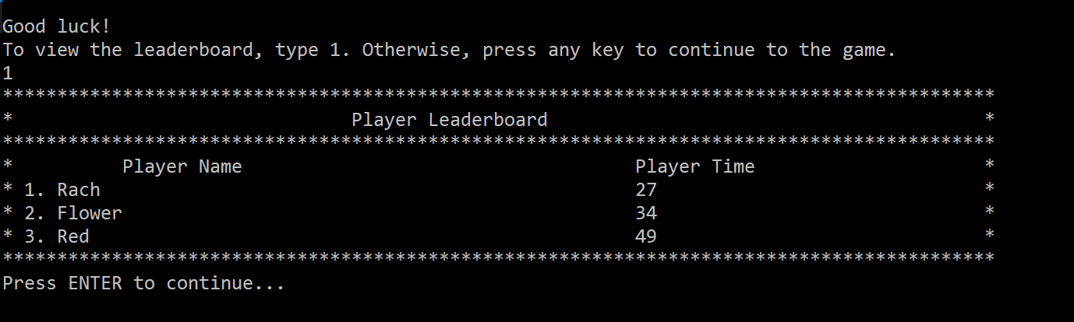

I also had a small issue with the end of the game leaderboard display if the user chose to display it at the beginning of the game. My algorithm was simply adding a struct to a vector and the leaderboard displays each item in that vector in order, so if it had already been displayed once before, the vector wasn’t empty for the second call and was either adding twice or was out of order by time. I solved this by clearing the vector each time the DisplayLeaderboard() function is called. I also added an algorithm to display only the maximum number of people from the table. For example, the maximum number on the leaderboard is 5, but in my example above, my SQL table only had three entries, so it only displays the top 3. I had a lot of fun with this and surprised myself with how well it came out. I learned a lot about connecting to a database for the first time and working with the data using a new programming language.

My create script for the mySQL db:

CREATE DATABASE lcr;

USE lcr;

CREATE TABLE scores (id int NOT NULL AUTO_INCREMENT, name varchar(32), time int, PRIMARY KEY (id));

INSERT INTO lcr.scores (name, time) VALUES ("RachelTest", 10000);

SELECT * FROM lcr 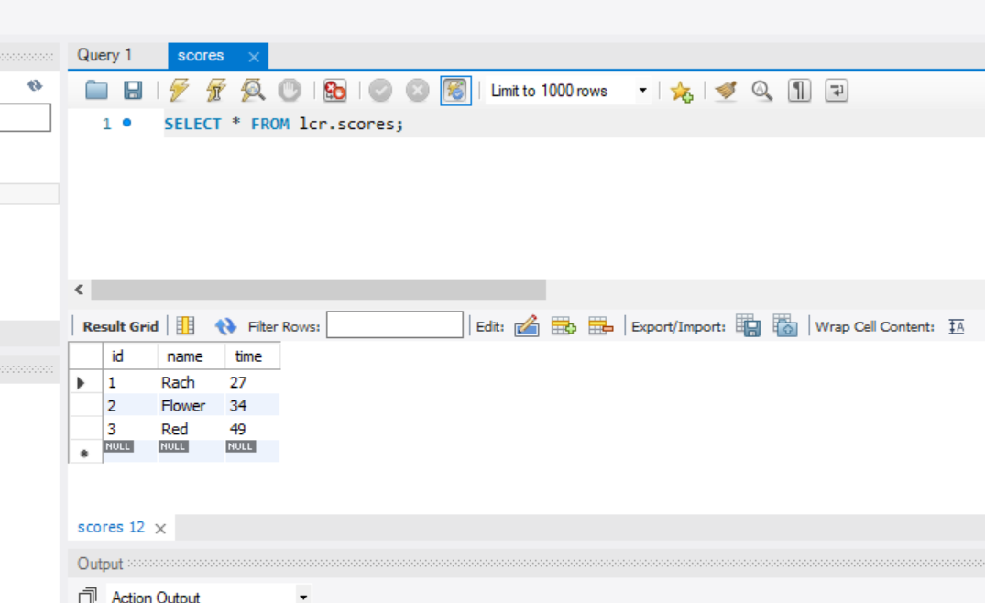

References:

Tenor Games. [Tenor Games]. 2018, July 20. *MySQL Installation and Setup for C++ Development on Visual Studio* [Video]. YouTube. <https://www.youtube.com/watch?v=yNniOHn9Xe0> .