**Data Analysis: School District Features**

*(SAT)*

Let’s start of by viewing the regional averages for each class year and the distribution of district-level scores.

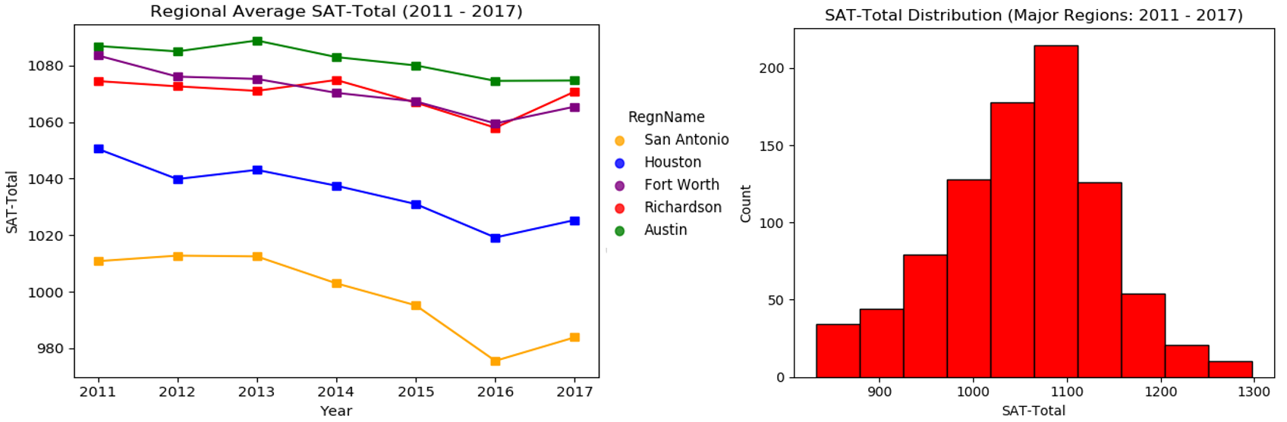

We can see that Austin performed the best while Fort Worth and Richardson were neck in neck. The gap between the top region and San Antonio is quite alarming and will remain a common theme throughout this analysis.

*(ACT)*

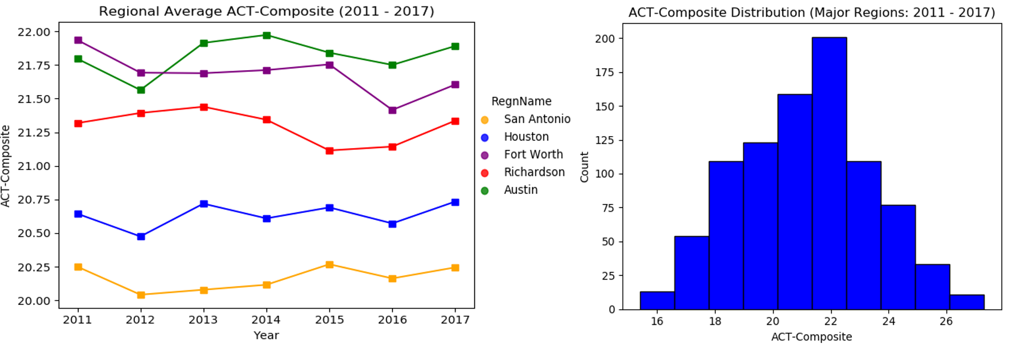

It appears that the districts located in Austin and Fort Worth achieved the best average scores on the ACT with Richardson not too far behind. As with SAT scores, there appears to be a slight uptick in the average scores for 2017 (improved educators/smarter kids?).

*(SAT/ACT Participation %)*



Something interesting I discovered is that more students consistently choose to take the SAT than the ACT. Why is this? Well… it’s very tough to know for certain without surveying high school students across Texas, but I’ll provide a possible theory. The SAT is the test students hear the most about while growing up from friends, parents, and teachers. You could say it’s the “standard test” students feel they have to take in high school.

It’s good to see in the later years that the ACT participation rate grew, but it is quite concerning that students are not being encouraged to take the ACT as well as the SAT. Taking two tests instead of just one immediately increases the chance of a student doing well on at least one. Doing well on one of the college admission tests is all it can take to get into college and earn scholarship money. With scholarship money, enrolling into college becomes more likely/possible for a student. As you can see below, both SAT and ACT participation rates contain similarly positive correlation with Texas college enrollment percentage. Why not take both??

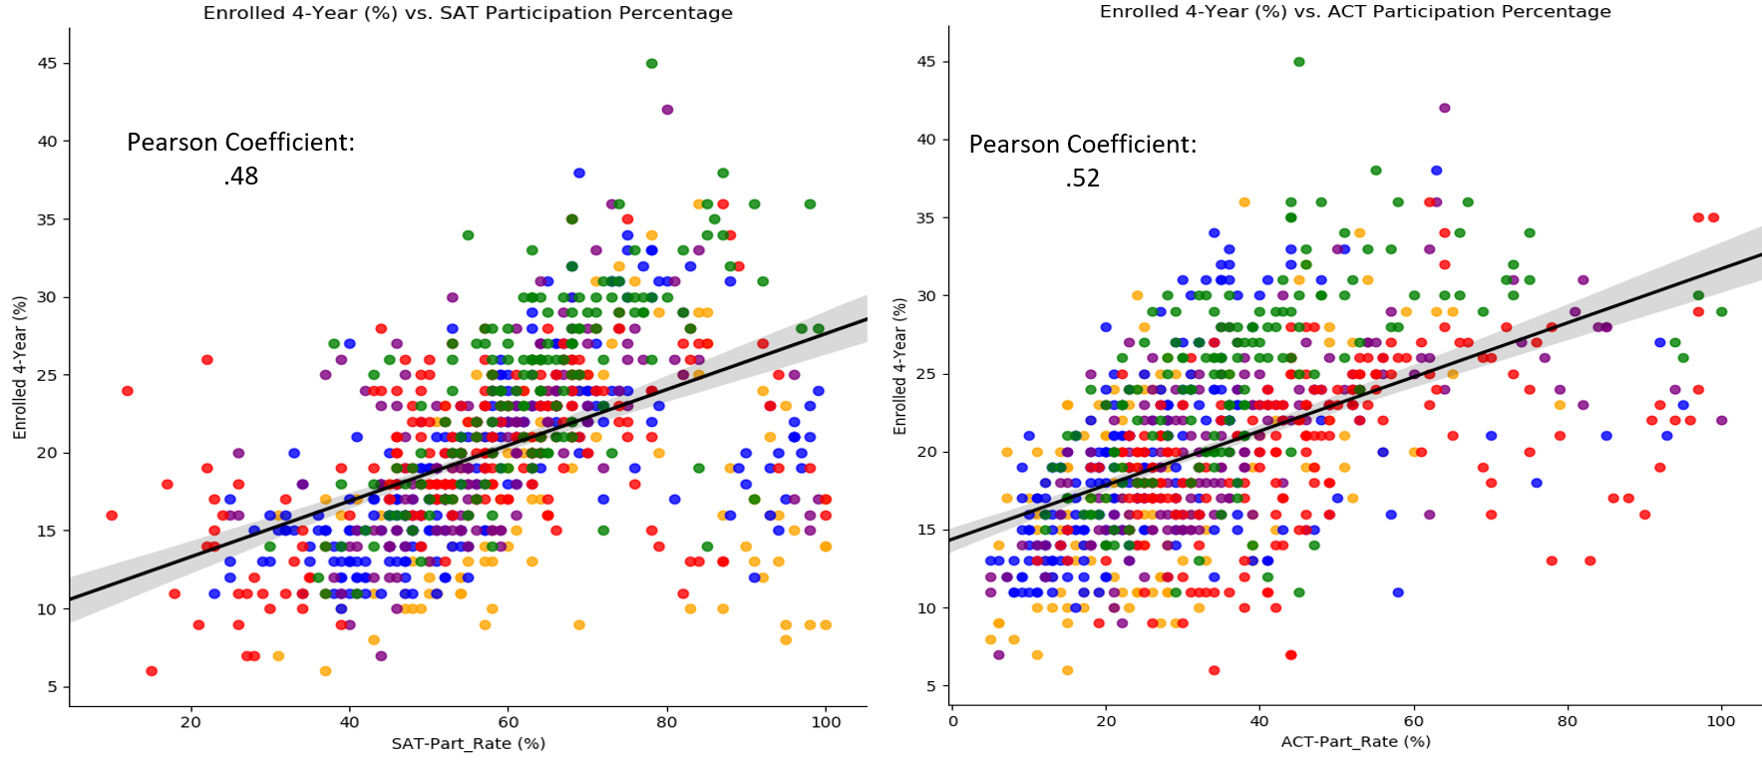

*(AP Exams)*

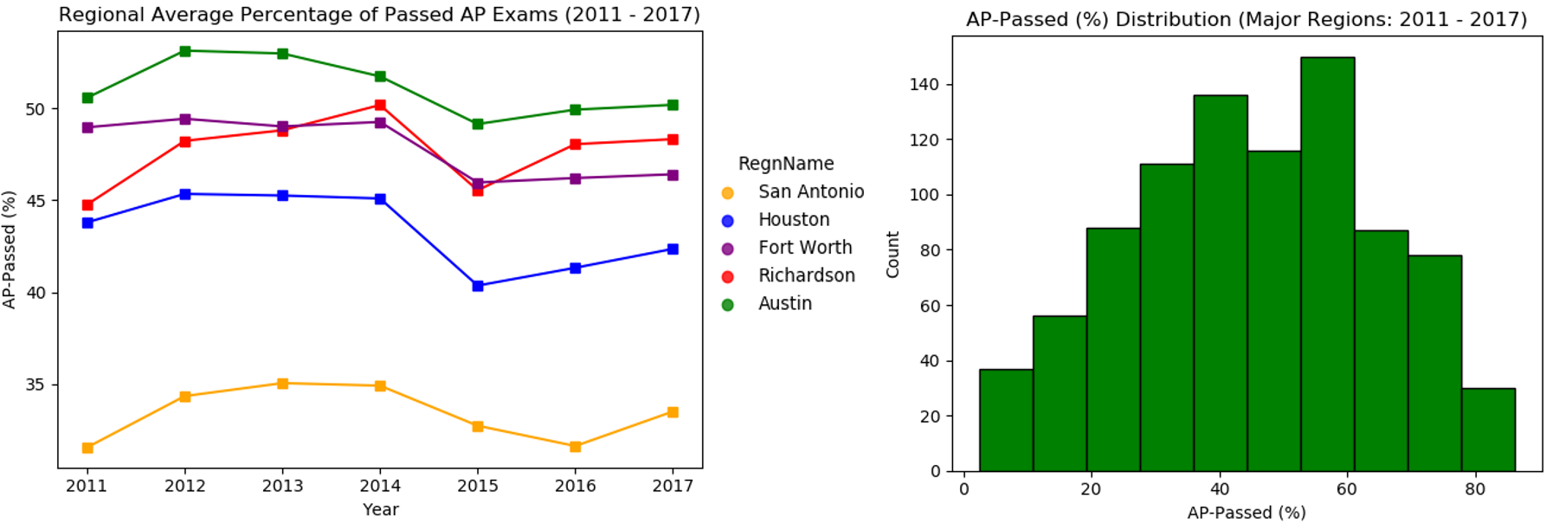

The regions of Austin, Richardson (Dallas), and Fort Worth appear to contain the best passing percentages. I found it interesting to also take a look at the availability of AP classes to students. One could argue that more availability to AP classes would result in a student being able to take more exams and potentially earn more college credit.

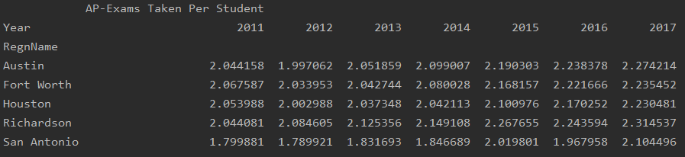

From the standpoint of AP class/exam availability, it appears that Richardson (Dallas) gives the most opportunity to students to earn college credit. Austin tends to offer the second most opportunity which is quite impressive when also taking into account that Austin contained the best passing percentage.

The next figure will offer a transition to our next analysis of the Wealth/ADA feature of school districts. Let’s take a look at how Wealth/ADA affected the amount of AP exams taken per student throughout 2011 - 2017. One might hypothesize that we could see a positive correlation as wealth/funding would bring in more qualified teachers and increase the number of AP classes offered to students.

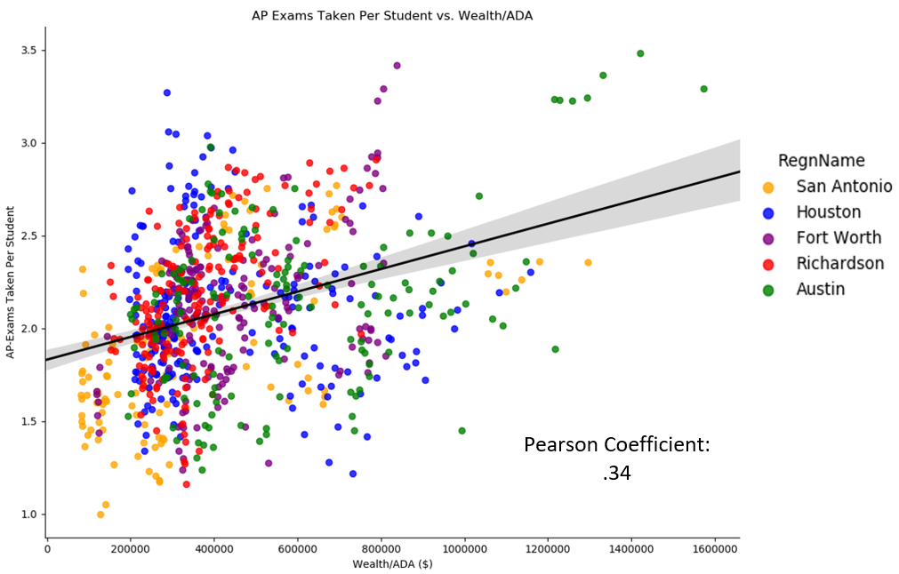

As anticipated, there was indeed a positive correlation (.34). The cluster on the top rights represents Eanes ISD in Austin, which averaged the largest Wealth/ADA. The school that averaged the second highest Wealth/ADA was Alamo Heights ISD in San Antonio. It’s interesting to view the difference in Wealth/ADA between the Alamo Heights ISD cluster and the rest of the districts from San Antonio.

*(Wealth/ADA)*

Austin held a healthy lead over its nearest competitors in Fort Worth and Houston. It should be interesting view how Wealth/ADA correlated with college enrollment percentage over the years as well. Let’s take a look.

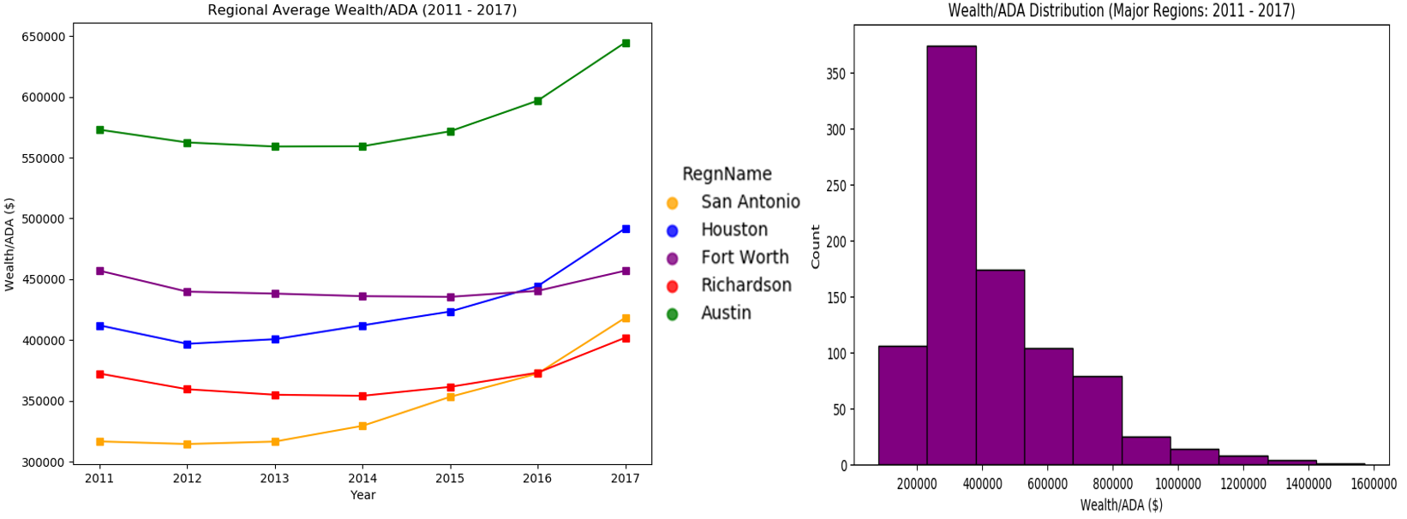

It should be interesting view how Wealth/ADA correlated with college enrollment percentage over the years as well. Let’s take a look.

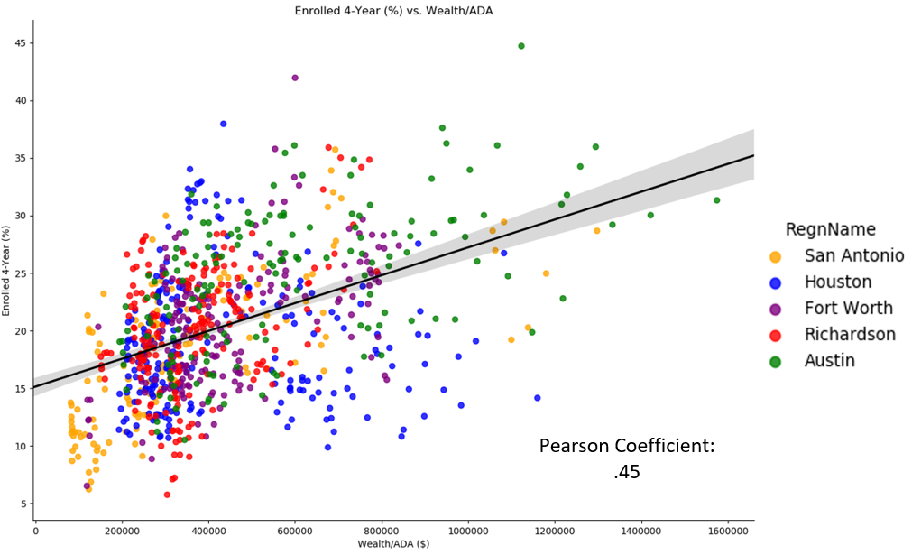

Though it shouldn’t be mistaken for the only factor determining college enrollment percentage, Wealth/ADA certainly contains a positive correlation with college enrollment percentage (.45). As discussed before, this can partially be attributed to “wealthier” students having more access to college even if they do not always have the best scores and aren’t necessarily as prepared to handle the rigors of college.

With that being said we still have to acknowledge that there are plenty of students in the districts containing higher Wealth/ADA that are taking advantage of quality education in testing well and earning scholarships/being more attractive to colleges. Though I can’t necessarily prove it with data right now, it’s not that ridiculous to assume that many of the parents in these “wealthier” areas are well educated and therefore, encourage/press their children to do well in school as they know firsthand what education can bring to an individual’s life.

**Data Analysis: Percent of Students Earning College Degree Within Four Years**

For the classes of 2011 – 2014, let’s look at the average percentage of students who were able to earn their college degree by region.

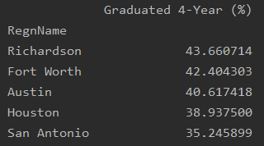

Looks like Richardson (Dallas) contained the highest percentage of students who were able to earn their college degree within four years. There’s roughly an 8% difference between the Richardson (Dallas) and San Antonio, which isn’t too much of a surprise as San Antonio contained poor school district features.

(Wealth/ADA Affect on College Graduation %)

As an exercise, let’s assume that most of the students attending high school in the wealthier districts are simply going to college because they can afford it and there’s a college out there willing to accept them for their money. We could then expect to see a very poor correlation between Wealth/ADA and those who graduate from college within four years as we could expect many of these unprepared students to fail out of college.

The students attending college from less fortunate areas will most likely be intelligent ones who earned scholarship and will have greater chance of earning their degree (more prepared), hurting the positive correlation as well. Let’s take a look at the real historical data from 2011 – 2014 (college graduation year: 2015 – 2018) I collected as a comparison.

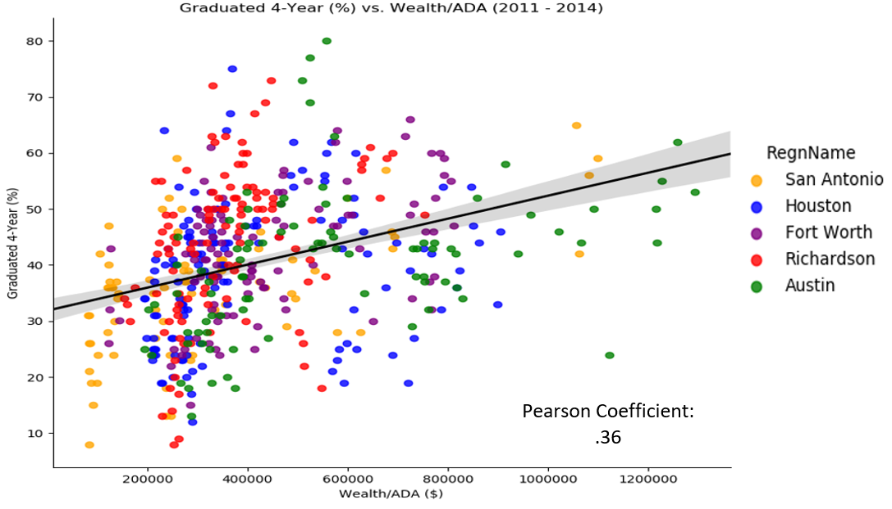

The correlation may be lower than the one for college enrollment percentage (pearson coefficient: 0.45), but the difference is not as extreme as one would expect assuming the hypothetical situation described in the exercise. These wealthier areas tend to attract well-educated families and teachers, so it’s not all that surprising to see that students from these areas tend to do a well in earning their degree percentage-wise.

It’s important to note that not having as much financial worry, can lift an immense amount of pressure from a student in their attempt to earn a degree. Financial pressure is one of the top reasons a student will drop out of college and not earn their degree.