Chapter 1
INTRODUCTION
  - General Overviews
The population increases day by day. Therefore people don’t get enough benefit from health services. It is impossible for the patients to be kept under the supervision of a physician at all times. In recent scenario’s, a lot of children are facing the problem of Autism Disorder. This project is intended to help doctors to analyze the symptoms. This program can also be used for education.

  - Darwin Theory
Facial expressions are the facial changes indicating a person’s internal affective states, intentions or social communications. Based on the shown facial expressions, human face is the predominant mode of expressing and interpreting affective states of human beings. Automatic facial expression recognition impacts important applications in many areas such as natural human computer interactions, image retrieval, talking heads and human emotion analysis. Over the last decade, automatic facial expression recognition has been increasingly attracting attention and has become an important issue in the scientific community, since facial expressions are one of the most powerful, nature and immediate means for human beings to communicate their emotions and intentions.
Darwin grouped several kinds of terms into similar groups. The classification is as follows:
- low spirits, anxiety, grief, dejection and despair.
- joy, high spirits, love, tender feelings and devotion.
- reflection, meditation, ill-temper and sulkiness.
- hatred and anger.
- disdain, contempt, disgust, guilt and pride.
- surprise, astonishment, fear and horror.
- self-attention, shame, shyness and modesty.

Darwin also classified the facial distortions that happen for each of the above-stated classes of expressions. For example, “the constriction of the muscles around the eyes when in sorrow”, “the stiff closure of the mouth when in contemplation”, and so forth.

Psychologists perceive moods as “diffuse affect states, characterized by a relative enduring predominance of certain types of subjective feelings that affect the experience and behaviour of a person”. Moods may carry for hours or days; as a result of people’s characters and affect natures, some people practice some moods more often than others. In 1872, Darwin postulated on his original work that facial expressions in people were the result of improvements and that: “The study of expression is difficult, owing to the movements (of facial muscles) being often extremely slight, and of a fleeting nature”. Initial research on undesirable emotional states has proved that particular features of the eyelids and eyebrows, which Darwin called “the grief muscles”, agree in that “oblique position in persons suffering from deep dejection or anxiety”. Darwin considered general facial muscles, which were involved in each of the emotions’ state:

Figure 1.1: Six basic facial expression
Table 1.1: Descriptions of facial muscles involved in the emotions Darwin considered universal

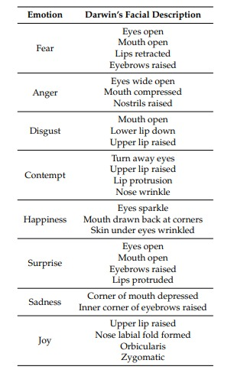

Facial expression presents key mechanism to describe human emotion. From starting to end of the day human changes plenty of emotions, it may be because of their mental or physical circumstances. Although humans are filled with various emotions, modern psychology defines six basic facial expressions: Happiness, Sadness, Surprise, Fear, Disgust, and Anger as universal emotions. Facial muscles movements help to identify human emotions. Basic facial features are eyebrow, mouth, nose & eyes.
  - Objectives of Study
The process of emotion recognition includes feature extraction and classification of extracted feature. Thus even a small change in any of the face organ leads to change in emotion and also extracted features is changes. Now, classifier should be efficient enough to monitor change in feature and map the feature to correct emotion class.

Thus, the challenge is to design a classifier for multi-class classification which is less complex, very accurate and feasible for hardware implementation along with to be compatible with the flow of process of facial expression recognition process.

The main objective is to implement a neural network-based machine learning algorithm on FPGA to evaluate the FPGA implementation and efficiency of regression method for automatic emotion state detection and analysis that has potential application in various field of human computer interaction (HCI) such as to aid autistic children, robot control and many more.

Chapter 2
ARTIFICIAL NEURAL NETWORK
2.1 ANN
For many centuries, one of the goals of humankind has been to develop machines. We envisioned these machines as performing all cumbersome and tedious tasks so that we might enjoy more fruitful life. Nowadays engineers and scientists are trying to develop intelligent machines. Artificial Neural systems are present-day example of such machines that have great potential to further improve the quality of our life.
A neural network’s ability to perform computations is based on the hopes that we can reproduce some of the flexibility and power of the human brain by artificial means. Network computation is performed by dense mesh of computing nodes and connections. They operate collectively and simultaneously on most or all data inputs. The basic processing elements of neural networks are called artificial neurons, or simply neurons. Artificial neural system computation lies in the middle ground between engineering and artificial intelligence. The mathematical techniques utilized, such as mean-square error minimizations, are engineering-like but an experimental adhoc approach is often necessary.

2.2 Biological Neurons and Their Artificial Models
The human brain consists of approximately 10ˆ11 computing elements called neurons. They communicate through a connection network of axons and synapses having a density of approximately 10ˆ4 synapses per neuron. Our hypothesis regarding the modelling of the natural nervous system is that neurons communicate with each other by means of electrical impulses (Arbib 1987). The neurons operate in a chemical environment that is even more important in terms of actual brain behaviour. We thus can consider the brain to be densely connected electrical switching network conditioned largely by the biochemical processes. The vast neural network has an elaborate structure with very complex interconnections. The input to the network is provided by sensory receptors. Receptors deliver the stimuli both from within the body, as well as from the sense organ when the stimuli originate in the external world. The stimuli are in the form of electrical impulses that convey the information into the network of neurons. As a result of information processing in the central nervous systems, the effectors are controlled and give human responses in the form of diverse action. We thus have three stage system, consisting of receptors, neural network, and effectors, in control of the organism and its actions.
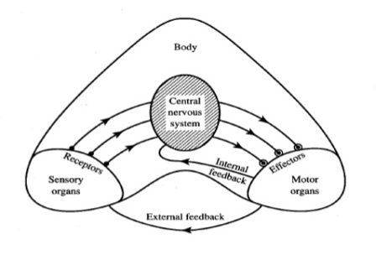
Figure 2.1: Information flow in nervous system.
As we can see from the figure, the information is processed, evaluated and compared with the stored information in the central nervous system. When necessary, commands are generated there and transmitted to the motor organs. Notice that motor organs are monitored in the central nervous system by feedback links that verify their actions. Both internal and external feedback control the implementation of command.

2.3 Models of Artificial Neural Networks
Artificial neural networks are the physical cellular networks that are able to acquire, store and utilize experiential knowledge has been related to the network’s capabilities and performance. The neural network can also be defined as an interconnection of neurons such that neuron outputs are connected, through weights, to all neurons including themselves; both lag-free and delay connection are allowed.
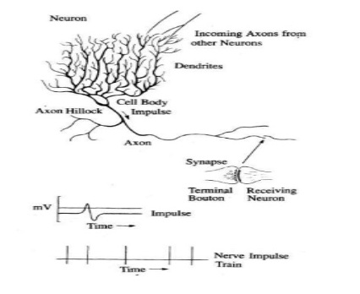
Figure 2.2: Schematic diagram of a neuron and a sample of pulse train
A typical cell has three major regions: the cell body which is also called the soma, the axon, and the dendrites. Dendrites form a dendritic tree, which is very fine bush of thin fibers around the neuron’s body. Dendrites receive information from the neuron through axon – long fibers that serve as transmission lines. An axon is a long cylindrical connection that carries impulses from the neuron. The end part of an axon splits into fine arborizations. Each branch of it terminates in a small endbulb almost touching the dendrites of neighbouring neurons. The axon-dendrite contact organ is called a synapse. The synapse is where the neuron introduces its signal to the neighbouring neuron. The signal reaching a synapse and received by dendrites are electrical impulses. The inter-neuronal transmission is sometimes electrical but is usually effected by the release of chemical transmitters at the synapse. Thus, terminal boutons generate the chemical that affects the receiving neuron. The receiving neuron either generate an impulse to its axon, or produces no response.
The neuron is able to respond to the total of its inputs aggregated within a short time interval called the period of latent summation. The neuron’s response is generated if the total potential of its membrane reaches a certain level. The membrane can be considered as a shell, which aggregates the magnitude of the incoming signals over some duration. Specifically, the neuron generates a pulse response and sends it to its axon only if the conditions are necessary for firing are fulfilled.

Chapter 3
LITERATURE REVIEW
3.1 Autism Spectrum Disorder
Autism Spectrum disorder (ASD) is the genetic disorder that is caused in the genes of the children of age 14 and below. This is the development disorder that affects communication and behaviour. Although autism can be diagnosed at any age but the symptoms can be seen in the first two years of life.
People with ASD have difficulty with social communication and interaction, restricted interests and repetitive behaviours. People with ASD may also experience sleep problem and irritability.
In 2018 the CDC determined that approximately 1 in 59 children is diagnosed with an ASD. Boys are fore times more likely to be diagnosed with autism than girls. Autism affects all ethnic and socio-economic groups. Over the last two decades, extensive research has asked whether there is any link between childhood vaccinations and autism. Then results of this researches are clear; Vaccinations do not cause Autism.
Over 31% of children with ASD have an intellectual disability and approximately 90% of deaths associated with wandering or bolting by those age of 14 and younger. Thus, for such children, an automatic real time facial expression recognition system can be a boon during face to face interaction or even to meet their daily communication needs.
Autism is not the single disorder, but a variation of closely-related disordered with shared symptoms. Every child with autism spectrum has a problems with social skill, flexible behaviour, communication and empathy. But, the level of the combination of symptoms and incapacity varies greatly from one person to another. In fact, two individual with same diagnosis may look different when it comes to their abilities and behaviour. When we talk about autism spectrum disorders, we are referring to the three most common pervasive developmental disorders.
- Autism
- Asperger’s Syndrome
- Pervasive Developmental Disorder – Not Otherwise Specified (PDD-NOS)
3.2 Autism symptoms & early signs
Behavioural symptoms of ASDs are hard to diagnose before 24 months, typically appear before child is 3, although difference can appear even in first year of life. If sign are detected by 18 months of age, intensive treatment may help to reverse the symptoms and rewire the brain. The early diagnosis and therapy can be tremendously helpful in improving the behaviour and abilities of children with ASD.
- Early signs of autism in babies and toddlers.
- Doesn’t make eye contact.
- Doesn’t smile when smiled at.
- Doesn’t respond to their name.
- Doesn’t visually follow objects.
- Doesn’t make noises to get attention.
- Doesn’t respond to, or initiate, cuddling.
- Doesn’t imitate your movements and facial expressions.
- Doesn’t play with other people, or share interest and enjoyment.

3.3 Treatments of ASD
A range of teaching approaches and behavioural therapies are used to help children develop skills in the areas where they’re having difficulties. Depending on the child’s needs, occupational, physical and communication therapies may be very helpful too.
First type of widely accepted treatment is behaviour and communication approaches.
- Applied Behaviour Analysis (ABA). The goals of ABA are to shape and reinforce new behaviours, such as learning to speak and play, and reduce undesirable ones.
- Developmental, Individual Difference, Relationship-based (DIR) – aims to build healthy and meaningful relationship and abilities by following the natural emotions and interest of the child.
- Treatment and Education of Autistic and related Communication Handicapped Children (TEACCH) – emphasizes adapting the child’s physical environment and using visual cues, for example, having classroom material clearly marked and located so that students can access them independently.
- Interpersonal Synchrony – targets social development and imitation skills, and focuses on teaching children how to establish and maintain engagement with others.

Medications: There are no medications that can cure ASDs, or even treat the main symptoms. But some medications can help reduce symptoms that cause problem for the child in school, or at home. All medications carry the risk of side effects.
Complementary and Alternative Treatments: To relieve the symptoms of ASDs, some parents and health care professionals use treatments that are outside of what is typically recommended by the paediatrician. These types of treatments are known as alternative and complementary treatments. These usually include special diets, biological, or body-based systems (like deep pressure).

3.4 Survey on facial emotion with ASD Child
During our project survey we personally met the patients suffering from the Autism spectrum disorder and recorded the emotion that they undergo in their daily life. He had a problem in communicating like stabbing while talking, no eye contact etc. But he had a good memory power along with that he also had good drawing skills and was attracted more towards the animals and fishes. We even noticed that he was able to differentiate between the people and recognizes them very easily. He took some time to get adjusted to us but later on was free to convey his emotions to us. He was more interested in using electronic gadgets with due care. He faced bit of problem in reading and writing.

Figure 3.1: Interview with Tarun Kumar (ASD Child)
Table 3.1: Description of facial emotion involved by ASD Child
Emotion | Definition | Motion of facial part
  Anger
  Anger is one of the most dangerous emotions. This emotion may be harmful so, humans are trying to avoid this emotion. Secondary emotions of anger are irritation, annoyance, frustration, hate and dislike.
  Eyebrows pulled down, Open eye, teeth shut and lips tightened, upper and lower lids pulled up.
  Fear
  Fear is the emotion of danger. It may be because of danger of physical or psychological harm. Secondary emotions of fear are Horror, nervousness, panic, worry and dread.
  Outer eyebrow down, inner eyebrow up, mouth open, jaw dropped
  Happiness
  Happiness is most desired expression by human. Secondary emotions are cheerfulness, pride, relief, hope, pleasure, and thrill.
  Open Eyes, mouth edge up, open mouth, lip corner pulled up, cheeks raised, and wrinkles around eyes.
  Sadness
  Sadness is opposite emotion of Happiness. Secondary emotions are suffering, hurt, despair, pitty and hopelessness.
  Outer eyebrow down, inner corner of eyebrows raised, mouth edge down, closed eye, lip corner pulled down.
  Surprise
  This emotion comes when unexpected things happens. Secondary emotions of surprise are amazement, astonishment.
  Eyebrows up, open eye, mouth open, jaw dropped

The emotions detected are anger, fear, happiness, sadness, and surprise. These emotions are understood to be cross-culturally and universally communicated with facial expressions. Recently, fuzzy support vector machines (SVMs) and feed-forward neural networks together with a stationary wavelet entropy approach were investigated, producing results of around 96% accuracy on stationary images.
“Facial Expression Emotion Detection for Real-Time Embedded System”
Real-Time facial expression recognition has attracted more and more research. An automatic facial real-time system in built and tested. The model were designed and tested on a MATLAB environment followed by MATLAB Simulink environment that is capable of recognizing continuous facial expression in real-time. The facial expression recognition system is built on field-programmable gate array (FPGA). The camera sensor used in this work is a Digilent VmodCAM-Stereo Camera Module.

“Facial Expression Recognition Based on Local Binary Patterns”
Automatic facial expression analysis is an interesting and challenging problem, and impacts important application in many areas. Deriving an effective facial representation from original face image is a vital step for successful facial expression recognition. In this project we evaluate facial representation based on statistical local features, local binary patterns, for person-independent facial expression recognition.

Chapter 4
SYSTEM ARCHITECTURE
4.1 System Architecture
Before presenting the used system architecture setup, we describe the basic steps and workflow involved in facial emotion recognition. This includes basically following phases:
- Image Acquisition: The inputs are the video frames captured from the camera.
- Data Pre-Processing: This includes operations applied to the data to prepare it for further analysis. Typically pre-processing operations includes data cleaning to filter out noisy data elements, data interpolation to cope with missing values, data normalization to cope with the heterogeneous sources, temporal alignment, and data formatting.
- Segmentation: It separates image into meaningful reasons. Segmentation of an image is a method of dividing the image into homogenous, self consistent regions corresponding to different objects in the image on the bases of texture, edge and intensity.
- Feature Extraction: It can be considered as “interest” part in image. It includes information of shape, motion, colour, texture of facial image. It extracts the meaningful information from image. As compared to original image feature extraction significantly reduces the information of image, which gives advantage in storage.
- Classification: classification stage follows the output of feature extraction stage. Classification stage identifies the facial image and grouped them according to certain classes and help in their proficient recognition. Classification is complex process because it may get affected by many factors. Classification stage can also be called as selection stage, deals with extracted information and group them according to certain parameters.

The following is the image that shows the workflow of the system architecture.

Figure 4.1: Facial Emotion Recognition System

Figure 4.2: Flow Chart

4.2 Facial Emotion Database
In order to detect the facial emotion of the person, it is necessary to create the database of the person and then match it with the real-time image. There are few steps to be followed in this process:
- Face Detection: It is basically computer technology being used in a variety of applications that identifies human faces in digital images.
- Face Recognition: It is a biometric method of identifying an individual by comparing digital image data with the stored record for that person.
- Pre-Processing Technique: For input image there is requirement of pre-processing techniques for enhancing the quality of image. In our project we use colour to grey image conversion technique which converts input image to grey scale image.
Mathematical representation for colour to grey image conversion:
There are three methods for conversion-
- Lightness = (max (R, G, B) + min (R, G, B)) / 3.
- Average = (R + G + B) / 3.
- Luminosity = 0.21R + 0.72G + 0.07B.
- Dataset: The dataset includes different number of image of the person’s face with different emotions in order to recognize his/her emotions.
- Database: In face emotion recognition for comparing face image and emotion with the image which is to be recognized database is needed.
- Training Set: Emotion recognition is done by comparing the face to be recognized with some training set of known faces. In training set we supply the algorithm faces and tell it to which person they belong. When algorithm is asked to recognize some unknown face. It uses training set to make the recognition.

Following are the few database collected to train the kit and create the training sets in order to recognize the facial emotion by the movement of the face muscles involved. This would help in recognizing in facial emotion of the person.

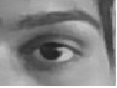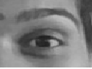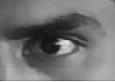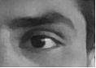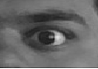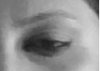
Figure 4.3: Database for Left eye open

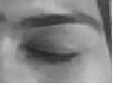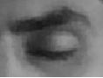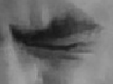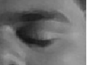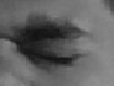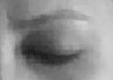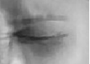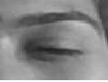
Figure 4.4: Database for Left eye close

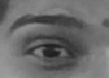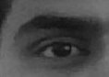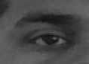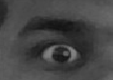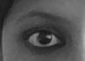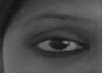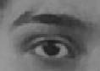
Figure 4.5: Database of Right eye open

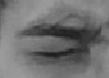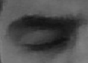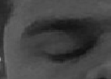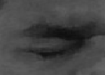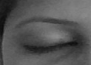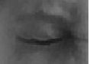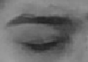
Figure 4.6: Database for Right eye close

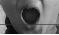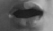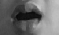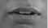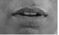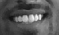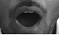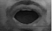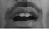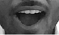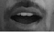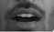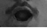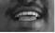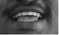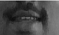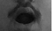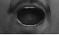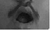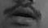
Figure 4.7: Database for Mouth open

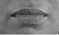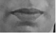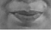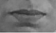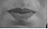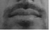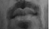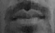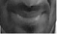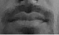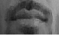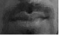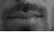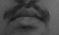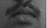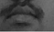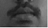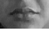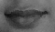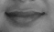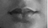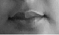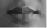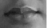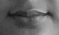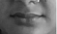
Figure 4.8: Database for Mouth close

Chapter 5
SYSTEM IMPLEMENTATION
5.1 FPGA
Field Programmable Gate Arrays (FPGAs) are semiconductors devices that are based around a matrix of configuration logic block (CLBs) connected via programmable interconnects. FPGAs can be reprogrammed to desired application or functionality requirement after manufacturing. This feature distinguishes FPGAs from Application Specific Integrated Circuits (ASICs), which are custom manufactured for specific design tasks. Although one-time programmable (OTP) FPGAs are available, the dominant types are SRAM based which can be reprogrammed as the design evolves following applications.
- Consumer Electronics: Cost-effective solutions enabling next generation, full featured consumer applications, such as converged handsets, digital flat panel display, information appliances, home networking, and residential set top boxes.
- Data Center: Designed for high-bandwidth, low-latency servers, networking, and storage application to bring higher value into cloud deployments.
- High Performance Computing and Data Storage: Solutions for Network Attached Storage (NAS), Storage Area Network (SAN), servers, and storage appliances.
- Industrial: Xilinx FPGAs and targeted design platform for Industrial, Scientific and Medical (ISM) enable higher degrees of flexibility, faster time to market, and lower overall non-recurring engineering cost (NRE) for wide range of applications such as industrial imaging and surveillance, industrial automation, and medical image equipment.
- Medical: For diagnostic, monitoring, and therapy applications, the Virtex FPGA and Spartan® FPGA families can be used to meet a range of processing, display, and I/O interface requirements.
- Security: Xilinx offers solutions that meet the evolving needs of security applications, from access control to surveillance and safety systems.

5.2 Xilinx Spartan-6 FPGA Board
The Atlys circuit board is a complete, ready-to-use digital circuit development platform based on a Xilinx® Spartan®-6 LX45 FPGA. The on-board collection of high-end peripherals, including Gbit Ethernet, HDMI Video, 128 MB DDR2 memory array, audio and USB ports make the Atlys board an ideal host for complete digital systems built around embedded processors like Xilinx's MicroBlaze™. Atlys is fully compatible with all Xilinx CAD tools, including ChipScope™, EDK, and the free WebPACK™, so designs can be completed with no extra costs.
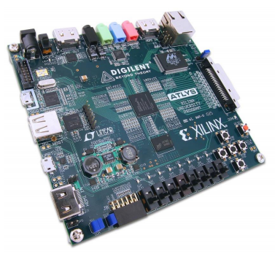
Figure 5.1: FPGA Board

5.2.1 Key Features
Key features of FPGA board as follows:
- LX45 FPGA, 324-pin BGA package
- 6,822 slices each containing four 6-input LUTs and eight flip-flops
- 2.1Mbits of fast block RAM
- 4 clock tiles (8 DCMs & 4 PLLs)
- 6 phased-locked loops
- 58 DSP slices
- 500 MHz+ clock speeds
- 128 MB DDR2 16-bit wide data
- 16 MB x4 SPI Flash for configuration & data storage
- 100 MHz CMOS oscillator
- Real time power monitors on all power rails
- JTAG programming interfaces compatible with Xilinx's iMPACT and Digilent Adept
- Ships with a 20W power supply and USB cables
- AC-97 Codec with line-in, line-out, mic, & headphone
- USB-UART and USB-HID port (for mouse/keyboard)
- GPIO includes 8 LEDs, 6 buttons, and 8 slide switches
- 48 I/Os routed to expansion connectors

Connector(s):
- One Vmod (high-speed VHDC) connector
- One 12-pin Pmod port
- One RJ-45 connector for 10/100/1000 Ethernet PHY and RS-232 serial
- Two HDMI video input ports & two HDMI output ports
- Two on-board USB2 ports for programming & data transfer
- AC-97 audio with line-in, line-out, microphone, & headphone

5.2.2 Benefits
Benefits of FPGA board as follows:
- Evaluate Real Time Applications
- Supports VHDL,VERILOG & Schematic
- JTAG Programming/Debugging
- Assess Communication Protocol
- Facility to interface external devices

5.3 What is MATLAB?
MATLAB is a numerical computation and simulation tool that was developed into a commercial tool with a user friendly interface from the numerical function libraries LINPACK and EISPACK, which were originally written in the FORTRAN programming language. As opposed to the well-known computer algebra programs, such as MAPLE or MATHEMATICA, which are capable of performing symbolic operations and, therefore calculating with mathematical equations as a person would nominally do with the paper and pencil. In principle MATLAB does purely numerical calculations. Nevertheless, computer algebra functionality can be achieved within the MATLAB environment using the so-called “symbolic” toolbox.

5.4 Introduction to MATLAB
Computer algebra programs require complex data structures that involve complicated syntax for the ordinary user and complex programs for the programmer. MATLAB, on the other hand, essentially only involves a single data structure upon which all its operations are based. This is the numerical field. Or, in the other words, the matrix. This is reflected in the name: MATLAB is an abbreviation for Matrix Laboratory. As MATLAB developed, this principle gradually led to a universal programming language. MATLAB is not just a numerical tool for evaluation of formulas, but is also an independent programming language capable of treating complex problems and is equipped with all the essential constructs of a higher programming language. The elementary MATLAB operations cab be divided roughly into five classes:
- Arithmetic operations
- Logical operations
- Mathematical functions
- Graphical functions
- I/O operations (data transfer)

Chapter 6
LBP & KNN ALGORITHMS

6.1 Principles of Local Binary Pattern
With the Local Binary Pattern (LBP) operator it is possible to describe the texture and shape of a digital (gray scale) image. One LBP is a binary code for an image-pixel which tells something about the local neighbourhood of that pixel. By producing a LBP of a pixel, the gray value of that pixel is compared to the gray value of pixels in its neighbourhood. In this chapter some aspects of the texture and shape description with LBP will be discussed. For this description also a few equations will be derived.

  - Local Binary Pattern and Histogram
LBP is a type of visual descriptor used for classification in computer vision. It is the particular case of the texture spectrum model proposed in 1990. It has further been determined that when LBP is combined with histogram of oriented gradient (HOG) descriptor, it improves the detection performance considerably on some datasets.

LBP is simple yet very efficient texture operator which labels the pixels of an image by thresholding the neighbourhood of each pixel and consider the result as a binary number. Using the LBP combined with histogram we can represent the face images with the simple data vector.

  - Step by Step procedure of LBP
Parameters: The LBPH uses 4 parameters:
- Radius: The radius is used to build the circular LBP and represents the radius around the central pixel. It is usually set to 1.
- Neighbours: The number of sample points to build the circular LBP. It is usually set to 8.
- Grid X: The number of cells in the horizontal direction. The more cells, the finer the grid, the higher the dimensionality of the resulting feature vector. It is usually set to 8.
- Grid Y: The number of cells in the vertical direction. The more cells, the finer the grid, the higher the dimensionality of the resulting feature vector. It is usually set to 8.
Extracting the Histograms: Using the image generated in the last step, we can use the Grid X and Grid Y to divide the image into multiple grids, as can be seen in the following image.

This operator works with the eight neighbours of a pixel, using the value of this center pixel as a threshold. If a neighbour pixel has a higher gray value than the center pixel (or the same gray value) than a one is assigned to that pixel, else it gets a zero. The LBP code for the center pixel is then produced by concatenating the eight ones or zeros to a binary code

Figure 6.1: The original LBP operator

Later the LBP operator was extended to use neighbourhoods of different sizes. In this case a circle is made with radius R from the center pixel. P sampling points on the edge of this circle are taken and compared with the value of the center pixel. To get the values of all sampling points in the neighbourhood for any radius and any number of pixels, (bilinear) interpolation is necessary. For neighbourhoods the notation (P,R) is used. Figure 6.2 illustrates three neighbour-sets for different values of P and R.

Figure 6.2: Circularly neighbour-sets for three different values of P and R
If the coordinates of the center pixel are (xc, yc) then the coordinates of his P neighbours (xp, yp) on the edge of the circle with radius R can be calculated with the sinus and cosines:

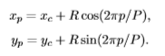

If the gray value of the center pixel is gc and the gray values of his neighbours are gp.

Although invariant against gray scale shifts, the differences are affected by scaling. To achieve invariance with respect to any monotonic transformation of the gray scale, only the signs of the differences are considered. This means that in the case a point on the circle has a higher gray value than the center pixel (or the same value), a one is assigned to that point, else it gets a zero:

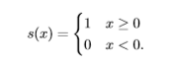

In the last step to produce the LBP for pixel (xc, yc) a binomial weight 2p is assigned to each sign s(gp − gc).

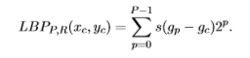

The Local Binary Pattern characterizes the local image texture around (xc, yc). The original LBP operator in figure 6.1 is very similar to this operator with P = 8 and R = 1. The main diﬀerence between these operators is that in LBP the pixels ﬁrst need to be interpolated to get the values of the points on the circle.

  - KNN Algorithm
It is the computer classification algorithm. KNN has been used in statistical estimation and pattern recognition. It requires some reference data to indicate the correct expressions. In this the nearest neighbour of the each data point are found and neighbourhood graph is plotted where edge length between points in the neighbourhood are set as the kernel discriminated distance.
Given the input data point (x_{i}, L_{i}), where x_{i} ∈ R^{D} and L_{i} is the class label of x_{i}, the output data point is y_{i} ∈ R^{d} (i = 1, 2, 3, ..., N). The detailed steps of KNN are presented as follows:
- Step 1: Kernel mapping for each input data point x_{i}.
A nonlinear mapping function φ is defined as: φ: R^{D} → ℱ, x ↦ φ(x)
The input data point x_{i} ∈ R^{D} is mapping into an implicit high-dimensional feature space F with the nonlinear mapping function φ. In a RKHS, a kernel function κ(x_{i}, x_{j}) can be defined as:
κ(x_{i}, x_{j}) = 〈φ(x_{i}), φ(x_{j})〉 = φ(x_{i})^{T}φ(x_{j})
where κ is known as a kernel.
- Step 2: Find the nearest neighbours of each data point φ(x_{i}) and construct a neighbourhood graph where edge lengths between points in a neighbourhood are set as the following kernel discriminant distance.
The kernel Euclidean distance measure induced by a kernel κ can be defined as:
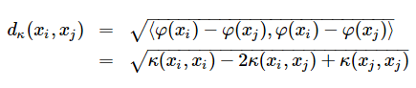
To preserve the intra-class neighbouring geometry, while maximizing the inter-class scatter, a kernel discriminant distance in a RKHS is given as follows:

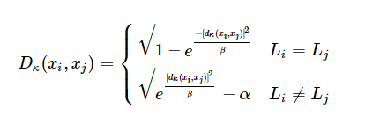

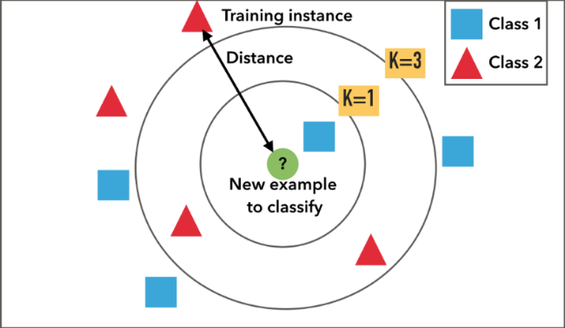

Figure 6.3: KNN Algorithm representation

  - Feature Vector
Once the Local Binary Pattern for every pixel is calculated, the feature vector of the image can be constructed. For an efficient representation of the face, first the image is divided into k2 regions. For every region a histogram with all possible labels is constructed. This means that every bin in a histogram represents a pattern and contains the number of its appearance in the region. The feature vector is then constructed by concatenating the regional histograms to one big histogram.

Figure 6.4: LBP, Feature Vector and Histogram

The above given figure shows the Local Binary Pattern, featured vector and the histogram equalization for the happy facial emotion. Similarly, the process is carried out with different facial emotions and the histogram equalization is carried out.

Chapter 7
METHODOLOGY
7.1 Block Diagram and its Explanation
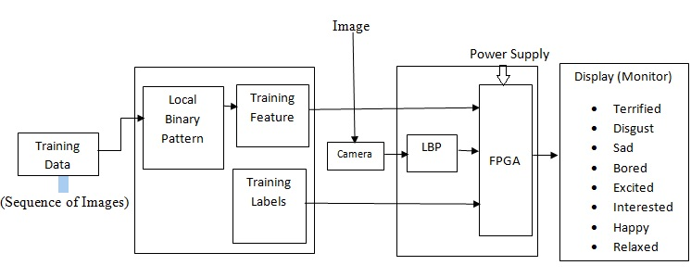
Figure 7.1 Real-Time Emotion Recognition System from Facial Expression
- The inputs are the video frames captured from the camera. WEB CAM was used to capture the videos and extract the training datasets. LBP features were extracted from the captured videos. The k-NN algorithm was used for regression. For training, the LBP features were extracted from 10 video image sequences. Video captures from the FPGA connected camera were processed, and the LBP features were used for the k-NN regression with dimensional emotion labels.
- The LBP algorithm converts local sub-blocks of the gray-scale converted image to an alternation counts histogram. The histogram values of each block were horizontally concatenated together to form a single feature vector, which is the descriptor for the entire image.
- In effective dimensional space, more details on how the emotional states other than the six basic emotion categories (i.e., happy, sad, disgust, anger, surprise and fear) are represented. The three-dimensional (3D) model contains arousal, dominance and valence. Therefore, the automatic emotional state detection system needs to comprehensively model the variations in visuals and convert these to the arousal, dominance and valence scale from the captured image. From the machine learning point of view, this is not a classification problem but a regression problem, because the predicted values are real numbers on each individual frame in the image sequence.
- The inputs into the merger system are the image recorded from four volunteers, which were used to build the system training part.
- LBP features were extracted from the image. We note that LBP is the most common feature extraction that has been used in numerous emotional state recognition systems.
- A k-NN algorithm was used for the regression because of its simplicity and lesser complexity to implement on FPGA compared to other algorithms. At the training phase, features were extracted from image sequences .
- At the testing step, features of the new image from a camera connected to FPGA were calculated and sent to the k-NN for regression with dimensional emotion labels (e.g., real values for activation and valence) as the output. As the training set was complete, the entire system was expected to produce incessant dimensional labels.

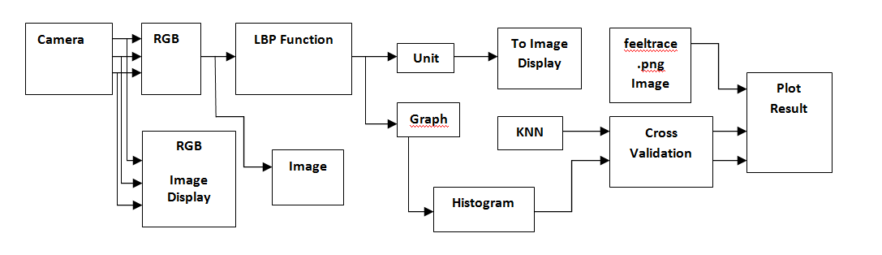

Figure 7.2: Simulink data workflow diagram

7.2 Procedure for Face Detection
- Play the video using camera.
- Prepare MATLAB Code.
- Pass Camera ID.
- Get Signal from the camera to capture the image.
- Collect all frames and detect for the color space.
- Convert ‘RGB’ image to ‘B/W’ image.
- Detect Face.
- Sub detect the parts of the faces.
- STAGE 1:- Detect Eyes.
- STAGE 2:- Left Eye.
- STAGE 3:- Right Eye.
- STAGE 4:- Mouth.
- Save the image for further comparision.

7.3 Procedure for Database creation
- Save the captured picture.
- Open the saved pictures and compare it with the new pictures.
- Compare all the 30 frame with the real time image captured.
- In which 20 frame belong to eye frames each, which records different expressions.
- And 10 frames belongs to mouth frames.
- Check for the conditions.
- If the condition matches then the following expression is displayed on the screen.

Chapter 8
RESULTS AND DISCUSSION
When we run the program we encounter a interface which has multiple section. The LBP method was implemented for comparison in MATLAB and the FPGA. The values of the activation and valence for the database were extracted.

MATLAB was used to test the model and find the best possible method that could be implemented on the available FPGA. A collection of video was needed to be recorded to build the model database, and this had to be obtained from the FPGA sensor camera. The biggest challenge for this work was how to obtain the video data from the FPGA and save it; there was only 128MB of DDR2 RAM available on the FPGA board, and thus there was a limitation on saving the video data. Therefore, three different methods were implemented and tested on the two different boards:
- Receiving and saving the data in MATLAB Simulink via a universal asynchronous
receiver/transmitter (UART) available on the board.
- Saving data on an SD card and implementing and testing on the Xilinx Spartan-6 FPGA Industrial Video Processing Kit.
- Connecting the HDMI output to a computer and using the MATLAB Acquisition application to record the video.
Finally, the third option was found as the best way to save the data.

To build a model in VHDL code, the Xilinx Spartan-6LX45 FPGA was used. The code that Digilent provided was used and modified extensively to meet the target specification. In this way, many different Xilinx LogiCORE IP’s were used. The output of the model is displayed at the top-right corner of a monitor with the participant’s live video.

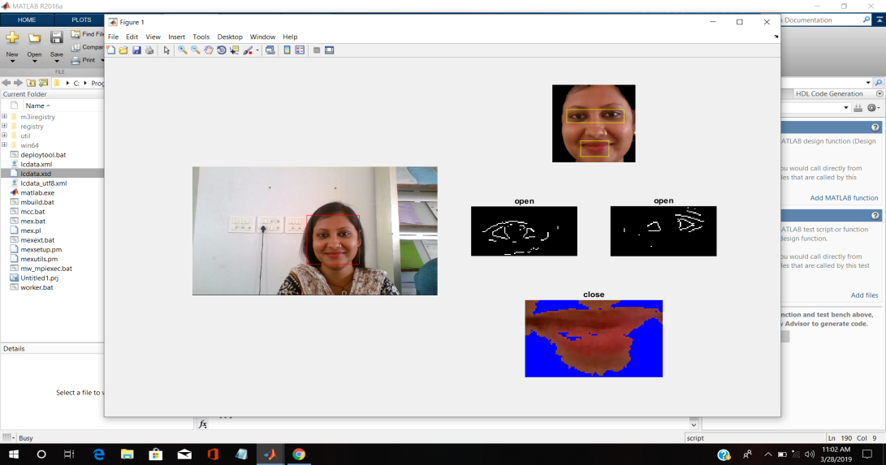

Figure 8.1: Facial emotion recognition output on Screen (Happy)

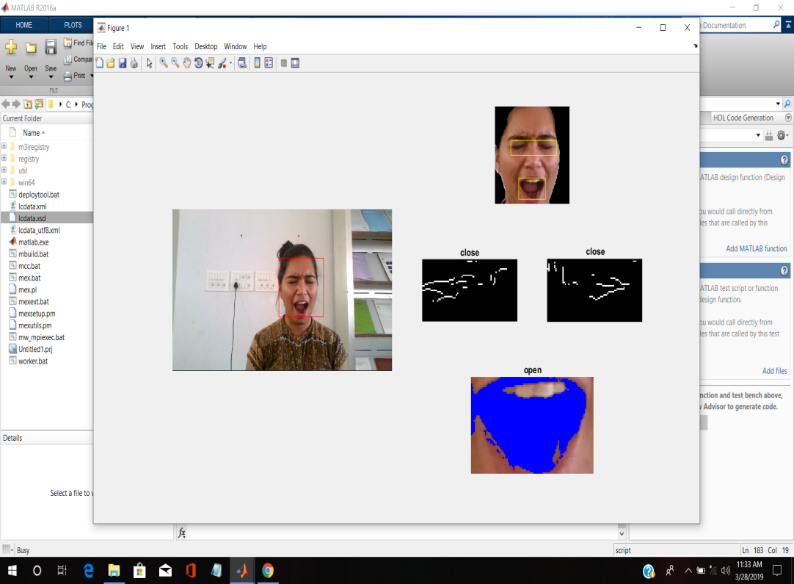

Figure 8.2: facial emotion recognition output on Screen (Scared)

Chapter 9
CONCLUSION AND FUTURE SCOPE
9.1 Conclusion
The project has an impact of artificial neural network (ANN) based architecture including FPGA implementation of an efficiency of regression methods for automatic emotional state detection and analysis for evaluating maximum accuracy, efficiency and performance compared to statistical methods.
It can be implemented on embedded device for human emotion recognition from live camera. This method presents a robust and hardware efficient algorithm for real time emotion recognition which gives very high rate of accuracy.

9.2 Future Scope
The system could be improved in the future work by using different deep learning algorithms; new feature extraction or different regression modelling methods such as SVR (Support Vector Regression), although difficult to design, have a proven potential to overcome the problems facing human emotion research today. The results presented in this project for automatic facial emotion recognition are promising. In the future, the audio features and speaker emotion detection models will also be tested and fused with the frame-level results.

