# What is computer

Computer is an electronic device that take some input and process and give some meaning full output.

# What is 0 and 1?

There is nothing like 0 and 1 in computer.there is no physical significance of 0 and 1.

Any information can be encoded as a sequence of 0 and 1.

When the north pole is make on the up, so we can say it 0 and if north pole is make on the down, so we can say 1.

# What is hardware?

Hardware is anything which is tangible.

Hardware is all physical part of computer, as distinguished from the data it contain or operates on and the software that provide instruction for the hardware to accomplish tasks.

# Program and process

Set of instruction is called program.

Active state of a program is called process.

# Operating system

It is a system software.

It provide interface between user and machine.

Acts as a manager of the computer system.

It does process management, memory management, file management.

Ex:-

Ms DOS, window 7,8,10 etc.

Ubuntu linux.

# Execution of a program

When we want to run the application or file and file or data are store in the hard disk hen file suddenly file converted in 0and1 form then file make a copy of this file and past on the ram and then 16 0and1 are placed on CPU on MU(memory unit) and suddenly MU and the send the instruction to the CU(control unit) then control unit understand the whole work and instruction then CU send the instruction to the ALU(arithmetical logical unit) then ALU doing the whole work.

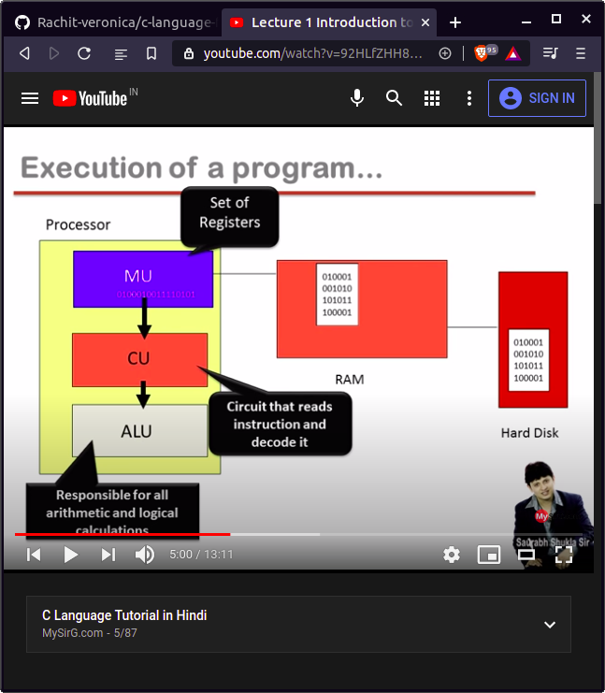

# Software development in c

When we want to make a exe file so, can user there step:-

1. Firstly we make source file and it have a extention is .c(because we make a file in c language).
2. Then the file is going to the preprocessor. Preprocessor it handel the keyword who it start from(#). then preprocessor is mix the source file and header file and then make some special file the do not show it harder file. It has a extention is (.i).
3. then the special file (.i) is coming in the compiler. The compiler is a translater that convert extention (.i) into (.obj).
4. Then we can use linker to link the (.obj) and library file (library is like a disnary that every keyword meaning are store in the library files) and then convert into .exe file.

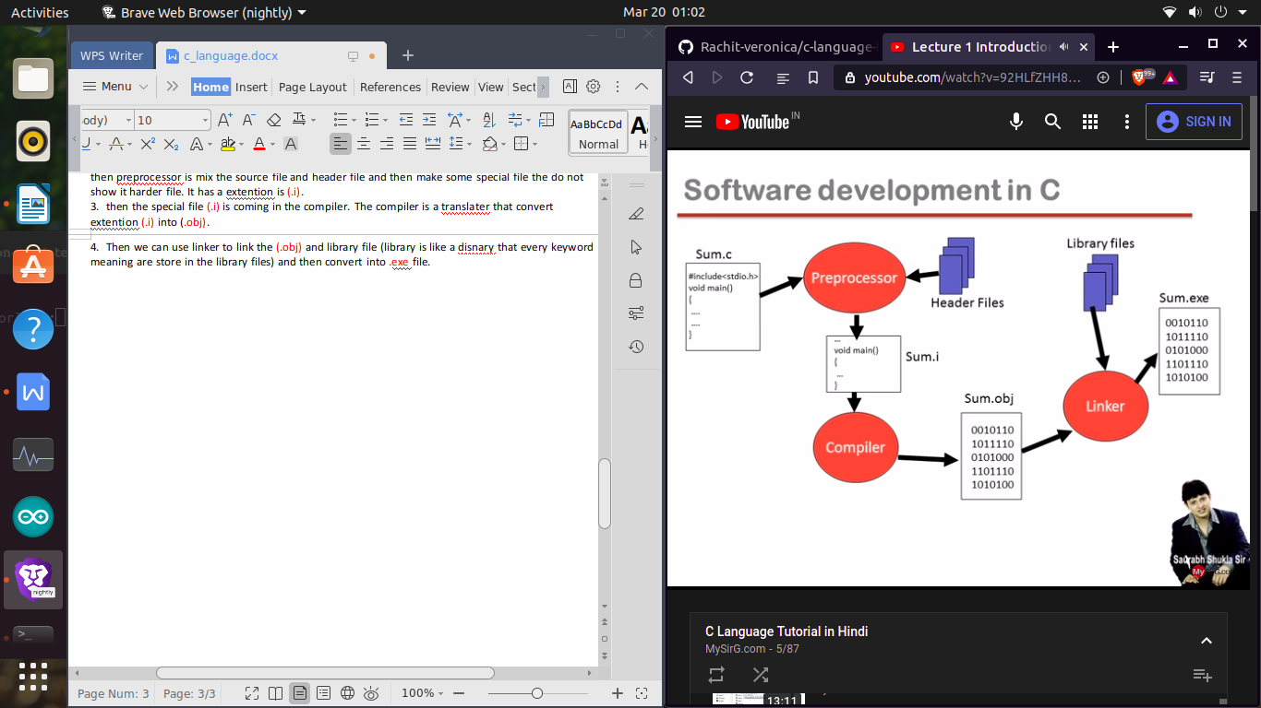

# Begin learning c

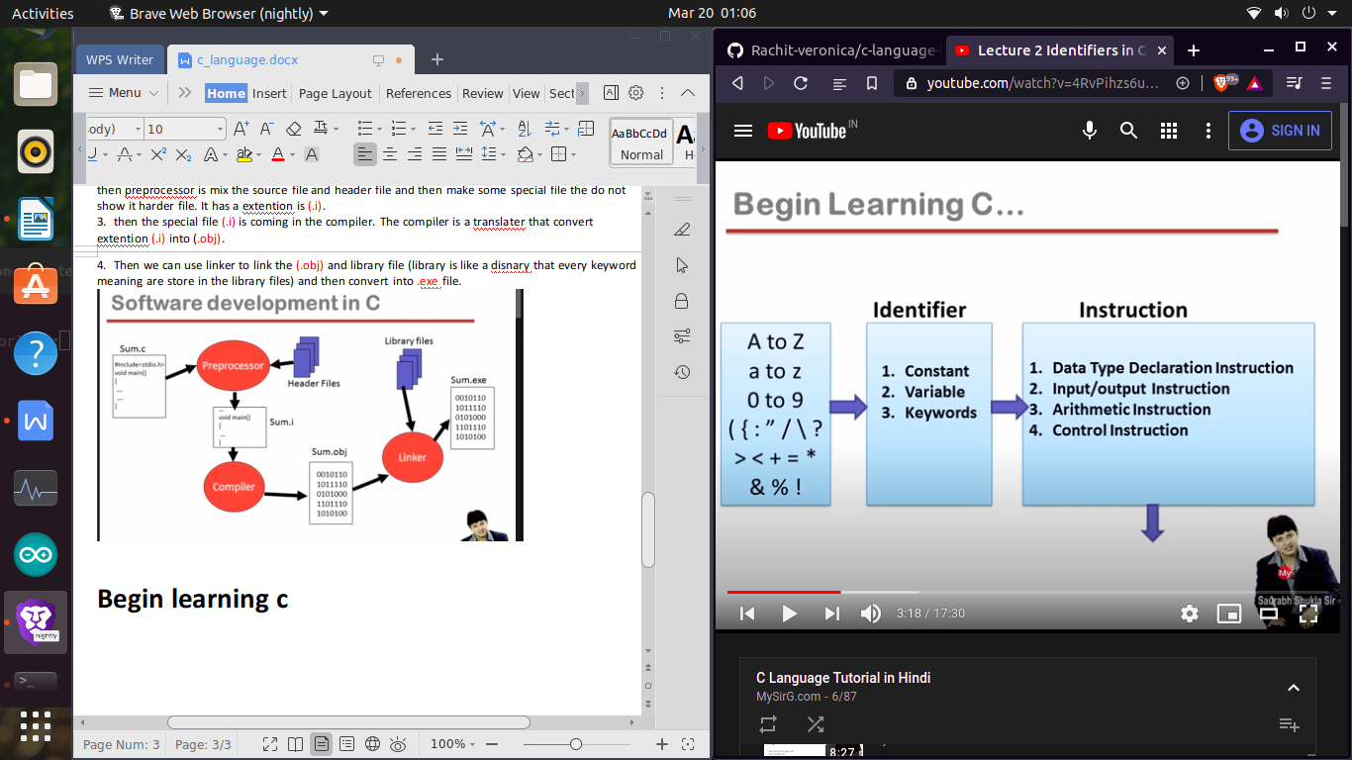

Constant

Any information is constant

Data=information=constant

There are two type of constant:-

1. Primary 2> secondary
2. Interger 1> array
3. Real 2> string
4. character 3> pointer
5. Union
6. Structure
7. enumerator
8. Integer

Integer is who number which do not have any decimal and character.

Ex:- -55 , 34.45

1. Real   
   real is who number which have decimal

Ex:- 21.4,32.3,45.3

1. Character

Character which only single word,number or special char but in it in single cote.

Ex:- ‘a’,’A’,’+’,’ ’,’2’.

Secondary constant

Secondary constant is totally depend on primary constant.

# Keyword

Predefined word

Reserved word

There are 32 keyword in c language in 16 bit architecture.

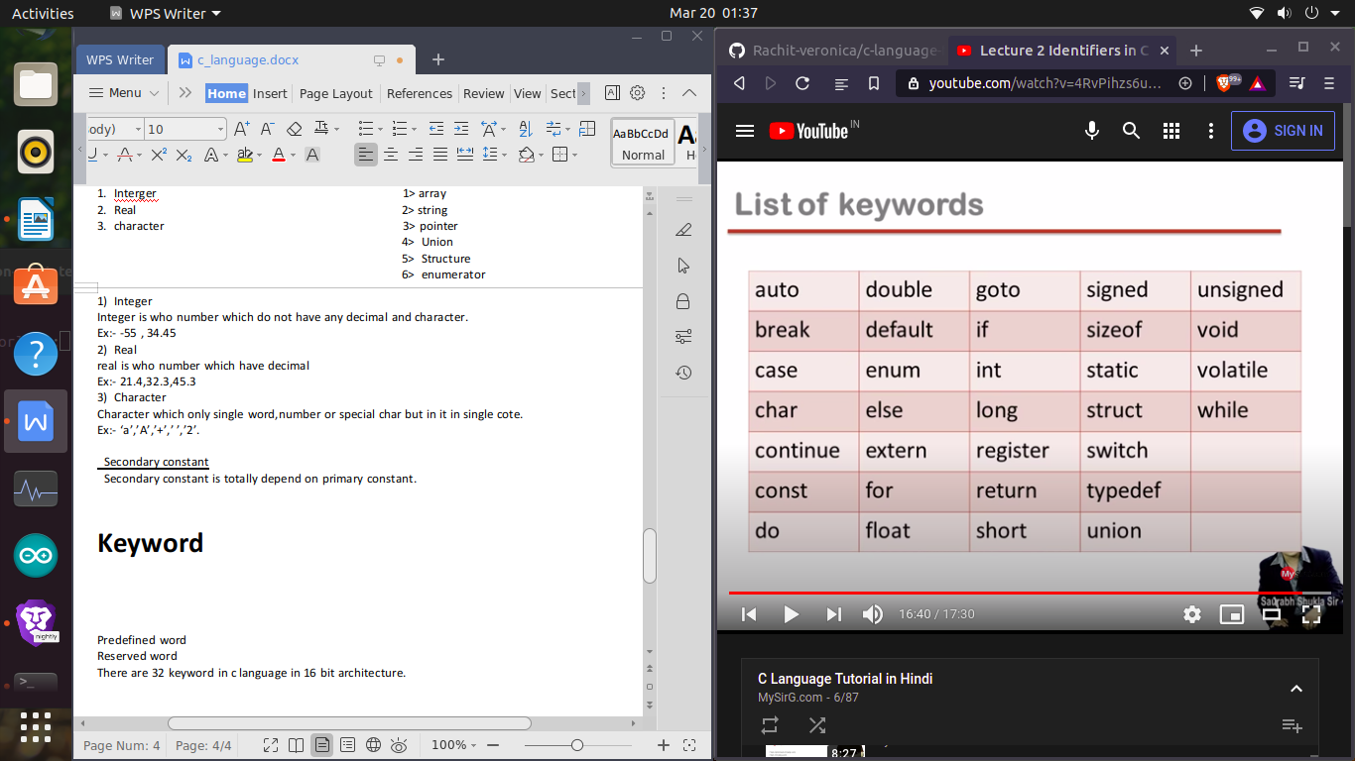

# Instruction

Program statements are call instruction

Instruction are commands

Type of instruction

1. Data type declaration instruction.
2. Input output instruction.
3. Arithmetic instruction.
4. Control instruction.

# Data type

1. Int
2. Char
3. Float
4. Double
5. Void

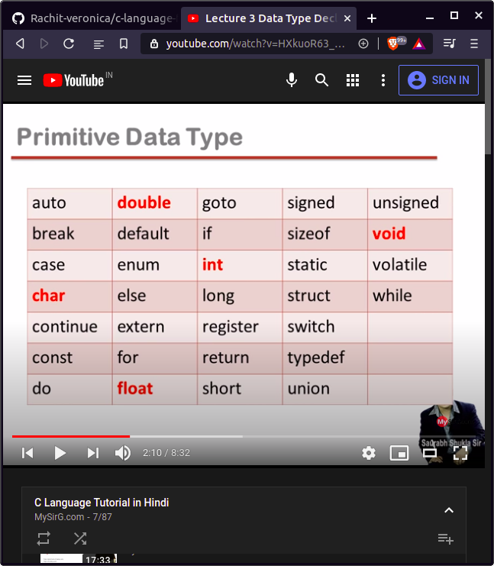

# Declaration statement

1. Int memory only store Integer constant.
2. Float only store Real constant.
3. Char only store Character constant.

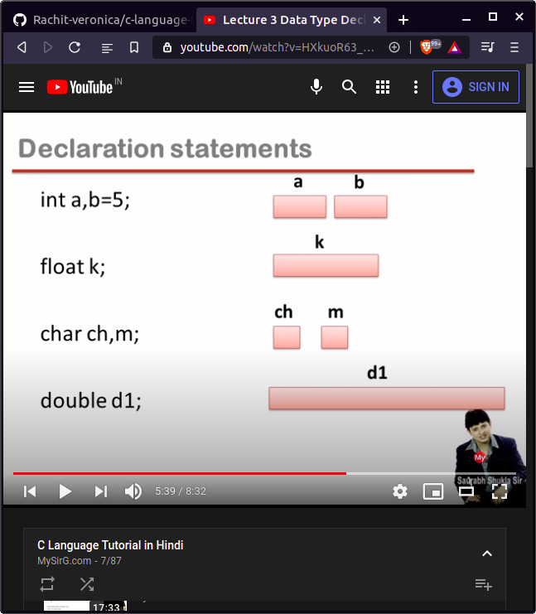

Data type consume size:-

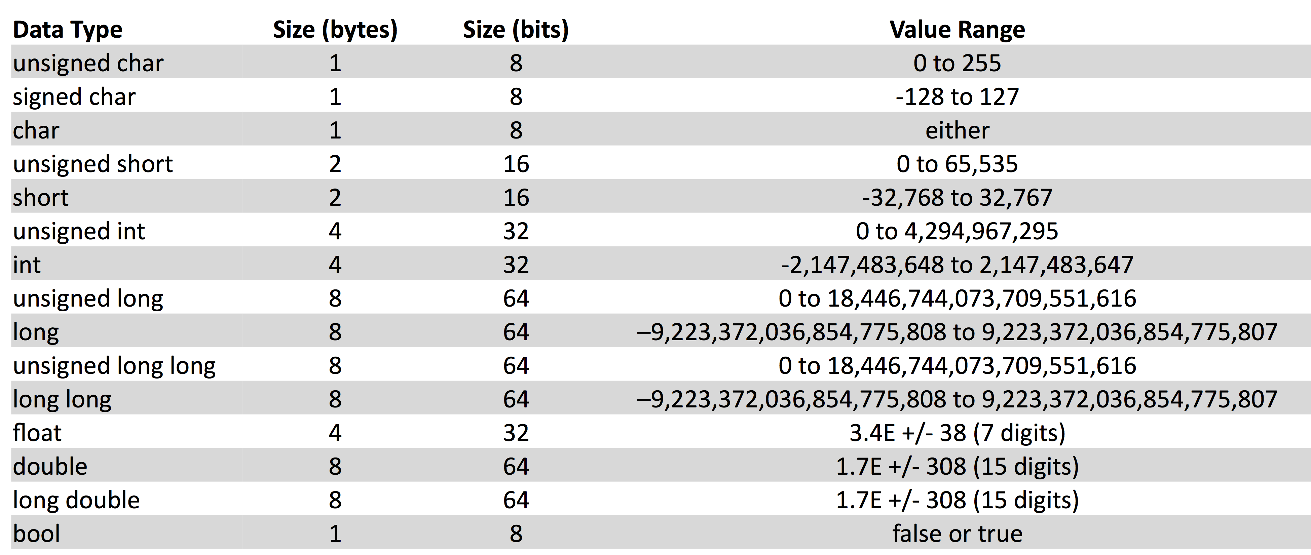

Printf

Printf is not a keyword

Printf is a predefined function

Printf is use to print any line or sentences etc.

Note:- when we wright any name or sentences in double codes, so it is make a string. String is combination single word is called string.

program

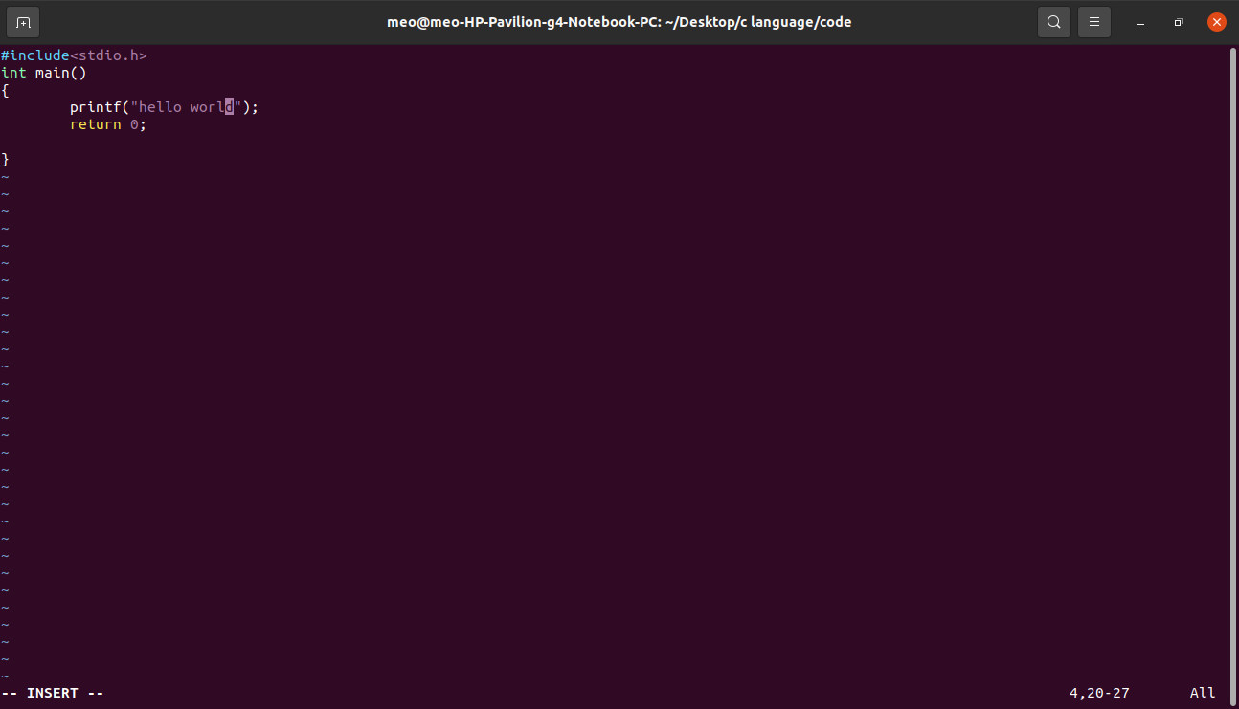

output

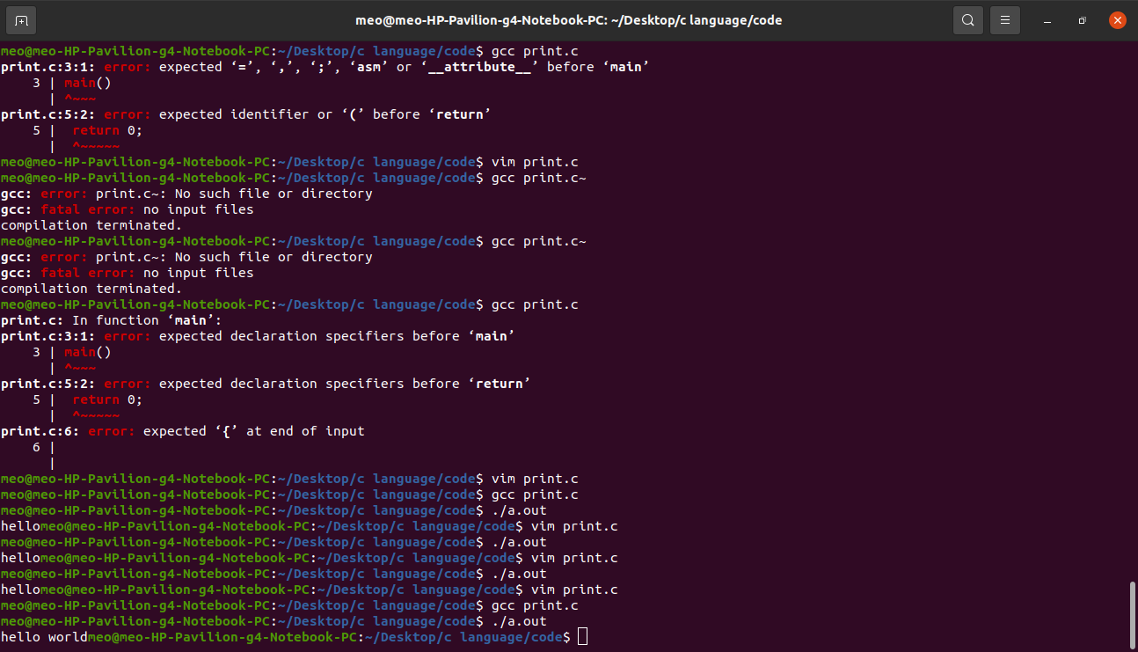

We print the line thorough( \n)

program

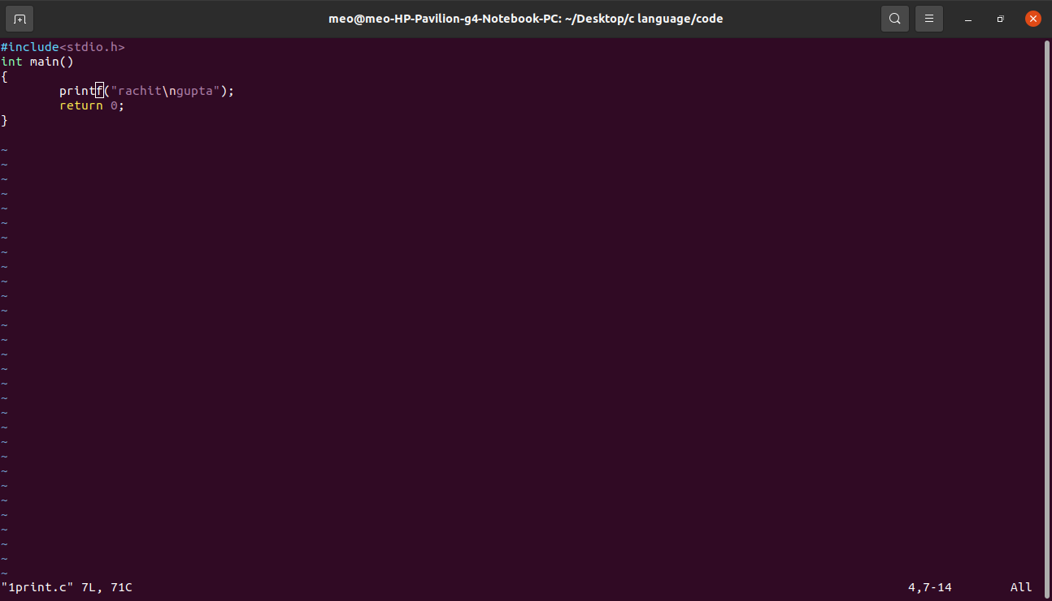

Output

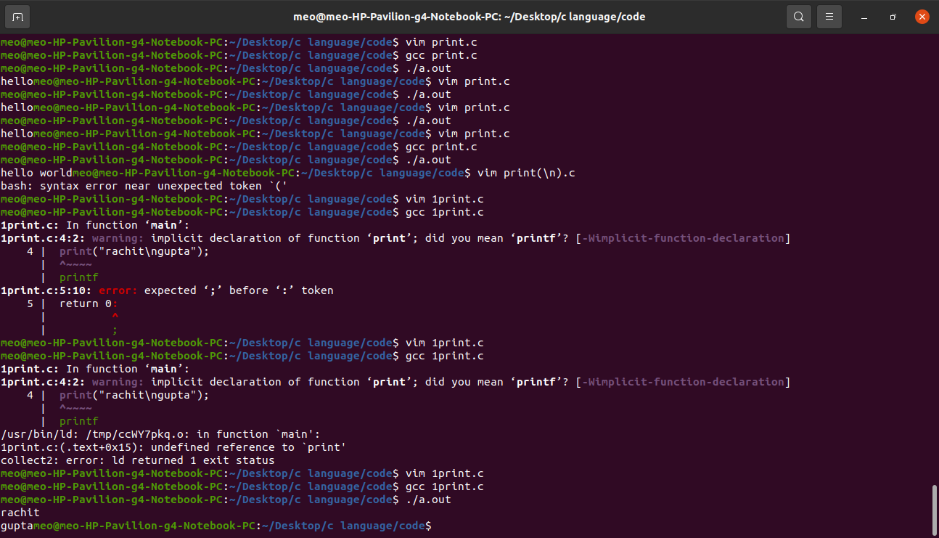

We print a line in the center with use (gotoxy())

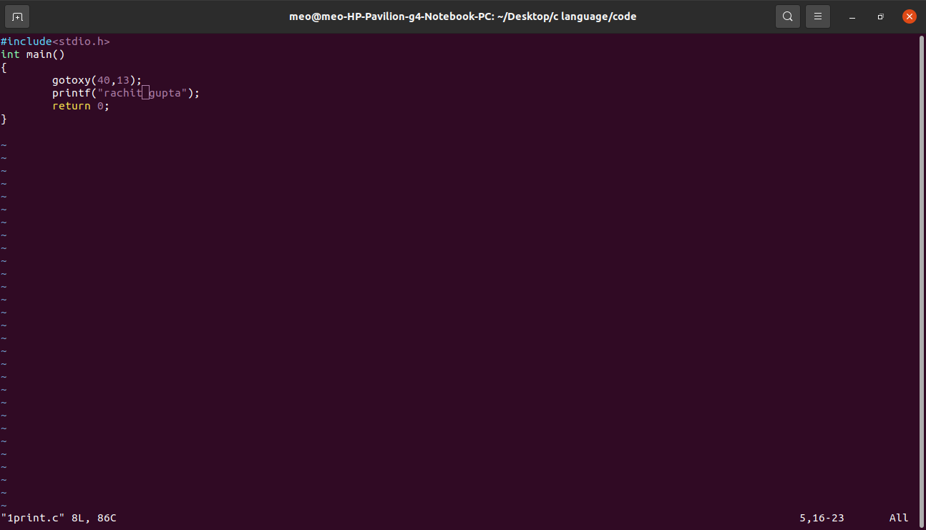

Space between two word with the help of (\t)

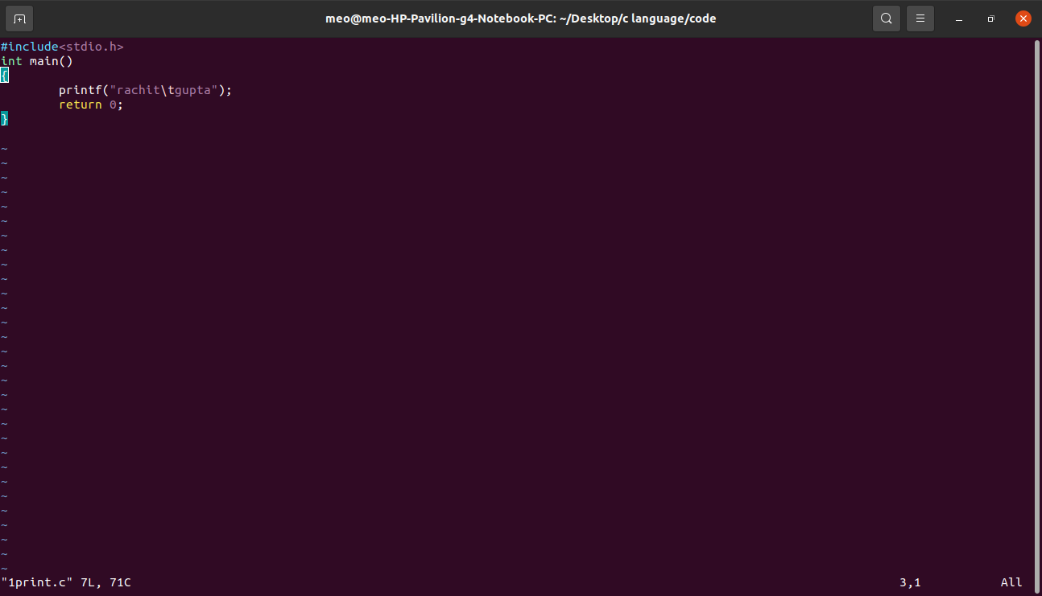

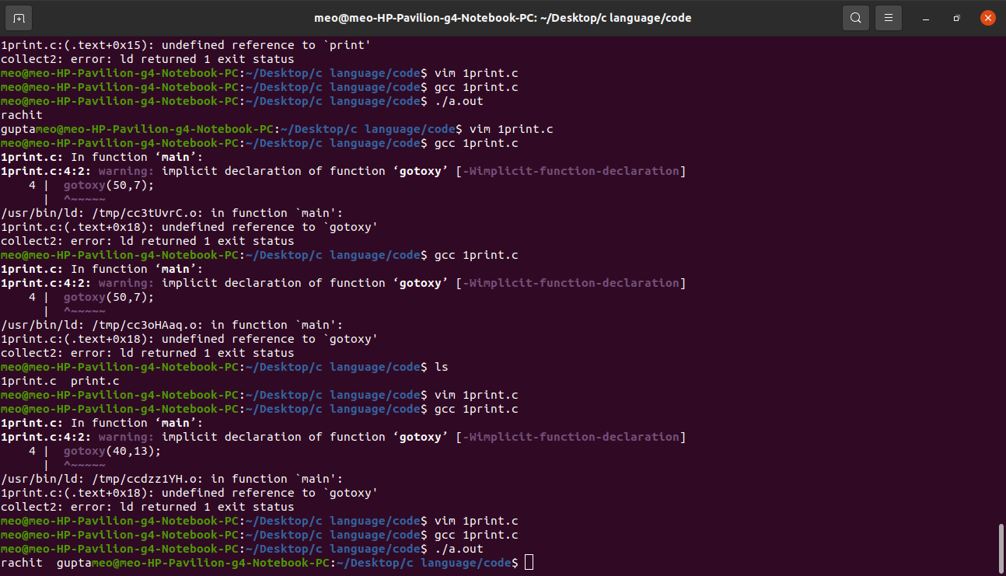

We earse the last word and also remove the space between two word

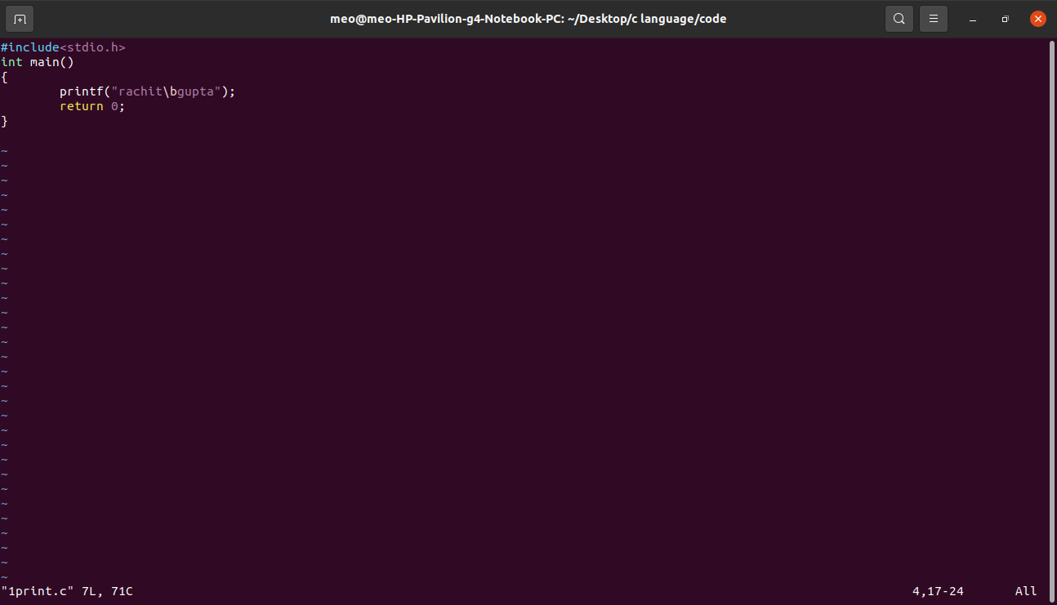

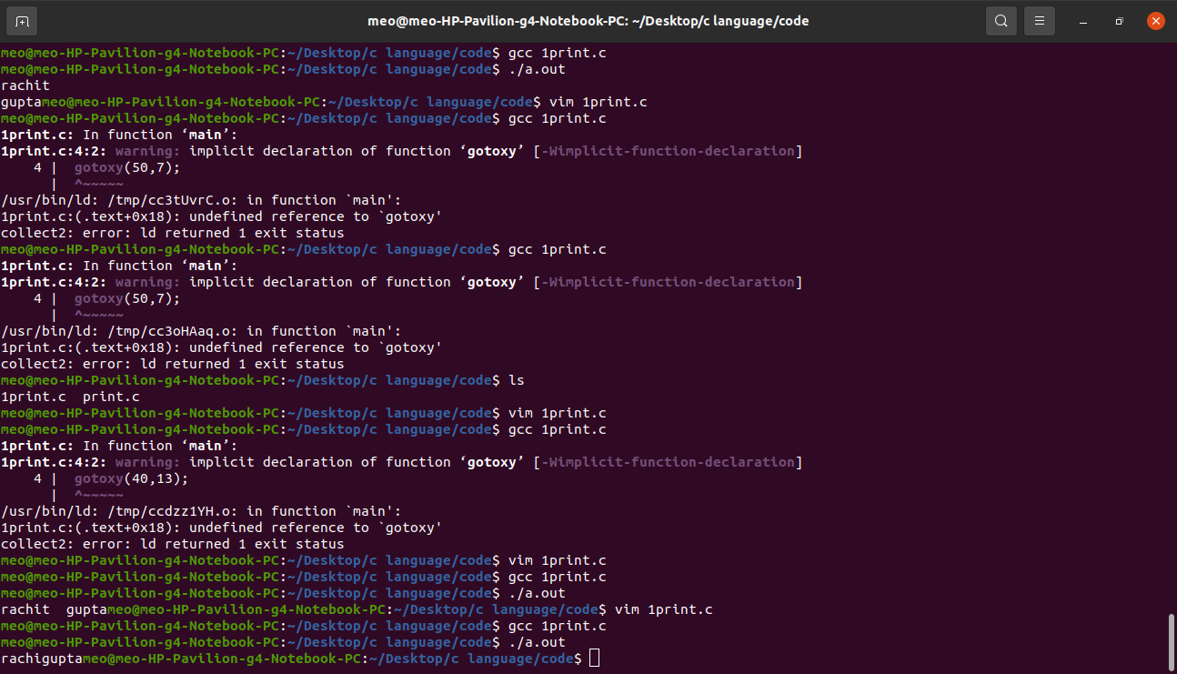

We wright (\) between two word

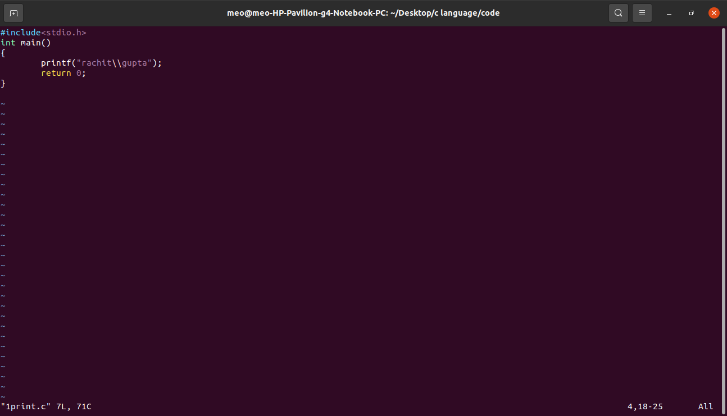

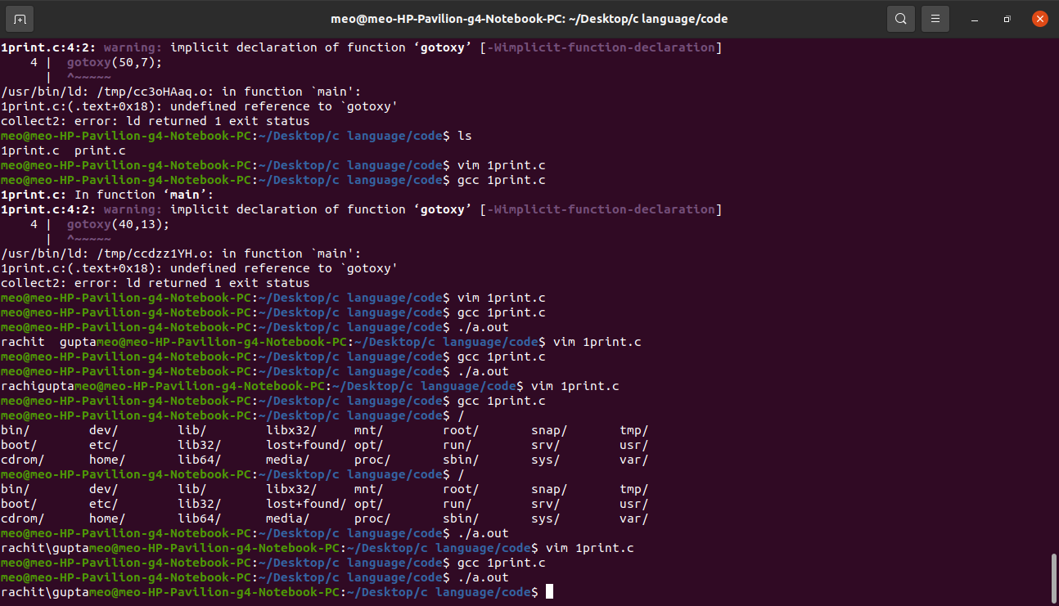

We make double codes between two word.

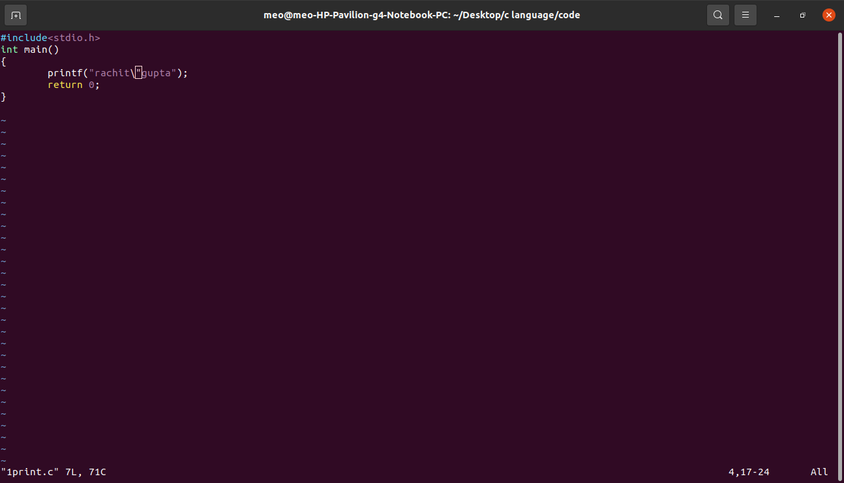

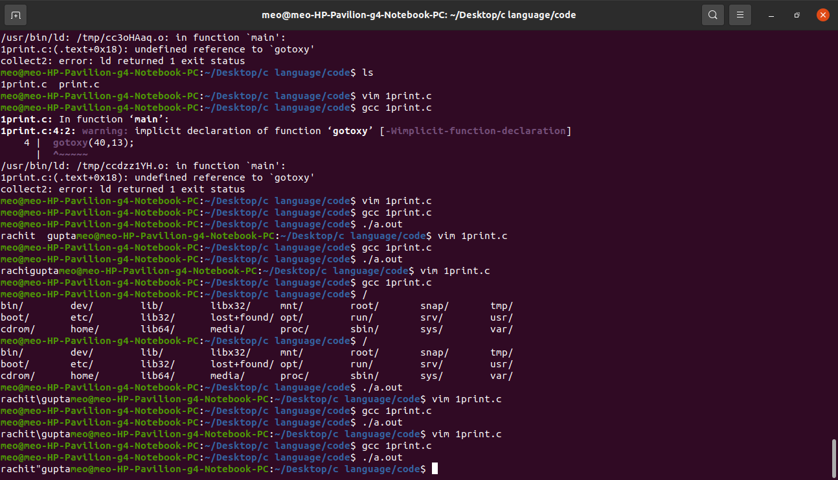

We remove first word between two word

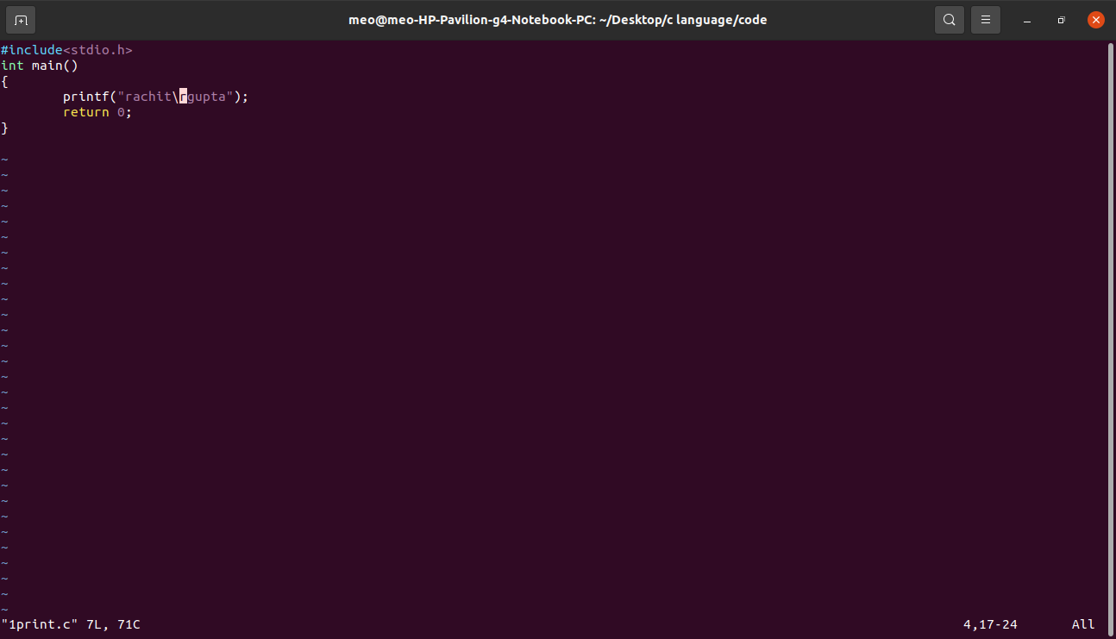

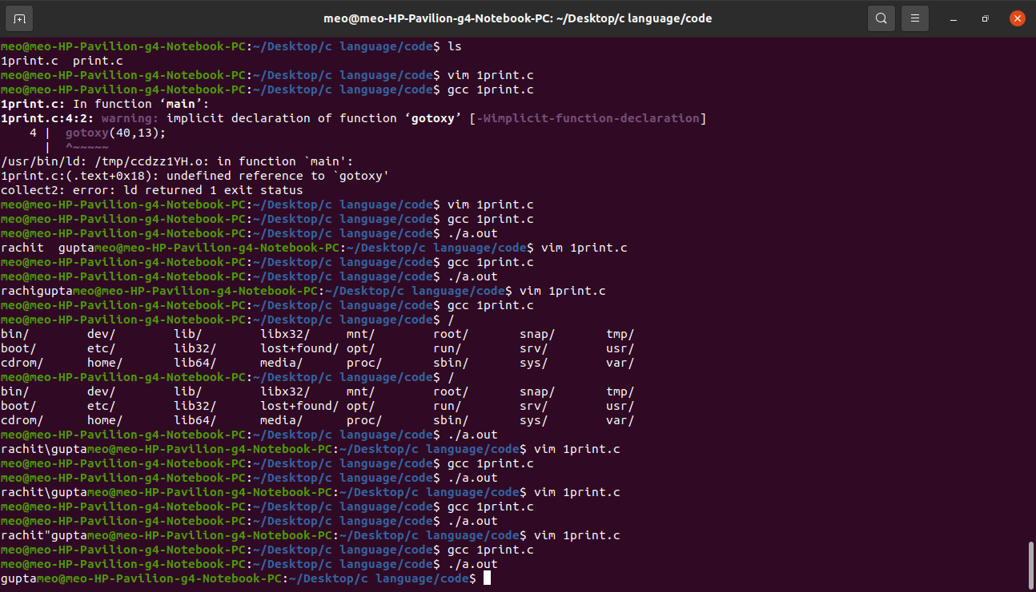

We want to print the value of any variable, so can you there program.

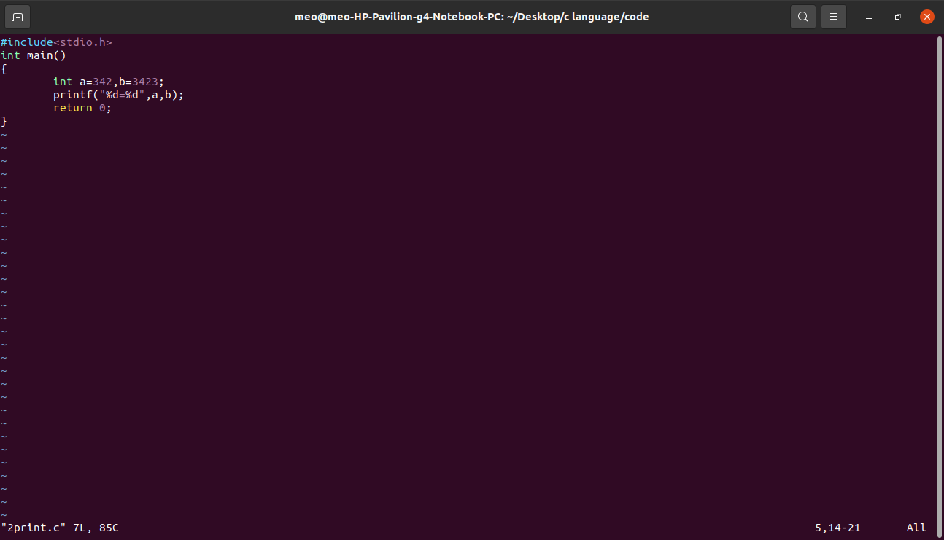  
  
Answer

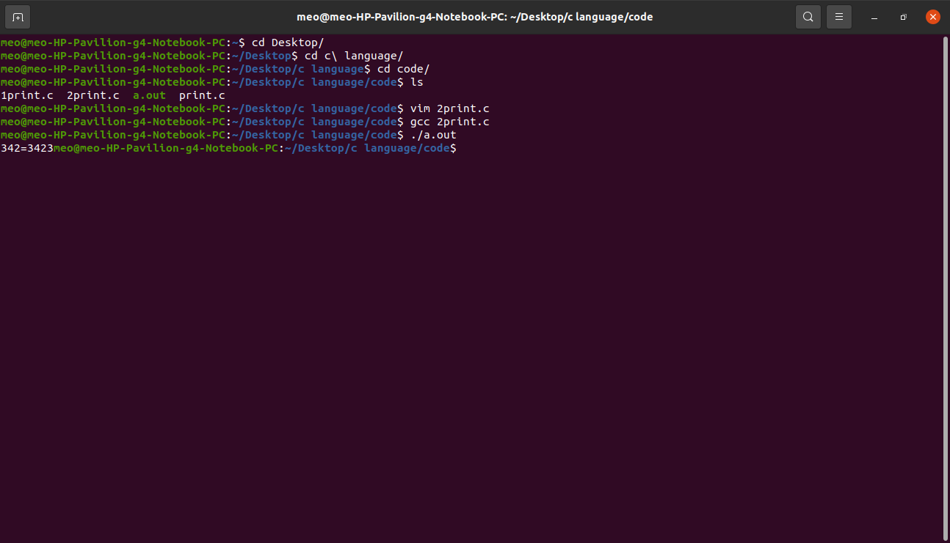  
  
when we want to (+),(-),(*) etc so, we can use these program :-

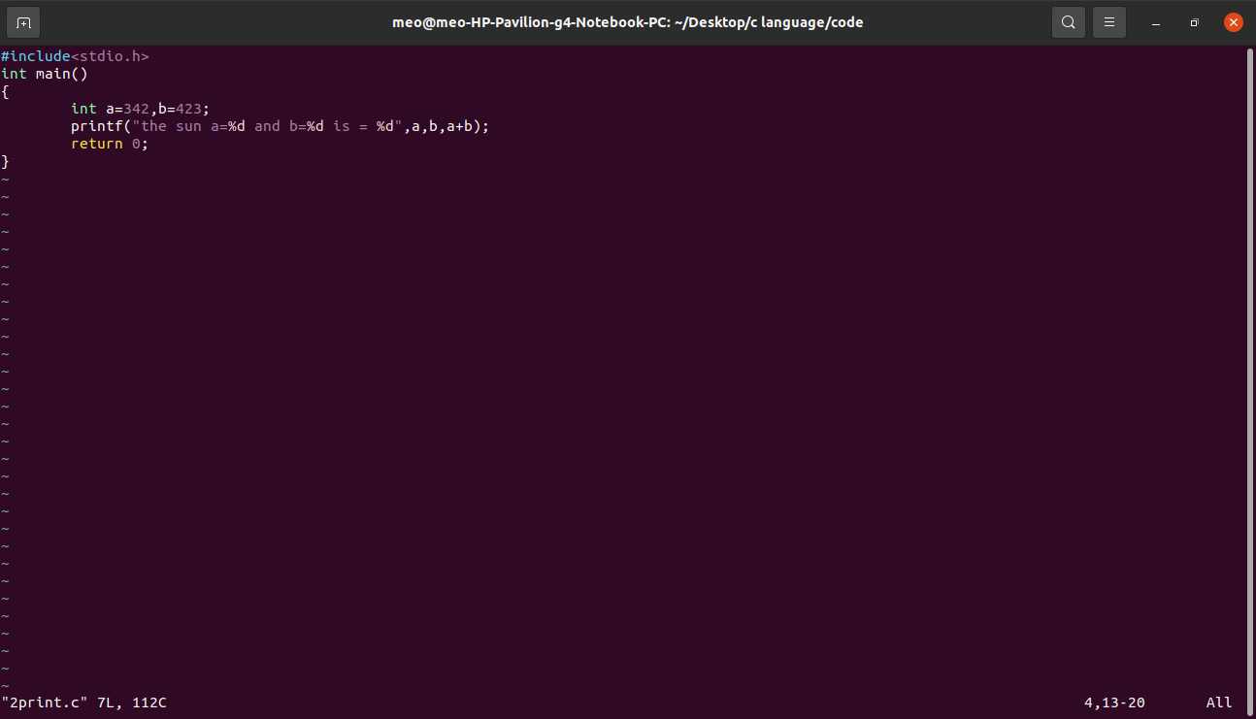  
  
Answer:-

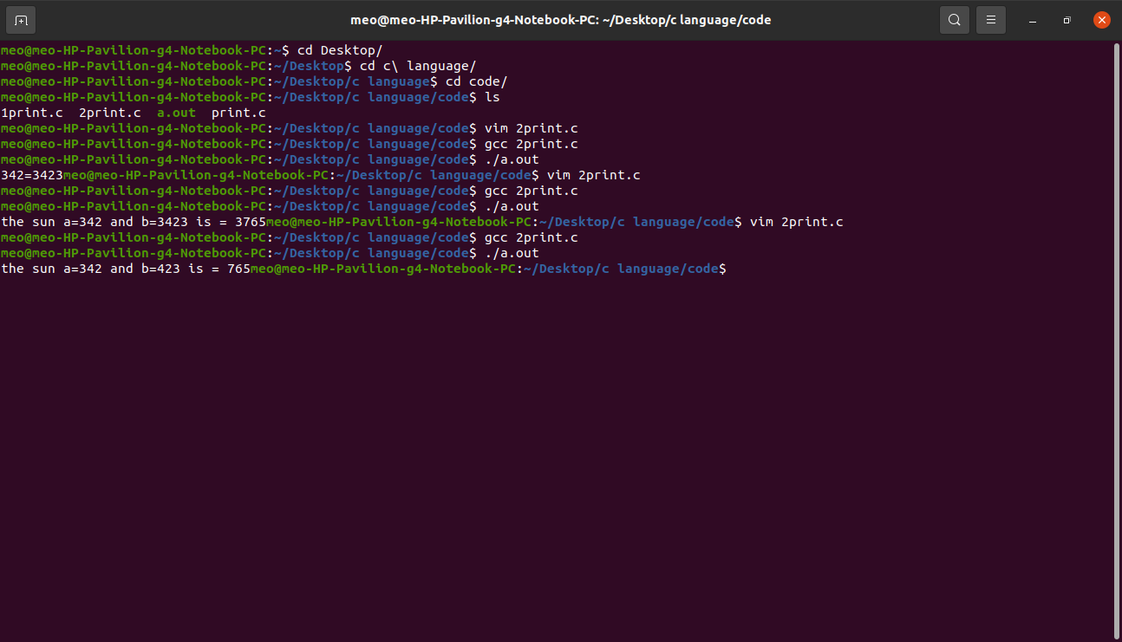  
  
 when we use to more format specifier :-  
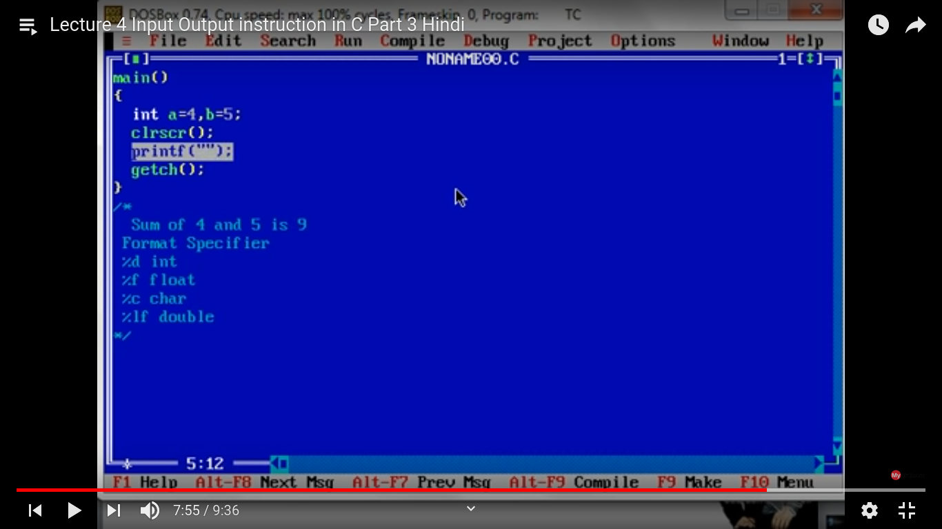  
  
Scanf()  
  
scanf() is not a keyword

Scanf() is a predefined function

We can use scanf() to take the value as a input through user.

Scanf(“format specifier”,variable address);