AWS white paper is most valuable documentation for AWS.

Also this will provided information how we can migrate from our on-primses to AWS.

EC2 - Elastic Compute Cloud.

This can provide virtual machine on the cloud.

S3 - simple storage servers.

Just like “One Drive” or “Drop Box”

RDS - relational data base services.

So this will create DataBase on cloud and give its endpoints.

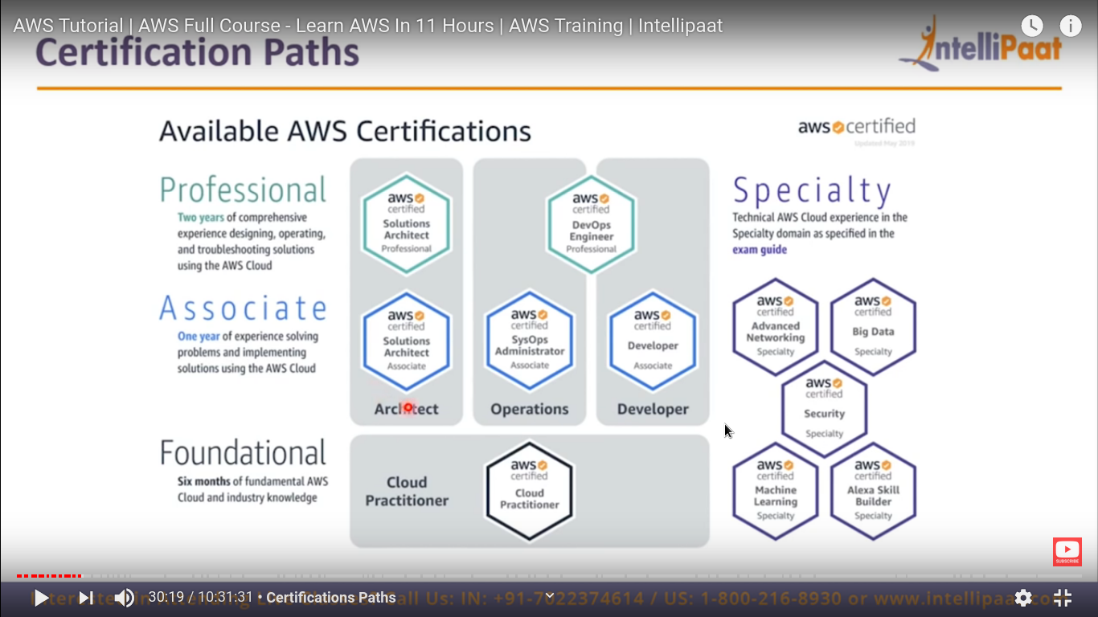

The basic is “Architecture” not much coding and other stuff required.

Here we just create infrastructure.

First we need to focus on “Associate solution Architecture”.

**AWS services:-**

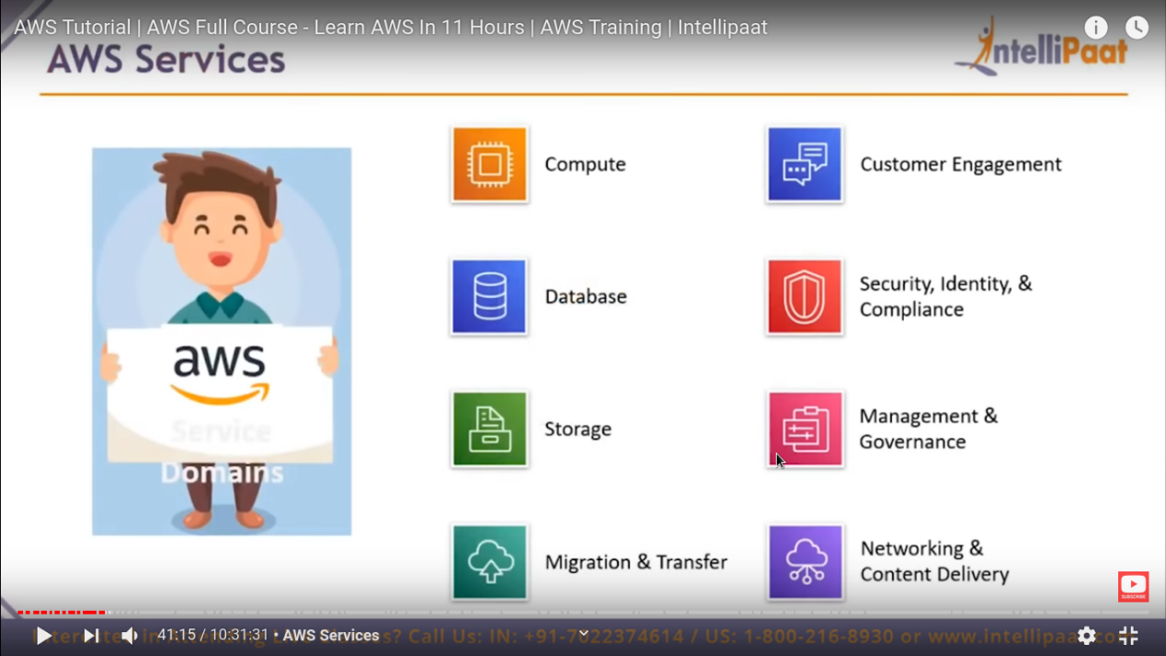

AWS services of some most used domains (there are more domain as well)

EC2 is most popular services available in AWS.

It is a virtual machine service.

It will give on demand scalable compute capacity in AWS cloud.

**RDS - relational database services**

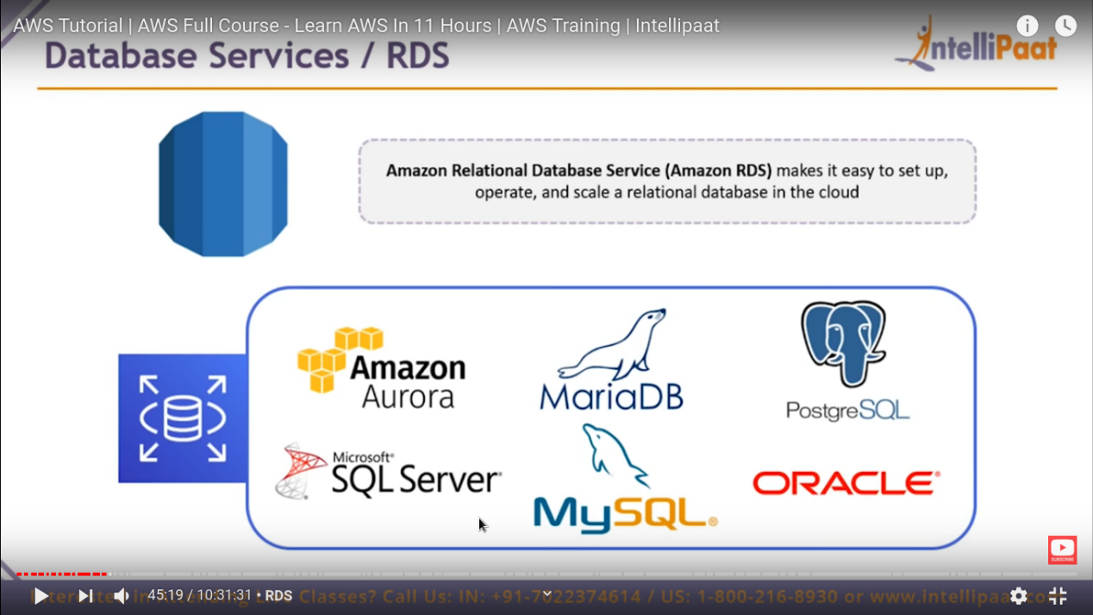

These are 6 database server that is provided by AWS.

Storage service (S3) :-

This is just like “google drive” , this is most used service after EC2.

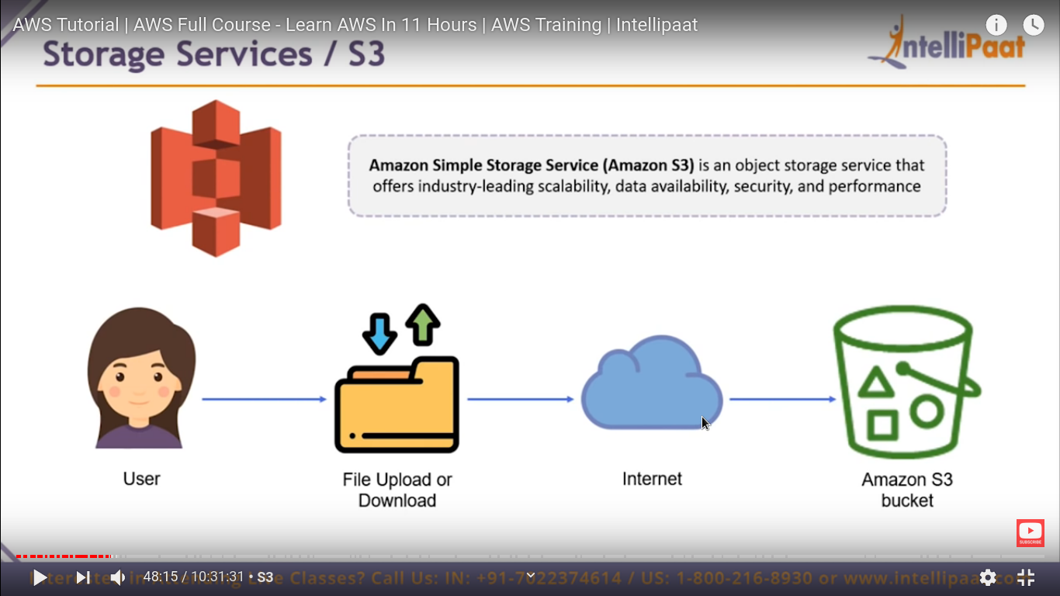

So it create “bucket” which is just like a folder .

This service is “CLOUD Front” this is actually a “networking service”.

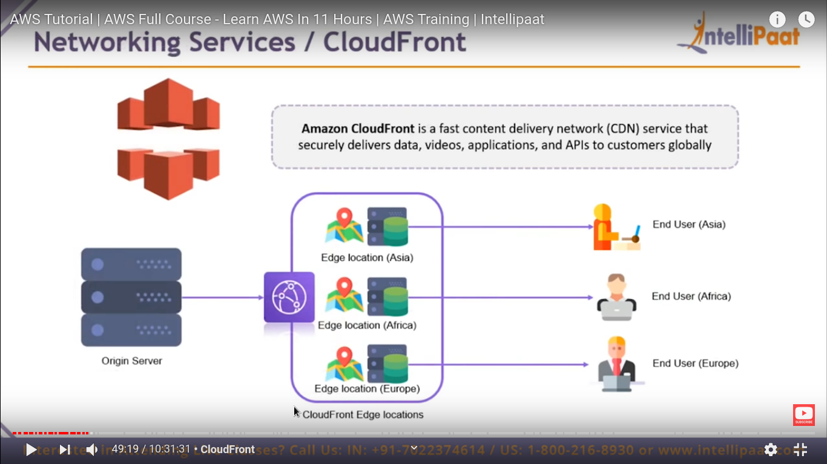

Amazon cloud Front is **CDN** content Delivery network.

Basically, CDN is a service by which we can securely and fast delivery of content like docs, image, video etc. And API to costumer globally.

**Security Service / AMI :-**

