# Application on pointers in c

1. Actual and Formal argument.
2. When we call the function in the bracket is called actual argument.(a and b)
3. When we define the function is called formal argument.(x and y)

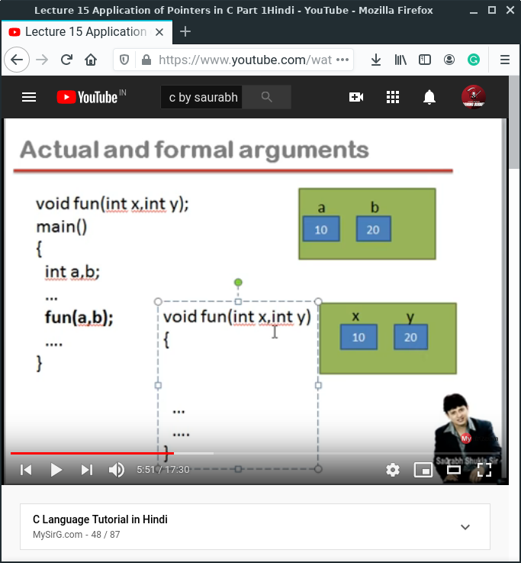

1. Write a function to swap two integers

When in any variable we take star (*) in the front so, the variable