# *Arrays in c language*

It is one Dimensional Arrays

1. Array is a linear collection of similar elements.
2. Array is also known as subscript variable.
3. Array is the group of variable.

Let we make the 10 number average program.

Note :- when we use for in the program so,we don’t use this (;)<we do not close the statement>

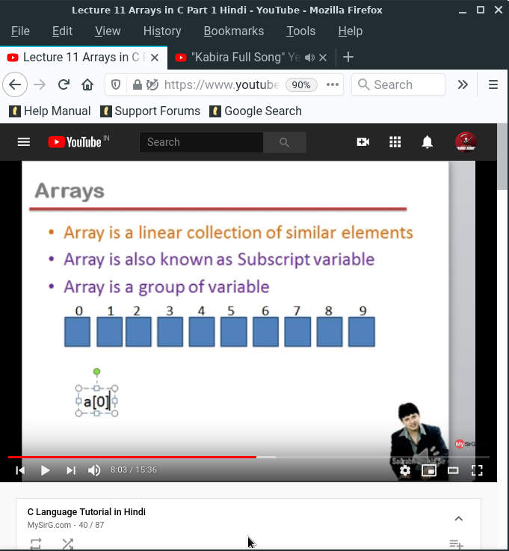

0,1,2----- is the counting of variable.

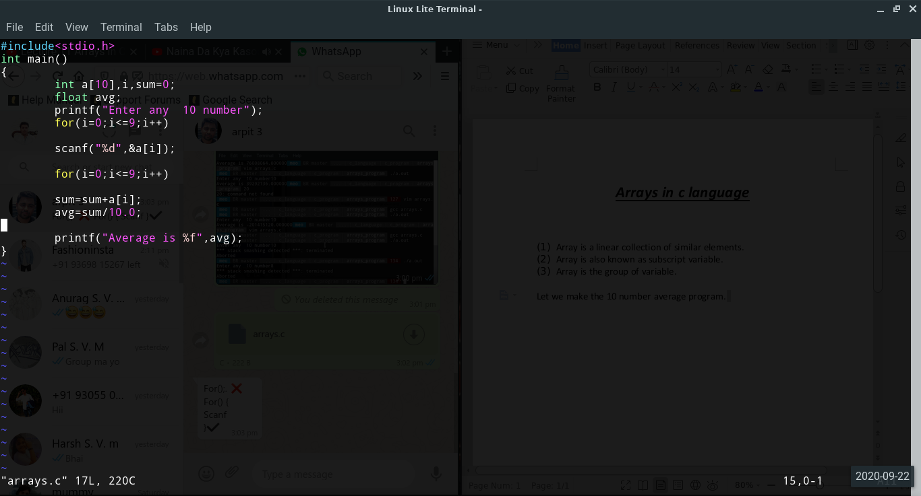

Program is also found in the arrays program folder.

Answer

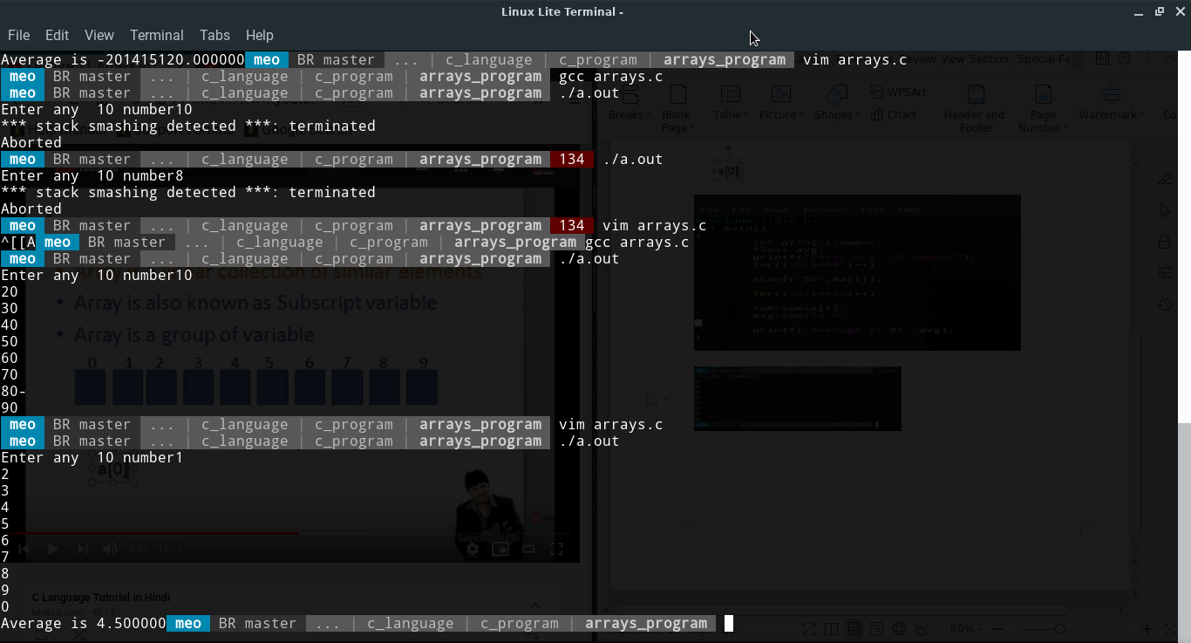

Note :-

1. we you use arrays function you need to fill the declaration, if you do not fill the declaration so,it is error.

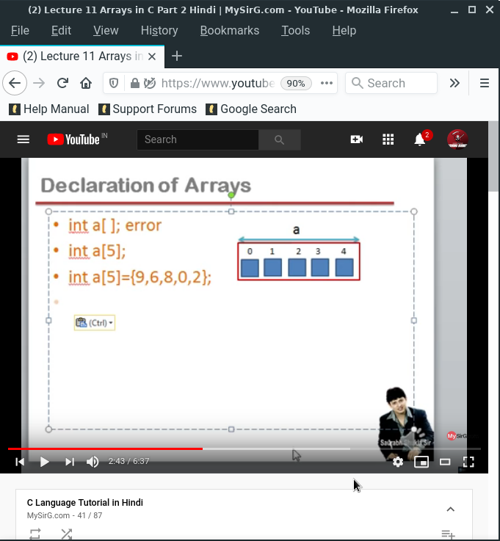

1. When you declare the number the set in the series
2. Sapose you declare more number the the compile show error.
3. Sapose when you daclare less number the compile aromatically set 0 is the other blocks memory.

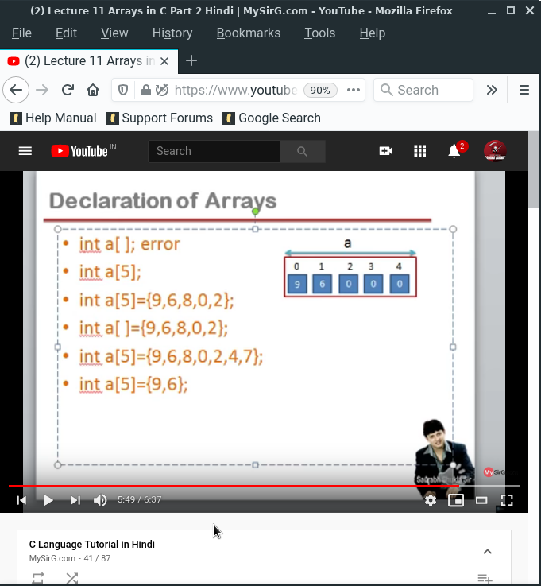

It is two Dimensional Arrays :-

It is has a two blocks and both are similar

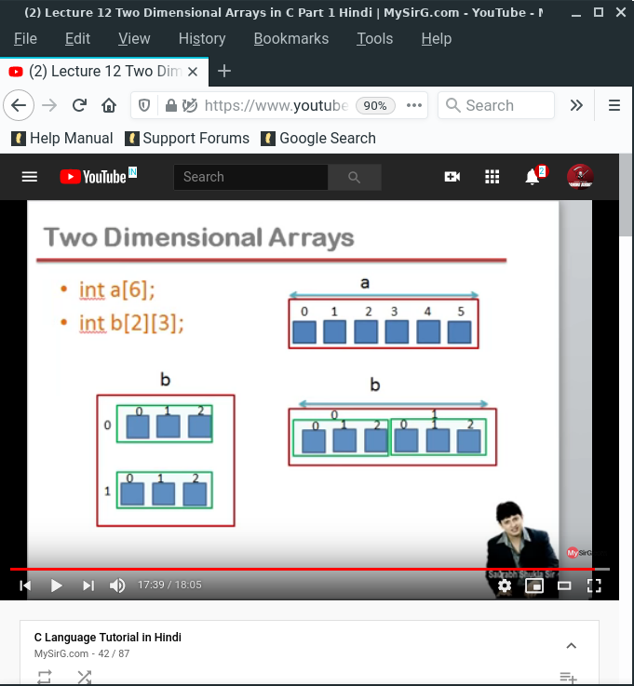

When to use array in programming :-

1. If the data use in real word so we can use arrays to make easy.
2. When the data in the real word and the data has two dimensional so,we can use two dimensional arrays.
3. Sapose we have a two subject < class, student >so, we can use two dimensional arrays.

