# ***C language part 3 (Control)***

1. What is control and control instruction types :-

=> The control is control the instruction line by line. Instruction is control by processor.

=> There are 4 type of control instruction :-

1. Decision control instruction.
2. Iterative control instruction.
3. Switch case control instruction.
4. Goto control instruction.

1. Decision control instruction:-
2. If :-

We can control the instruction that the line is working or not, we control it :-

We also make program and the is also found in the control folder his name is if_decision_control :-

1. (ans)

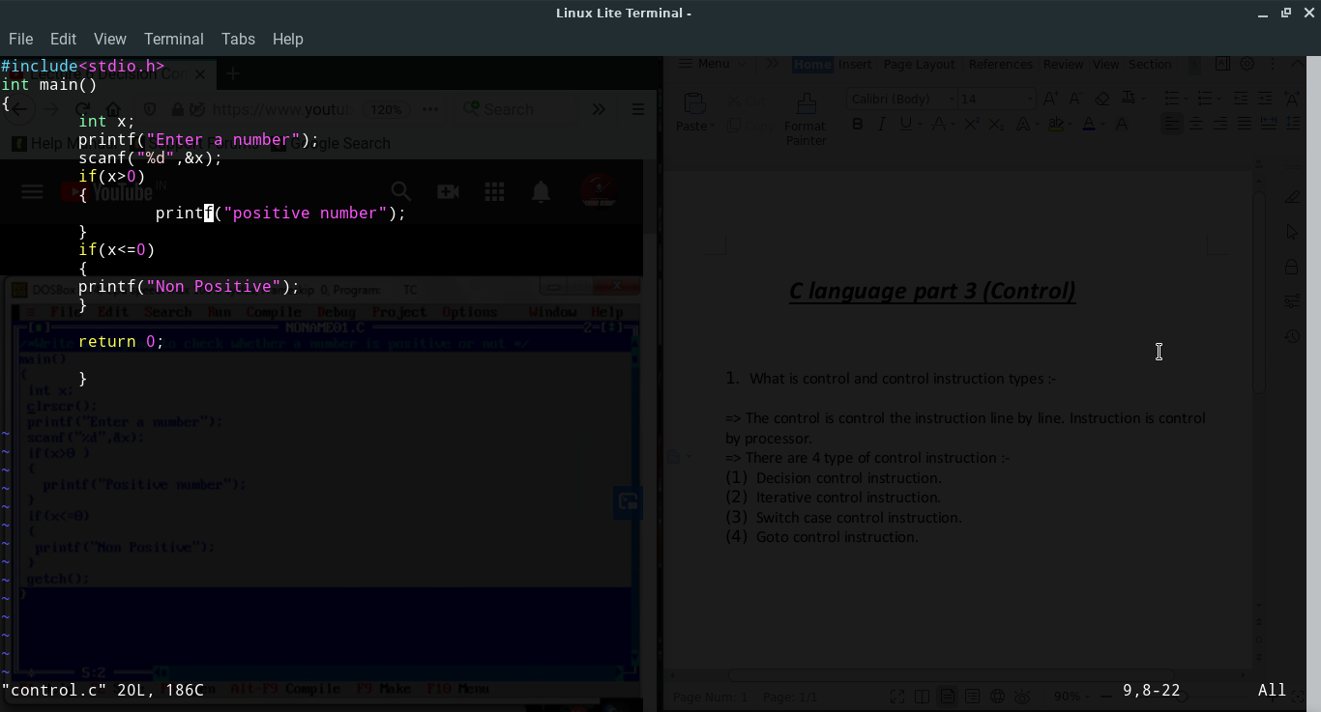 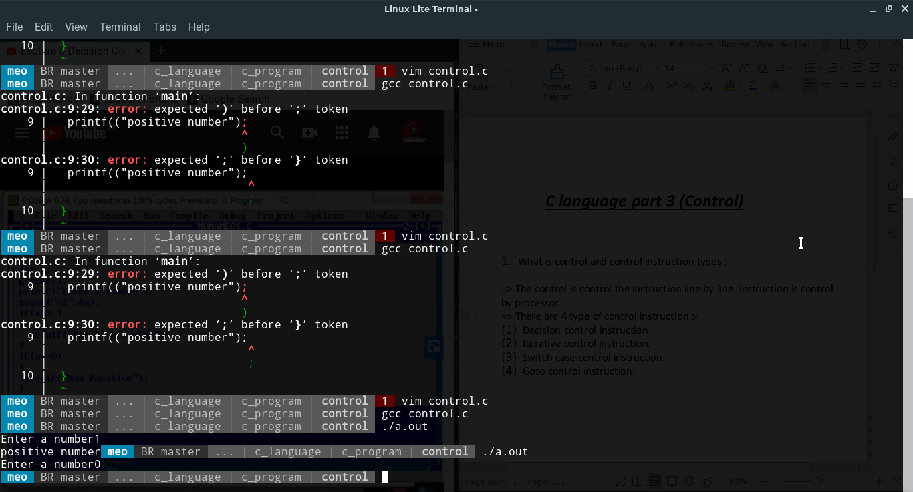

1. If else :-

If else is the almost similarly to if instruction. In if instruction use 6 instruction but in if else instruction use 5 instruction in the program.

We also make a program in blow and the program is also found in the folder :-

1. (ans)

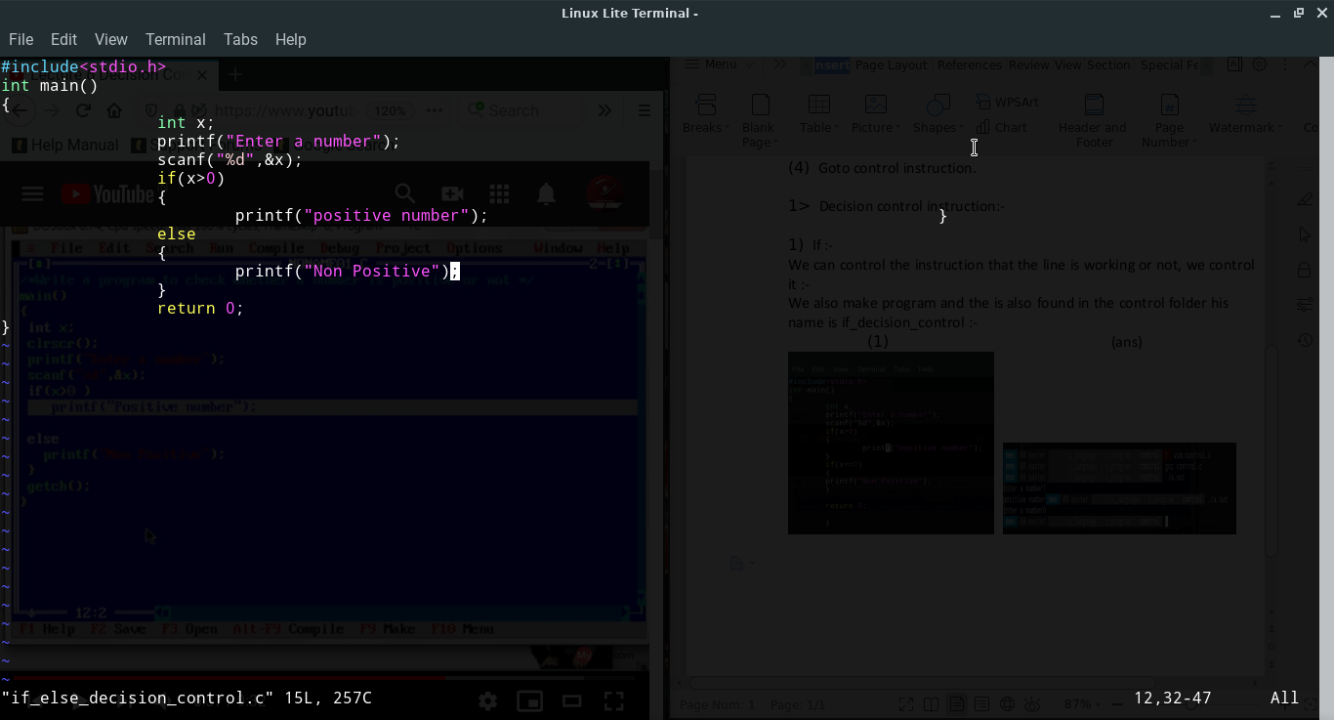 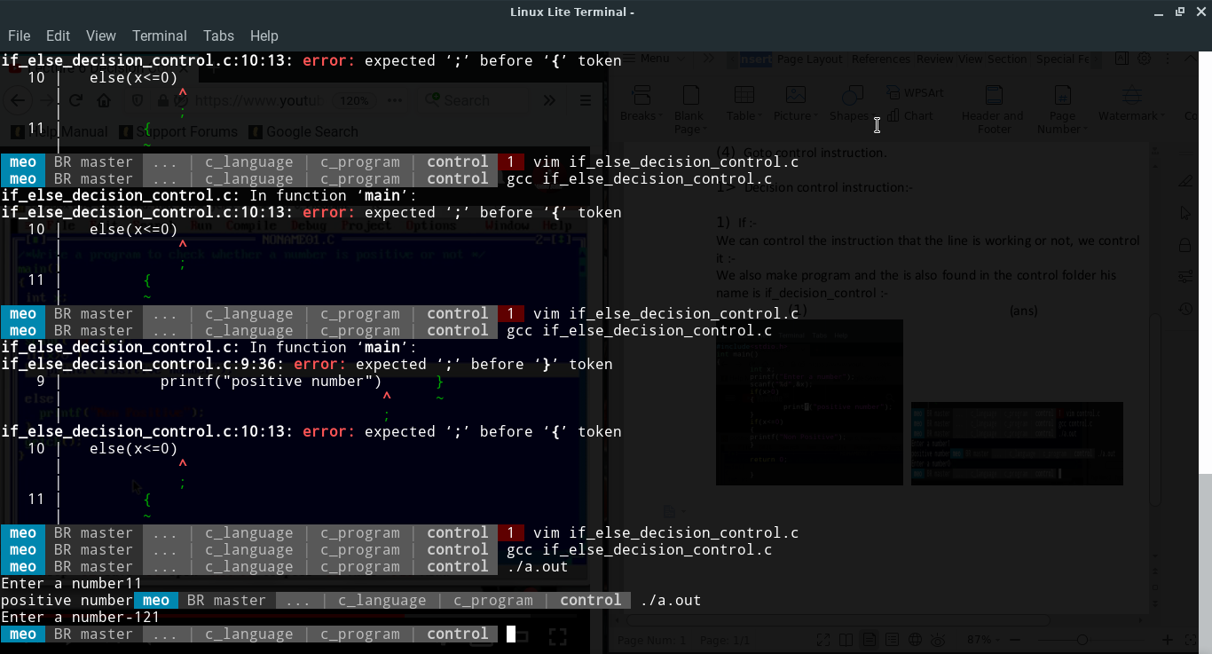

1. Condition operator(ternary operator)<?:> :-

=> condition operator is also know as ternary operator. It is need 3 operator to operate the instruction. It is similarly working if else instruction.

We also make a program in blow and the program is also found in the folder :-

1. (ans)

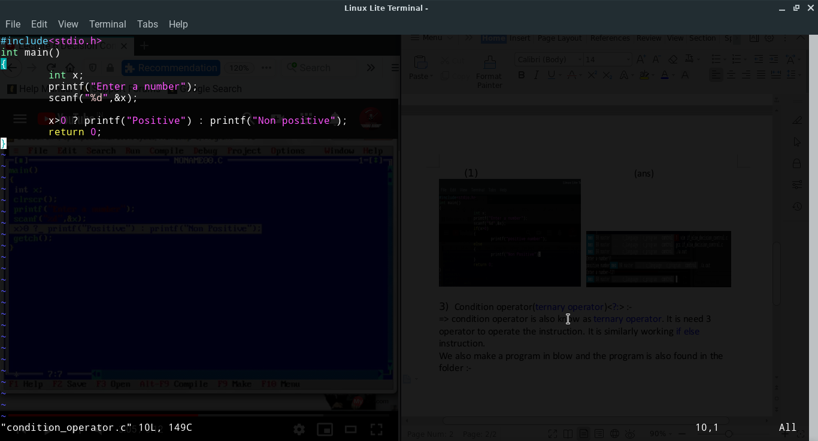 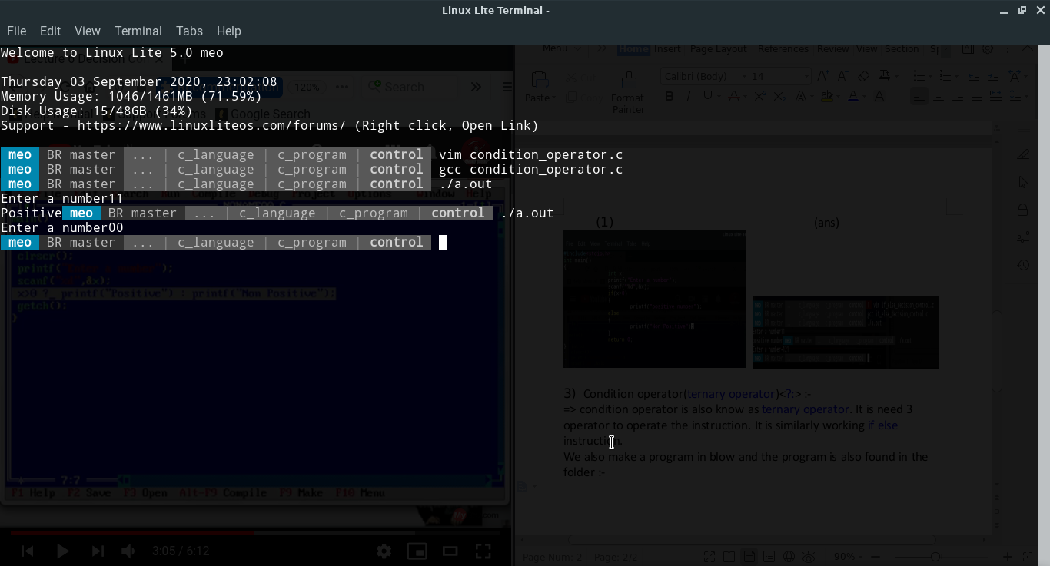

Selective Assignment (x=a>b ? a:b;):-

1. (ans)

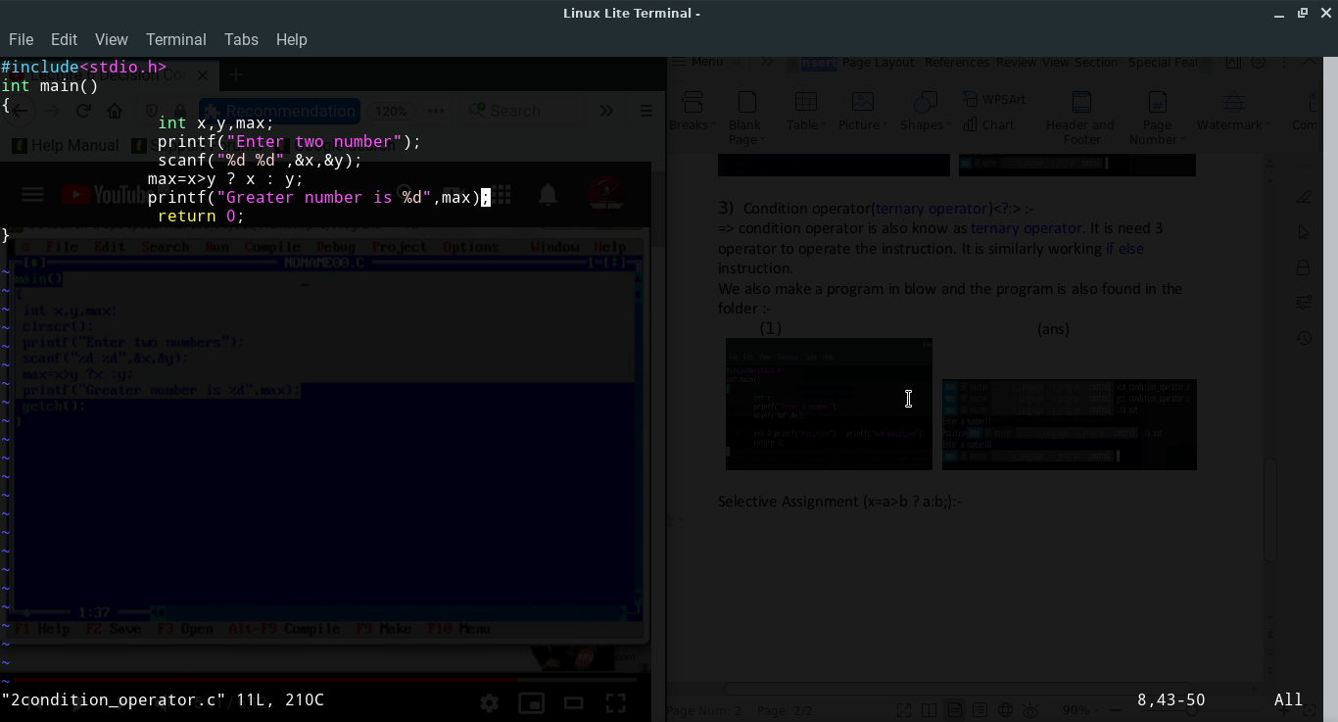 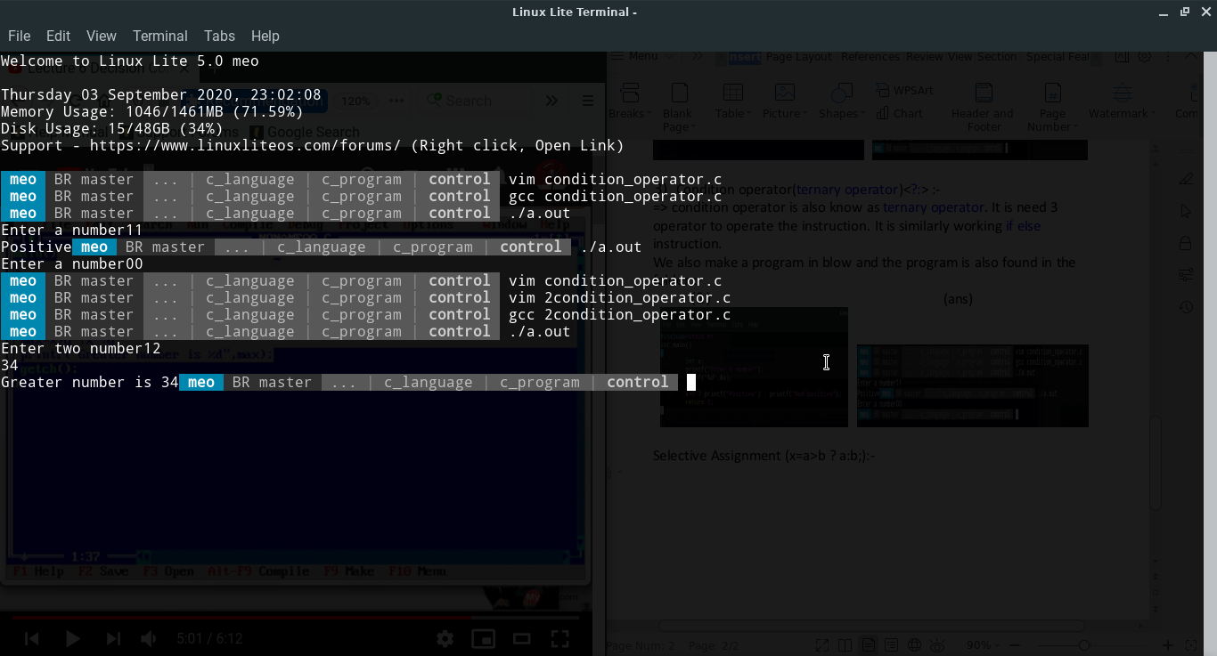

1. Nested if else:-
2. Without nested

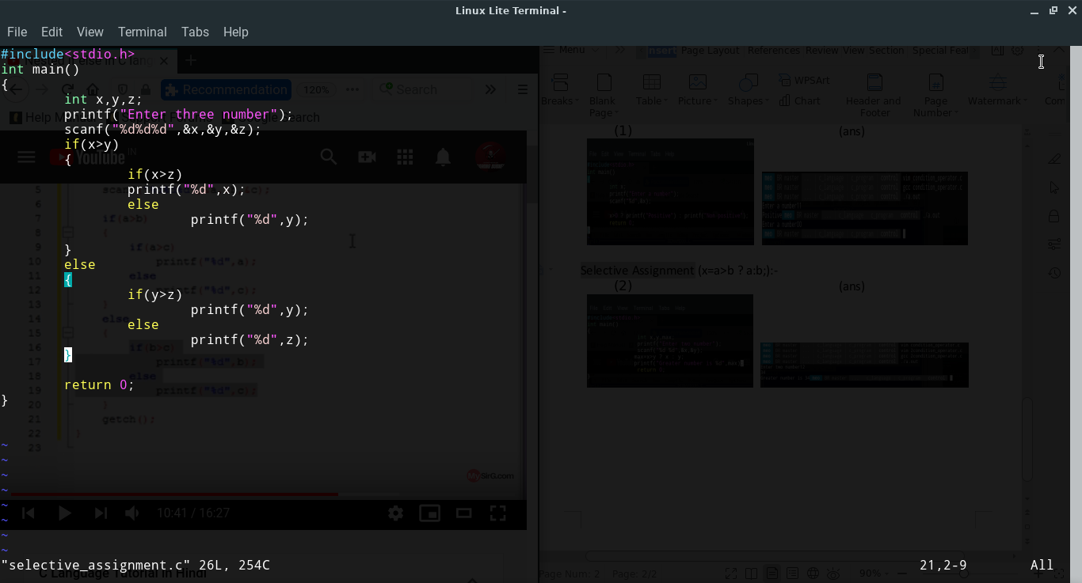

(ans)

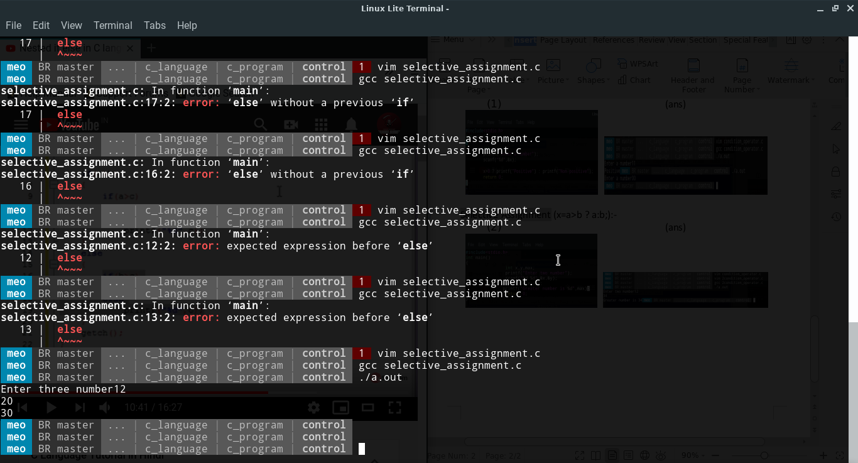

Nested (imp)

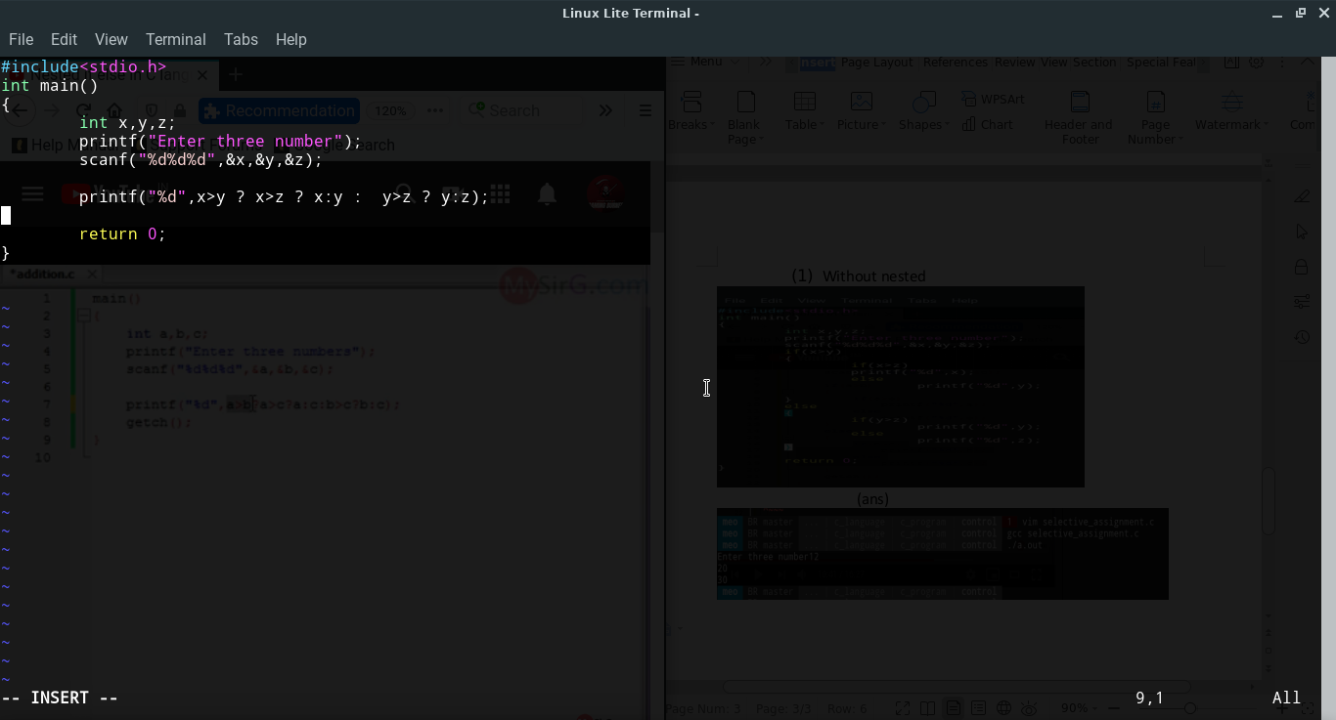

(ans)

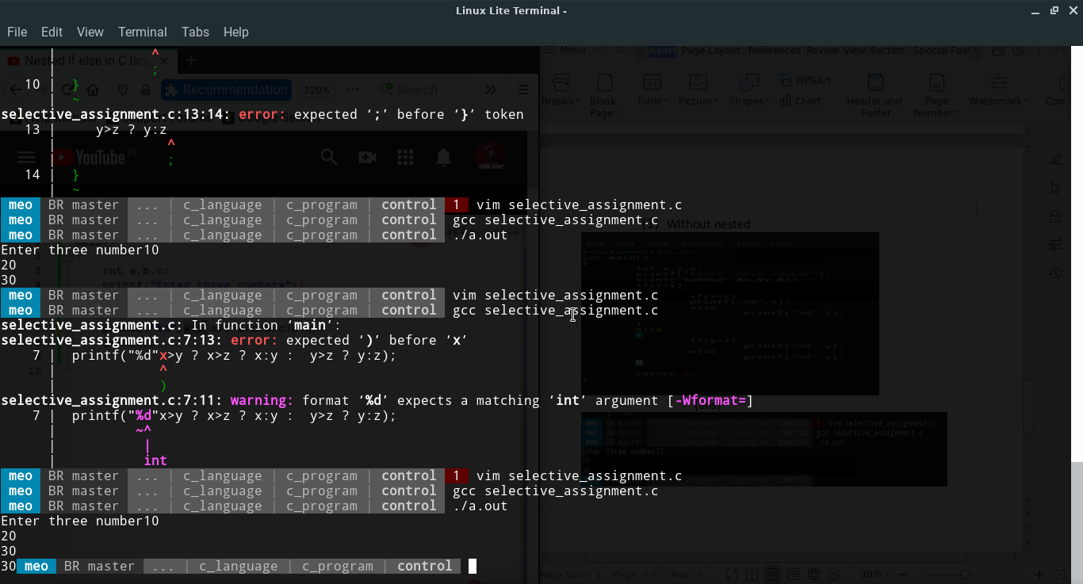

1. If else ladder :-

=> It is similarly working like nesting.

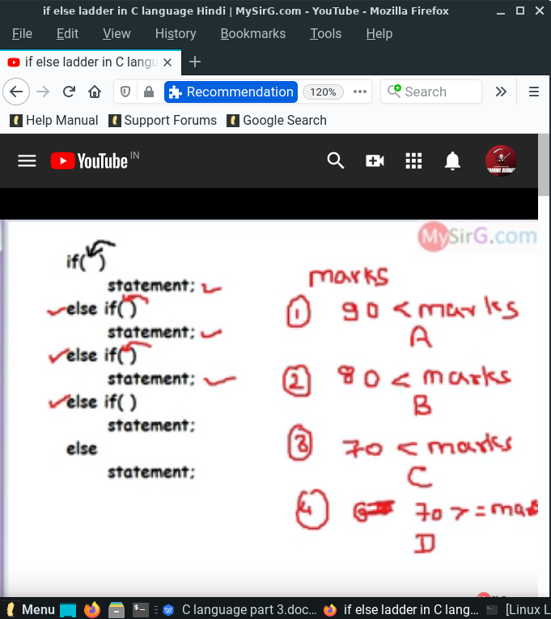

(program)

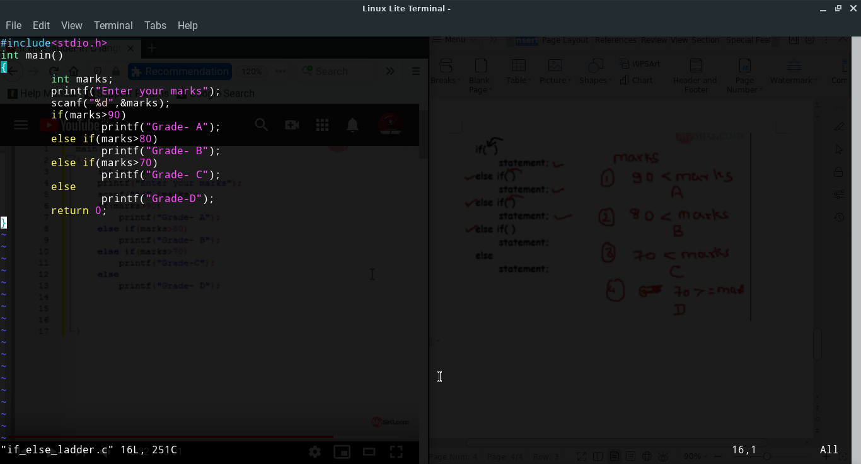

(ans)

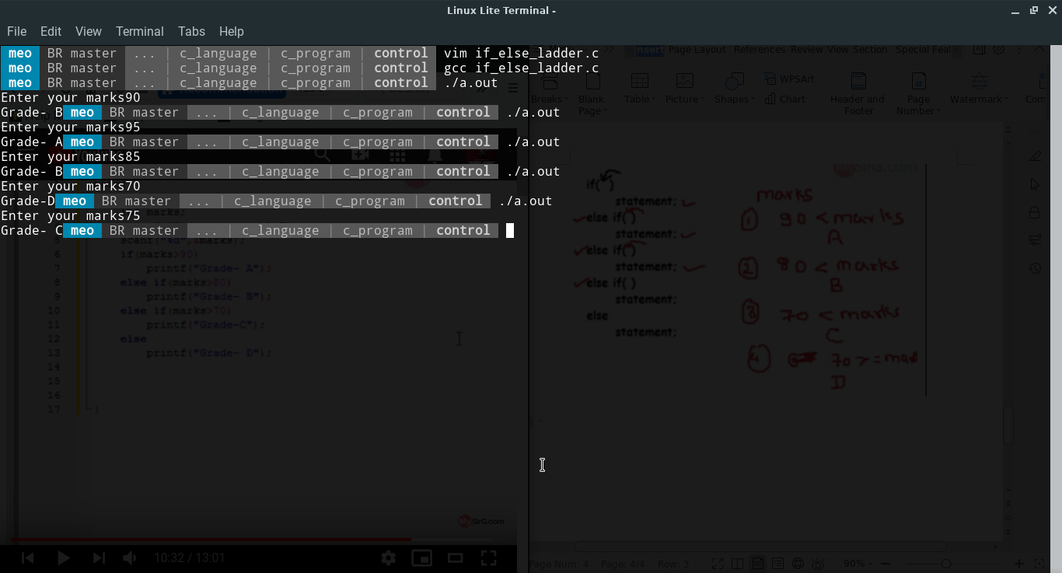

1. Iterative control instruction :-

=> Iterative control instruction is also know as loops.

There are 3 type of Iterative control instruction :-

1. While
2. Do while
3. For
4. While is use to repeat <any time >the program like printf(); , so you use there command and 6 times condition check in while and the program is found in control folder.it is also know enter control room.

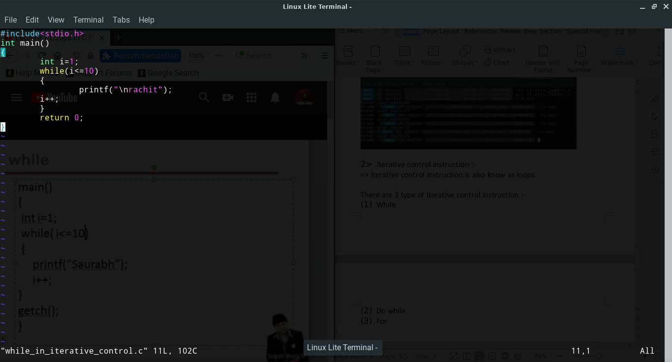

(ans)

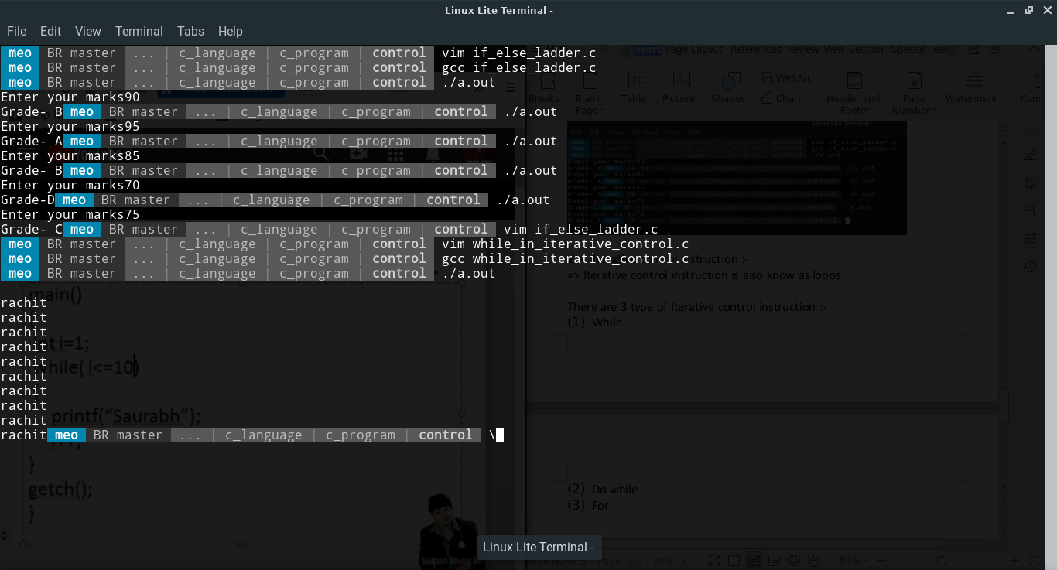

1. Do while :-

Do while is almost similarly while loops, only one differed in while the condition check 6 time but in do while the condition is check 5 times. It is also know as exit control room.

(program)

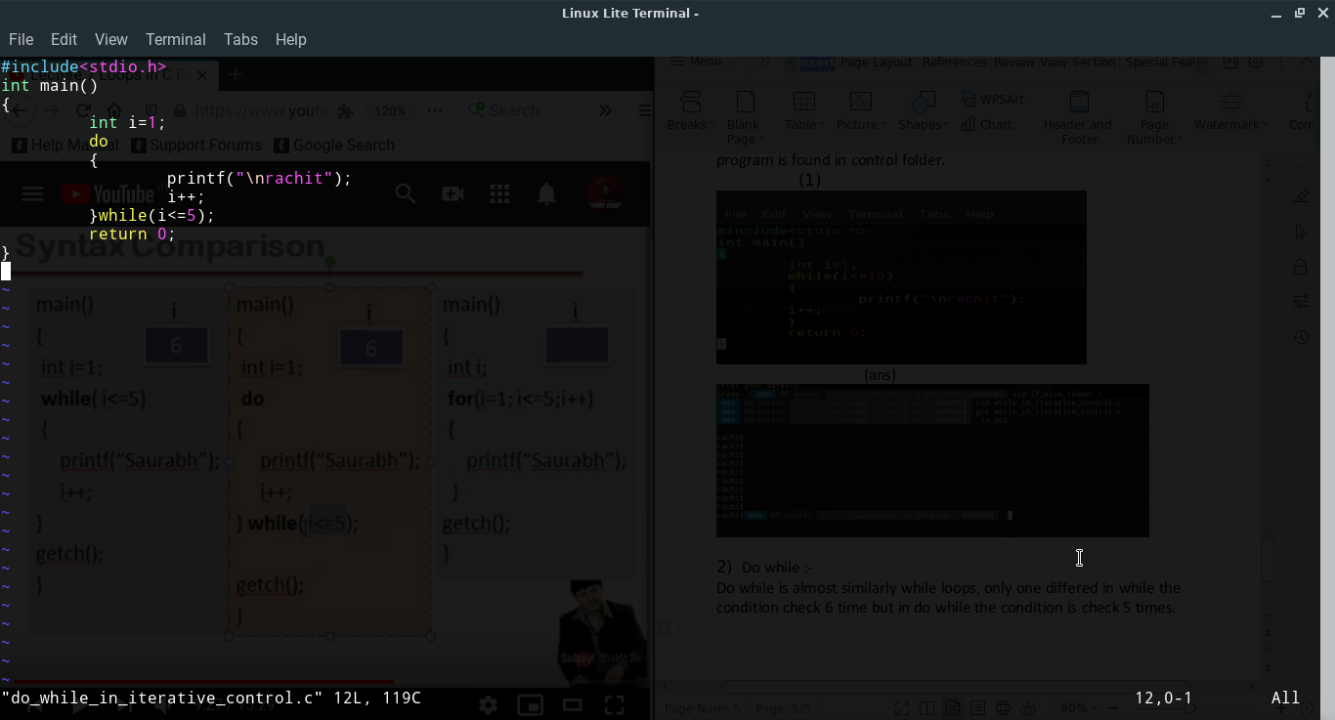

(ans)

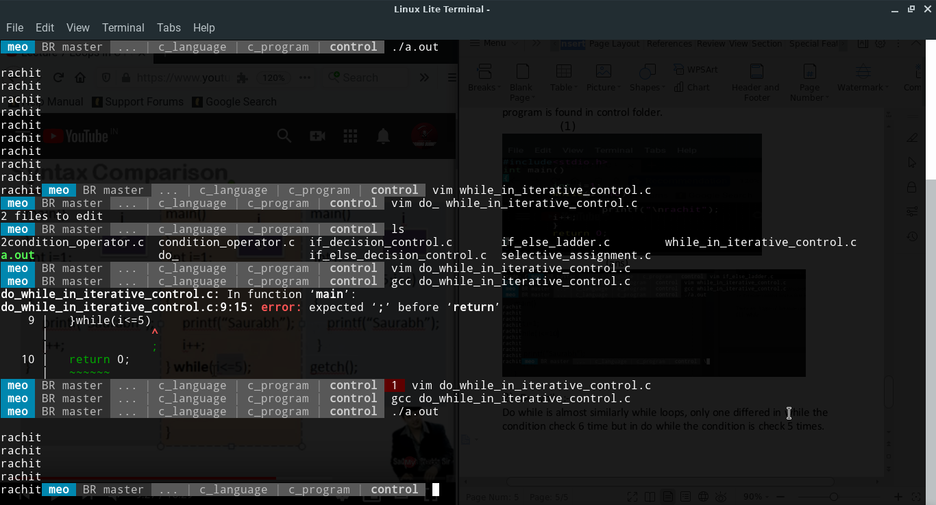

1. For:-

=> For is using professional. For is almost similar to while and do while loops. Only one defines initialization and condition lying in same line. It is easy to understand. Program is also found in control folder his name for_in_iterative_control.c .

(program)

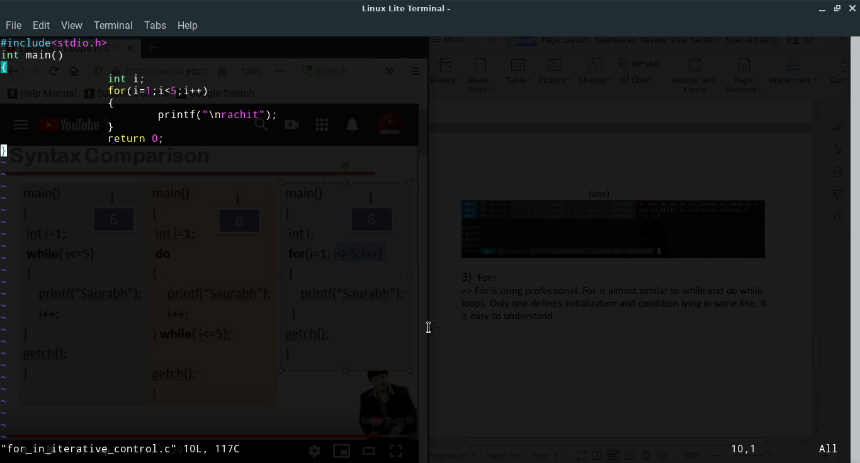

(ans)

