# *Function in c*

1. What is function?
2. Piece of code to accomplish certain operation.
3. It has a name for identification.
4. They are of two types :-
5. Predefined functions
6. User defined functions

What is the mean of piece of code :-

If want to my code is run many time but you also want any other code is also run in program, so you can create name of in code and when you want to run any code when you enter code name and then you see that your is run.

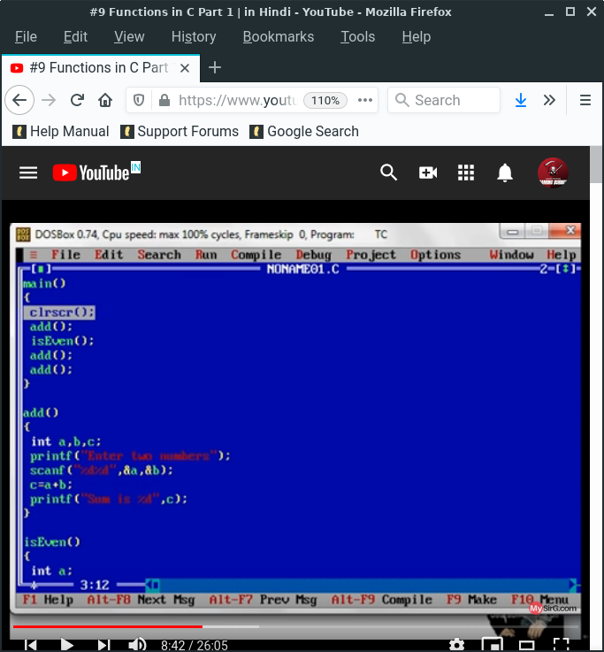 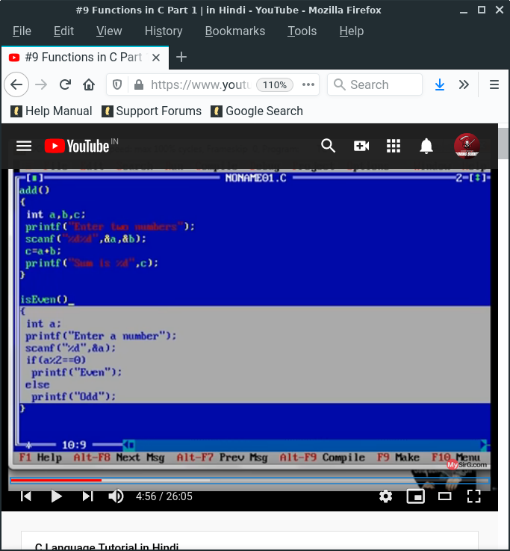

1. Technical terms :-
2. Function Definition
3. Function declaration(Function Prototype)
4. Function call

Function definition :- suppose you want to write a code and take it name but you do not call it.

 that is definition.

Function declaration(Function Prototype) :- declaration statement is made by compiler to understand the new word.

Function call :- A function call is an expression that passes control and arguments (if any) to a function.

 that is call.

When function is call then some memory is store in ram. When function doing all work and then memory is release in the ram. It is also helpful for utilize memory.

***Remember***

1. Program mush have at least one function.
2. Function name mush be unique.
3. Function is an operation, once defined can be used many time.
4. One function in the program mush be main
5. Function consumes memory only when it is invoked and released from Ram as soon as it finishes its job.

***Benefits of function***

1. Modularization
2. Easy to read
3. Easy to debug
4. Easy to modify
5. Avoids rewriting of same code over and over
6. Better memory utilization

***Ways to define a function***

(all program in also found in function folder)

1. Takes nothing, return nothing <file name function.c>
2. Take something, returns nothing < 2define_function.c >
3. Takes nothing, returns something
4. Takes something, return something
5. (answer)

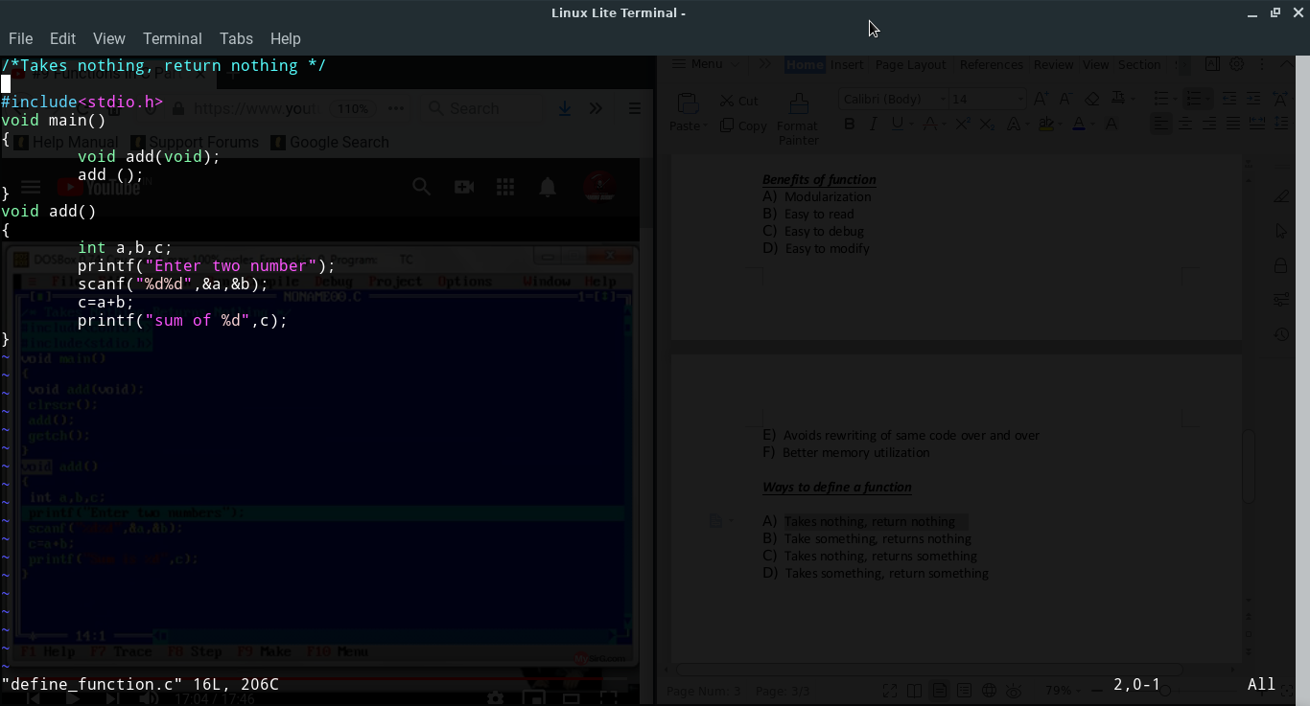 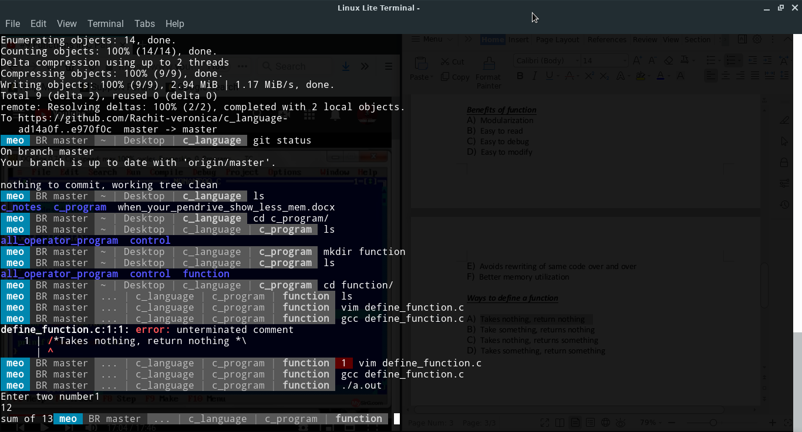

***What is void***

=> Void is the return type. If you don’t have any return, so you can you void type.

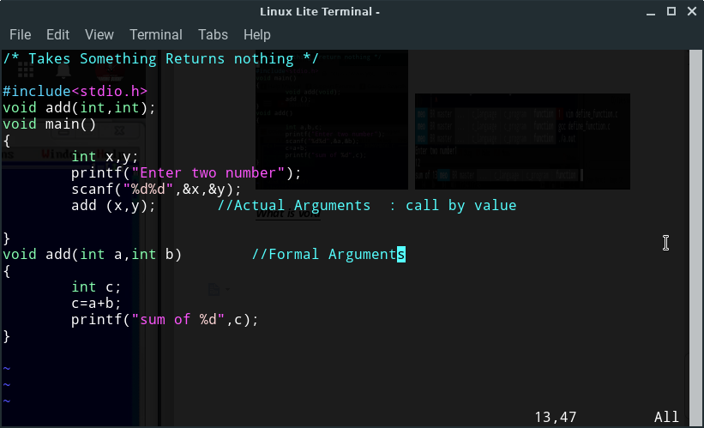

(answer)

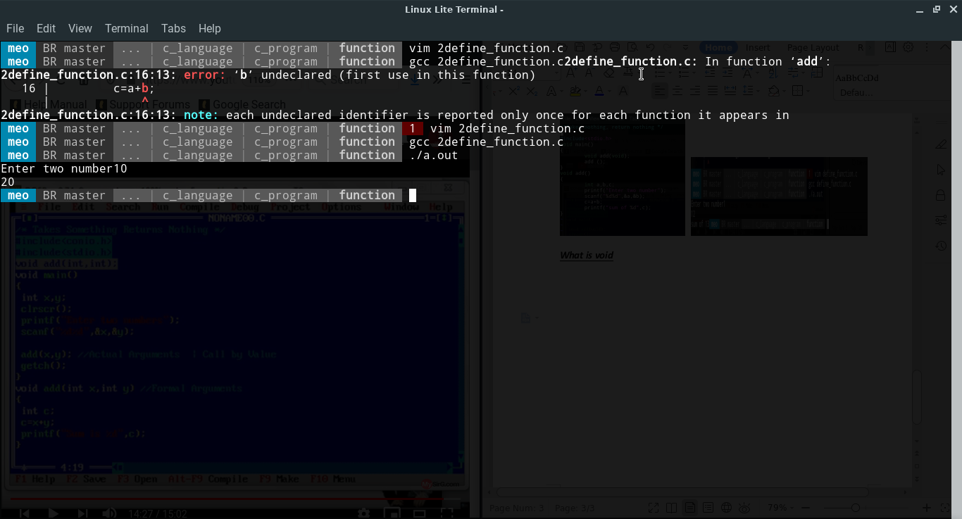

(c)

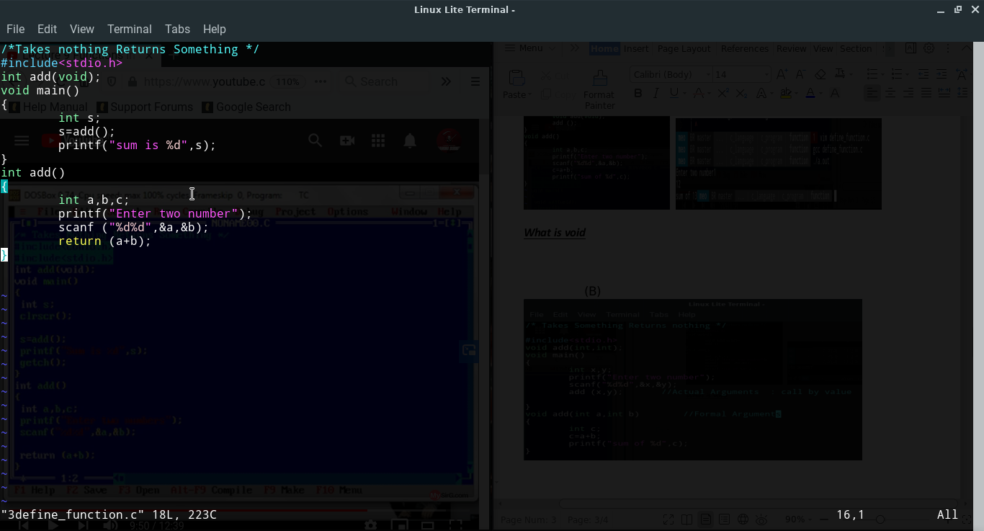

(Answer)

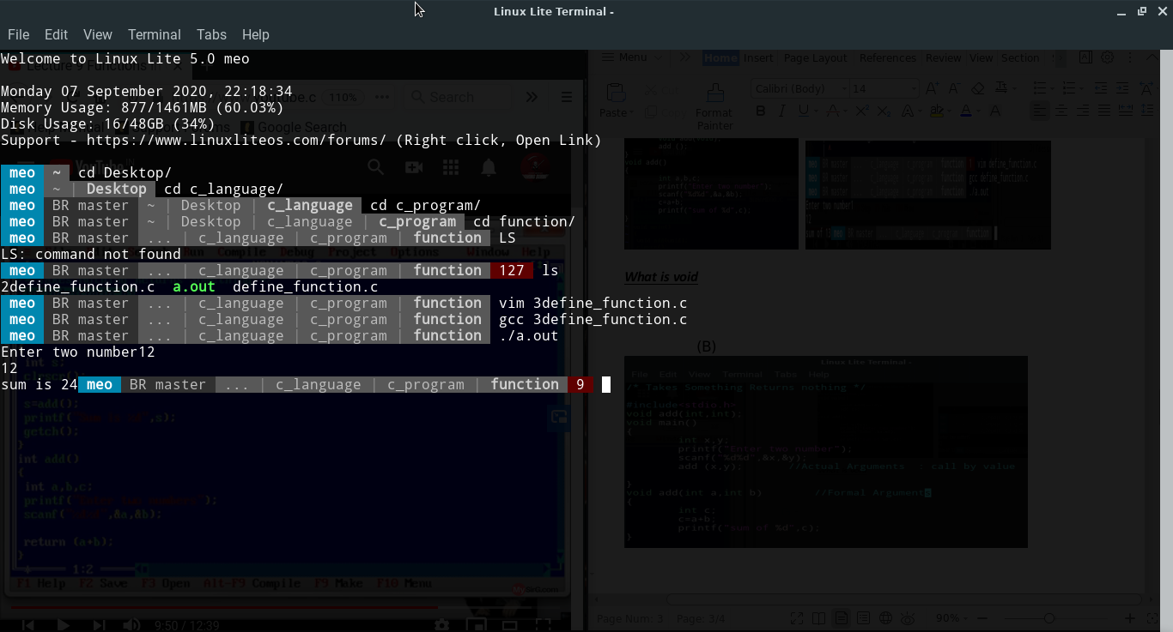

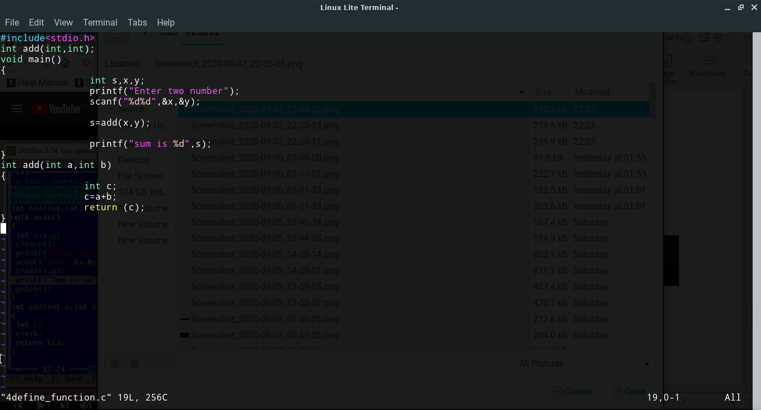

(Answer)

