# *Pointers in c*

Noter

Pointer is type.

1. Pointer basics
2. Pointer’s arithmetic
3. Application of pointers
4. Pointer basics :-

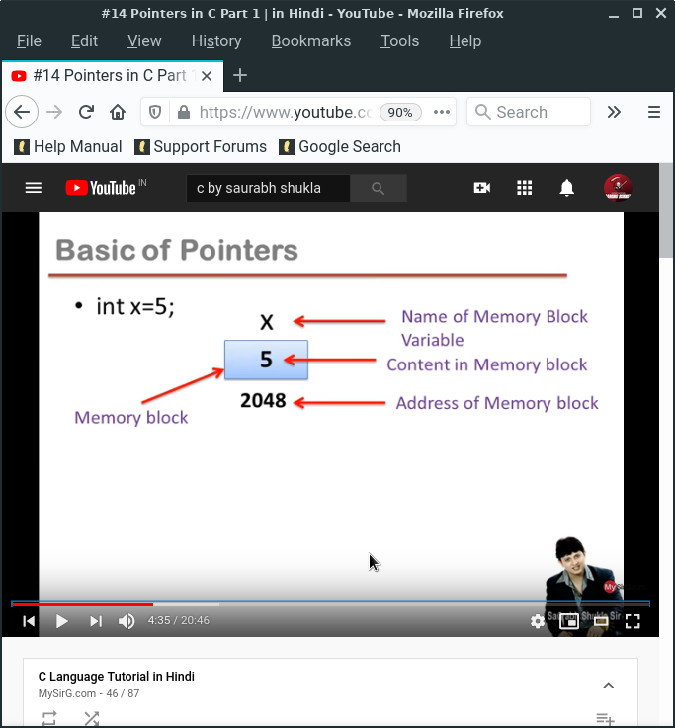

There are three main point. it is very necessary to run the program

1. In the program the location store in your disk that like memory block.(blue box)
2. Spouse we wright the name of the program name of memory block variable (x).
3. We also want some data store in the program that we called content in memory block(5).
4. We also necessary have a address that your data store in your disk we also know as address of memory block.we always first bit name will be give 0 to start and so on. Always program address given in those address 0 to 65535.

We also make a program to find the address but in this program we take input to the user.

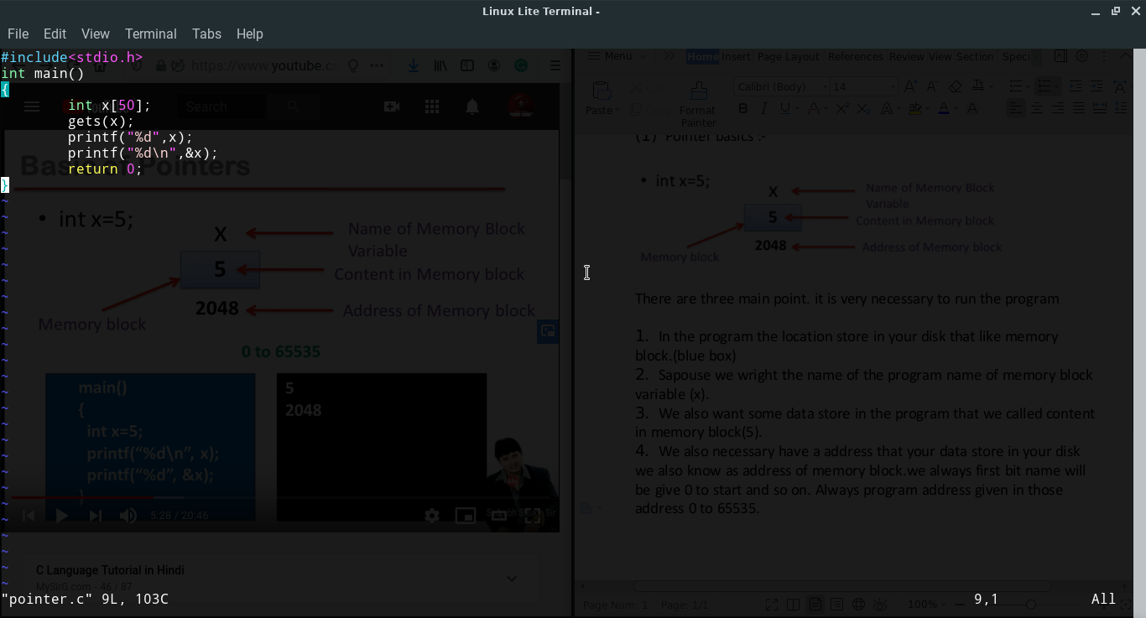

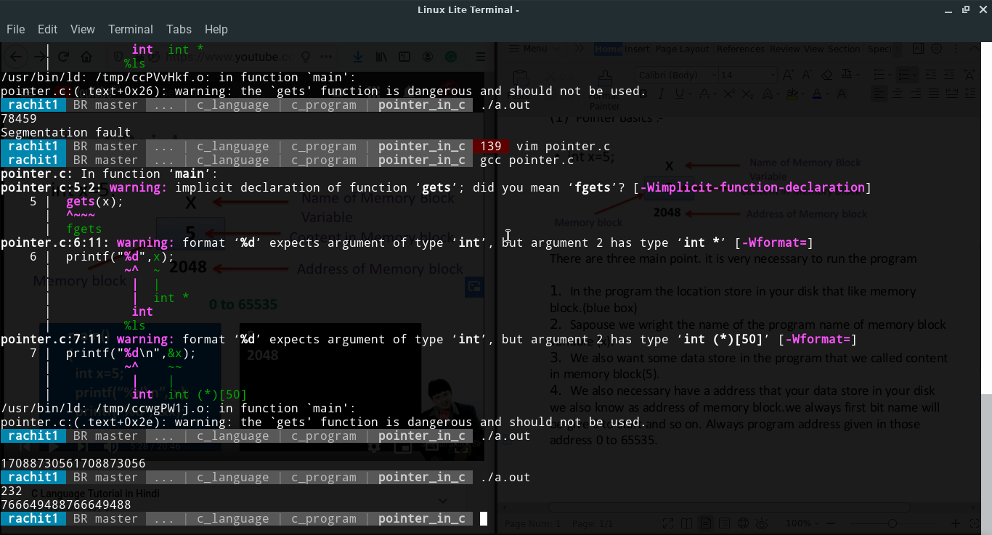

1. & is know as address of operator.
2. it is an unary operator.
3. Operator give address number of variable.
4. & operator gives address number of variable.
5. & is also known as referencing operator.

***Indirection operator***

1. * is indirection operator.
2. It is also known as dereference operator.
3. It is an unary operator.
4. It takes address as an argument.
5. * returns the content/container whose address is it argument.

***Note***

&x=7

1. We cannot store anything in &x as &x is ***not a variable*** it is the way to represent address of block x.
2. We use * symbol to show the address. (int *j, x=5);
3. We can store address in another variable.
4. But j has to the declared before use.

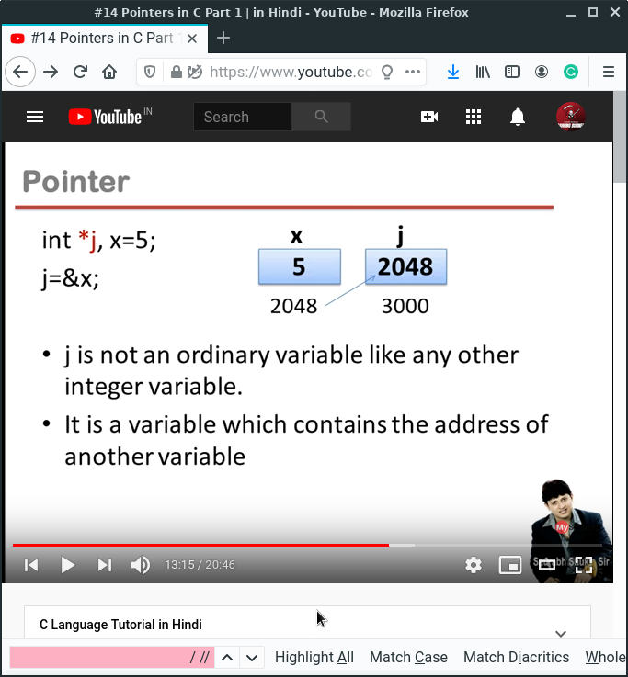

***Pointer***

1. Pointer is a variable that contain address of another variable.
2. Pointer always consumes 2 bytes in memory in dos base architecture.

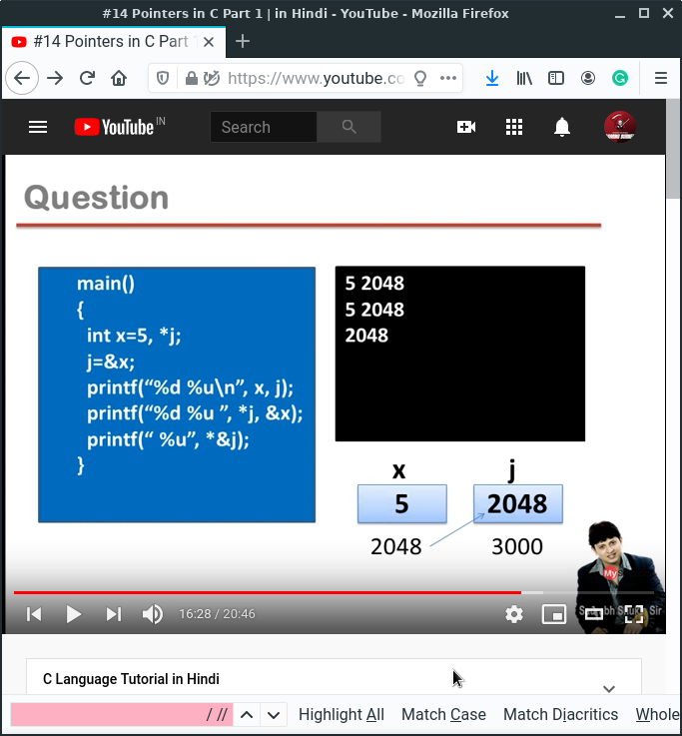

***Base address***

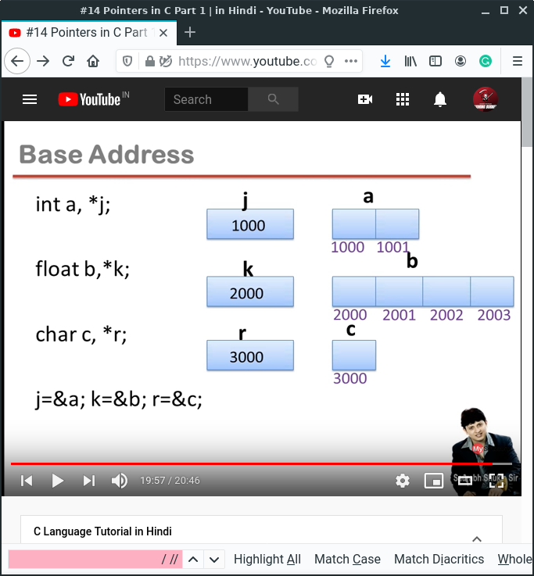

Pointer only contain value which you make data type.

***Extended concept of pointers***

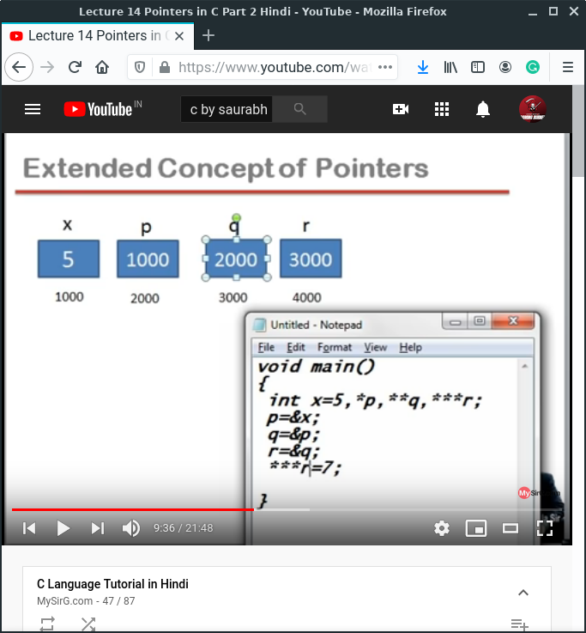

I also make the program to learn more. This program is also found in the c_program folder or gits also.

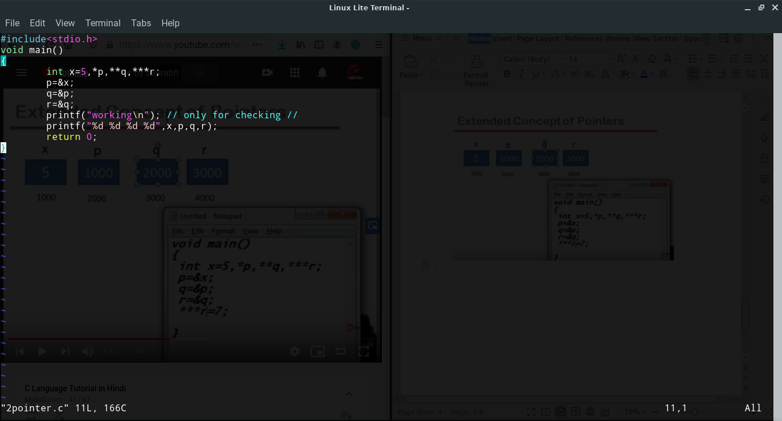

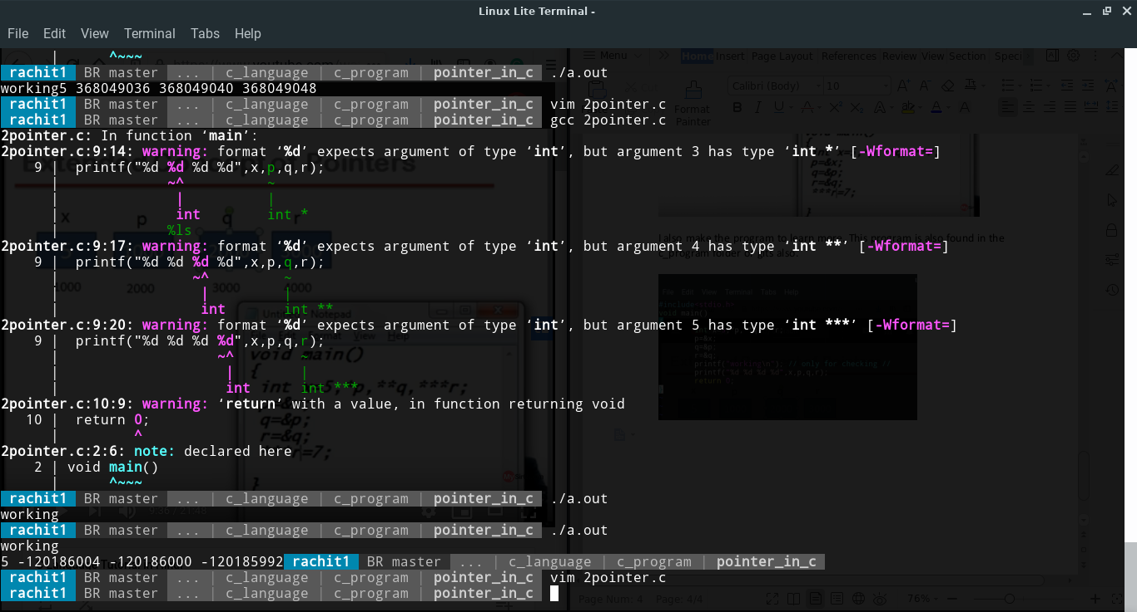

***Pointer’s arithmetic***

1. We cannot add,multiply or divide two address(subtraction is possible)
2. We cannot multiply an integer to an address and similarly we cannot divide an address with an integer value.
3. We can add or subtract integer to/from an address.
4. Pointer+n =pointer + sizeof(type of pointer)*n.
5. We can subtract two addresses of same type.
6. Pointer1-pointer2 = literal subtraction/sizeof(type of pointer)

Thank you count. In the next docx.