# *c language*

### My first program in c language (printf)

### We can use “Printf()” to print the any word and any numerical value in the screen.

***Note***:-

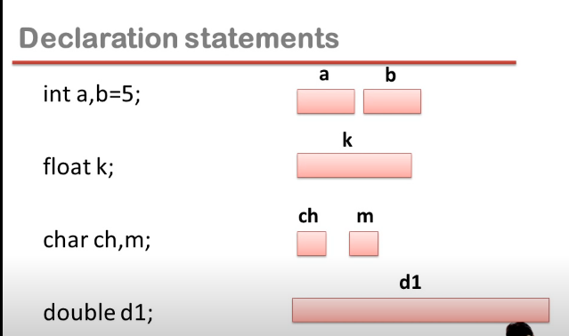

1. **Printf() is not a keyword.**

**Printf() is the predefined function.**

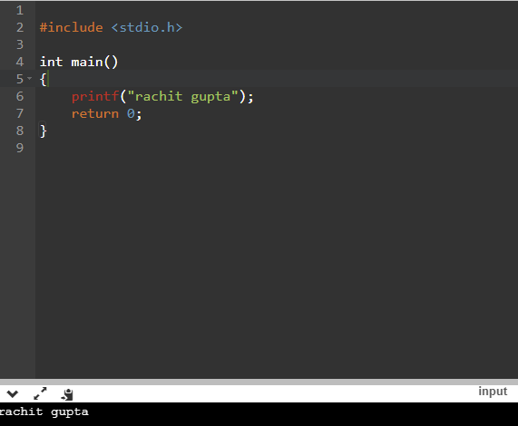

***We can print his name”rachit gupta”and you can see that his is print in the output.***

1. ***If we can print the name in the next line, so we can use the(\n).***

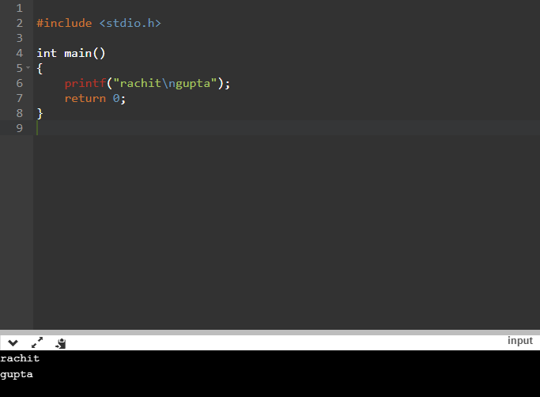

1. ***When you want to print your name without any space, so we can use (\t) but the one alphabet is cut.***

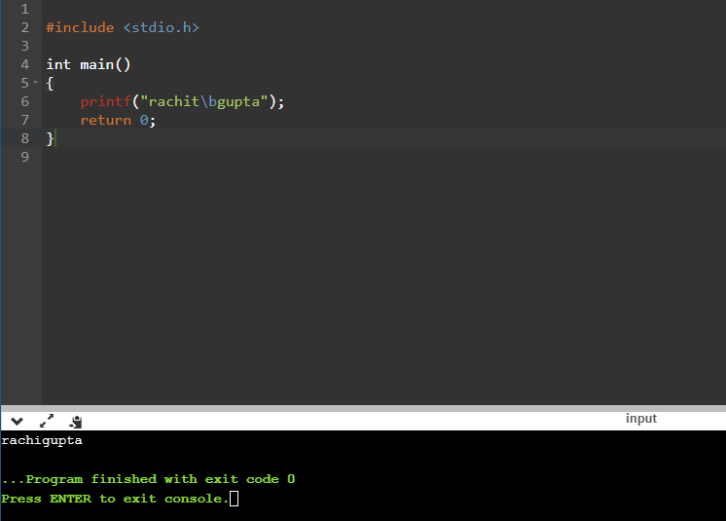

1. ***If you want your name come in the upon, so we can use (\\).***

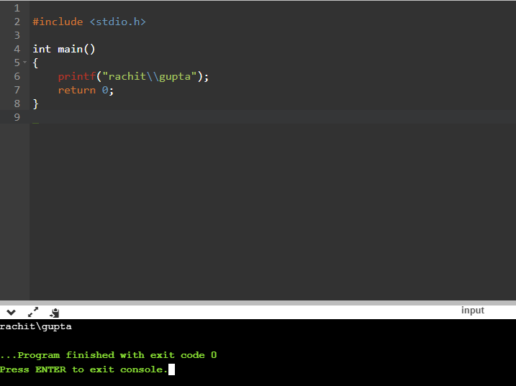

1. ***If you want your (“) is come between your full name, so we can use (\”).***

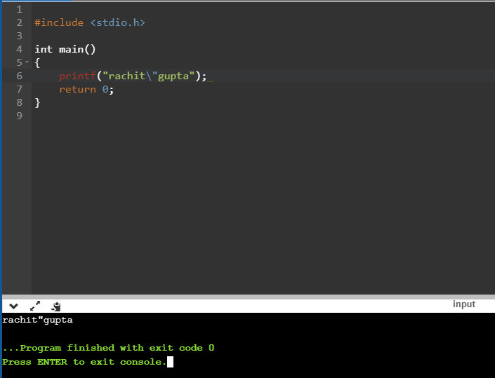

1. ***When you want your surname and your last name alphabet come in one word, so you can use (\r).***

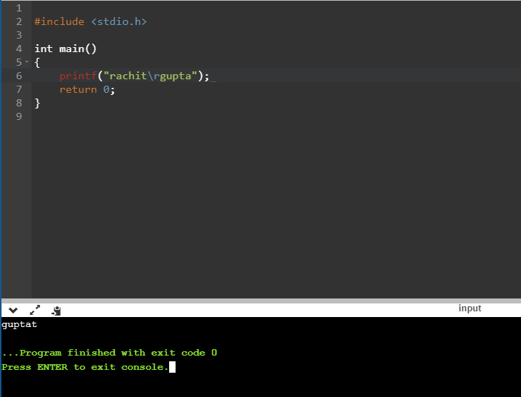

1. ***When you want to print the any value, so you can use this program.***

***$= #include <stdio.h>***

***$= Int main()***

***$= {***

***$= Int a=4,b=6;***

***$= Printf(“%d”,a);***

***$= Return 0;***

***$= }***

***Int Int***

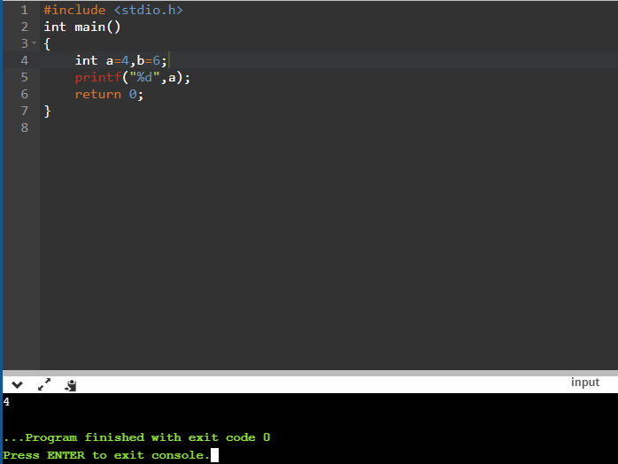 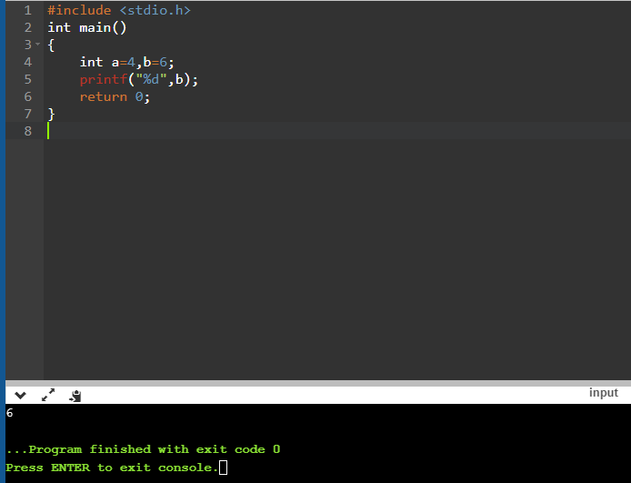

***We also use:-***

***%f => float***

***%c =>char***

***%if =>double***

***%d =>int***

***Float Double***

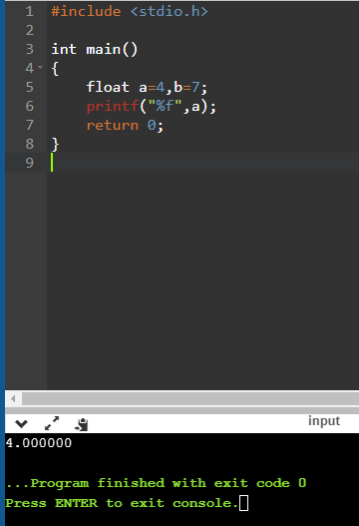 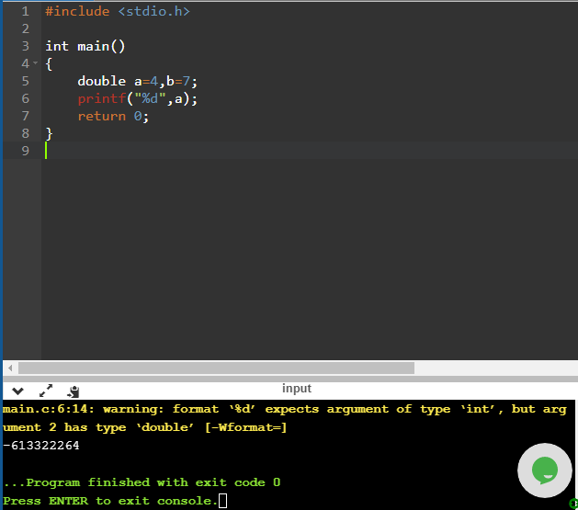

***Char***

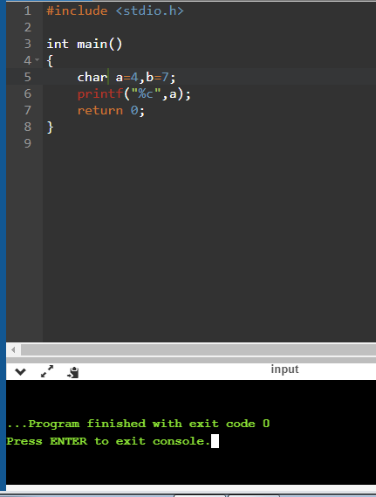

1. ***If I want to add any numerical number and you want to print it, so use this program.(sentence => sum of 4 and 7 is 11 )***

***$ #include <stdio.h>***

***$ int main***

***$ {***

***$ int a=4,b=7;***

***$ printf(“sum of %d and %d is %d”,a,b,a+b);***

***$ return 0;***

***$ }***

