# *Recursion in c (part 5)*

Recursion

1. Function calling itself is called Recursion
2. Each time the function call itself with a slightly simpler version of the original problem.
3. Recursion is the process of repeating items in a self-similar way.
4. The C programming language supports recursion, i.e., a function to call itself. But while using recursion, programmers need to be careful to define an exit condition from the function, otherwise it will go into an infinite loop.

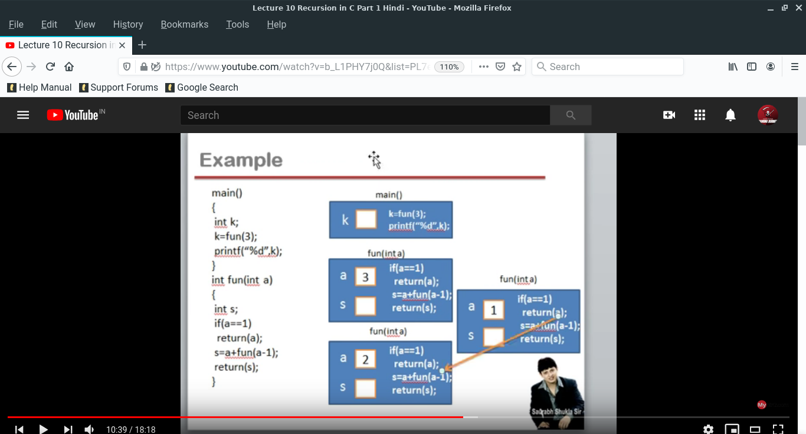

We also make program and the program is also found in the <program->recursion_program> folder.

(Program)

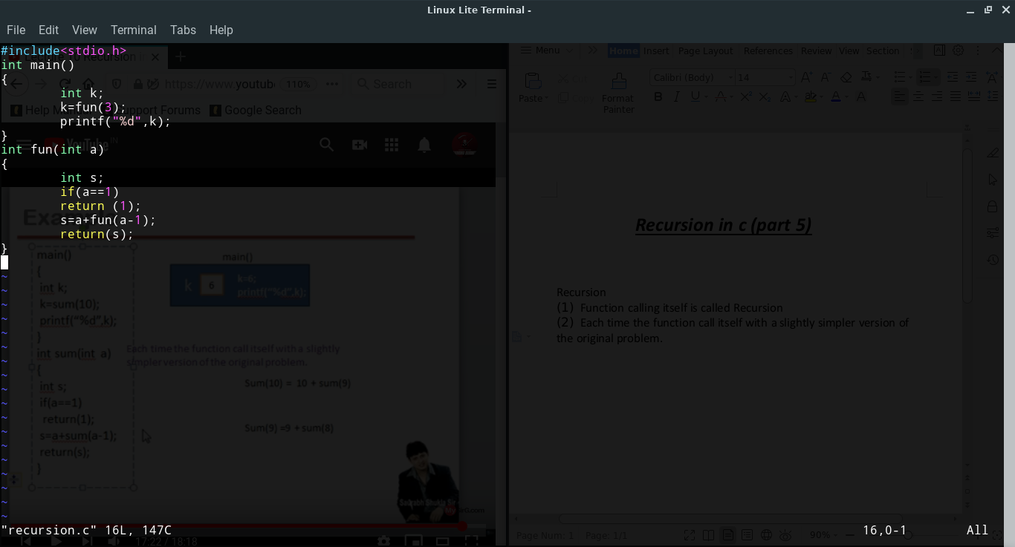

(Answer)

