# *String in c*

1. Sequence of characters terminated at null character.
2. ASCII code of null character is 0 (zero).
3. when we make arrays char type so, then we fill the value when the value fill in bracket and coma(,) but in the last characters we add null character(\0).

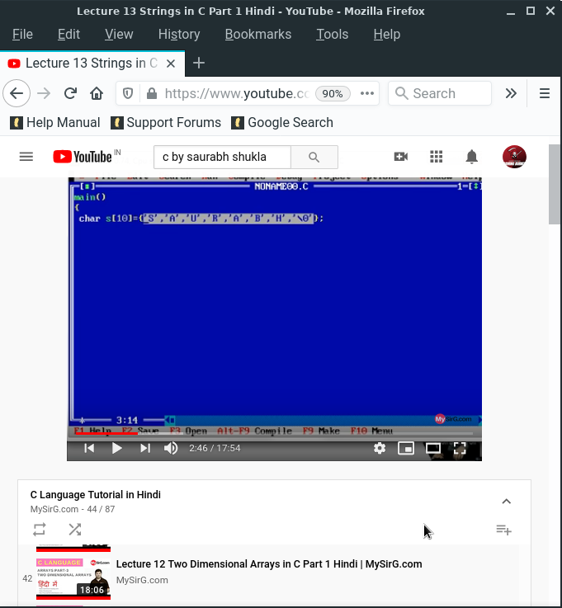

Note :-

1. If we don’t want to use printf() function so, we can use put() function to print the string and when you can use put() function then carers lying on the new line.
2. When we can using scanf() function only first word is print.

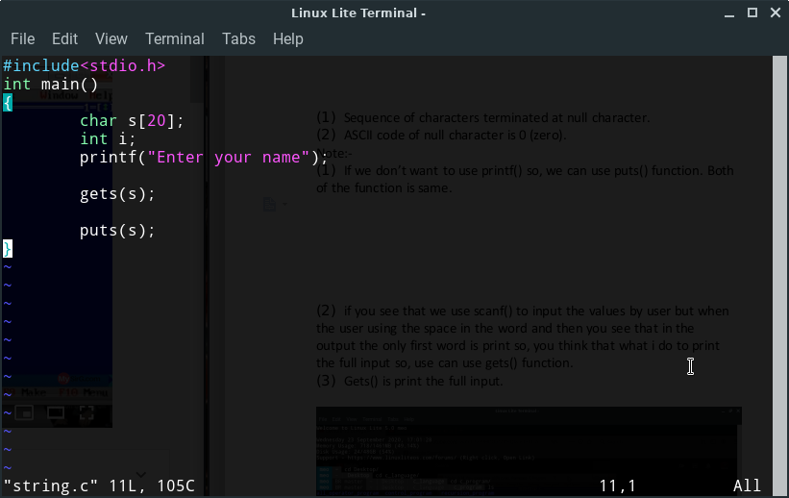

:- String related function :-

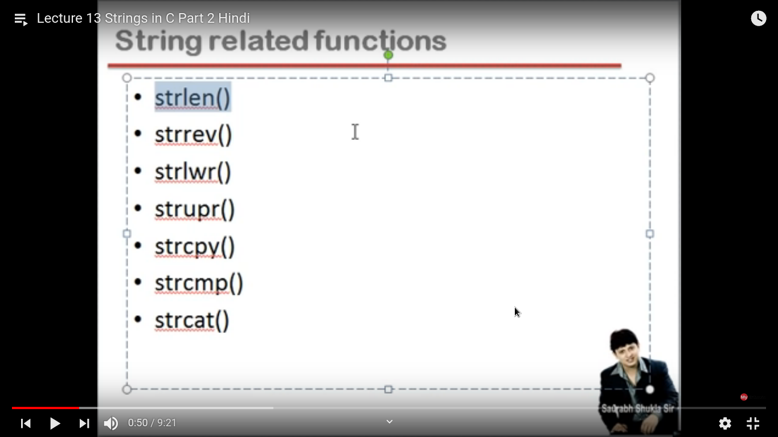

1. Strlen() :- this Function measurement the string of the length.
2. Strrev() :- This function is use to reverse the string.
3. Strlwr() :- This function user is in the string that ever upper later converted into small.
4. Strupr() :-This function user is in the string that ever small later converted into upper.
5. Strcpy() :- then function user when you want to copy the string.
6. Strcmp() :- ??
7. Strcat() :- ??

Handling Multiple Strings