Linux
Linux is kernel not OS.

Linux is not a UNIX derivative it was written from scratch.

A Linux distribution(OS)is the Linux kernel and a collection of software that together, create an OS.

Linux is open source and its secure as compare to Window. Its is light weight and easy to update and easy to install all other application.

Its is multi-user and as well as multitask.

There are some changes between windows and linux.

Folder --> Directory
Administration --> root user
File --> File
Software --> package

File system hierarchic

The structure of linex (kernal)

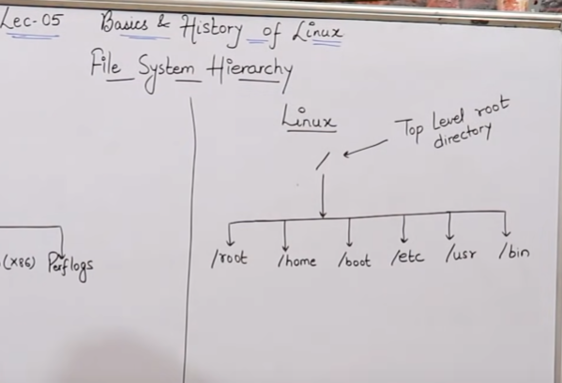

Explanation of this command

