# Nevbar

In bootstrip we don’t use css to make the nevbar. It already set in the class element title.

1. Firstly we make unorder list and give class (navbar nav) and also give (ml-auto<margin-auto>) to take navbar in right side..
2. Then we make list item to make home,contact,etc.
3. When we want to display the item in inline so we can use (nav-expant-lg) tag.
4. we want to set logo or logo brand name so we can use (navbar-brand).
5. When we make the navbar and logo then we want to change the nav background color so,we can use (bg-dark) and we also change the color of text in nevbar so, we can use (navbar-dark).
6. After making navbar to we want to make a navbar toggle so we defind the button we can use button tag and wright the class..
7. After defind the button element then we make a button so, we can use <div > to make the button and give class (collapse navbar-collapse) the we also give id of data-target we already defind in the button tag element..
8. We also add a script file to run the toggle button.

Finally we make a responsive navbar..

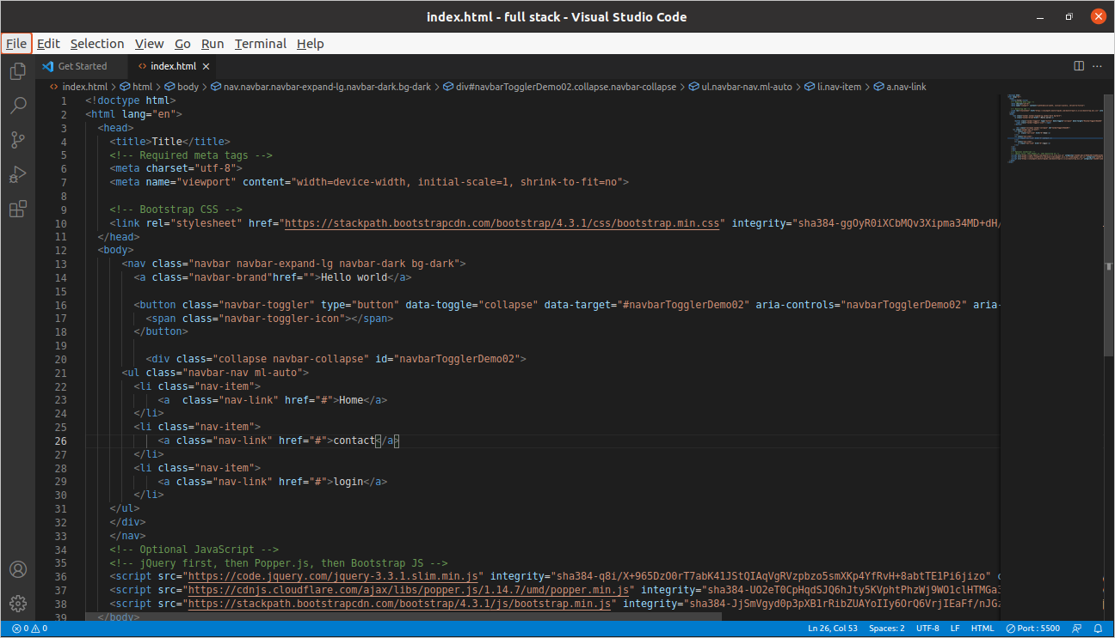

***Grid layout system (how to make row and column in boot strip)***

We make a responsive column:-

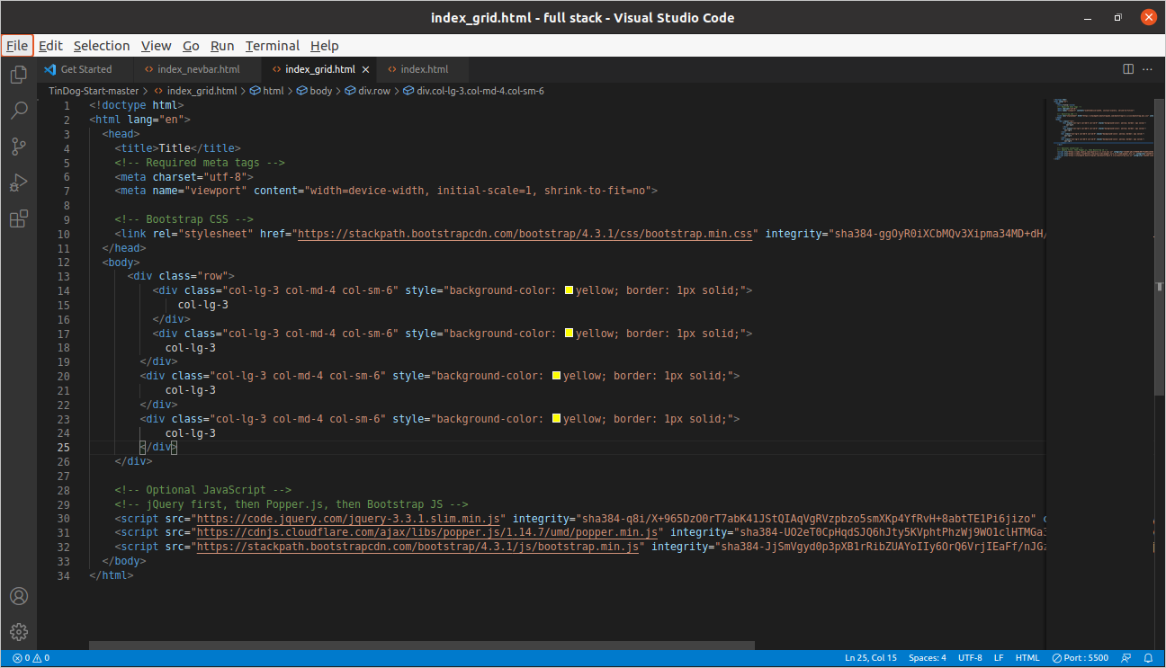

1. Firstly we make div and give class (row).
2. There are 12 box in the full screen.
3. 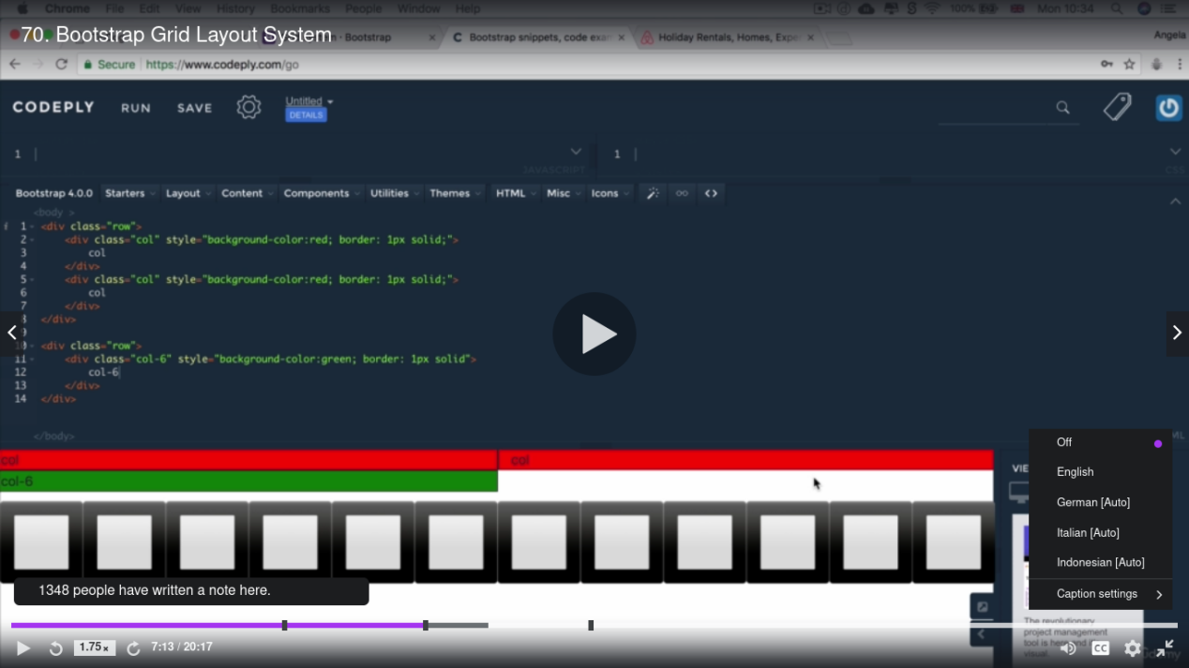
4. Then we also make second div and give a class (col-lg-3 col-md-4 col-sm-6).
5. (col-lg-3) mean column-large-12/4=3 mean we make a divided column in 3 part of screen.
6. (col-md-4) mean column-middel-12/3=4 mean we make a divided column in 4 part of screen.
7. (col-sm-6)mean column-small-12/2=6 mean we make a divided column in 6 part(helf)of the screen.
8. Then we use style to change the background colour.