# Nevbar

In bootstrip we don’t use css to make the nevbar. It already set in the class element title.

1. Firstly we make unorder list and give class (navbar nav) and also give (ml-auto<margin-auto>) to take navbar in right side..
2. Then we make list item to make home,contact,etc.
3. When we want to display the item in inline so we can use (nav-expant-lg) tag.
4. we want to set logo or logo brand name so we can use (navbar-brand).
5. When we make the navbar and logo then we want to change the nav background color so,we can use (bg-dark) and we also change the color of text in nevbar so, we can use (navbar-dark).
6. After making navbar to we want to make a navbar toggle so we defind the button we can use button tag and wright the class..
7. After defind the button element then we make a button so, we can use <div > to make the button and give class (collapse navbar-collapse) the we also give id of data-target we already defind in the button tag element..
8. We also add a script file to run the toggle button.

Finally we make a responsive navbar..

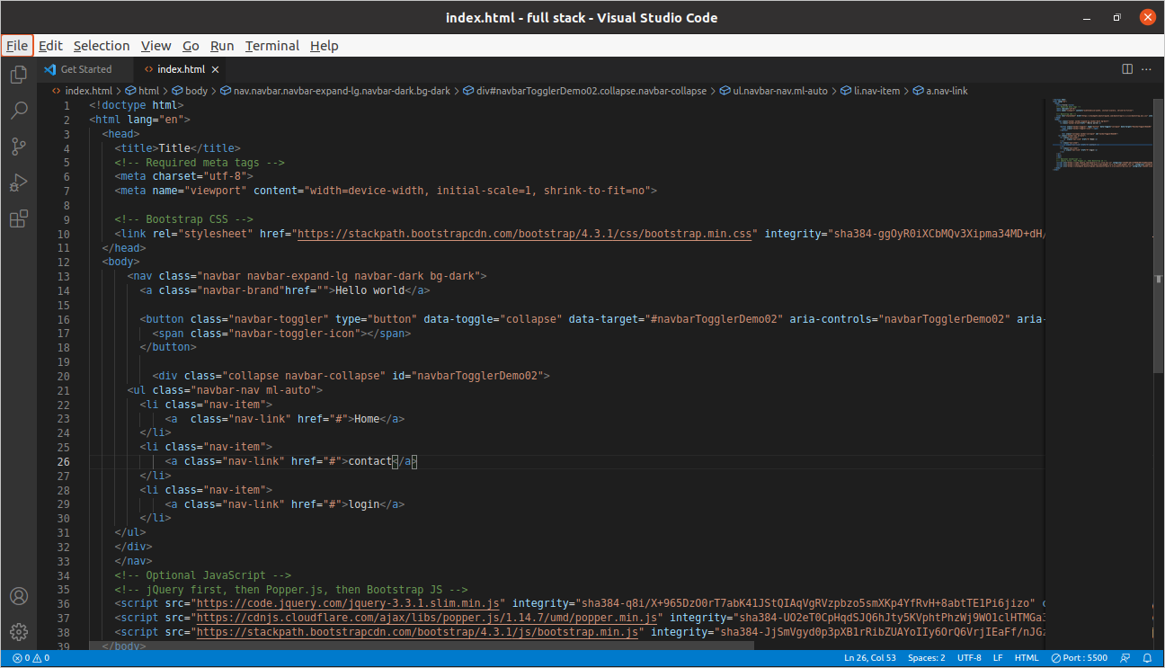

#### Grid layout system (how to make row and column in boot strip)

We make a responsive column:-

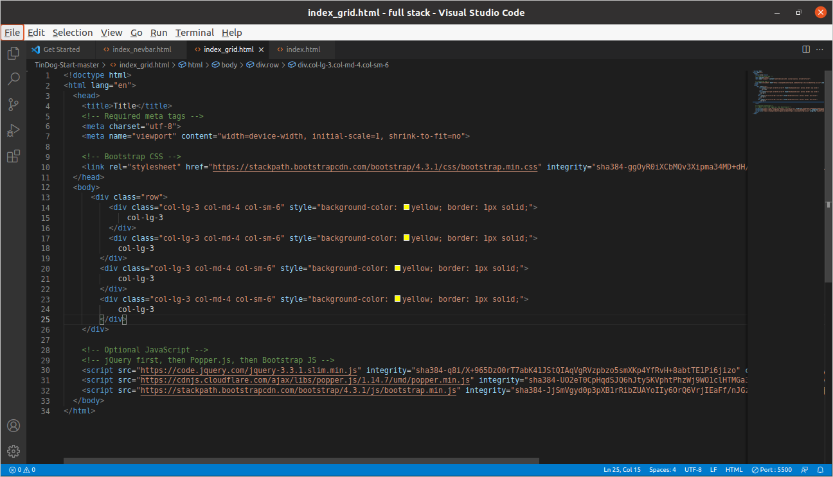

1. Firstly we make div and give class (row).
2. There are 12 box in the full screen.
3. 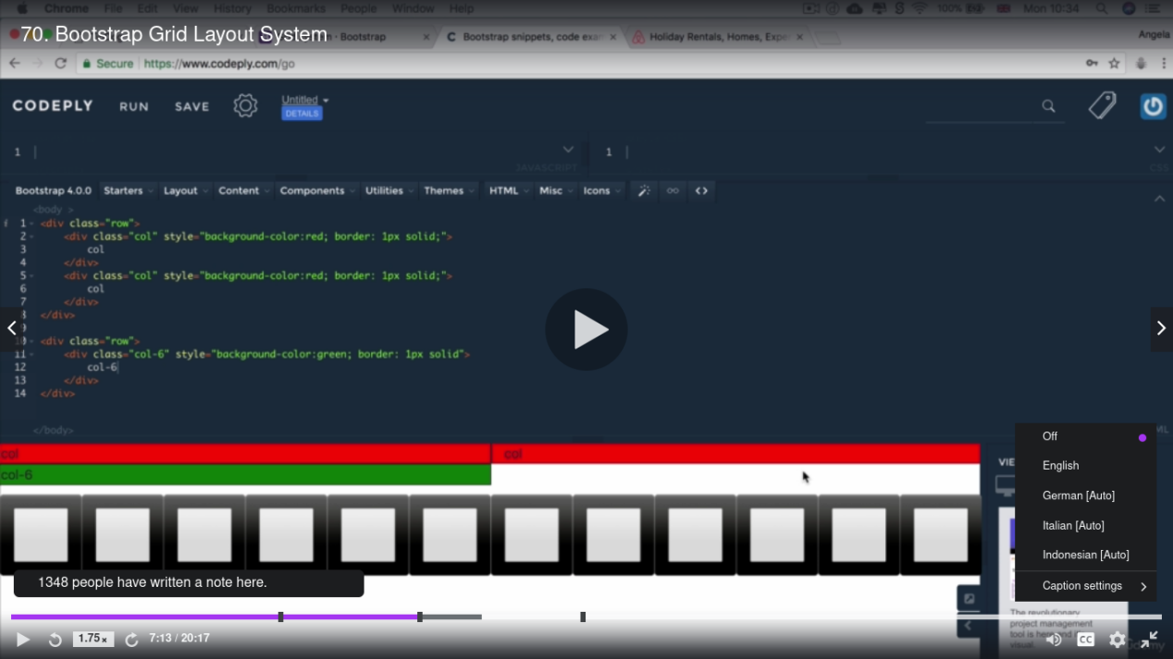
4. Then we also make second div and give a class (col-lg-3 col-md-4 col-sm-6).
5. (col-lg-3) mean column-large-12/4=3 mean we make a divided column in 3 part of screen.
6. (col-md-4) mean column-middel-12/3=4 mean we make a divided column in 4 part of screen.
7. (col-sm-6)mean column-small-12/2=6 mean we make a divided column in 6 part(helf)of the screen.
8. Then we use style to change the background colour.

***Boot-strip container***

Boot-strip container is use for making responsive section. We use (container-fluid) for making responsive text section column with the help of using class.

# Button

When we make a button so, we can use class to design the button.

(btn-lg) mean we want to make button in large size and similarly we also change the color of button we the help of class.

We also add CDN file link for access the resource file easily.

<script defer src="https://use.fontawesome.com/releases/v5.0.7/js/all.js"></script>

***rotate the image.***

When we want to rotate the image so, we can use

transform: rotate(45deg) in the css file.

# JavaScript

Javascript is work on interpreter and javascript is use in forntent and backend. In javascript it also have datatype.

1. String:- the group of alphabet is called string datatype .(“abcd.....z”)
2. Number:- the group number is called number datatype. (“12121+1212-1212.....”)
3. Boolean:- the true or false is called boolean. (true or false)

#### Javascript variable

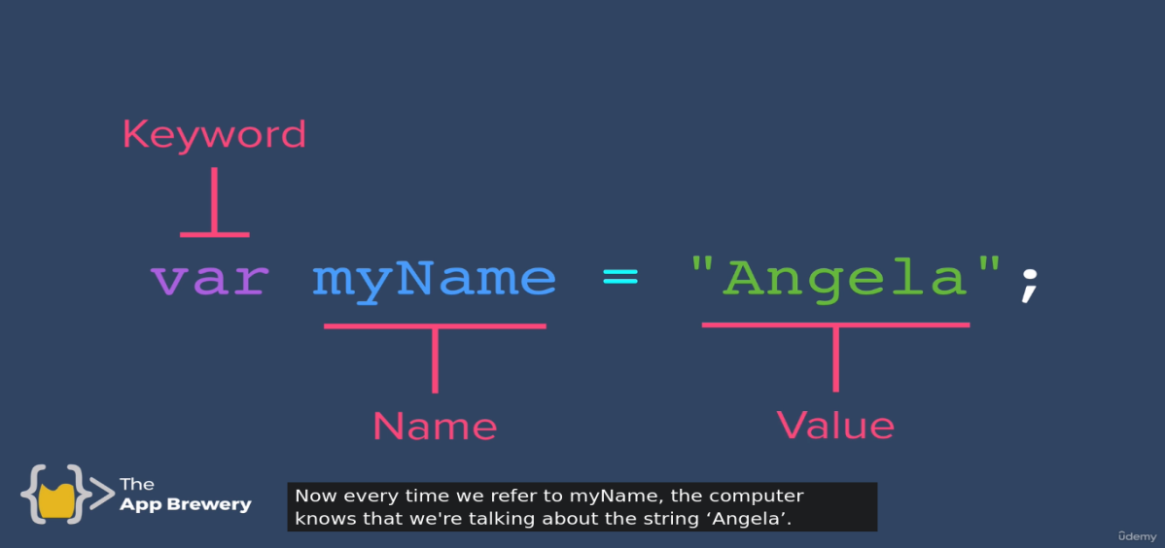

When we want to create a variable or store the value of variable so, we can use (**var**) var mean variable , (**myname**) mean variable name , (“**angela**”) mean the value of variable.

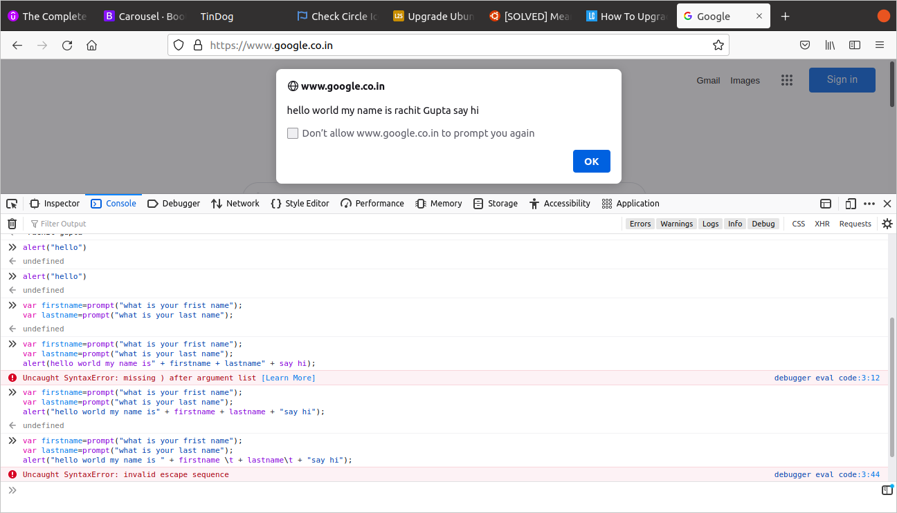

In this screenshot firstly we enter the first name and store the value in the variable, similarly we also enter the last name and it also store in the variable. Secondly we want to make a alert.

alert("hello world my name is " + firstname + lastname + "say hi");

In the coma(“”) we wright the string and then we add the variable name that the value store on it.

#### Valid variable name in JavaScript

1. Var myname=”hello world” (myname mean only use a small character).
2. Var myNAME=”helloworld” (myNAME mean we can use small + capital character).
3. Var myname2123=”hello world” (“myname2123 mean we can use small + number character name”).
4. Var my_name=”hello world” (“my_name mean we can only user underscore between two word”).

Note:- space is note valid between two word.

we can not use number in the font on the character name.

Var type character name is not valid.

String in javascript

in javascript string mean the number of character mix and make a sentence or word is called string.

Alert (“hello ” + name + message) mean (name+message) without any space.

Alert(“hello ” + name+ “ ”+ message) mean (name + message) with space.

#### When we want to find out the length of any string so, we can use (<var name>.length).

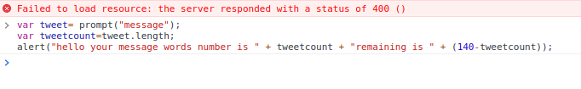

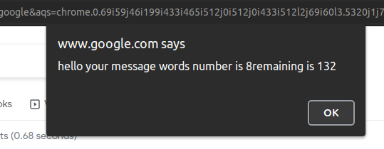

in this case we store length of string in the variable and the we will be print it and we can also used in anyother work.

When we want to stop or set the limit of any string so, we can use (<var name>.slice(limit) first mean starting word and last is ending word).

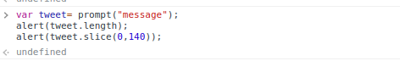

When we want to change word lower case into upper case

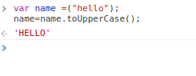

When we want to change word upper case into lower casr.

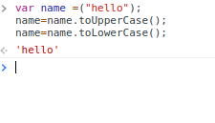

### JavaScript

Javascript is almost similarly to the c language.

Function

When we want to call or declaration the function is mostly similarly to the c language function call and declaration.

Jab hum log function ko declare karta hai tab he hum log variable ke value ko bhi pass karta hai..

Return in function

Hum log return keyword ka bhi javascript ma use karta hai. Hum log return kwyword ka use print aur pass karna ka leya use karta hai...

***Random***

When we want to display and random number so we can use ***Math.random*** function.

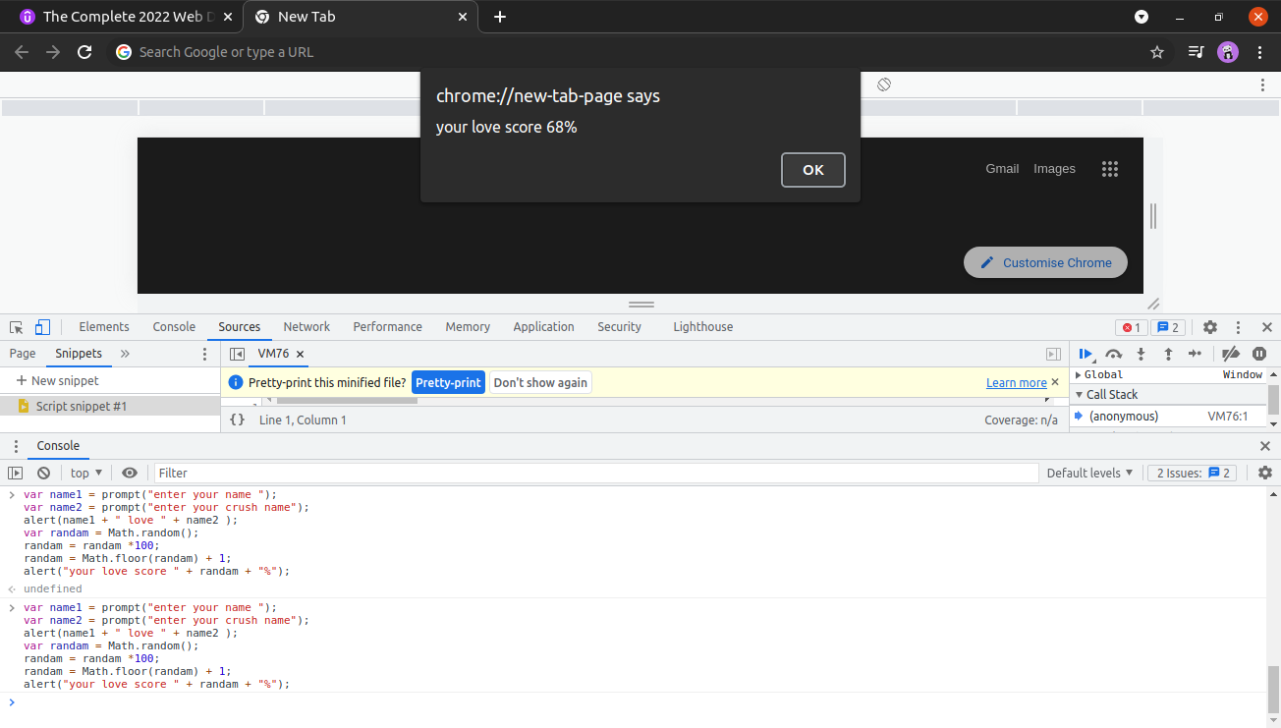

***If or else***

We also use if and else in JavaScript. It is similar to the c language.

When we want to check the data type of 2 var so, we can apply === 3 time equal sigh to the show the data type of 2 var is equal (right hand side and left hand side).

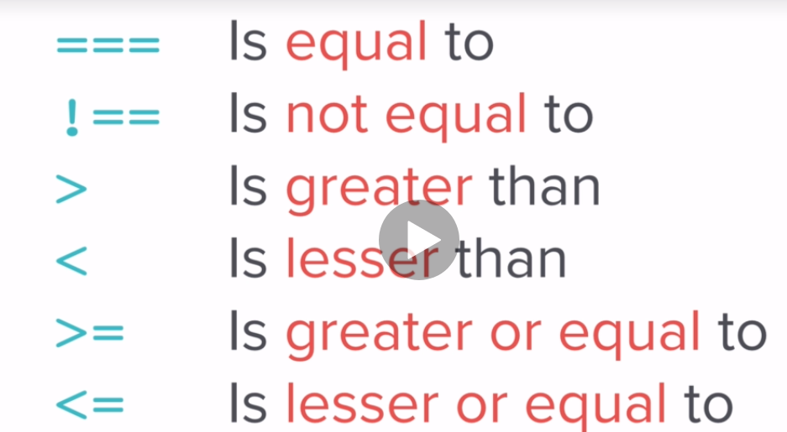

When we want to add 3 condition in if and else so, we can use there keyword.

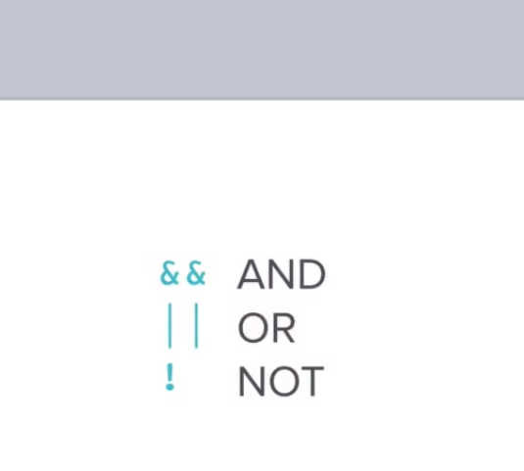

In this photo we used 3 time if and else.

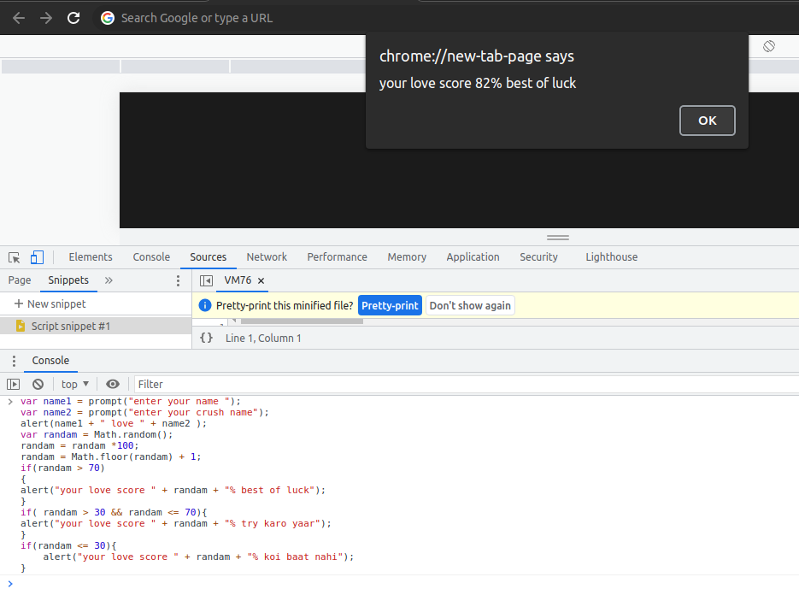

Arrays

In arrays we can create large amount of variable with the help of single price of line.

It is almost similarly to the c language arrays.

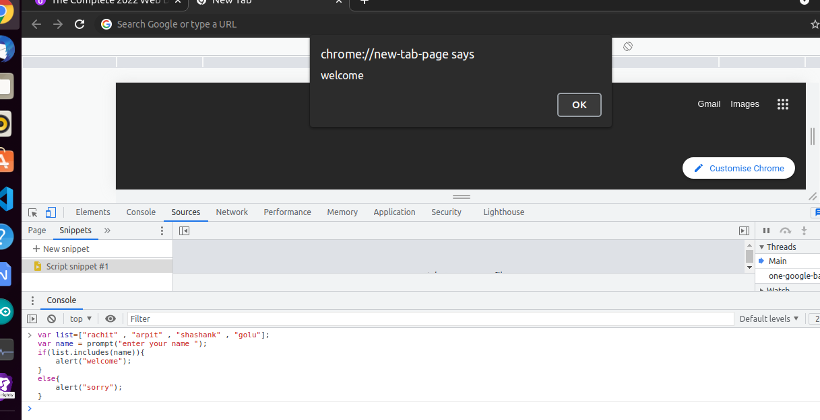

FizzBuzz

Write a program that prints the numbers from 1 to 100. But for multiples of three print “fizz” instead of the number and for the multiples of five print “Buzz”. For number which are multiples of both three and five print “FizzBuzz”.

There are 3 types of JAVASCRIPT :-

1. Inline
2. Internal
3. External

Inline :- in inline JavaScript we write javascript on html page in the element line.

Inline javascript is difficult to debug the code.

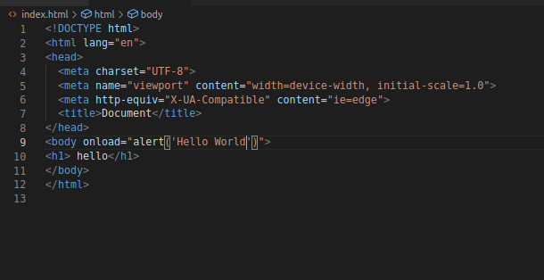

Internal javascript :-

Internal javascript is also used in html file. In internal javascript we write javascript code in the script tag.

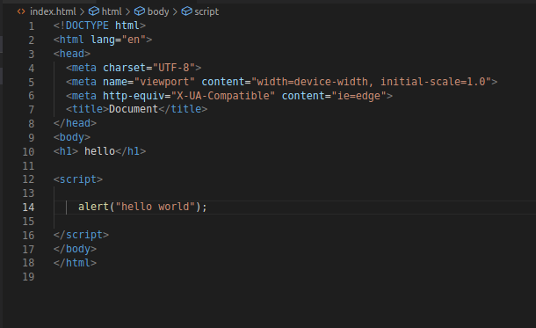

External javascript :-

External javascript we write javascript code on external file and link on the main file. We add or link the external in the last and in the body element.

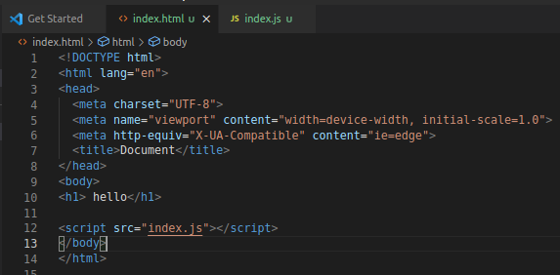

DOM (document object modal ) :-

We can access or change the html file detail with the help of javascript in the web page.

Properties :-

* innerHTML
* Style
* Firstchild

Methods :-

* Click()
* AppendChild()
* setAttribute()

When we want to change the element properties so, we can use **document.getElementsbyTagName or ClassName or Id (< element name >) [<here we can add position address of list item>].<here we can change the color or properties >;**

Its is working like a array. We also applying the position of the element or array item address.

We also show in the image....

Using TagName

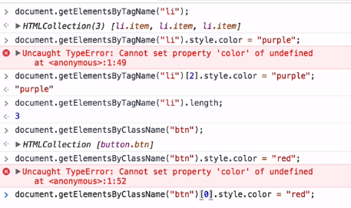

Using ClassName

Using Id

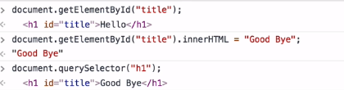

If we want to select all the items of array so, we can use **document.querySelector(“<position>”);**

Using All

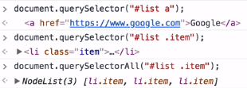

We also change the style propertes with the help of javascript by the using there code.

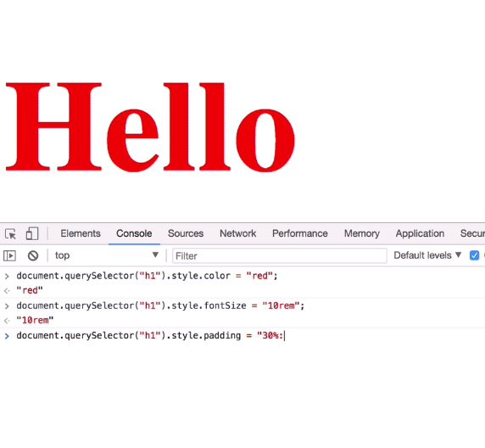

**code**

When we want to change the text and we also want to change the normal text into bold text so, we can use <em> tag in the javascript.

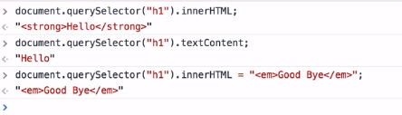

We want to show all the attribute are link with the help of using single tag its name attribute.

When we want to show that what url is link to the attribute so, we can use there code line.

If we want to change to change the url who link the attribute so, we can used there code line.

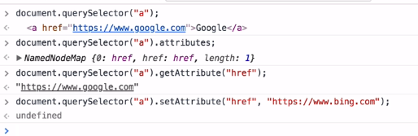

There are 3 ways to targate the html element with the of java script.

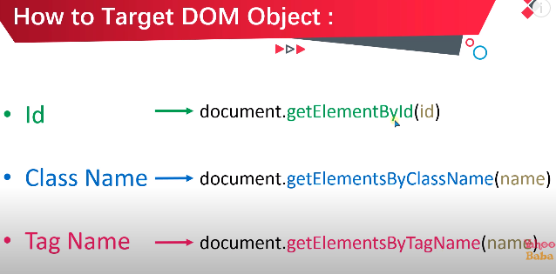

We can also used QuerySelector or QuerySelectorAll for targate html element.

When we want to targate any button with the help of java script. So we can used or

**< addEventListener("click", clickbutton); >**

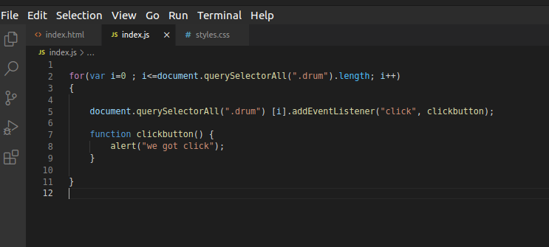

This is also known as higher order functions :-

Higher order function are function that can take other function as inputs.

We can also debugger the code in the console log. By the using there code.

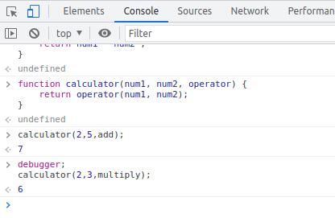

When we want to add any audio so we can use the function

new Audio(‘url’);

audio.play(); //for play the audio

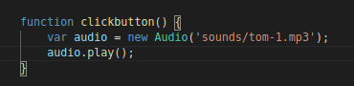

When we want to add using keyborad keys in the website so we can use there function



Hum log event ka throught keyboard se ek input deta hai. Jesko hum log functiion ma pass karta hai.

***Jquery***

Jquery is almost similarly to the bootstrap.

Jquery come under JavaScript. It is very helpful and useful. Jquery make easy to tragate any element.

Jquery is used in java or java script. When we want to targate any element so we can used < $ > sigh to tragate the element.

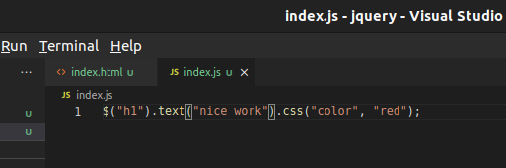

***End***