***Html and Css***

Html :- Hyper Text Markup Language.

Html that work in the background. That html is the backbone of the website.

***Index.html***

1. When we can make website so, we wright

$ <html >

And when the coding is completed so,we can use

$ </html>

(/) this sing is always use to close the function.

1. Then we add head and we also close the head. We make head to show our keyword.

$ <head>

When we complete the word of function so, we close the function.

$ </head>

1. Then we add body, body is the main function that the main work come under the bady function. When any thing we can wright that is display on the website.

$ <body>

When we complete the word of function so, we close the function.

$ </body>

1. Then we can add title function in the head function.

$ <title>

When we wright the title then we close the function.

$ </title>

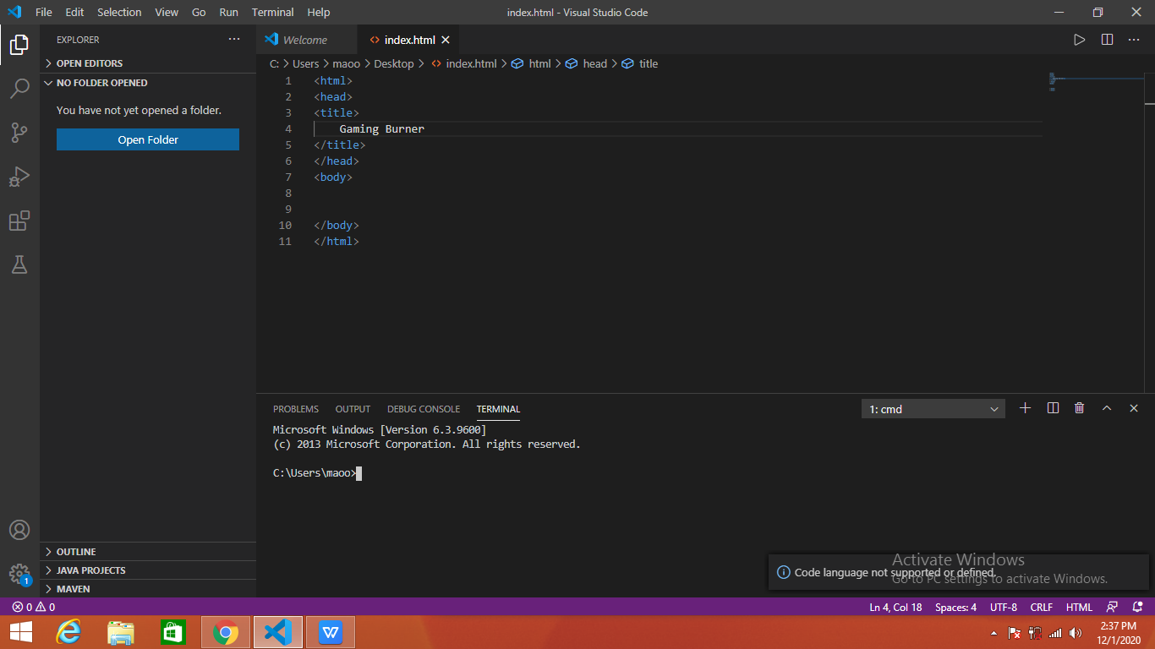

Then we can add line in the body so, we can use the

$ <h1>

Then we wright the sentience and close it.

$ </h1>

(h1) mean the line is max bold and max thick.

Similarly we can also use <h2>,<h3>,<h4>,<h5>,<h6>.

These function in descending order, mean the line thickness and bold go on descending order.

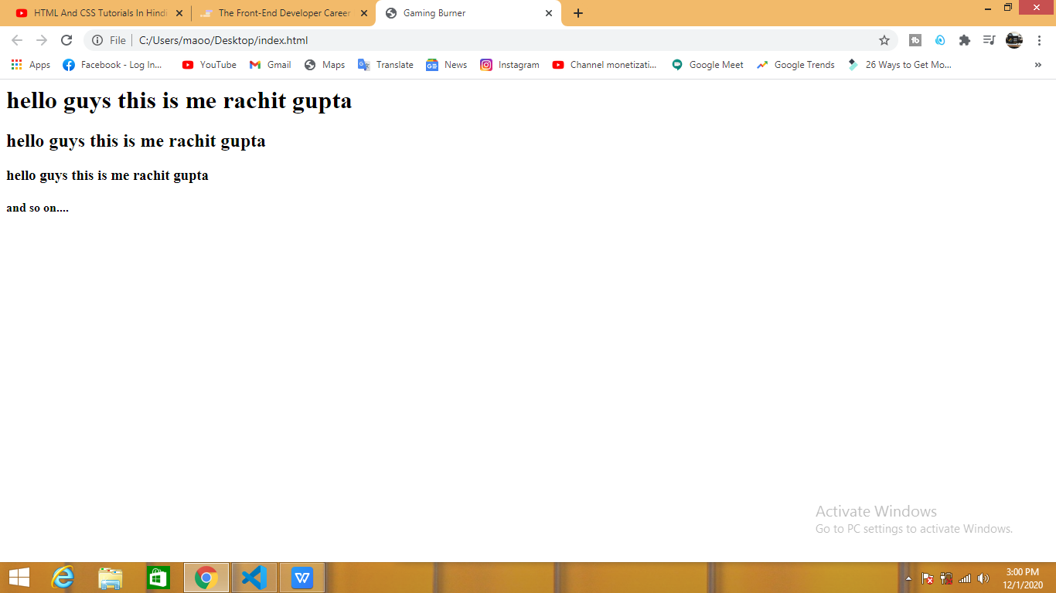

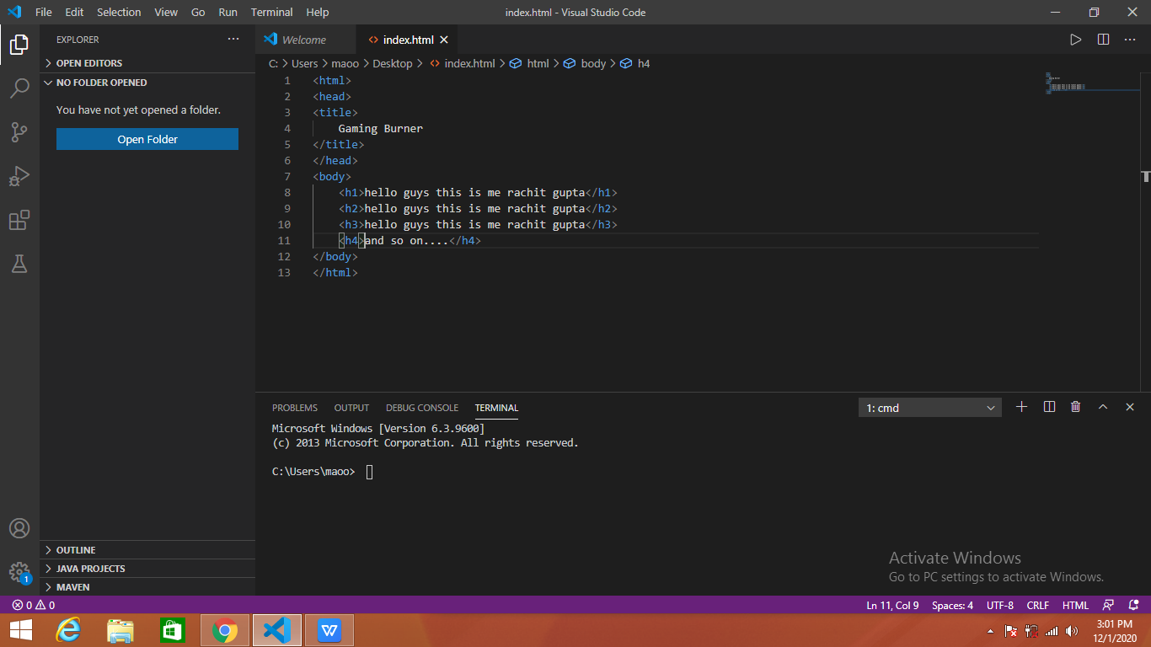

if we want to add the paragraph in the main body so, we can use this function.

$ <p>

When we wright the paragraph and complete it so, we can use this function.

$ </p>

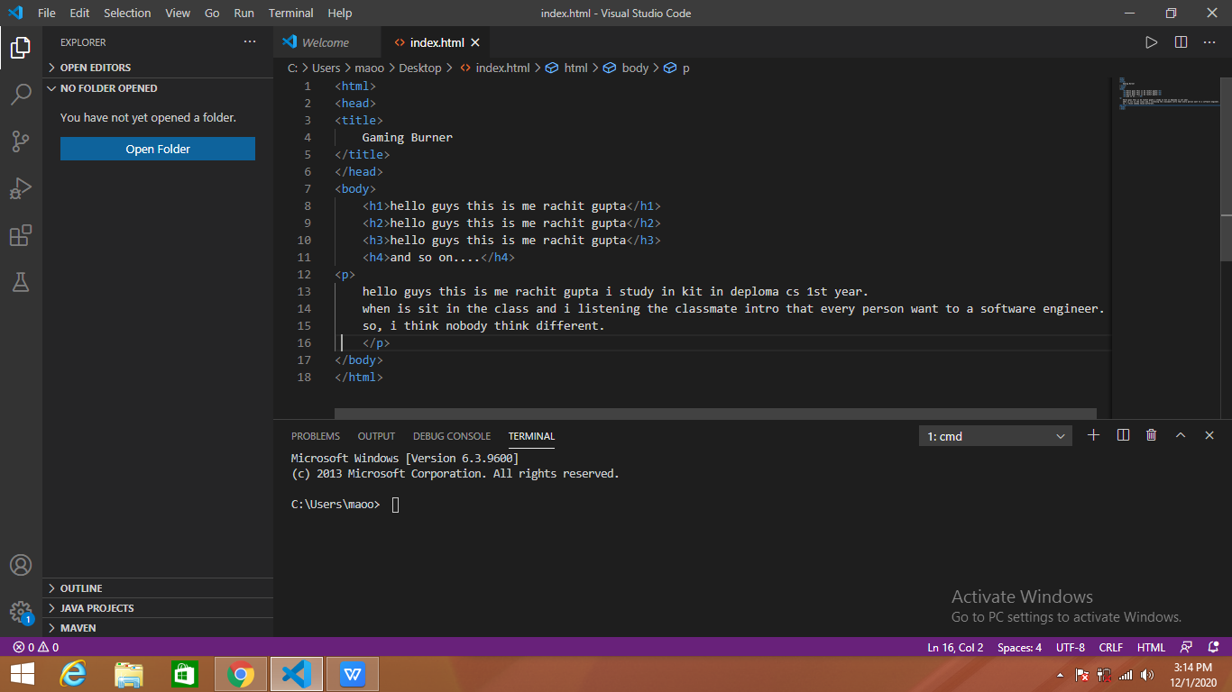

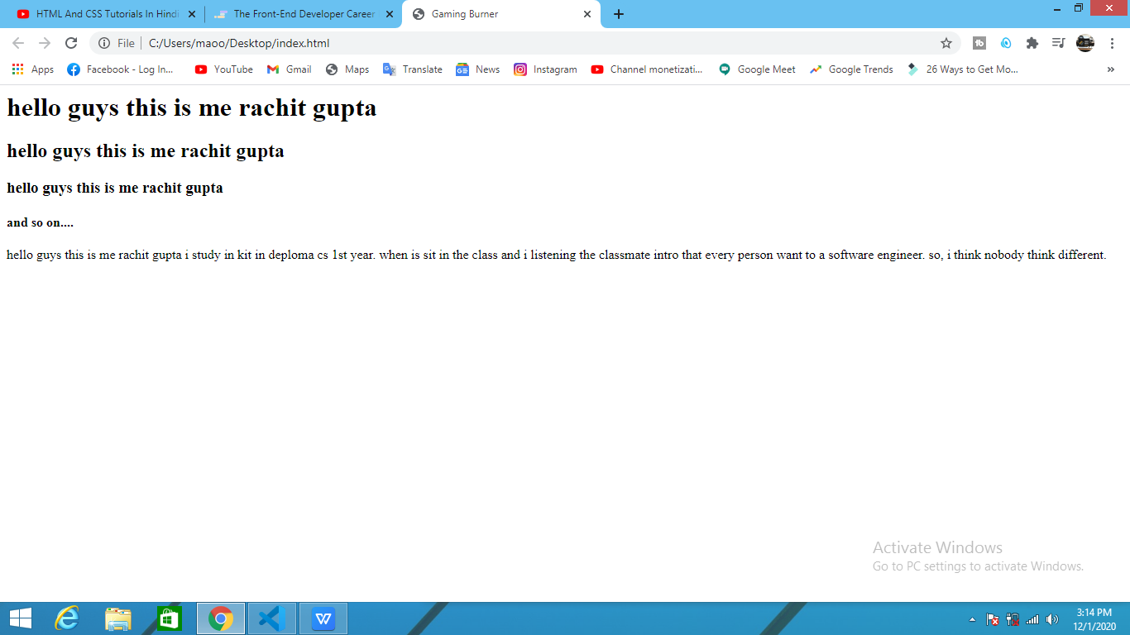

We want to add the link so, we can use this function.

$ <a href=”https://gamingburner.wordpress.com”>

And we to add a text like”click here”and close it.

$ </a>

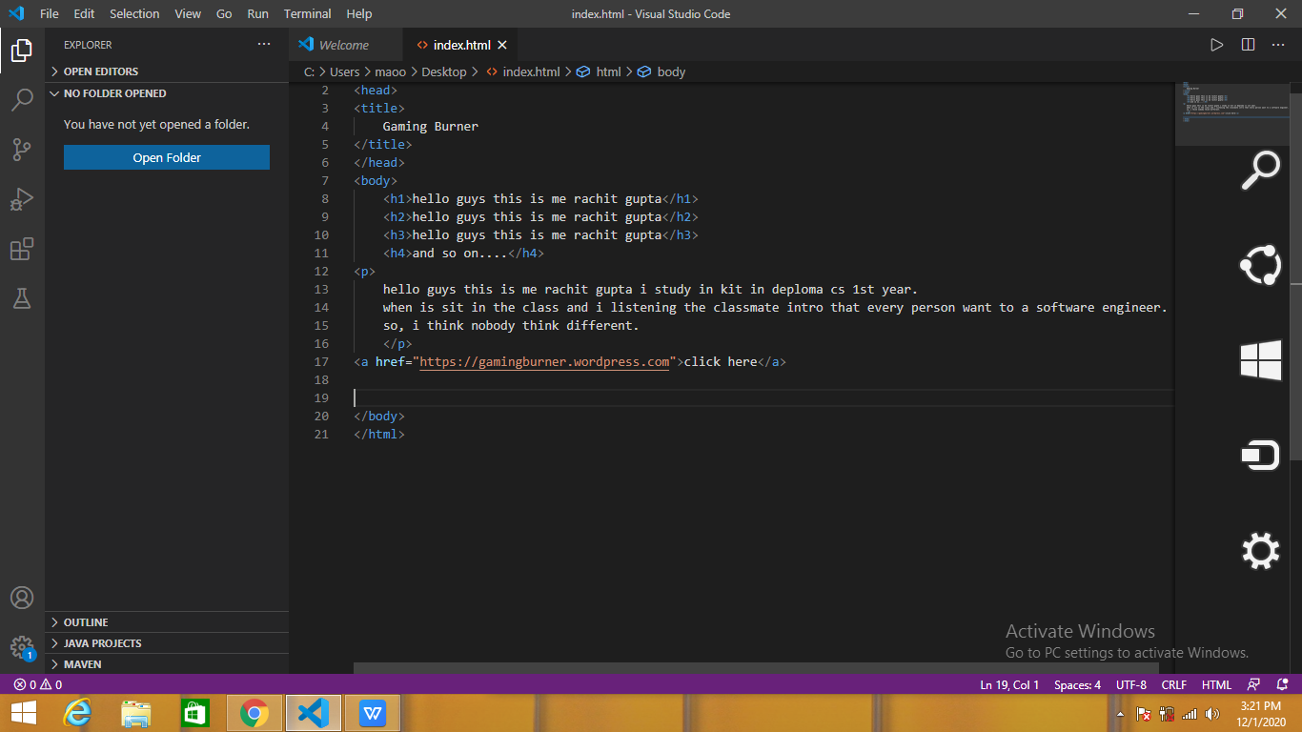

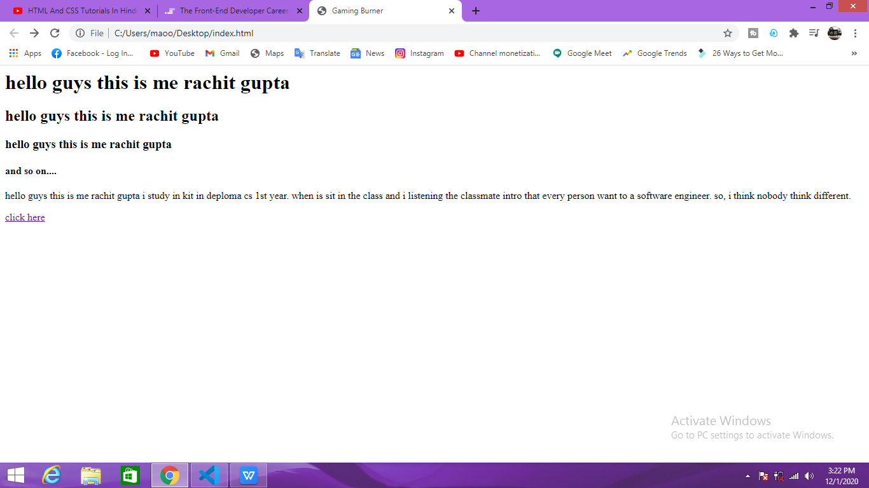

When we can press the click here buttan so, website is open.

If we want to add small line so, we can use this function.

$ <small>

Wright the line

$ </small>

Suppose we want to Bold/hightlight the text so, we can use this function.

$ <b> or <strong>

Wright a text

$ </b> or </strong >

If we want to change the line in the paragraph so, we can use.

$ <br>

Choose the line

If we want to create a horizontal line so, we can use

$ <hr>

Next we make a form

So we can use this function.

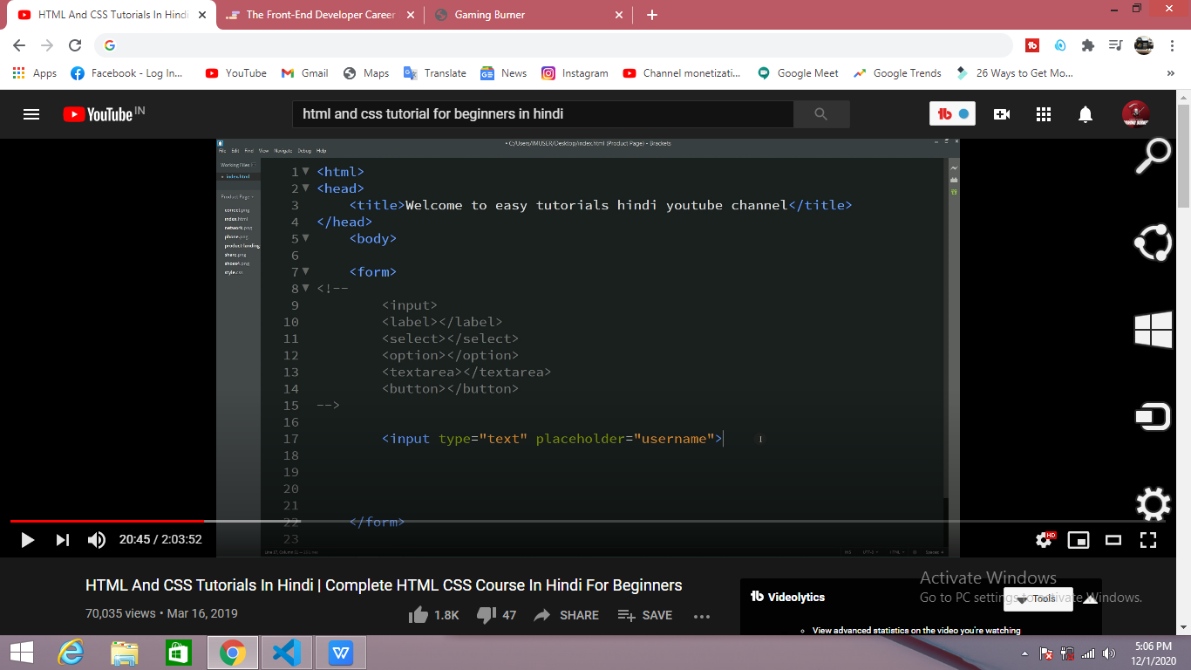

There are the function that we can use in make form.

<input> mean we make like a box that any text or information is wright on.

<label> mean wright the any name or information in 2or more word.

<select> mean when you choose any option then the select function use.

<option> mean you give two or more option to select the user.

<textarea> want make that area that your user sent the message so,we can use textarea.

<button> mean we create the any button in the website like:-

Log in,summit, click here etc.

<Placeholder> mean we wright name in the small box.

So, make the form like this:-

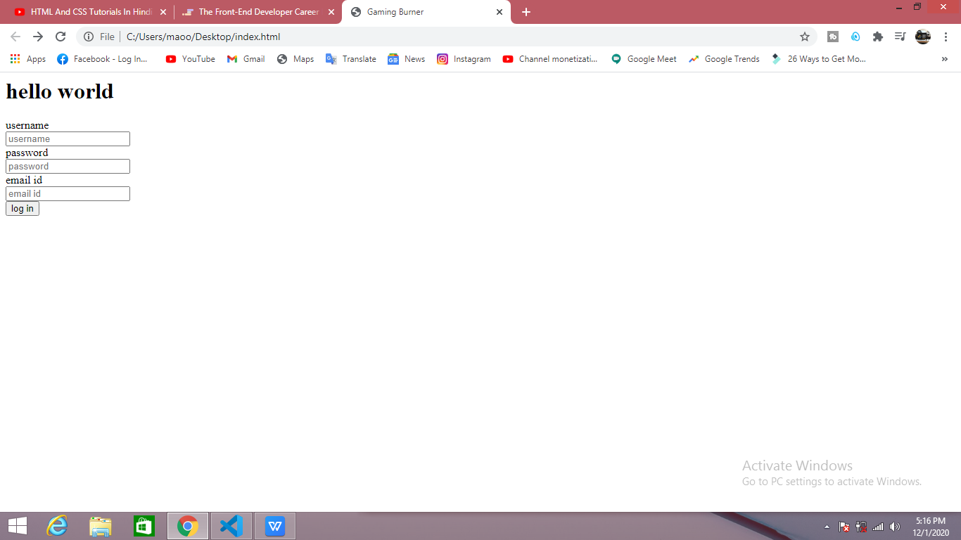

We can use this code to make this

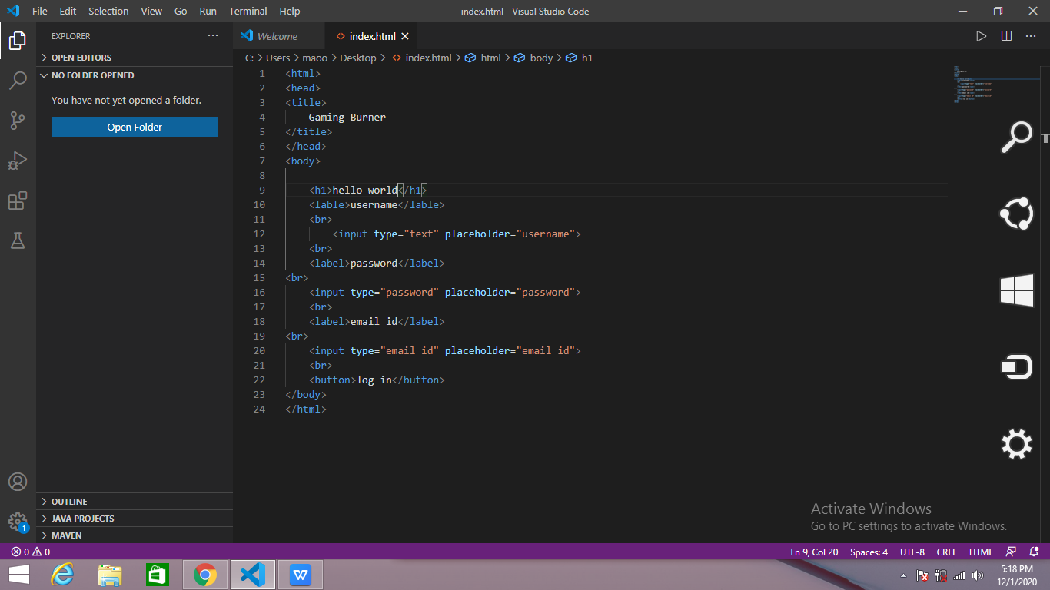

<radio> mean we create a small button like a dot.

<checked> mean by default one option is choose.

<checkbox> mean when I want to add option or button so,we need to add the checkbox option.

<textarea> mean when you make any website and you want make that area when your user sent the message so,we can use textarea.

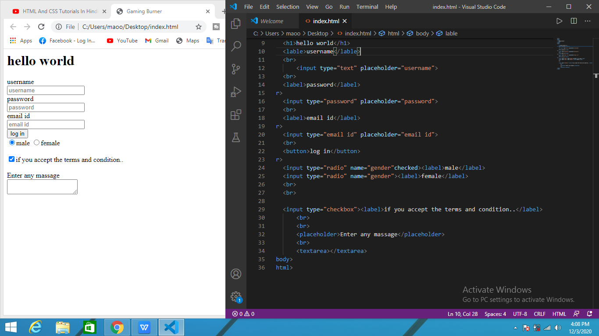

<file> mean when you want to add or upload the file in the website so we can use file.

<input type=”file”>

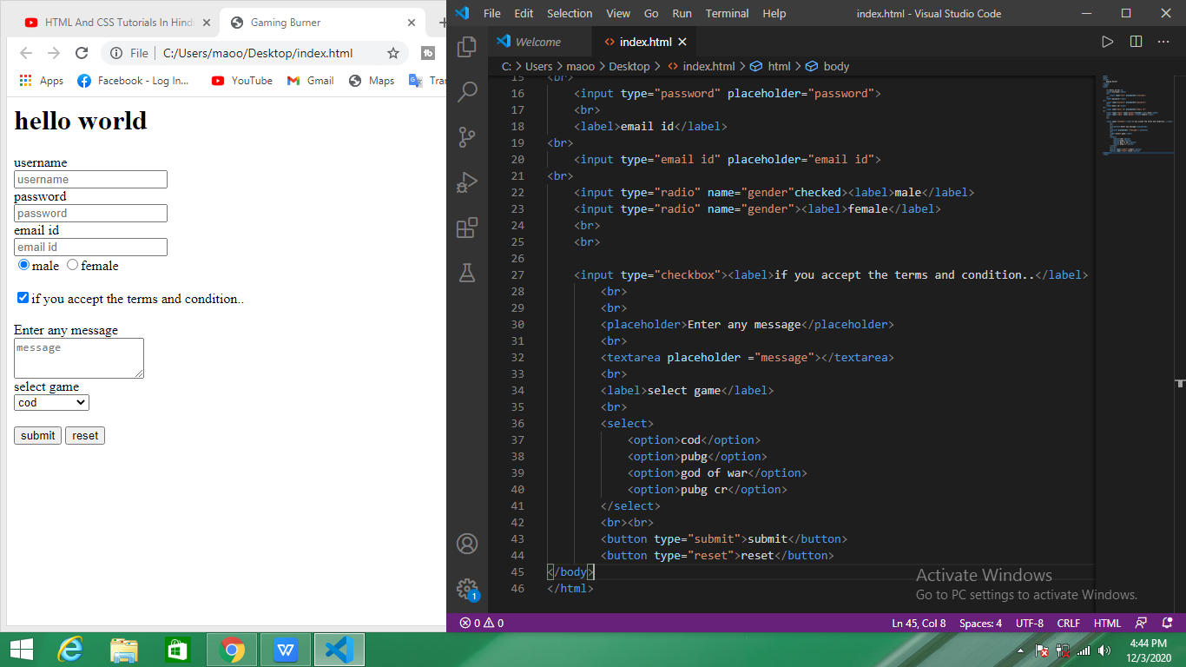

Note:- in this code we don’t wright <form>function eske vajaya se reset or sumit button nahe kam kar raha thi..

So, we also add the <form> function in the top(blow the main function) and when the coding is complete the you end the </from> function(blow the main function).

***2index.html***

How to make a list in the website

There are 2 type of list :-

1. Ordered <ol></ol>
2. Unordered <ul></ul>

First we can use unordered list:-

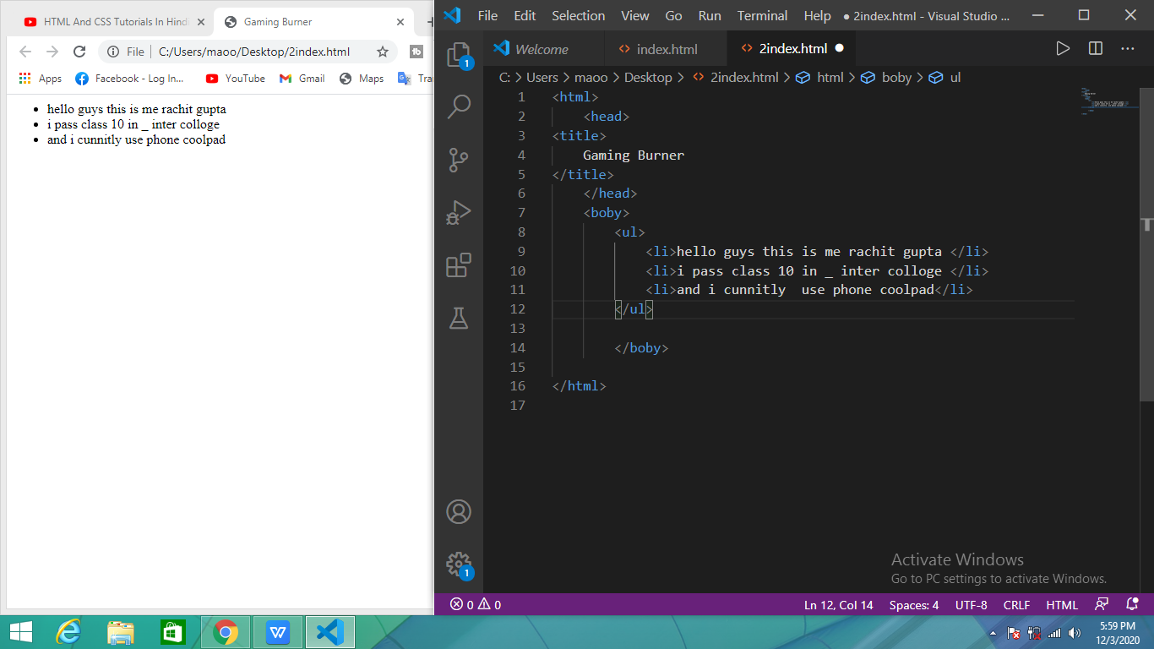

The all line is arrange in the dot.

Second we can use ordered list:-

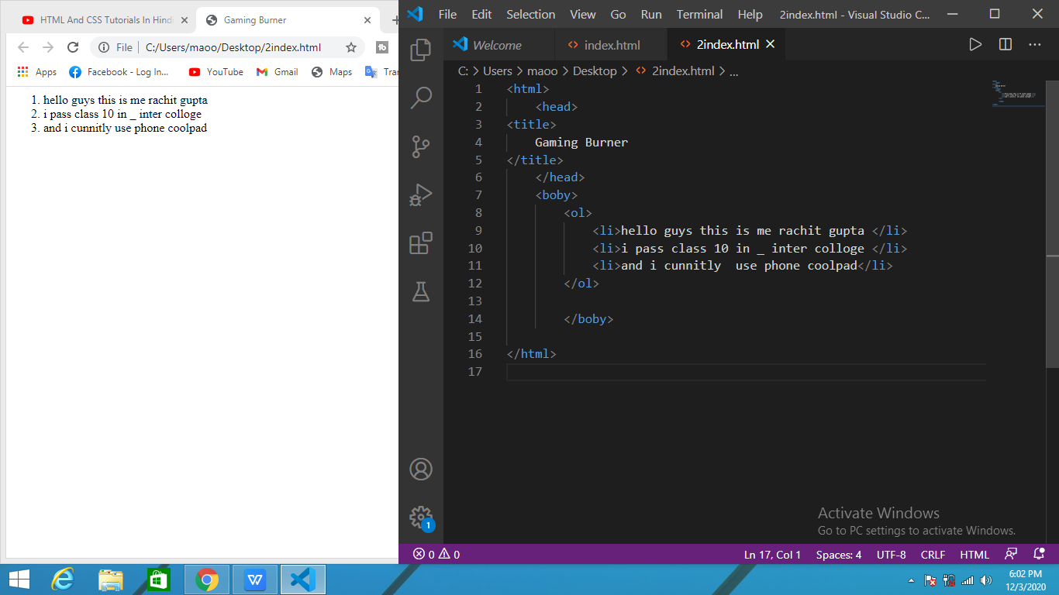

All line are arrange in the ascending order.