C++

made by -> bjarne stroustrup

launched on -> 1983

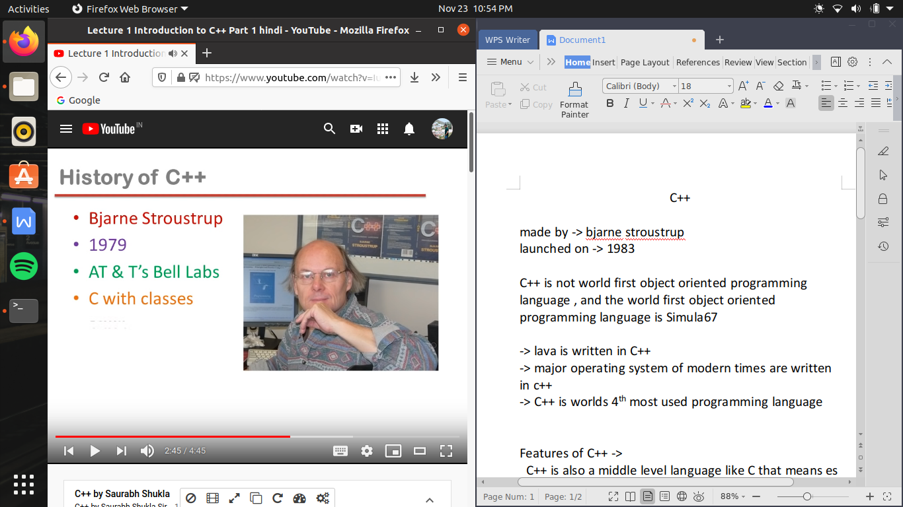

C++ is not world first object oriented programming language , and the world first object oriented programming language is Simula67 and C++ also inspired by this .

-> lava is written in C++

-> major operating system of modern times are written in c++

-> C++ is worlds 4th most used programming language

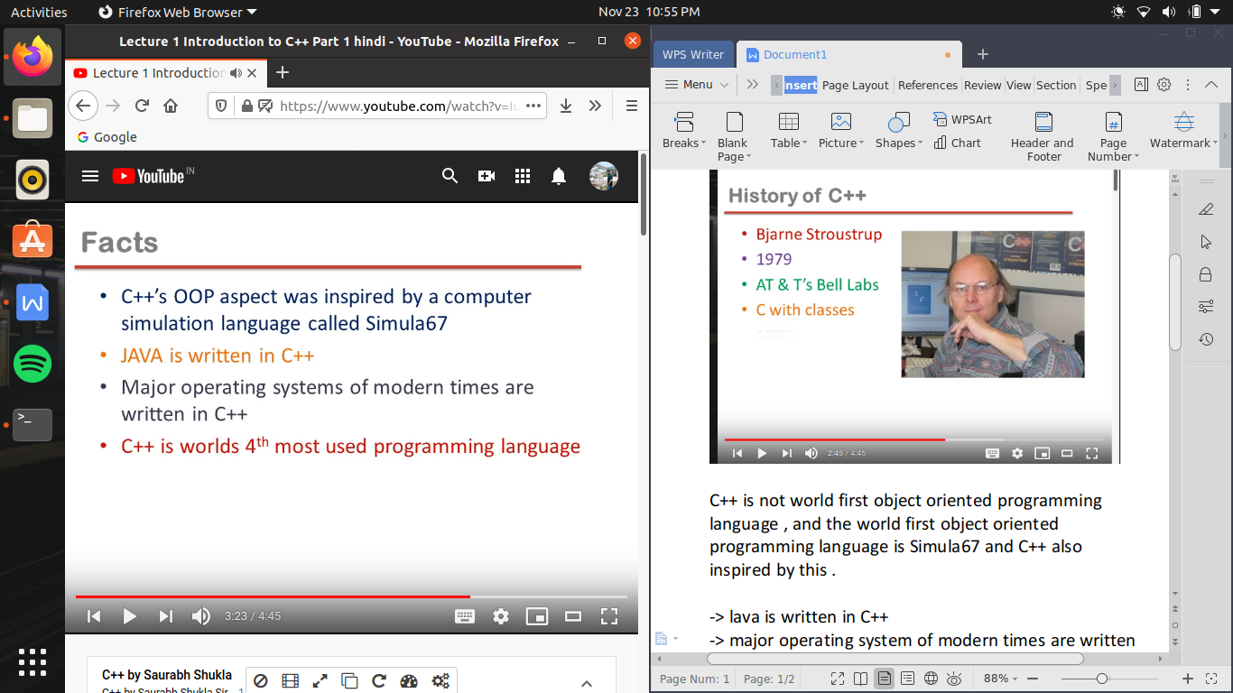

Features of C++ ->

C++ is also a middle level language like C that means es me low level programming bhi ki ja sakati hai or high level programming bhi ki ja sakati hai

low level programming means machine dependent coding , jis ki madat se hum system software or device driver jaise software bana sakte hai

high level programming mtlb es me application software bhi bana sakate hai jo ki independent hote hai hardware se

C++ supports principles of object oriented paradigm (object oriented principle ko support karane ke leye jo features chahiye wo C++ me hai )

C++ support three separate programming traditions like :-

1. the procedural language tradition , represented by C;
2. the object- oriented language tradition , represented by the class enhancements C++ adds to c;
3. generic programming , supported by C++ templates

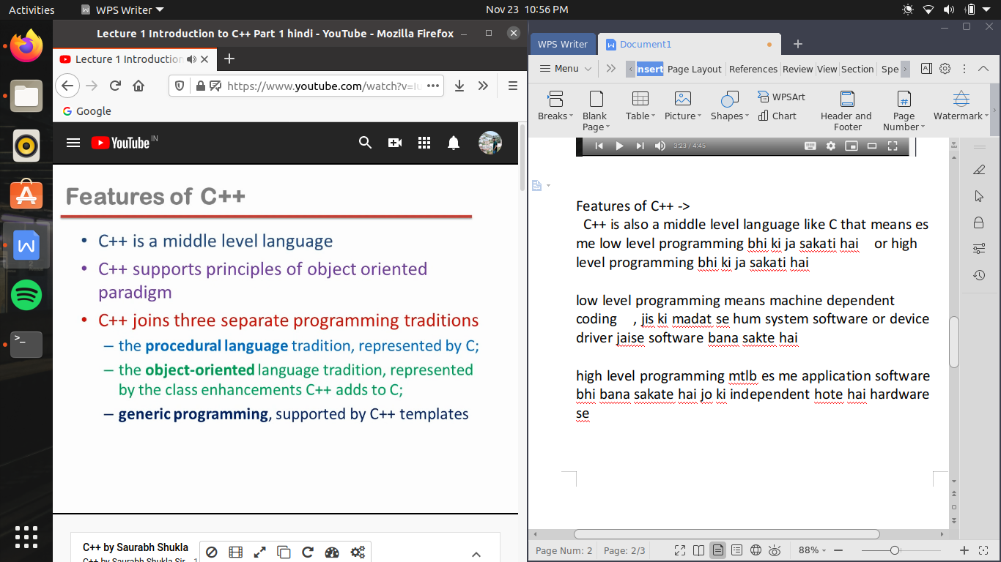

Comparison between C and C++ ->

1. C ++ is a super set of C language ,( means C me jitane bhi function hamane pade hai wo as it is C++ me bhi apply hoge , plus addition kuch chije hai toh C++ me a gyai hai)
2. C++ program can use existing C software libraries
3. C fallows top down approach of programming

(top down approach mtlb program banane ki hamari approach kaisi hai , hum sab se pahale Top level ka kam karate hai yani main()function bana kr program ke flow ko decide kr lete hai or fix kr lete hai ki hum kab kis function ko karane wale hai call exactly us function ko define hum bad me karate hai i.e detailing wala kam hum bad me karate hai , toh es tarah ki approach ko Top Down approach kahate hai )

1. C++ , C ke opposite ek bottom up approach of programming hai (yani C++ me bade bade software banana jayda asan hota hai or Bottom of approach es ke leye ek idea tarika hai , bottom of approach ka mtlb hai ki hum pahale sare detailing wale kam kr lete hai mtlb sare fuction ko define kr lete hai or last me hum sari function ki assembling kr ke en ke flow ka decision lete h yani main function hum sab se akhiri me banate hai )
2. C adopts Only procedure oriented Programming (koe bhi procedure oriented programming and object oriented programming kya hai toh yeh ekl tarika ka guidlines hai ki programmer ko program kaise banana chahiye )
3. C++ follows both procedure oriented programming and object oriented programming

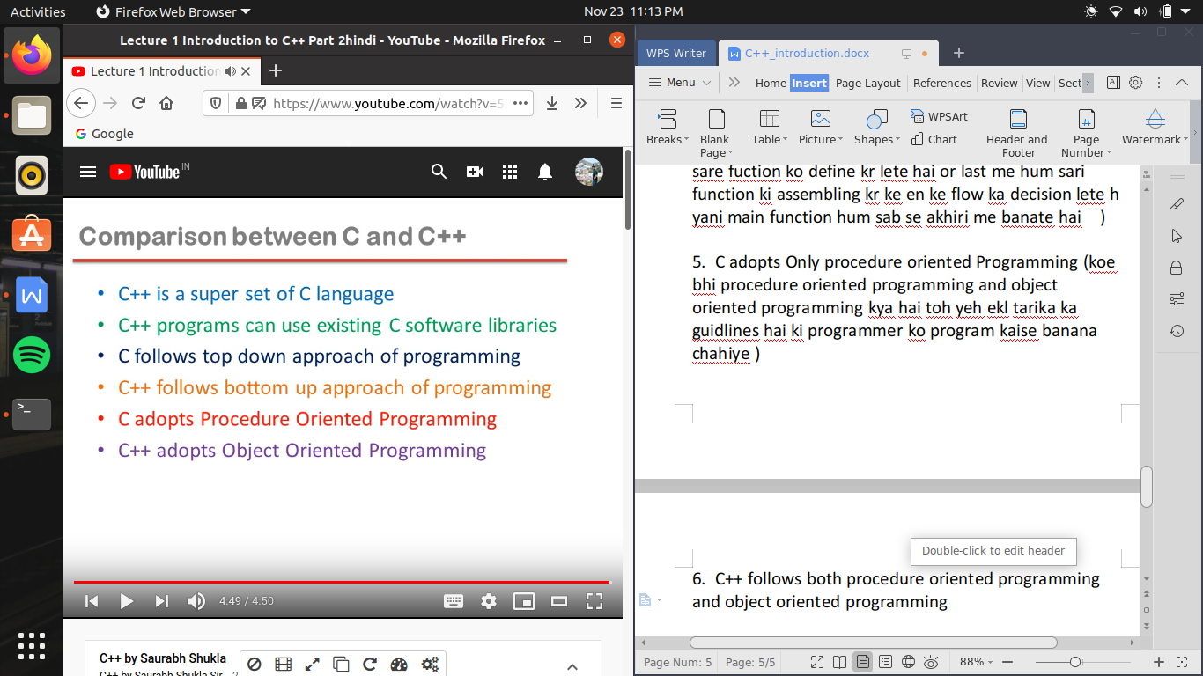

object oriented programming :-

jaise ki gita ko pd kr insaan ki sabhi musili dur ho jati hai usi tarah ek programmer ki problem dur ho sakati hai agar wo object oriented guidelines ko fallow kare .

OOPs ko samajhane se pahale hame samajhana hoga ki object kya hote hai, jaise duniya me har chij ek object hai , object wo hoga jis ki kuch properties hogi , agar hame school ke leye software banana hai toh hame school se related bahot sari information ko manage karana hai , jaise student ki information, management ki information , resources ki information ab etane bade software ko banane ke leye hame yeh tay karna hoga ki hame kya kya information ko handle karana hai , hum janate hai kisi bhi programming language me hame chahiye hote hai variables, ab hame bahot sare variables banane hai but es me ek problem hai ki jo data ke beech me relation hai use store nhi kr parahe , jaise hamene student ka nam store kiya ek variable me or dusare variable me usi ka hi age store kiya , but kyu ki do alag alg variables hone ke karada kyu ki program me bahot sare variables hai toh kaise yad rahega ki yeh dono variable apas me related hai.

C language me hi ham ne ek topic pada tha structure kis me hum variables ki grouping kr sakte hai , or ese tarah se ek chij C++ me hoti hai jis kahate hai Class , jaha pr hum seekhege ki hum variable ki grouping kis tarah se kr sakate a hai , but variables ki grouping toh C me bhi ho sakati hai toh es me nayi bat kya ayi , toh C++ me hum en varaibles ko handle karane ke leye banayege ek functions , yeh functions jo en hi variable ko use kr ke kuch functions perform karege , yeh function bhi use chij se related hai jis ke varibles bhi related hai , jaise student ki information store karene ke ye variables or un ke leye corresponding function jo ki us ke related kam perform karege , toh yeh sabhi , mil kr ek group banane chahiye

toh object oriented programming language ke andar object ek self entity hota hai jis ke andar information bhi rkh sakate hai or us information koe manage karane wale sare function bhi hote hai

-> any entity in the system that can be defined as a set of properties and set of operations performed using entity’s property set, is known as object

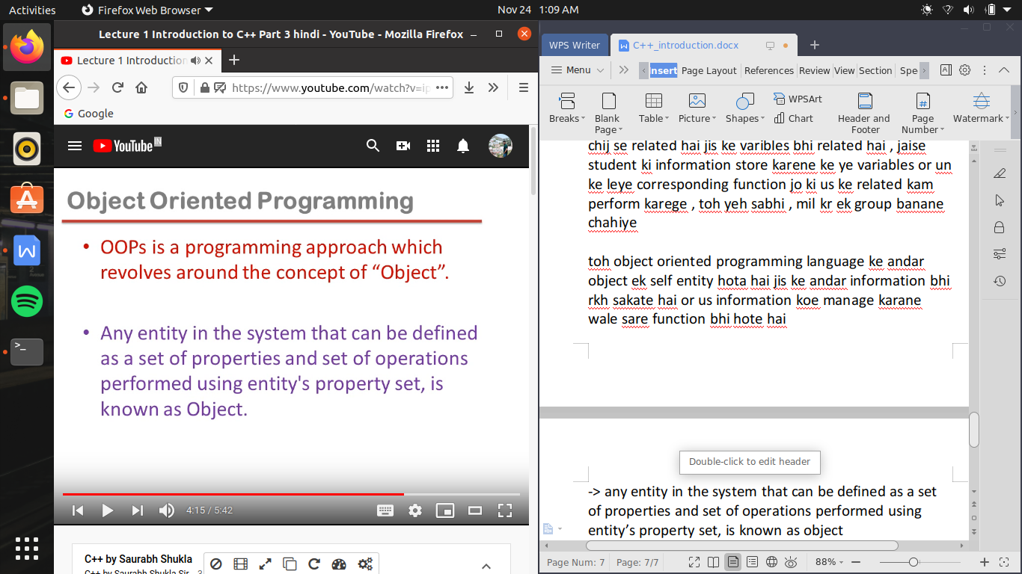

waise toh object oriented guildline me bahot kuch kaha gaya hai but agar hum es 5 principle ko samajh le toh kh sakate hai ki ham ne mote aur pr ese samjh liya hai

these 5 principles are :-

1. Encapsulation
2. Data Hiding
3. Abstraction
4. Polymorphism
5. Inheritance

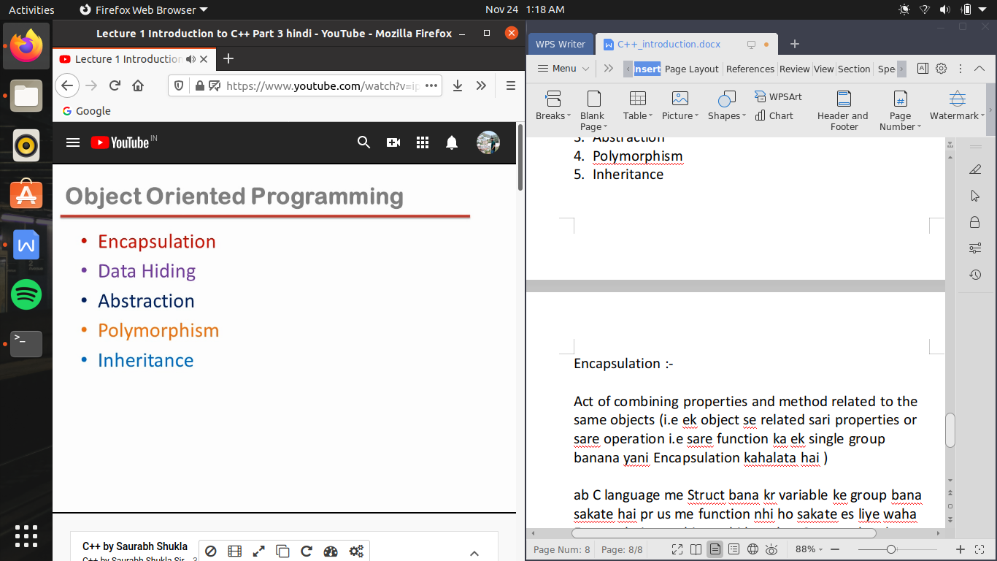

Encapsulation :-

Act of combining properties and method related to the same objects (i.e ek object se related sari properties or sare operation i.e sare function ka ek single group banana yani Encapsulation kahalata hai )

ab C language me Struct bana kr variable ke group bana sakate hai pr us me function nhi ho sakate es liye waha Encapsulation archieve nhi hota but C++ me class ke jariye aisa kr sakte hai

Concept of classes and objects :-

es ko samajhane ke leye ek ex lete hai jaise house banane ke leye us se pahale us ka blue print banaya jata hai us blueprint se samjh pate hai ki house kaisa deekhega but wo blueprint house nhi hai , us blueprint ki help se house banaga

wo Class is a blueprint of an object

hum kisi information ko rakahne ke leye variable banate hai , but ek variable me sirf ek information store ho sakati hai toh kayi sari information store karane ke leye hame bahot sare variable banane padege

object and variable me thoda sa fark hai , object ek bada memory block hai jis ke andar kayi sare variable hai , and variable ek single data contain karane wala block hai , jab hum nayi class banate hai toh hum ek naya data type bana dete hai , yeh naya data type non-primitive data type kahalata hai or es naye data type ki madat se banane wala variable object kahalata hai

toh variable bhi memory lega and object bhi memory lega , variable single value contain karega or object multi value yani ek record contain karega , or ek object ki memory me kitane varibles hoge hai , kya kya yeh value contain kr sakata a hai es ki puri design taeyar hoti hai class ke andar

toh class is a blueprint of an object mtlb object kaisa hoga memory me us ke andar kitane variables hoge

us ka size kya hoga yeh sari information hoti hai class ke andar

i.e

Class is a description of object’s property set and set of operations (yani es ke andar wo function bhi hoge jo object ke variables ko use karege )

ek object ke andar variables bhi hai or function bhi hai pr kon se function or kon se variables yeh class banate wakat decide hota hai

toh jab hum class banate hai toh banate bilkul waise hi hai jiase C language me hum structure banate hai toh class banana yani ek naya data type banana jise bolate hai user defined data type ya non-primitive data type ya customized data type

class bana kr hum Encapsulation ke concept ko archieve karate hai (for ex students se related information sare ke sare variables and sare ke sare funtion ek hi group me hone chahiye )

object is a run time entity (class ko memory nhi milati object ko milati hai class toh sirf object ka description hai toh object ko jo memory miulegi wo es adhar pe milegi ki class ke andar hum ne kitane variable banaye hai)

object is as instance (means example) of a class

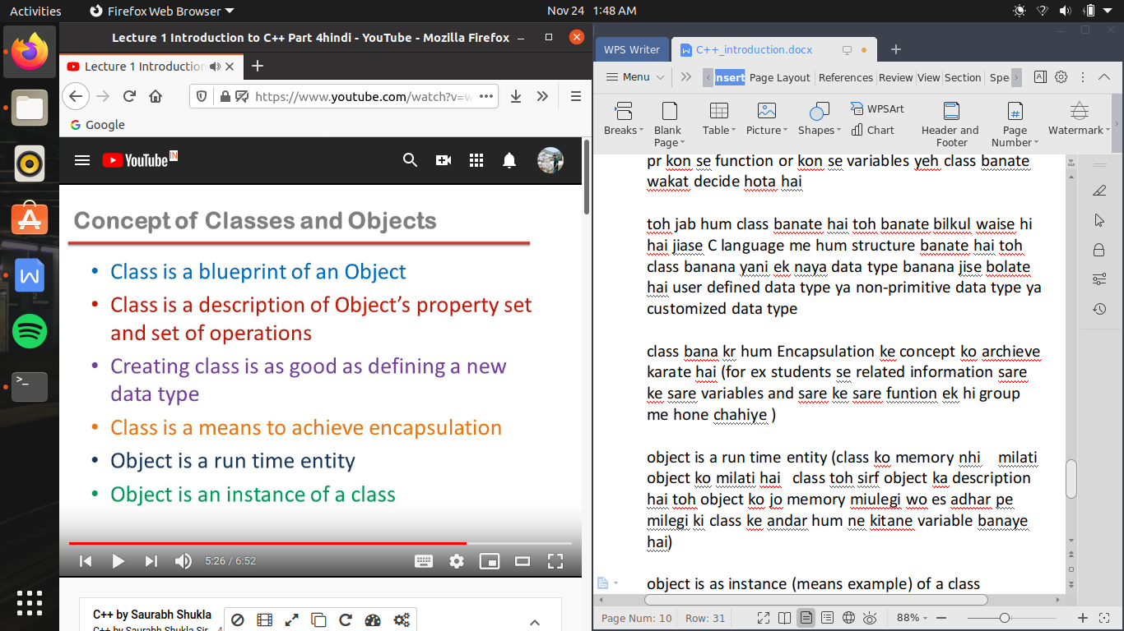

ab yaha pr hum ne ek box nam ka data type banaya hai

or ab us data type se hum b1 object banayege (yaha ese variable na bol kr object bolege)

ab b1 ko ram me memory milegi

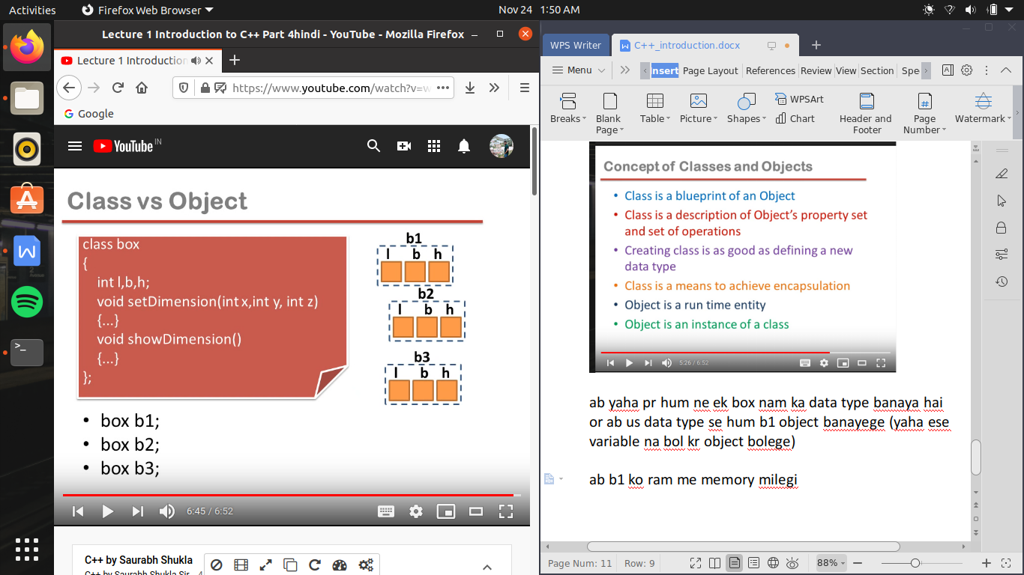

or agra hum es tarah se or object banaye jaise b2 and b3

ab note karane wali bat yeh hai ki b1 ke andar agal l,b,h hai or b2 or b3 ke andar alag

software development in c++ :-

it is just like C language

c++ me jo file hum coding kr ke banayege us ko extenction hoga .cpp

