Identifiers

constants -

Data = information = constant

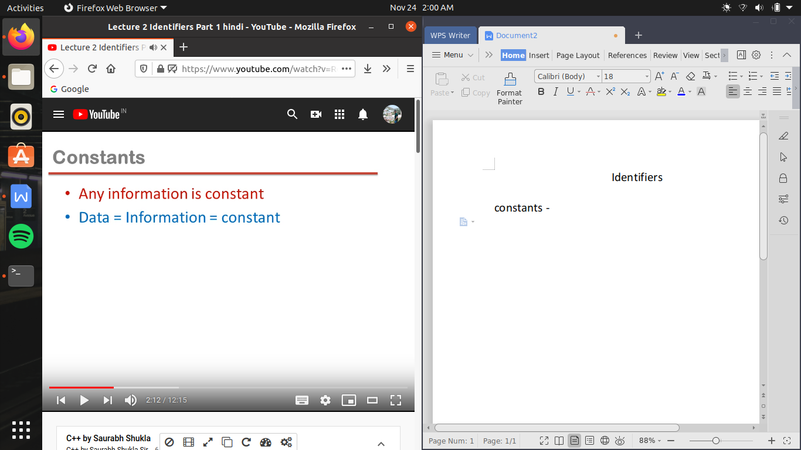

type of constant :-

integers - > numbers without decimals

reals -> numbers having decimals

character -> any number , digit , alphabet and symbol can be character constant , provided wo single coats me likha hona chahiye , infact space is also a character constant ex-( ‘ ’ ) or single coats ke andar keval ek hi symbol hona chahiye

i.e ‘-45’ is not character constant because es me - bhi a gaya

or agar ek se jayada charater constant ho toh ese bolate hai string , or ese double coats me likhate hai

“shashank”

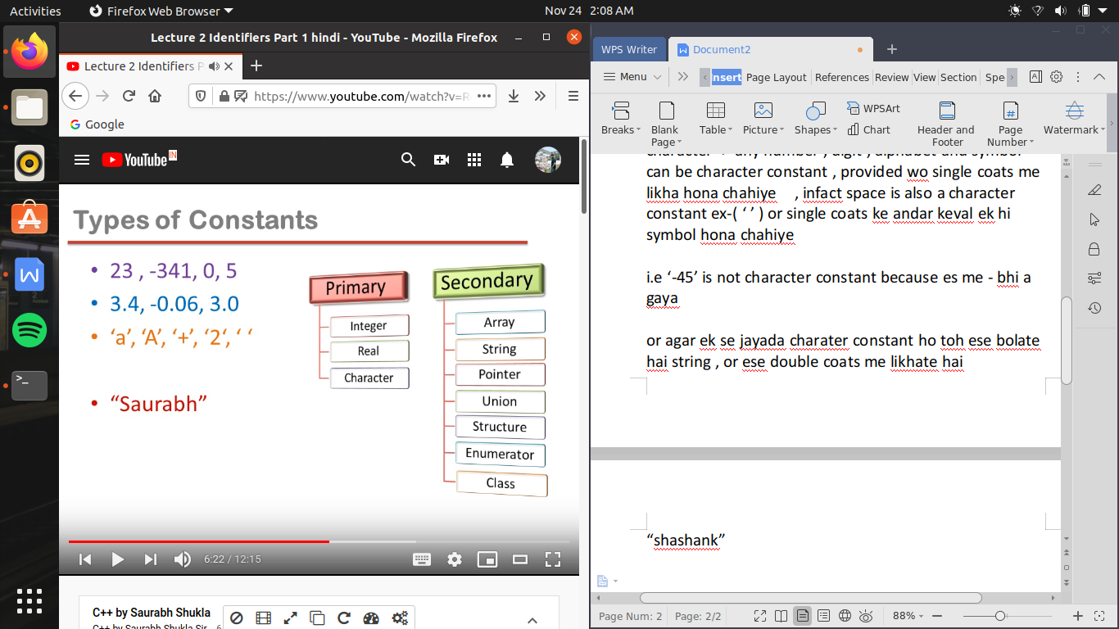

In memory :-

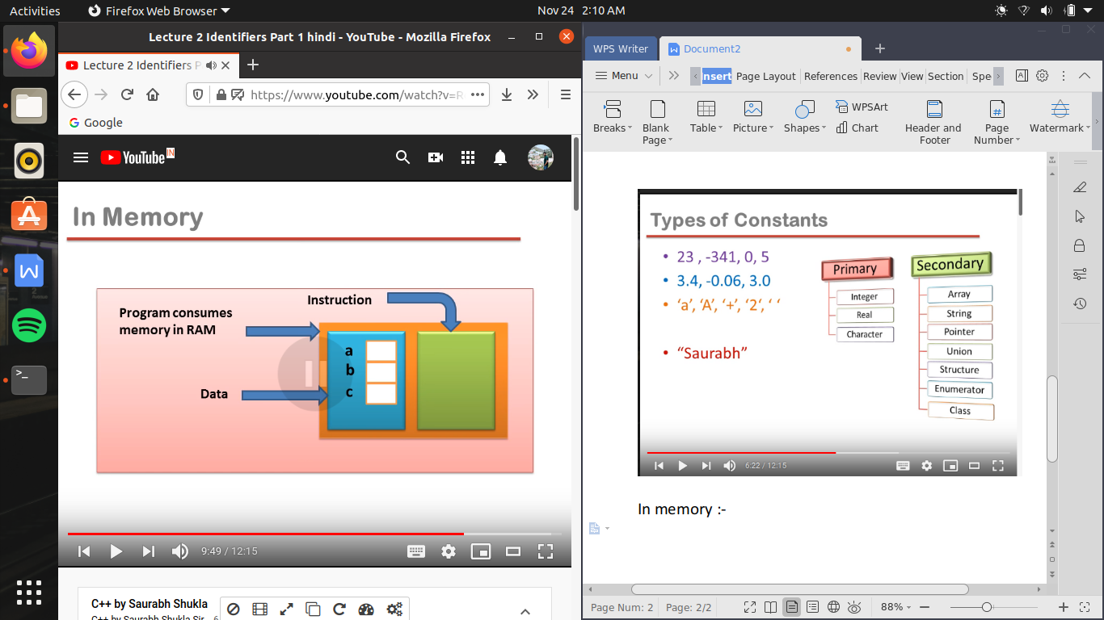

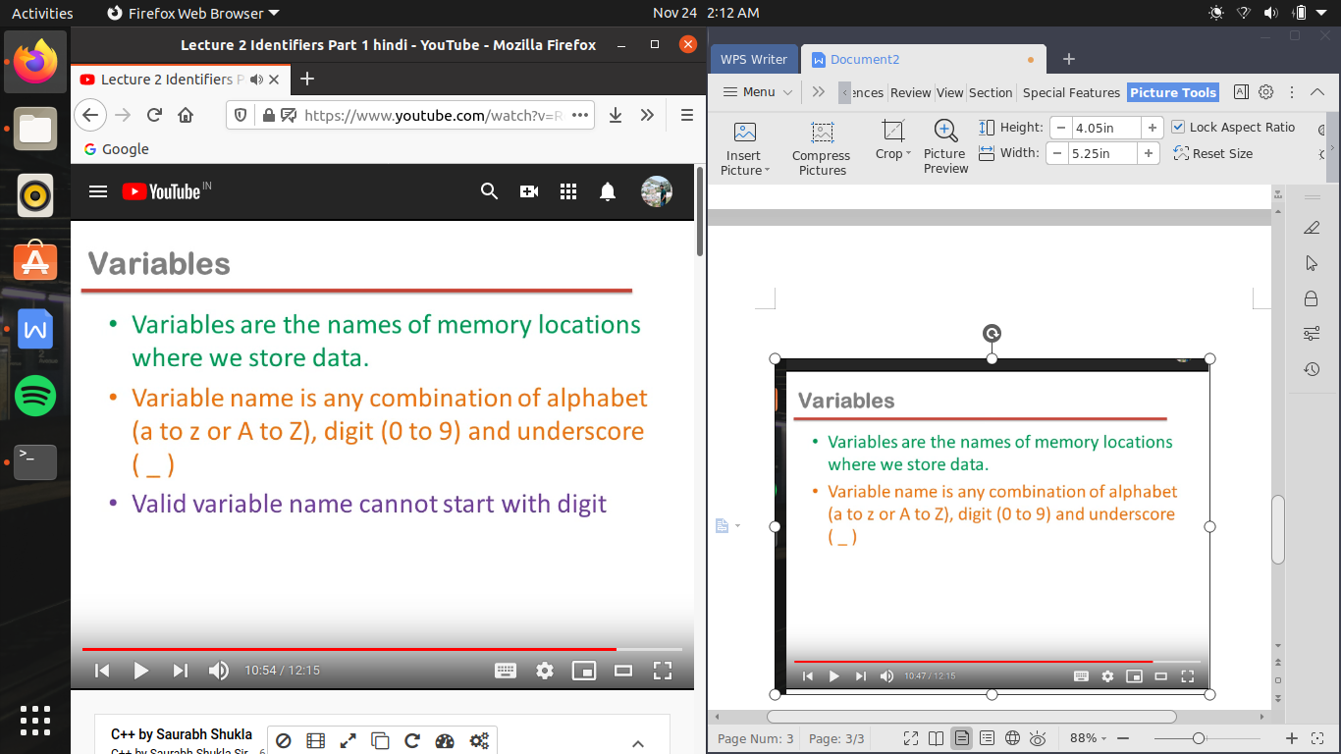

kisi bhi variable ke nam me alphabets ho sakate hai , numbers ho sakate hai or under score <_> ho sakata hai

but kisi bhi variable ke name me pahala number digit nhi ho sakata

keywords :-

yeh wo predefined functions hote hai ki ka meaning compiler ko pahale se pata hai hum use alaga se samajahane ki jarurat nhi hai

black wale keywords pahale se hi C me the

red wale C++ me naye introduce kiye gaye hai

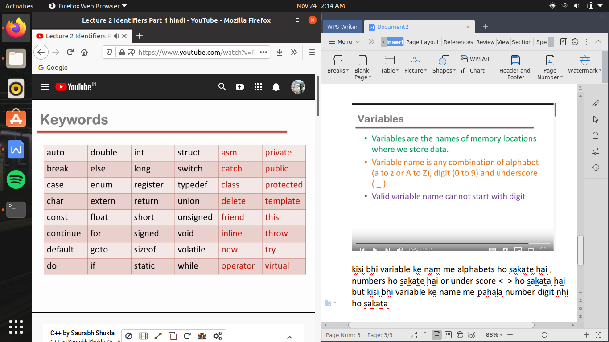

C me 32 keywords the toh us se bad kr C++ me ab 48 ho gaye hai

Data type :-

C ki tarah es me bhi data type wohi 5 hai

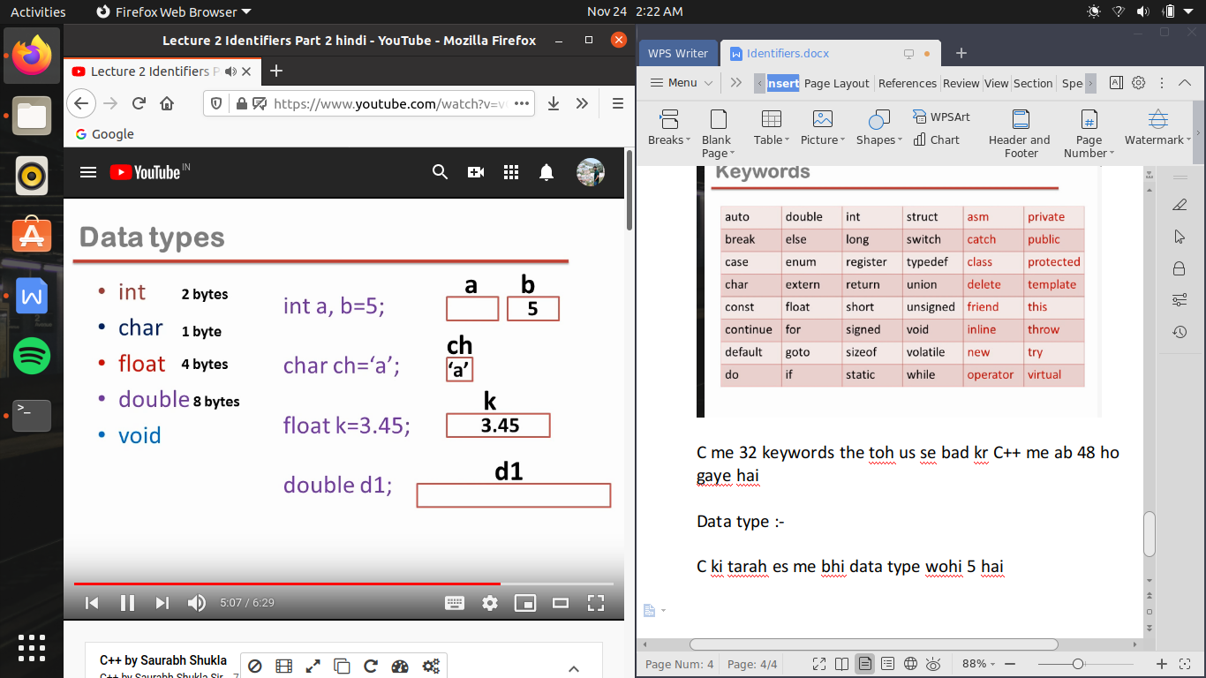

double variable ke andar bhi real variable store karate hai as like float but double 8 byte ka hota hai or float 4 bytes ka

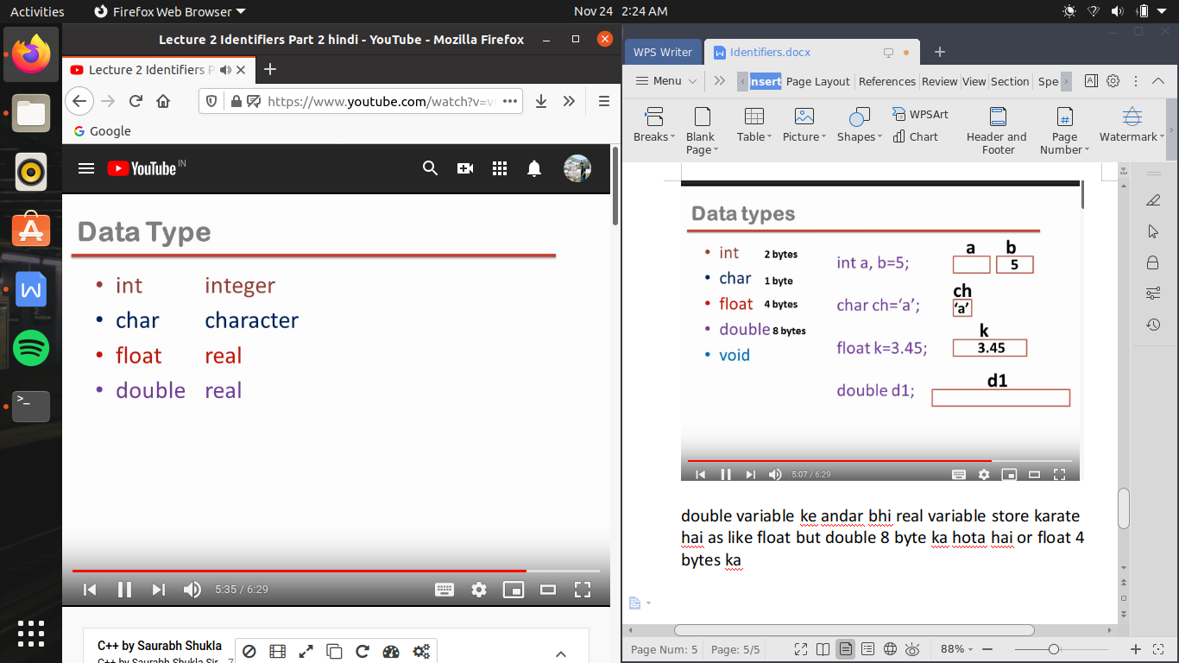

C language or C++ me difference yeh bhi hai ki har block ke andar action statement ke pahale hi decleration statement likhana hota tha

C++ me yeh naya rule hai ki hum action statement ke bad bhi decleration statement likh sakate hai

