Input output in c++

output instruction :-

as we know about printf() in C language

we can also use it in C++ but C++ hame ese acha ke option deti hai jis se hum screen pe koe me message print karawa sakate hai or wo hai

cout;

as we know printf(); is a function but here cout is not a function or es ke age koe parenthesis bhi nhi laga hua hai , function ke ange parenthesis us ki pahachan hoti hai

technically cout ek object hai

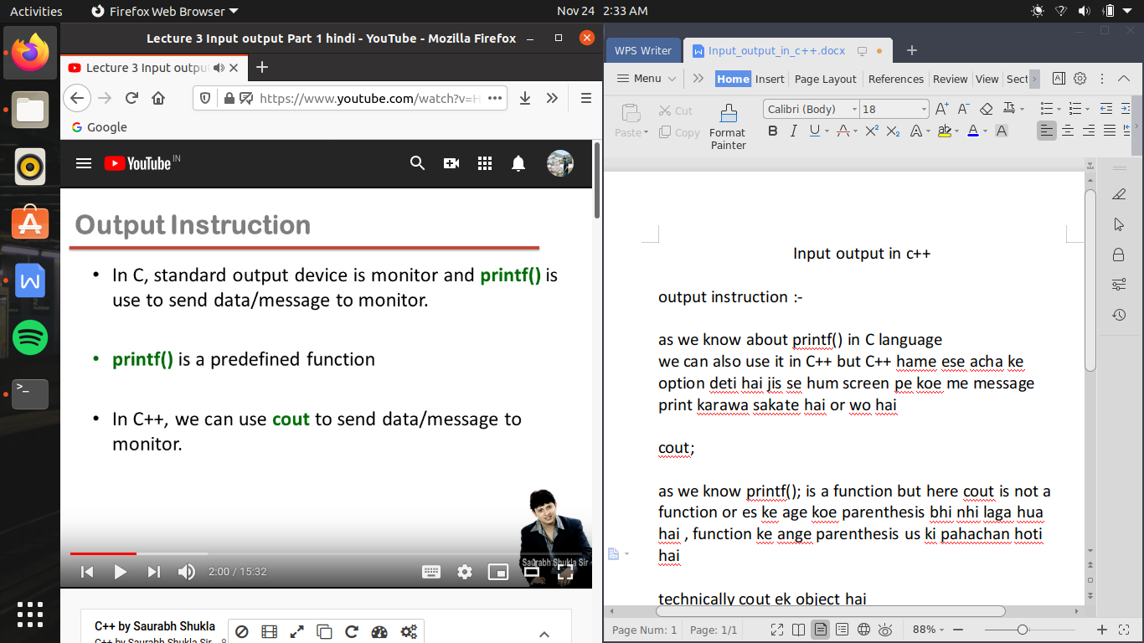

we can say that cout; is a prefined object

cout ke sath hame ek operator bhi use karana hota hai jise bolate hai insertion operator ya put to operator ,

basically cout ka kam es operator help se kisi message ko output stream me enter karana hota hai

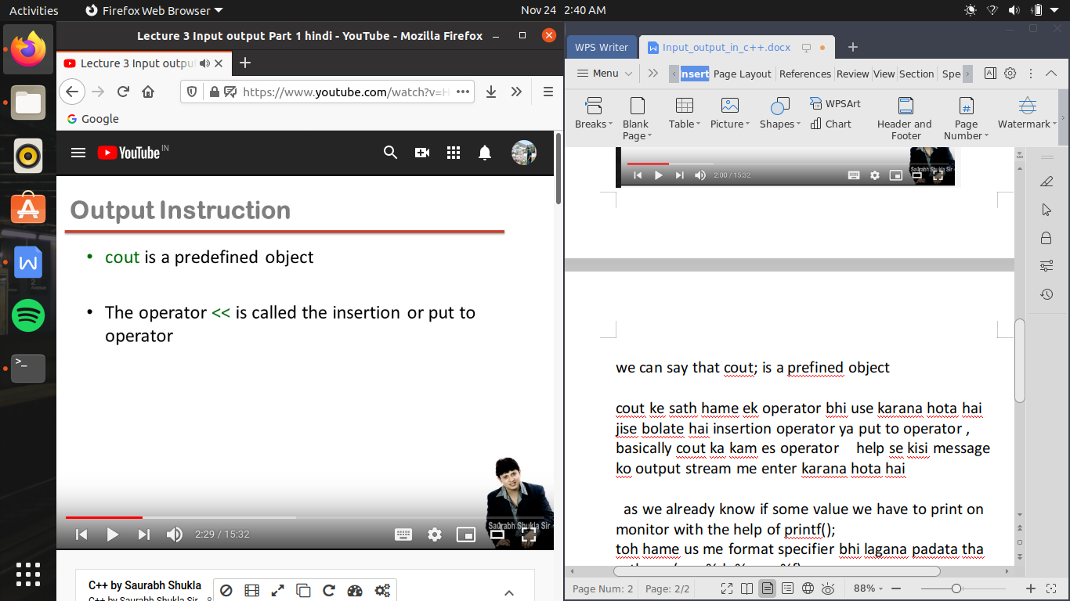

as we already know if some value we have to print on monitor with the help of printf();

toh hame us me format specifier bhi lagana padata tha sath me (ex - %d, %c, ya %f)

but in c++ hame format specifier ki chinta karane ki jaruart hi nhi hai

es me

hame jo as it is print karana hai use double coats me likhege

ex -

cout<< “sum of ”<<a<< “and ” <<b<< “is”<<c

es me pahale hame sum of print karwana hai toh ham ne ese double coats me likh diya fir ese insersion operator ke jariye print karwa diya ab seedhe variable ka nam likhege ab hame c ki value print karwani hai naki c alphabet so hum ese bina double coats ke likhege ,

and ek chij yad rahani chaiye ki double coats or bina double coats ek sath nhi likh sakate

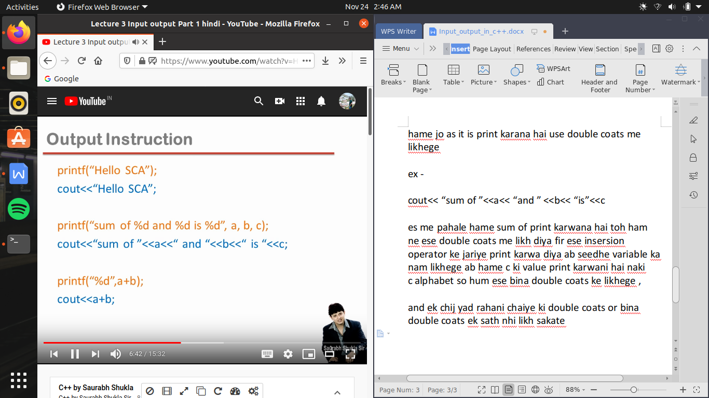

Input instruction :-

as we already have a predefined function to scanf();

use to take the input form keyboard

but here in c++ we have better choice named as

cin;

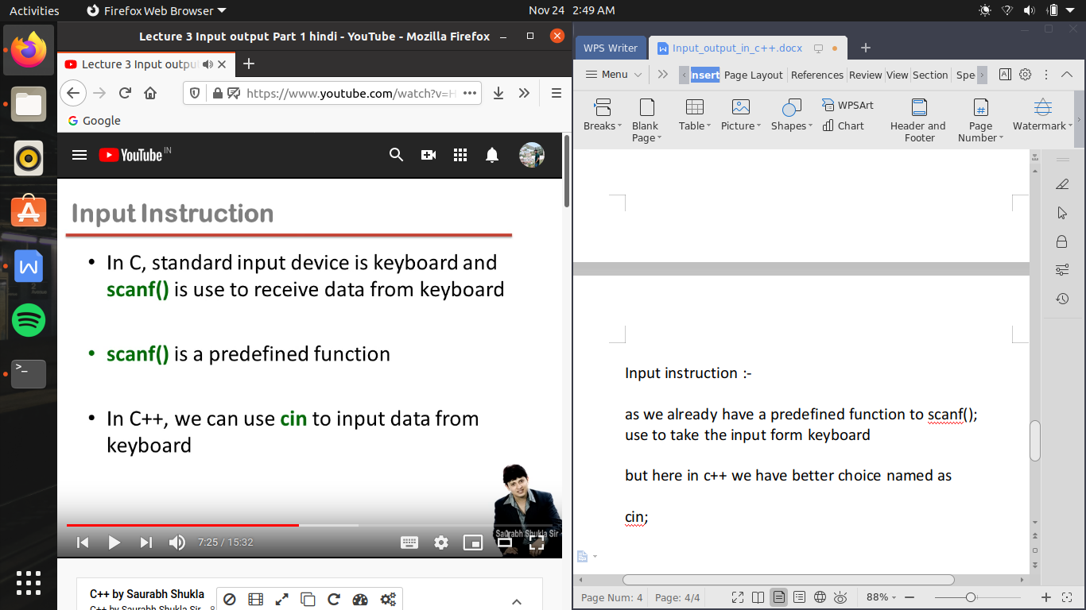

cin is also a predefined object ;

here we use >> is know as extraction operator or get from operator

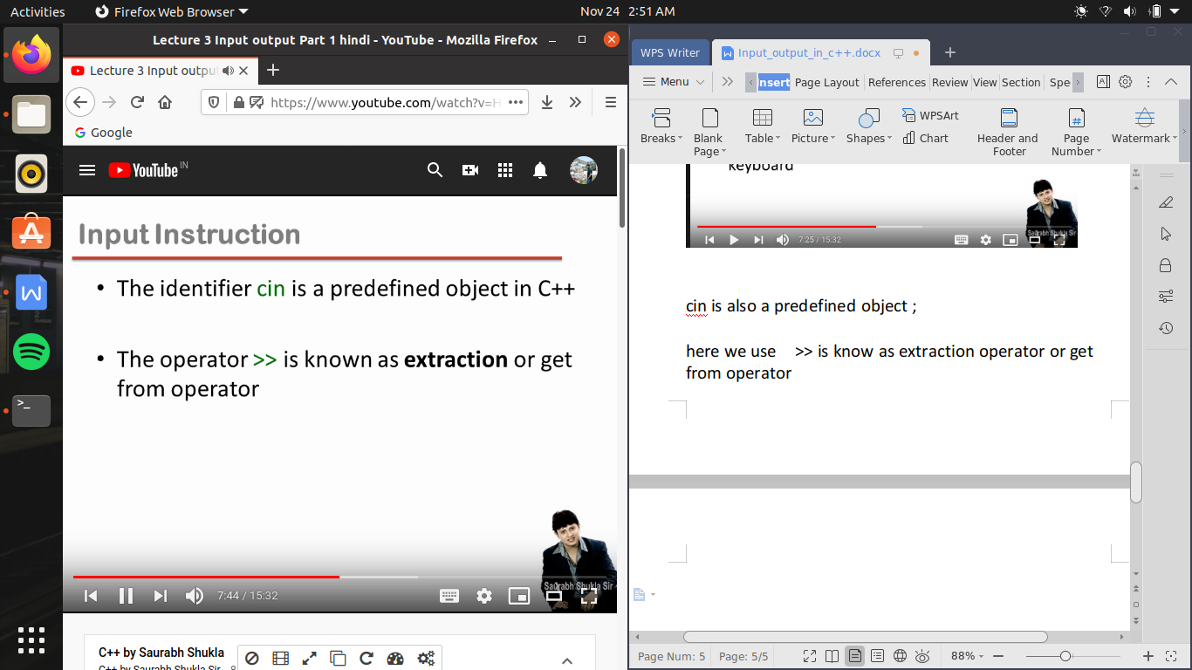

as in scanf(); we have to write format specifier as well as address of variable

but in cin , we direclty write the name of variable

and ek extraction operator ek hi value ko handle karega toh jitani bar variable lagayege utani ba hame extration operator ka use karana padega

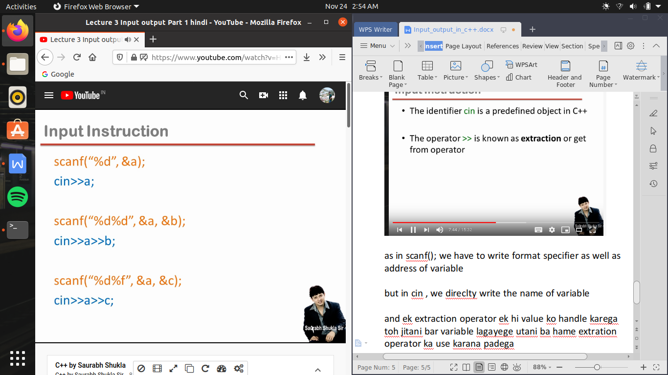

According to ansi standard for c is not mandatory to only recommended to do deceleration of any function

i.e #include<> (header file), which have deceleration of any predefined function

but here in C++ it is mandatory to do declaration of function.

header file only contain the deceleration of predefined function and it doesn’t contain any coding of that function

as that coding of that function include in (or any predefined function) available in library file

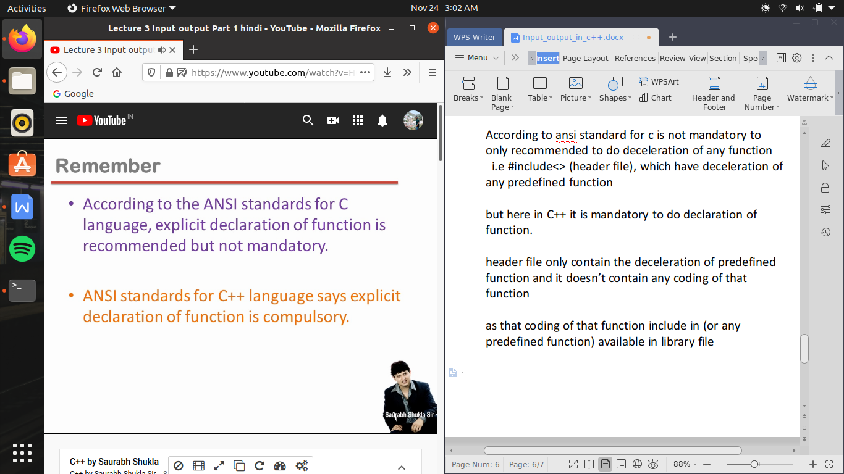

header file -

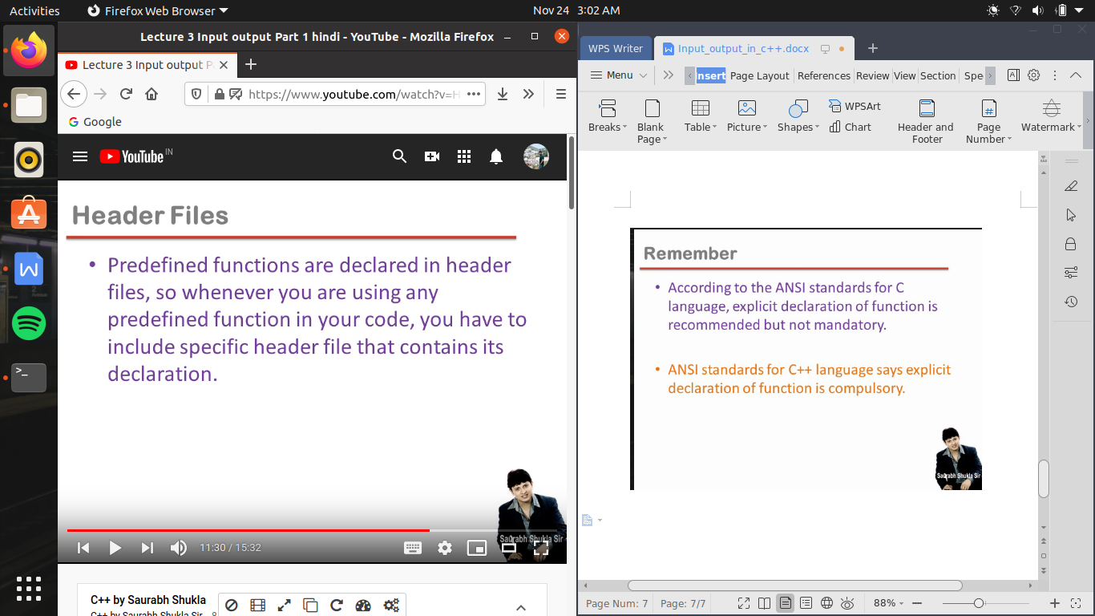

about iostream.h ->

yeh ek header file hai jo ki C me nhi thi C++ me introduce hue hai es header file ke andar cout and cin ka definition hai es ke alwaya insertion (<<) and extraction(>>) operator ka bhi definition include hai

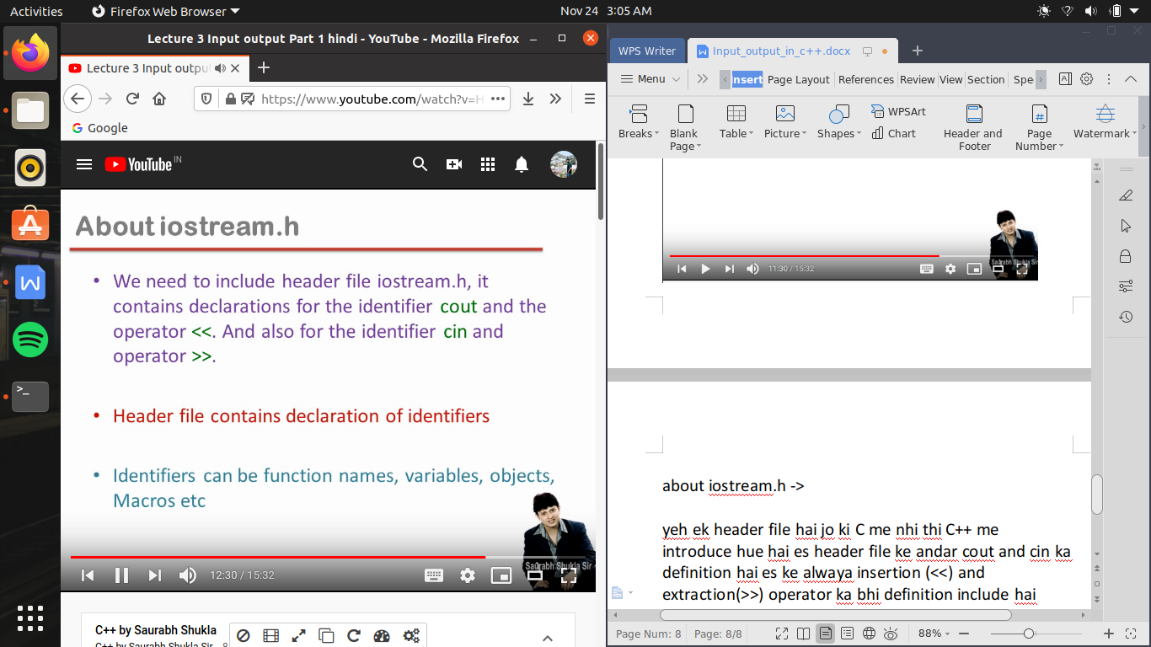

endl -> (it is same as \n)

hum cursor ko nayi line me le jane ke leye endl ka use karate hai ,

endl , ek manipulator kaha jata hai ,yeh ko key word nhi hai eska bhi decleration iostream.h me hota hai

es ko double coats me nhi likhege