constructor in c++

constructor ek member function hai class ka , es ki khas bat yeh hai ki hum ese dhek kr hi pahachan sakate hai, constructor ka nam us ke class ke nam se match karega , yani ek class ka nam hai student or agar us class me agar member banayege student nam ka toh wo us ka constructor mana jayega

constructor ki khas bat yeh hai ki es ka koe return type nhi hota jaise koe function ka agar return type na likhe toh use int mana jayega , but yaha aisa nhi hai , yaha constructor ka koe return type hota hi nhi hai es leye hum constructor ke andar hum return keyword bhi nhi likh sakate

constructor ek instance member function hai jis ka mtlb hai yeh kabhi static nhi ho sakata , instance member function , instances yani object ke leye chalte hai , or object ke dawara hi call kiye jate hai

toh constructor ek instance member function hai jise static nhi banaya ja sakata

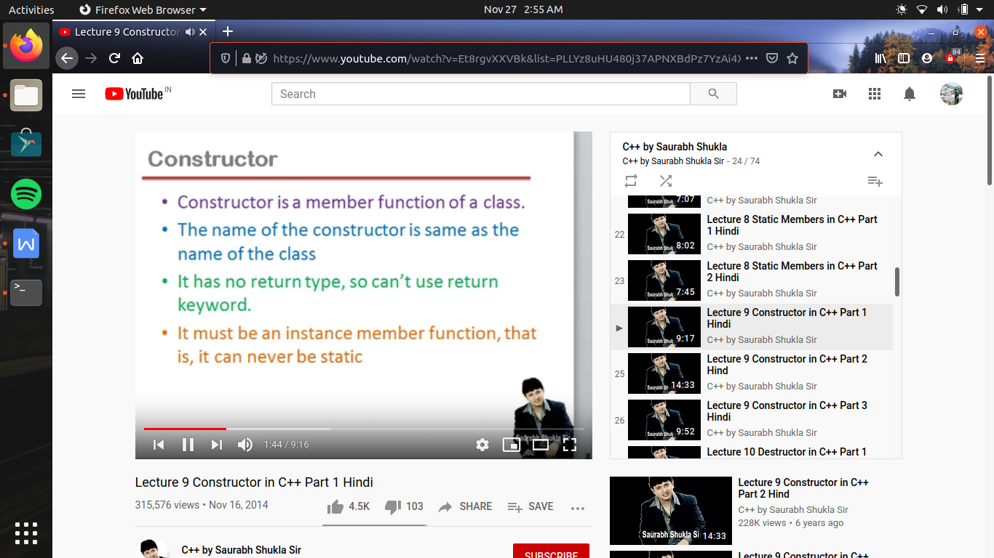

ab constructor ko call kaise kiya jata hai, toh constructor hum call nhi karate yeh apane app call ha hai , jab koe object create hoga

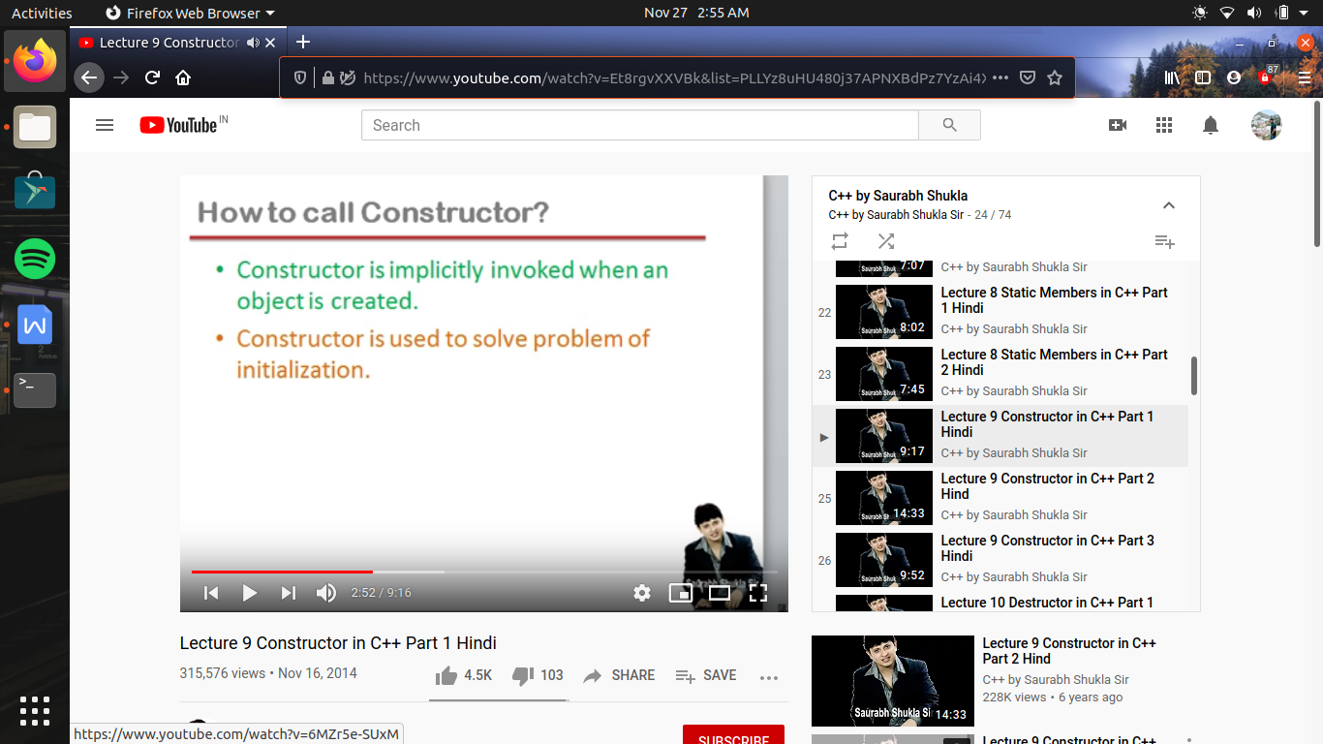

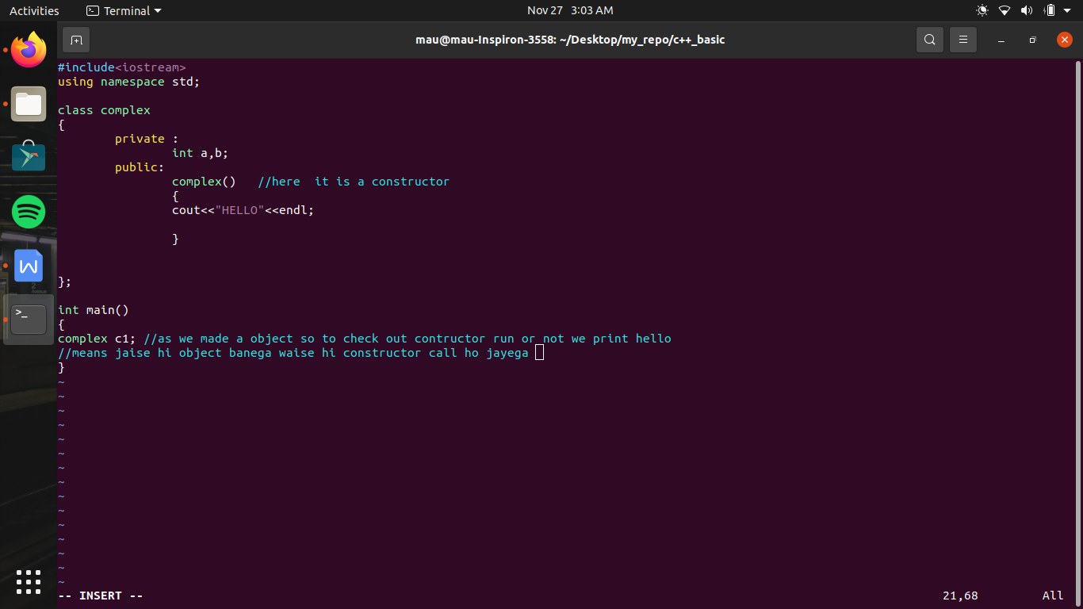

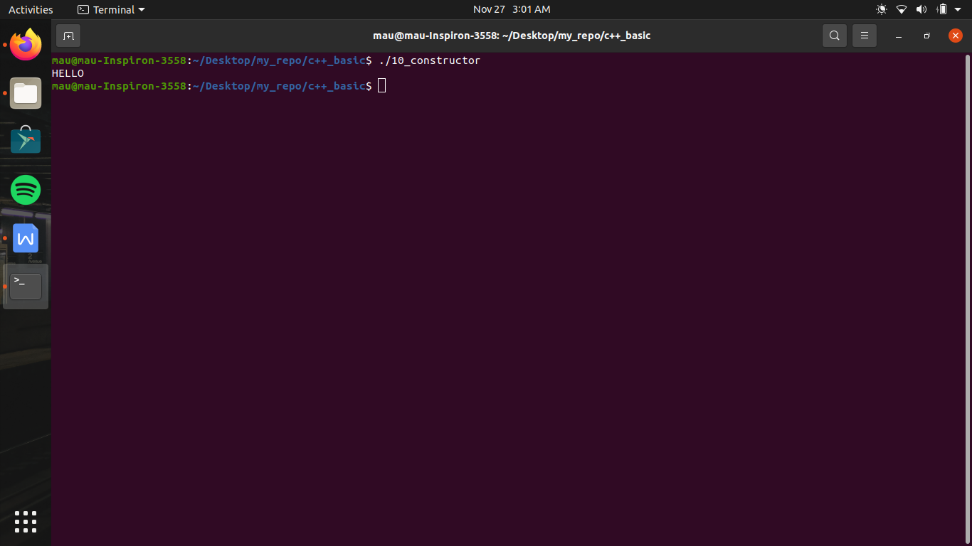

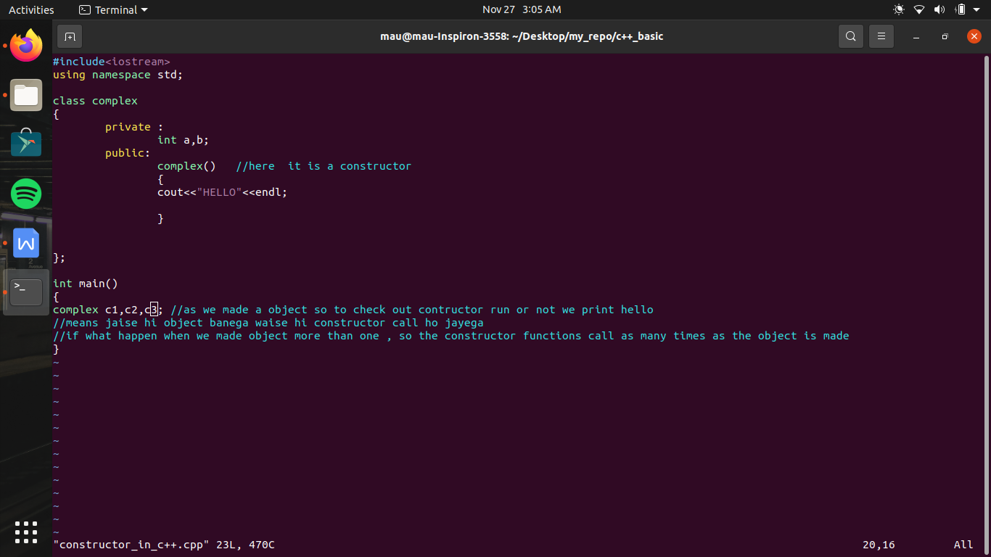

constructor used to solve problem of initialization

so what is the problem of initialization ?

pr pahale hame yeh samajahna hoga ki constructor ko constructor kyu kahate hai, because constructor , object ko object banata hai

jaise ham kisi se bolate hai ki ensan bano, but ensan toh hum pahale se hi hai toh ab kaha se bane , toh sayad us ko kisi ke andar ensan wale characters nhi lag rahe hoge

jaise hum likhate hai

complex c1; toh c1 sahi maene me object nhi bana hai jab tak yeh initialize nhi hoga

jaise hum ne hum ne char class ka object banaya , toh banate ke sath us ke member me rakha hua hai garbage value , lekin garbage value hone ke karad hum yeh toh nhi kh sakte ki yeh object koe actual char ko represent kr raha hai , ab object hota kya hai ,real world entity lekin yeh object toh abhi garbage value contain kr raha hai , as physical nature se toh aisa lag raha hai ki hum ne char class ka varaible bana liya hai pr yeh asal me kisi ko represent nhi kr raha hai , toh yeh hai problem of initalization

toh constructor kaise ese resolve kr ki constructor asie garanted function hai jo object ke banate hi call ho jata hai , toh jo kam hame object banate hi karwa dena hai toh wo constructor me likh dijiye , khas taur pr member variable ka intialization



now we see:-

1. default constructor
2. parameterized constructor
3. constructor overloading

#include<iostream>

using namespace std;

class complex

{

private :

int a,b;

public:

complex(int x,int y) //agar hame contructor me kuch arguments bhi pass karane ho // parameterised constructor

{

a=x; b=y;

}

//but ab yeh constructor call kaise hoga kyu ese x or y ki value chahiye hogi

complex(int k) //parameterised constructor

{

a=k;

}

complex() //default constructor

{}

};

int main()

{

complex c1(3,4), c4; //agar hame object banate time contructor funtion me value pass karani hai toh hum object ke bad parenthasis laga kr values mention karege

//or agar aisa ho ki hame ek or object banana hua pr us me keval ek hi value pass karani ho, toh es ke leye hum ek or contructor bana sakate hai jis me sirf ek hi value initialize ho rahi ho

complex c2(8);

//ab contructor me ek tarika or hai value pass karane ka

complex c3=complex(7,8);

//bs likhane ka tarika alag hai , baki mtlb toh ek hi hai

}

// or ab yaha kyu ki 2 version present hai contructor ke toh ese bol rahe hai constructor overloading

// i.e fuinction overloading i.e function ke nam same hai but arguyment me fark hota hai

// es me ek bat bilkul saf hai ki agar object banaga toh constructor call hoga , but agar hame ne koe contructor nhi banaya or us ke bad hum object bana rahe hai , toh bhi constructor call hoga , but wo default constructor hoga or use kahate hai implicit default constructor kyu ki use ham ne nhi compiler ne banaya hai

// but agar compiler constructor bana raha hai toh hame kyu nhi dhik raha , kyu ki compiler banata hai object file , or hum dhek rahe hai souyrce file toh , object file me costructor ki entry ho rahi hai

// ab esme khas bat kya hai ki yeh ko compiler constructor bana raha hai es me koe argument pass nhi hota i.e zero paramenter or us ki body me coding bhi kuch nhi hoti

// leking hota yeh hai kli jab hum koe object banate hai toh us ka yeh constructor call ho jata hai

// kyu ki compiler jo constructor banata hai wo takes nothing nature ke hote hai toh

// normally jab hum object banate hai toh koe error nhi ati , but jab hum us me argument pass kaarte hai toh us me error ati hai

// or rule yeh ki class me agar hum ne ek bhi constructor bana liya jo take somthing nature ka hai toh ab compiler koe constructor nhi banayega

// es ka mtlb ab hamare pass takes nothing nature ka ek bhi construtor nhi hai , toh ab agar hum object banayege jis me koe value pass nhi ho rahi ahi toh wo ab error dega

// toh es ke leye hame khud constructor banana padega jo takes nothing nature ka hi or us ke body me kuch na ho toh ese bolate hai defaut constructor

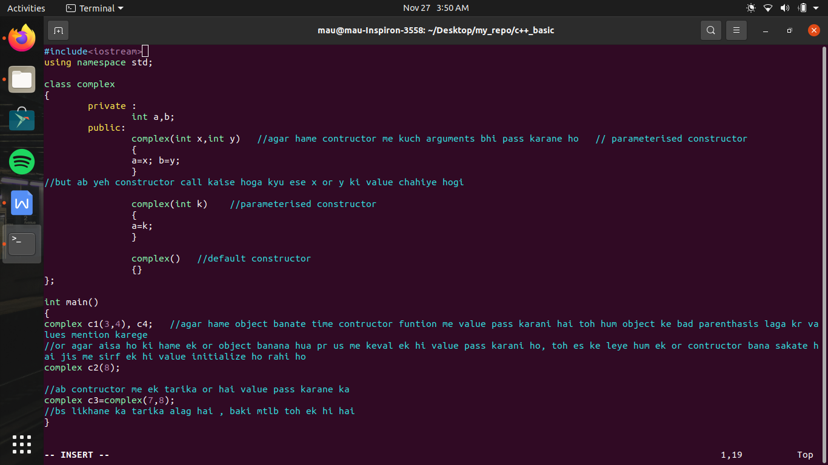

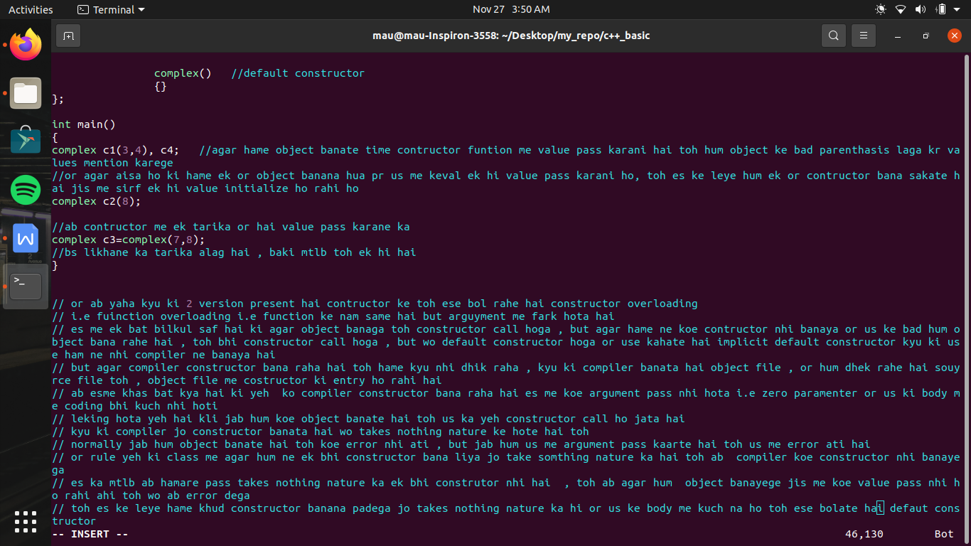

#include<iostream>

using namespace std;

class complex

{

private :

int a,b;

public:

complex(int x,int y)

{

a=x; b=y;

}

complex(int k) //parameterised constructor

{a=k;}

complex() //default constructor

{}

/\* complex(complex c) // ab yaha pr as because hum ek object bana rahe hai c toh fir se yahi function call hoga or yeh recursion ban gayega //toh yeh ek error hai or ese resolve karane ke leye hum object ka reference bana dege

{

a=c.a;

b=c.b;

} \*/

complex(complex &c) //copy constructor // here &c is a reference object , which is just another name of c1

{

a=c.a;

b=c.b;

}

};

int main()

{

complex c1(3,4); // pahala wala constuctor call ho raha hai

complex c2(6); // dusara wala constuctor call ho raha hai

complex c3(); // default construtor call hoga

complex c4 =5; // dusara wala constuctor call ho raha hai

complex c5=c1; //here we have to understand value of c1 value in object c5

//as c1 contain 2 value but yaha hum sirf ek comnplex type ki value pass kar raha hai

//ab wo ek ke andar 2 value hai usase fark nhi padata hum jo pass kr rahe hai sirf us se fark padata hai

//as waha ek value pass ho rahi hai toh pahala wala consturtor toh call nhi hoga

//or ab dusare define hai ki int type ka variable pass hoga but hum toh yaha complex type ka varaible pass kar rahe hai toh dusara wala

//contructor bhi nhi call hoga

//toh kya es me error ayegi , toh nhi es me koe error bhi nhi ayegi

//ab hum ne pada th aki jab bhi object banaga toh constructor call hoga

//or yeh wo constructor hai jo compiler bana raha hai

//pr compiler ke bare me hm ne pada tha ki yeh koe constructor nhi banayega agar hum ne ek bhi constructor banaya hai toh

//samajahiye compiler hamari class me 2 constructor banata hai , ek default constructor or dusare ko bolate hai copy constructor

//agar class me koe bhi constructor nhi bana hai toh compiler 2 constructor banayega , default constructor i.e bina argument ka or dusara copy constructor

//jo es situation me call hoga i.e which pass complex variable

//and if ham ne apani class me koe constructor bana diya hai , but copy constructor nhi banaya hua hai simple construtor banaya hua hai jaisa ki ham ne banaya hua hai, toh es case me default constructor nhi banayega compiler but copy construtor abhi bhi banayega

//ab agar hum copy constructor bhi bana lete hai toh compiler koe bhi constructor nhi banayega

}

