destructor in c++

destructors is a instance member function

(i.e kabhi static nhi ho sakata)

destructive member function ka nam wohi hota hai jo class ka nam hota hai

es me ek tilt (~) symbol laga hota hai class ke nam ke pahale

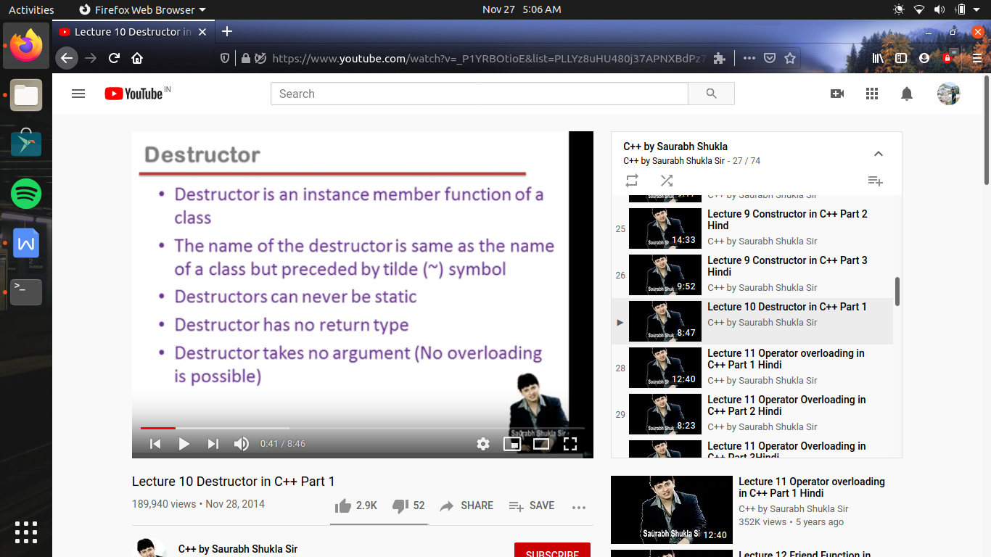

es ka bhi koe return type nhi ho sakata

destructor koe argument bhi nhi leta , toh jis se es me overloading jaisi problem bhi nhi ati

kyu ki ek se jayada version bhoi nhi banege , toh agar hum destructor nhi banayege toh compiler khud bana dega

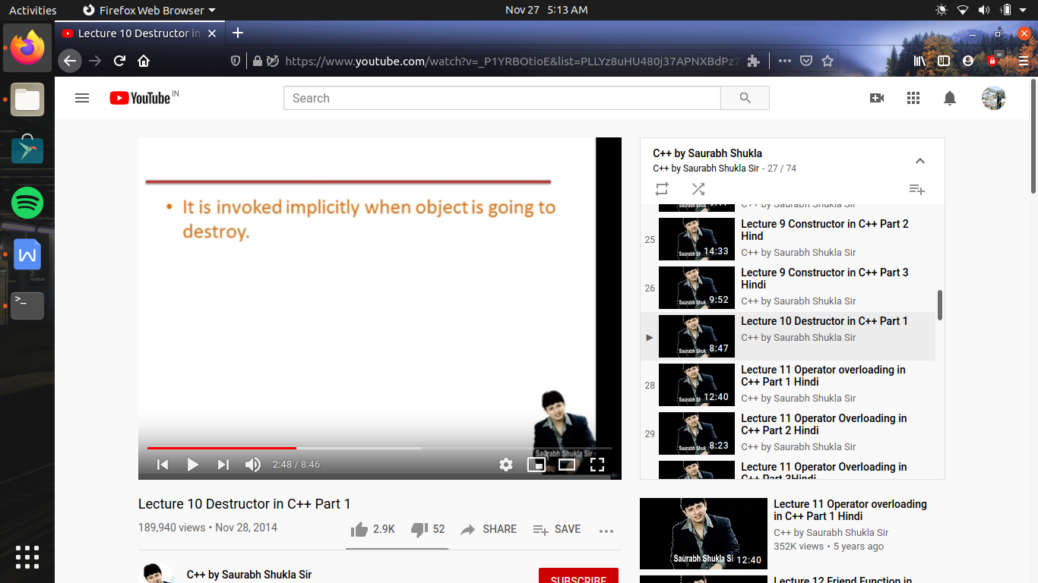 yeh bhi apane app ki call hota hai , or yeh tab call hota hsi jab koe object end hone wala hota hai (bahot logo ko yeh misconcept hai ki destructor object ko destroy karata hai) balaki destructor object ki jindagi me chalane wala last function hota hai , yani es ke bad object ka destroy hona tay hai

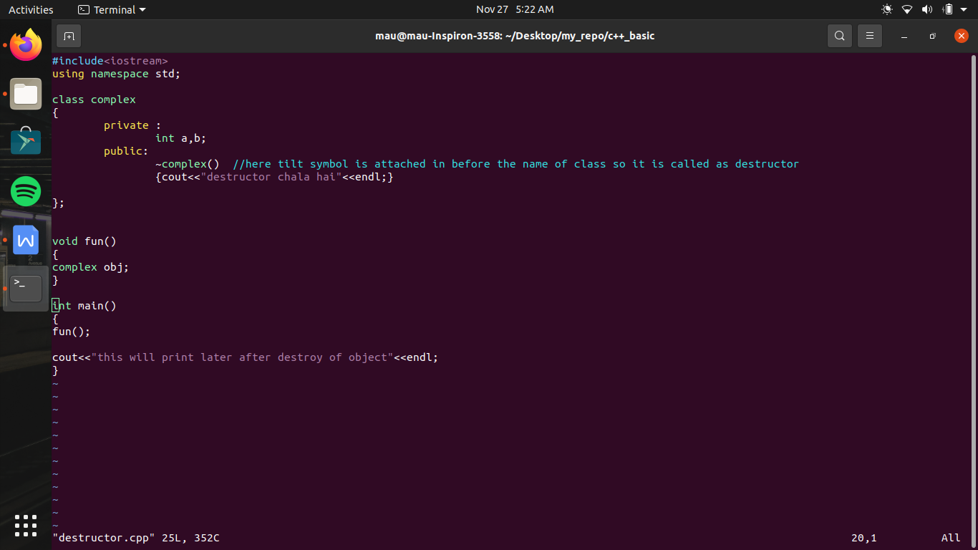

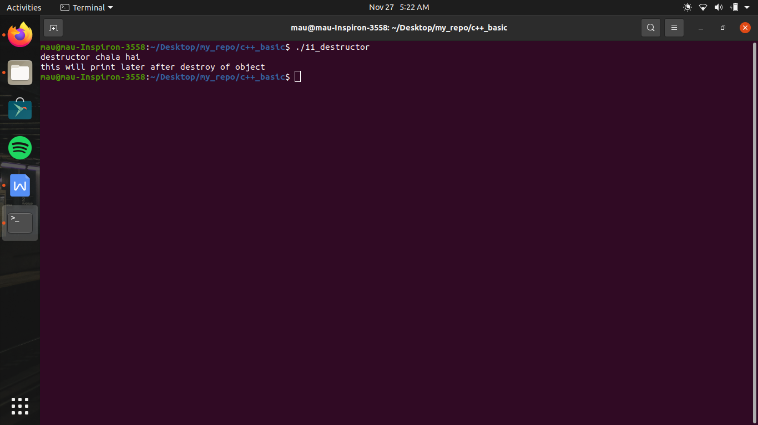

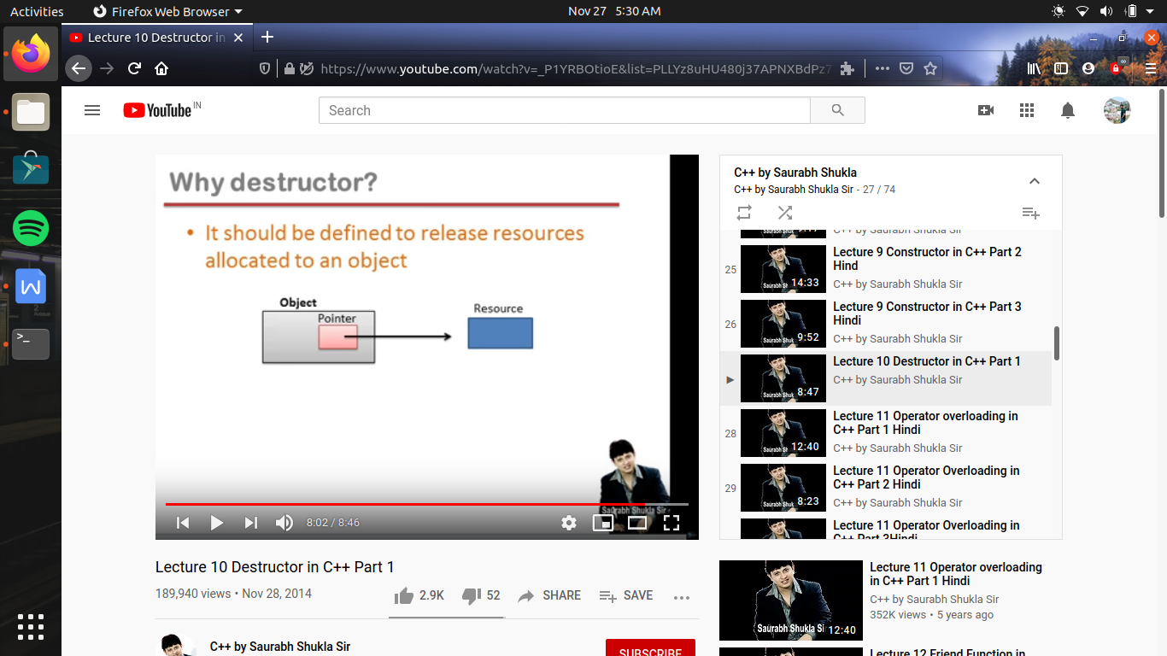

destructor wo function hai jis ke chalane ki gurantee hai , i.e object destroy hone ke pahale yeh chalega , yani aisa kam jo object ke destroy hone ke bad hum nhi kr payege toh aise kam hum destructor ke andar code kr dete hai

jaise , jo memory object ko assign ki gayi hai , object ki memory nhi , use free karwana

kyu ki agar kisi resource ko jaise ek pointer point kar raha hota hai , wo us resource ko us pointer ki help se access kr sakate hai , ab agar jab wo pointer destroy ho jayega , toh na hi hum us resource ko use kr payege or na hi use free karwa sakate hai

toh es ke leye hum object ke destroy hone se pahale us me rakhe variables ki memory free karawa lete hai