Referance variable in c++

Types of variable

1. ordinary variable
2. Pointer variable

But in c++ one new type of variable is introduced

1. Reference variable -> es ko banate time lagate hai m % symbol

As int &y=x;

As &y is in the left side of assignment operator so we didn’t read it as address of y. it is just a symbol jo compiler ko bata raha hai ki yeh reference variable hai

Reference variable ki shart yeh bhi hai kin ese banate time hi assign karana jaruri hai , or initialize bhi pahale se bane kisi variable se

And int &y=x;

Here it means y is a reference variable and y me x ka reference ja raha hai

Ab jo reference mtlb address, i.e reference or address ke hi bat hote hai

Jaise ki real life me pani word ka use hum ordinary work me karate hai or jal word ka use puja ke leye karate hai

Toh waise hi

Address word ka use pointer ke context me karege or lekin reference word ka use reference varaible ke context me karege

Actual me reference variable ek pointer hi hota hai but wo internally pointer hai hum hum aisa ahsas nhi hota

C++ hame ek modern type ka pointer provide kr raha hai reference variable ke roop me

Toh y me x ka reference jana mtlb y me x ka address jana toh but hum use address nhi bolate taki koe confusion na ho

ab es se hua kya ek bar jab hum y me x ka reference le lete hai toh hum y bolo kr hum x ko hi access karate hai

for ex y++; //we thought that address me increament ho jayega but aisa nhi hai kyu ki y , x ko reference kr raha hai toh y++ karane se y ki value nhi x ki value increment ho jayegi

kuch log es ko aise bhi bolate hai ki y is just another name of x.

toh ek hi block ke do nam ho gaye but yeh ek illusion hai or sachae yahi hai ki y bhi ek saperate variable hai or us me x ka reference rakha hua hai ,

but y bol kr ham y nam ke variable ko use nhi kr sakate hai , hum us ko use karate hai jis ko y reference kar raha hai yani x ko

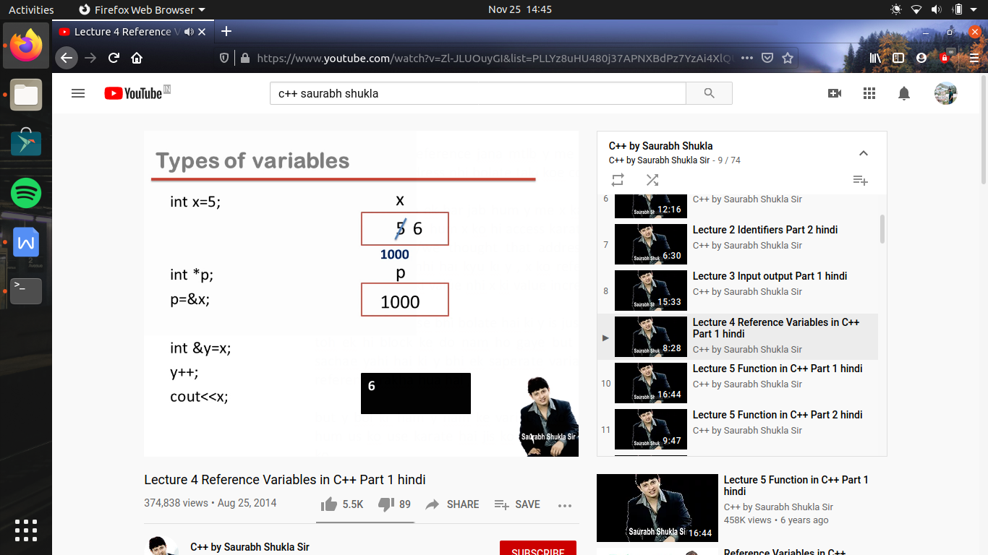

pointer can be updated but reference variable can’t be updated , yani reference variable banate time us time jis ka bhi reference us me rakha hai toh wo wo kabhi change nhi ho sakata

