static member

1. static local variable
2. static member variable
3. static member function

static local variable ka concept c language me bhi tha , but static member variable and function ka concept c++ me aya hai

static local variable :-

kisi block ke andar generally function ke andar banaya gaya variable jis ko static keyword se qualify kiya gaya ho

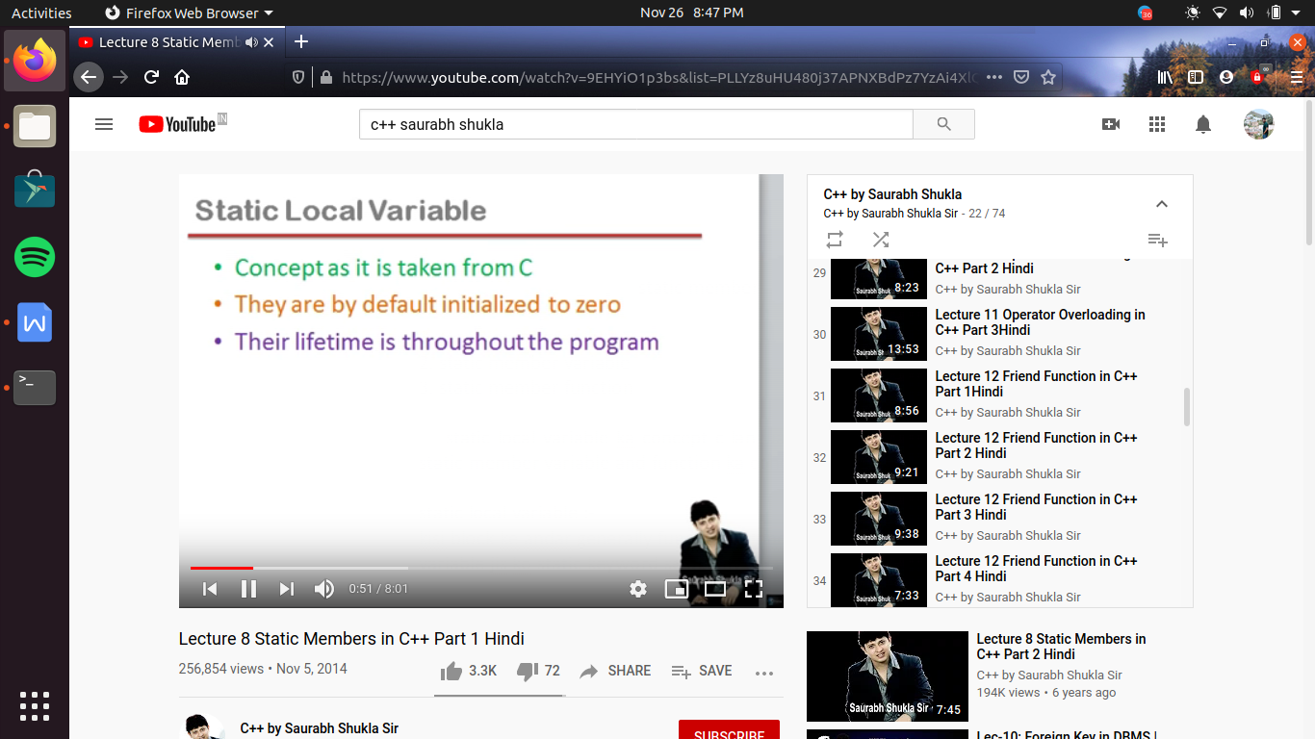

#include<iostream>

using namespace std;

void fun()

{

static int x; //ese memory tabhi mil jayegi jab program start hoga or end tak rahegi jab tak program end nhi hota

int y; //ese memory tabhi milegi jab fun() function call hoga or fun() function khatam hote hue hi yeh memory release ho jayegi

//agar initialize na kara jaye toh y me garbage value hogi

//or x me 0 hoga

}

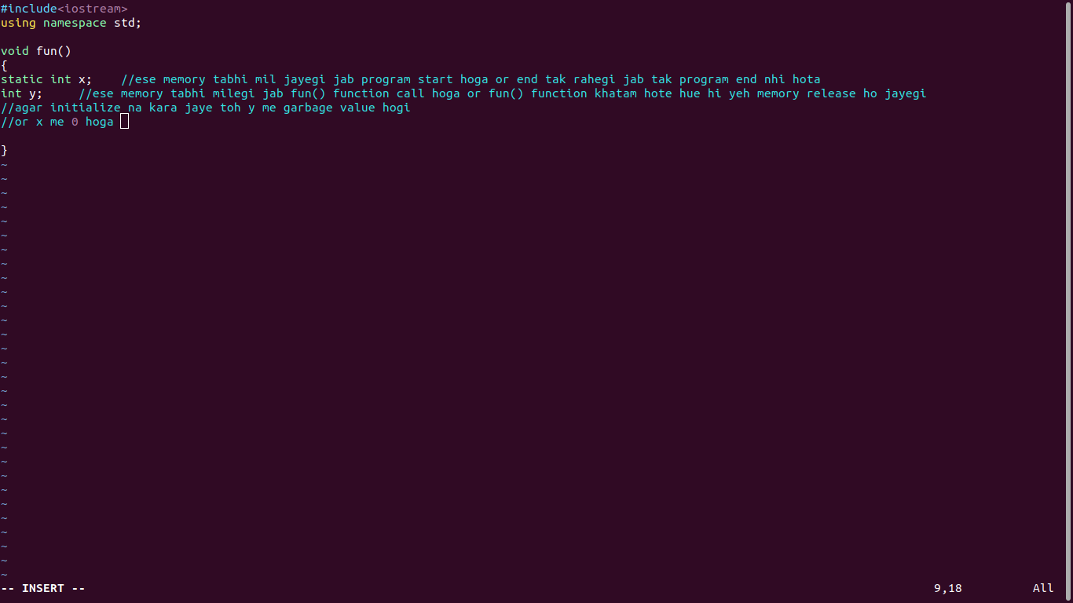

static member variable and static member function :-

kisi class ke andar banaya gaya variable jis ko static key word se qualify kiya gaya ho

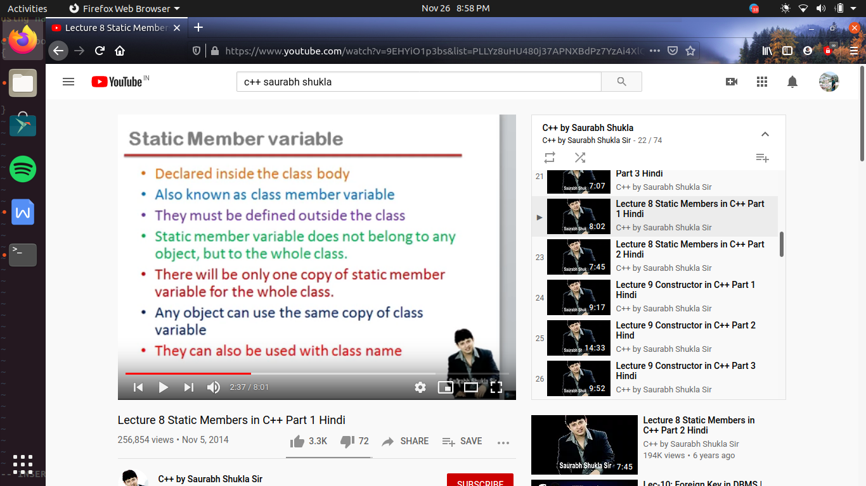

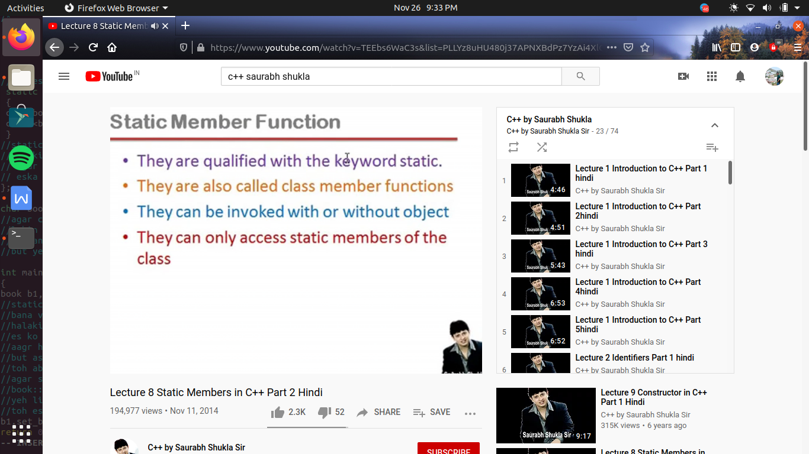

#include<iostream>

using namespace std;

class book

{

private :

int bookid; //this is instance member variable

static char booktitle[10]; // this is static member variable or class variable //ese boloate hai variable ka decleration karana

public :

void set_id()

{

cin>>bookid;

cout<<bookid<<endl;

}

/* void set_bookid() //as this is a instance member function so we can access it by object //but agar koe object hi na banaya ho toh

//hum ese access bhi nhi kr payege

{

cin>>bookid;

cout<<bookid<<endl;

} */

//toh es ke leye hum laga dege static before the funtion

static void set_booktitle() //so it becomes static member funtion

{

cin>>booktitle;

cout<<booktitle<<endl;

}

//static member function ki khas bat yeh hai ki yeh keval static member ko hi access kr pate hai

//kyu ki yeh function bina object ke bhi call ho sakate hai

// agar object na ho toh sirf hame <class ka nam>::<function ka nam likhana hoga>i.e book::set_booktitle();

// eska mtlb hum static member funcntion ko bina member ke call kr sakte hai

};

// char book::booktitle="shashank"; //jab hum ese define karege tabhi ese memory milegi

//agar chahe toh at the time of definition ese me value assign kr de warana esme by default 0 hoga

//lekin es variable ki memory object pr depend nhi karati ese leye ese class variable kaha jata hai instance varaible nhi kaha jata

//instance variable ka matlb hi hota hai jo instance ko belong kare i.e object

//but yeh instance ko belong nhi karata

int main()

{

book b1,b2; //es me account class ka ek object banaya hai b1 , jis ke andar ek hi variable hai bookid

//static keyword ke bana varaible object ka part nhi hota , es ka mtlb aagar hum ek bhi object nhi banate book class ka tabhi static keyword se

//bana variable exist karata

//halaki c++ me static keyword se bana varaible ko declare bar kr dene se ,es varaible ko memory nhi milati

//es ko class ke bahar define bhi karana padat hai

//aagr hum ek or object bana de b2 toh es ke leye bhi bookid ek variable hoga

//but as member variable doesn't depend on object hence pure program me sirf ek hi booktitle variable banega

//toh ab agar hum ne koe object nhi banaya tabhi static member variable ban jayega toh ese access kaise karege?

//agar static member variable , public hota toh hum

//book:: booktitle = "shashank";

//yeh likh kr access kr lete pr yaha yeh private hai toh

//toh eske leye hum ek function bana lege

//b1.set_booktitle();

book ::set_booktitle();

return 0;

}

