template in c++

template , c++ languaage me ek keyword hai , jis ki madat se hum , function template or class template banate hai

ab template kya hota hai?

jaise ki hum gaye bank me account me paise jama karane ke leye , toh hame ek slip bharani padati hai, jis wo sari necessary information hoti hai , jo bank ko chaiye account me paise transfer karane ke leye , yeh slip ya form ek tarah ka template hai jis me bahot sare fill in the blanks hai

or yeh form har customer ke leye same hota hai , toh yeh form hi template hai , hum usme value put karate hai jisase hi ,template ek gernalized structure ho jata hai

toh template ka meaning ek samaj aya ki template ke tarh ka format hai

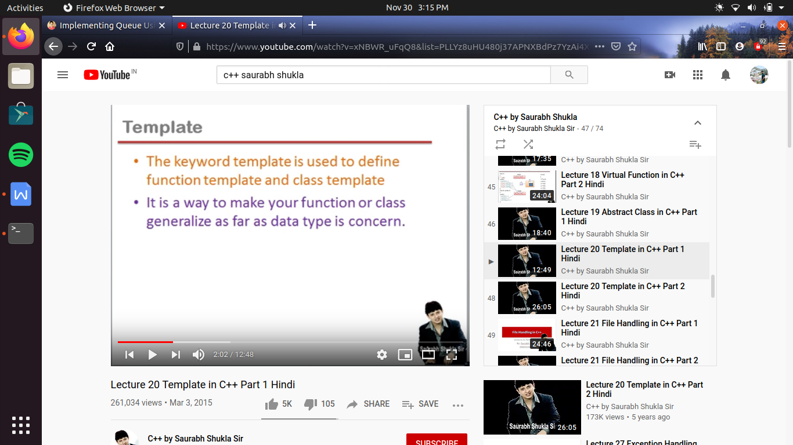

es template ka 2 jagah use hota hai ek function template banane me or ek class template banane me

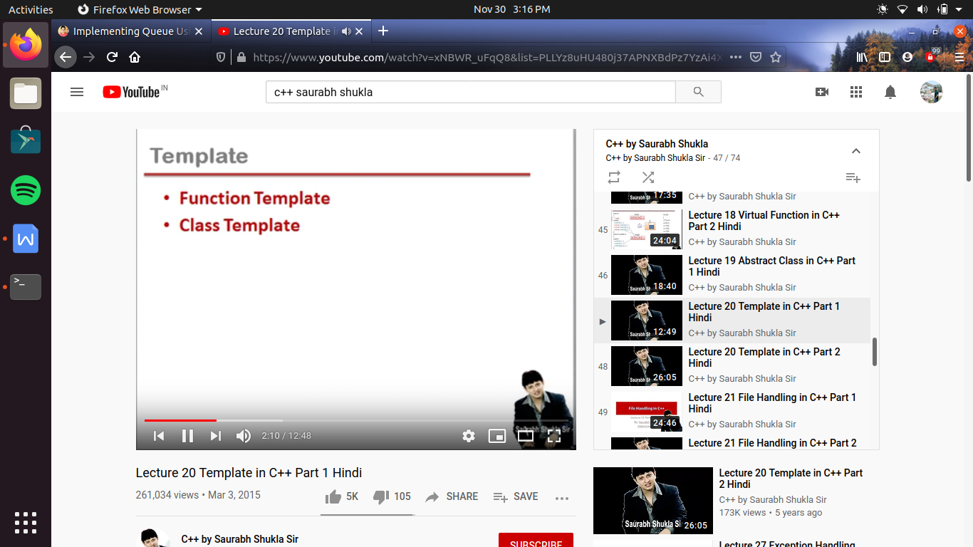

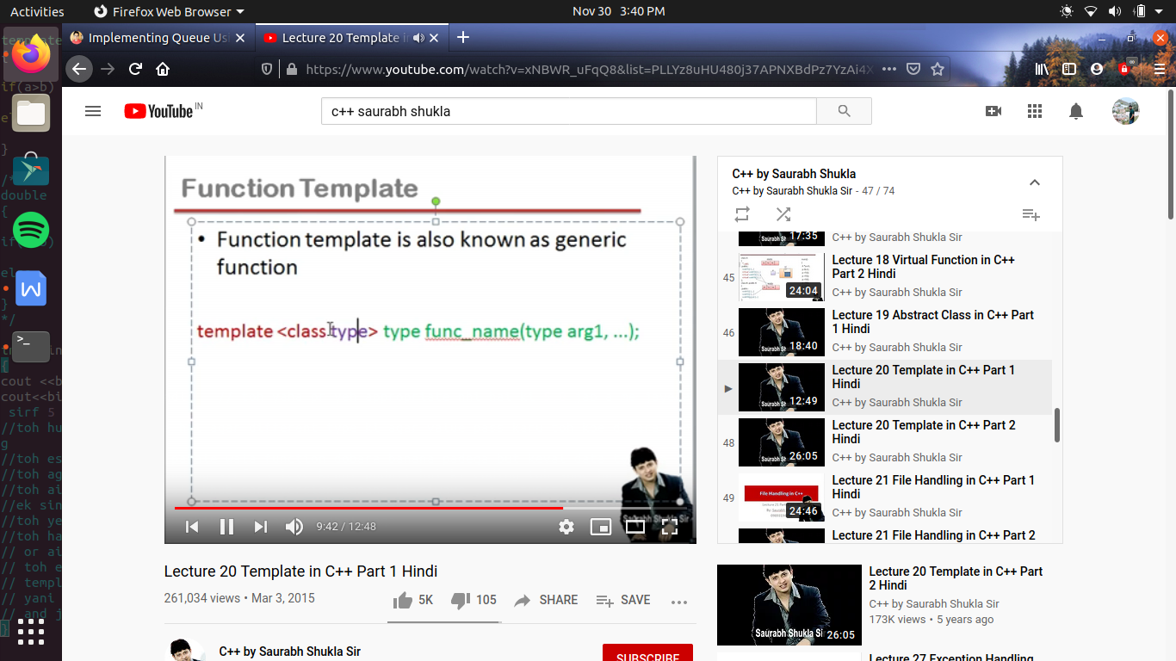

#include<iostream>

using namespace std;

template <class Q> Q big (Q a, Q b) //hum yaha pr ek se jayda place holder bhi bana sakate hai , jab hum argument me alag alag type ki value pass kar rahe hote hai

// like -> template <class A, class B> A big (A x, B y);

{

if(a>b)

return a;

else

return b;

}

/*

double big (double a, double b)

{

if(a>b)

return a;

else

return b;

}

*/

int main()

{

cout <<big(4,5)<<endl;

cout<<big(5.8,3.2)<<endl; // toh yaha pr yeh appropriate nhi hai ki 5.8 jab a me jayega ,as kyu ki a ek int type ka variable hai toh data loss ko kr sirf 5 bachega

//toh hum yaha chahate hai agar different type ki agar value pass karu toh koe dusara function call ho , that means hame yaha karane padegi overloading

//toh es ke leye hame pahale wala function dobara banana padega but keval data type me antar kr dege

//toh agar hame overloading sirf es leye krani padati hai ki coding toh same hai or no. of argument bhi same hai , lekin data type fe fark hai

//toh aise me hum alg alg khub sare version banane ki siwaye , i.e function overloading karane ki banajaye

//ek single version bhi function ka bana sakate hai jo etana gernalized ho , ki alag alag type ki value bhi pass kr ke es version ko call karate hai

//toh yeh zarurat ke mutabik apane app ko dhal lega

//toh hame aisa ek hi function banana hai , jo ki aisa kr pate hai template ki help se

// or aisa karane ko hi hum kahate hai function template banana , toh jis function ko hum generalized banana chahate hai

// toh es me hum function ke age template likh dete hai or sath me angular bracket me class or us class ka nam likhe dete hai jaise

// template <class Y> Y big (Y a, Y b); now here Y is treated as data type which customized their self as the function and argument demands

// yani jab hum function ko call kaarte time int type ki value pass kr rahe hi toh Y hojayega int

// and jab double type ki value pass karege toh Y ho jayega double

}

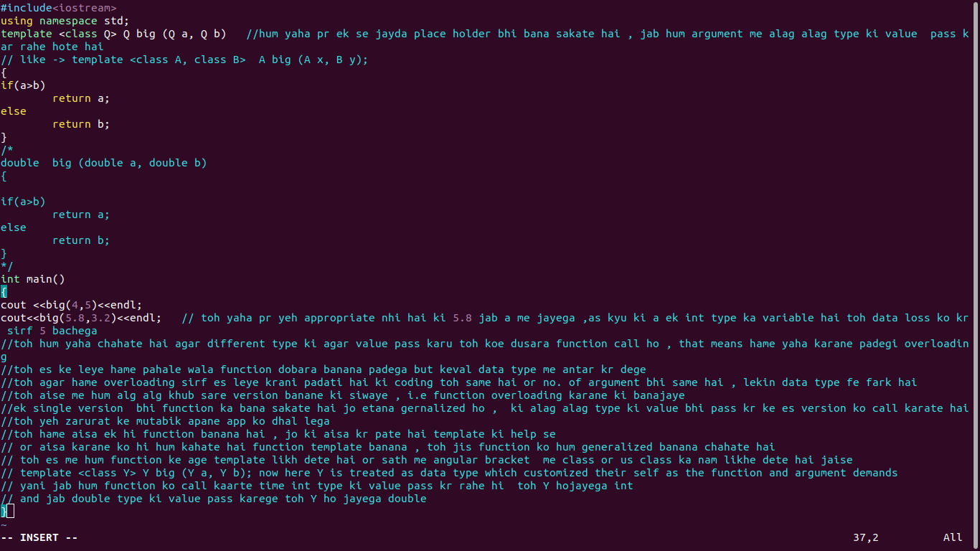

class template ->

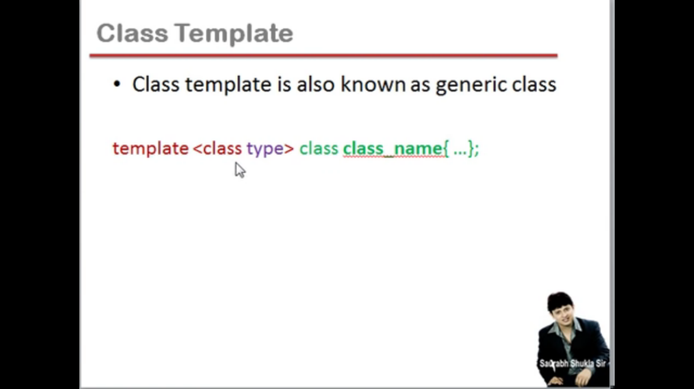

#include<iostream>

using namespace std;

template <class Y> class arraylist

{

private:

struct controlblock

{

int capacity;

Y * arr_ptr;

};

controlblock *s;

public :

arraylist (int capacity)

{

s=new controlblock;

s->capacity=capacity;

s->arr_ptr = new Y[s->capacity];

}

void add_element (int index , Y data )

{

if (index>=0 && index <= s->capacity-1)

s->arr_ptr[index]=data ;

else

cout<<"\n array index is not valid "<<endl;

}

void viewelement (int index, Y &data)

{

if (index>= 0 && index<=s->capacity -1)

data =s->arr_ptr[index];

else

cout<<"\n array index is not valid"<<endl;

}

};

int main()

{

float data;

arraylist <float >list1(4); //hamane object banate time 4 ese leye pass kiya kyu ki hamane banata hai ek constructor toh wo demand kr raha hai , ek argument ki //jo hi array ki capacity bata raha hai

list1.add_element(0,5.27);

list1.viewelement(0, data);

cout<<"value in the array is "<<data<<endl;

}

//ab agar hum yeh sare funtion int ke leye na kr ke float ke leye karana ho toh hame yeh sab dobara likhana padega , bs us me data type kr dege float

//ro hame asia nhi kara padega agar hum template ki help se class banaye

//toh or sath hi me hum jab object banayege toh hum anguar bracket me bas likhana hoga ki yeh int hai ya float

