this pointer in c++

object painter -

as we know , pointer jis type ka hota hai usi type ki value contain karata hai , i.e agar hum int type ka pointer banate hai toh us me int type ka hi address contain karege

or agar hum object oriented programming me samajhe , agar hame kisi class ke object ka rakhana hai toh hame chahiye hoga pointer hi usi type ka

toh aisa pointer jo kisi object ka address rakhe toh use kahege hum object pointer

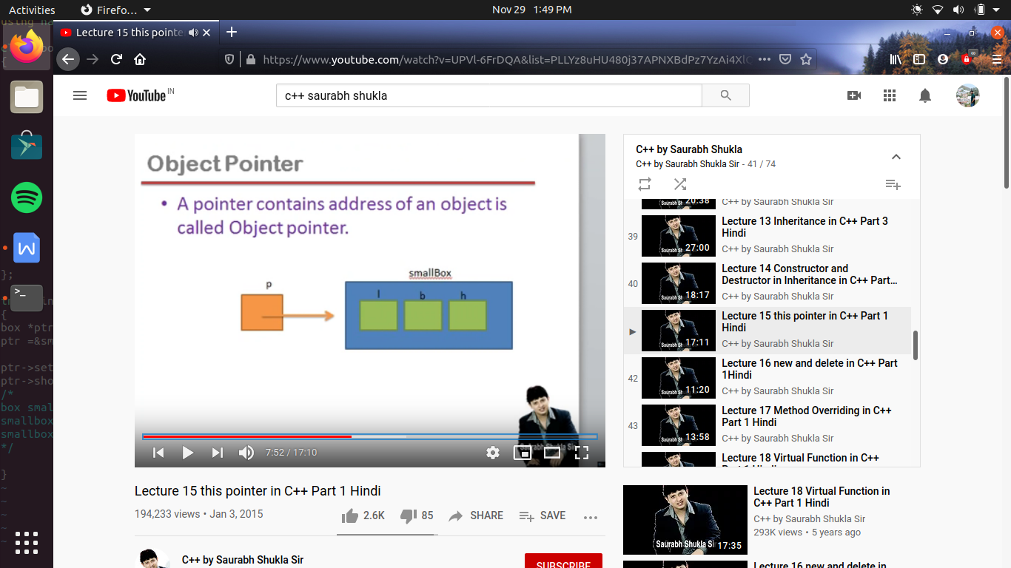

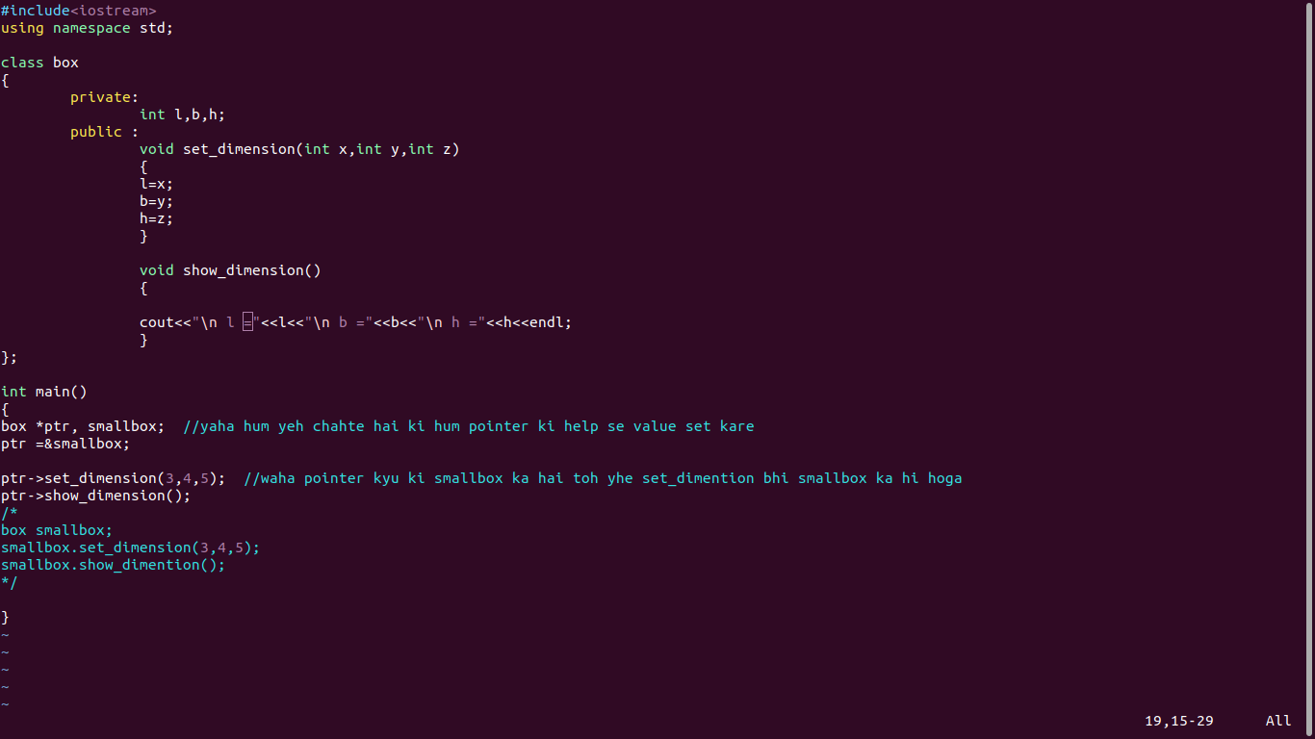

this pointer ->

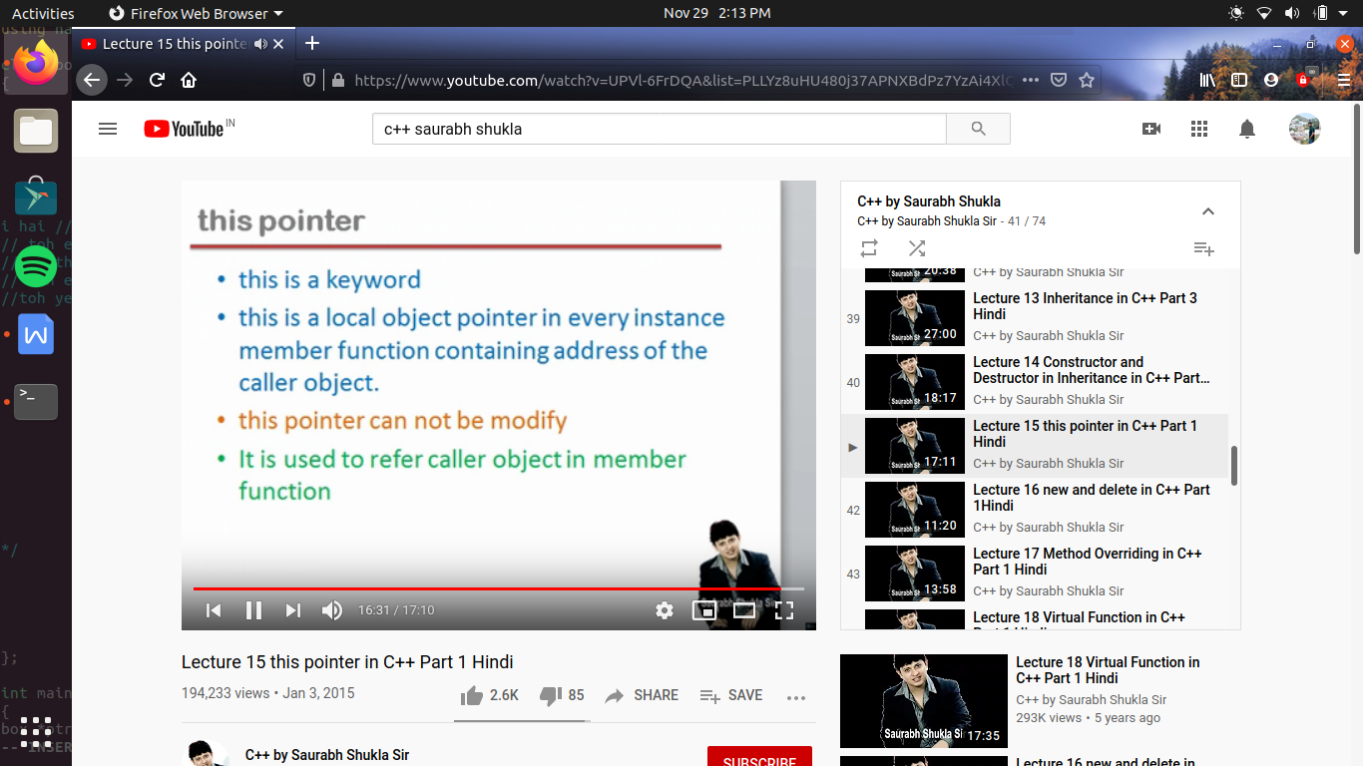

yaha pr this kya hai ?, this ek ke word hai c++ me

and this is a local object pointer (ab local kya hota hai , generally jis body ke ya block ke andar ka jis ka scope ho use hum local bolate hai yaha generally hum funtion ki bat kr rahe hai) this ek pointer variable hai or yeh ek local variable hai , es ka mtlb kisi particular function ke andar bana hoga , or wo variable usi function ke andar se hi access ho sakata hai

ab kyu ki this ek keyword hai toh ese hame banane ki zarurat nhi hai yeh pahale se hi maujut rahata hai har ek instance member funtion me i.e jo hi class ke andar ham ne function banaye hai , or agar mai wo function ke age static likh duga toh yeh instance member function nahi kahalayege

yeh this function hame banana nhi padata yeh apane app hi ban jata hai jo contain karata hai address of caller object

ab this kyu ki local hai toh jab bhi member function call hoga tabhi this pointer ko memory milegi

this ek aisa pointer hai jis ki value hum change nhi kr sakate

yeh caller object ko represent karane ke kam ata hai

