array in data structure

ADT ->

ADTs are the way of classifying data structures by providing a minimal expected interface and set of methods.

(abstract means simply aam khalo ghuthaliya mat gino i.e abstract is hide the details ki kya chij kaise hue hai )

#### Array – ADT

An array ADT holds the collection of given elements (can be int, float, custom) accessible by an index.

##### 1. Minimal functionality:

* get ( i ) – get element i
* set ( i, num ) – set element i to num.

##### 2. Operations:-

* Max()
* Min()
* Search ( num )
* Insert ( i, num )
* Append (x)

#### Static and Dynamic Arrays:

**Static arrays** – Size cannot be changed

**Dynamic arrays** – Size can be changed

#### Memory Representations of Array

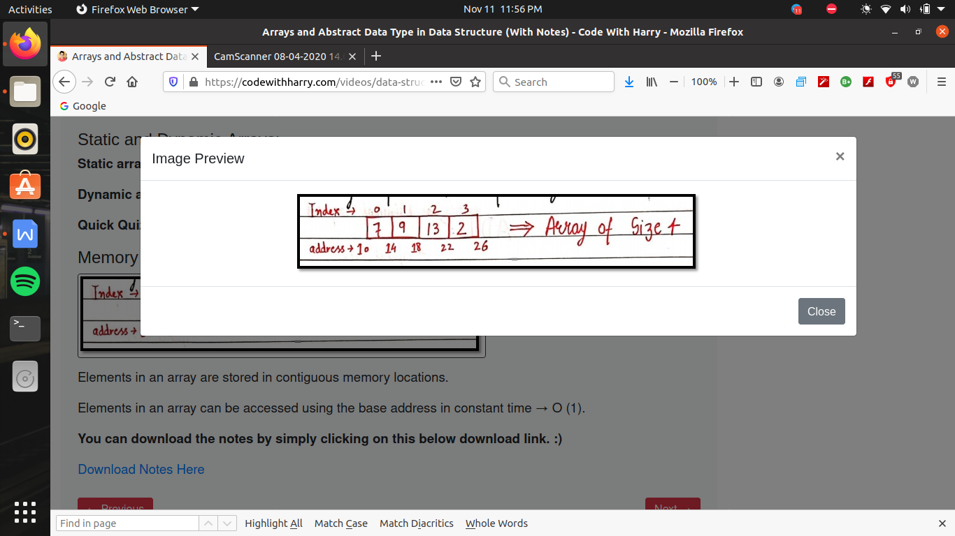

Elements in an array are stored in contiguous memory locations.

Elements in an array can be accessed using the base address in constant time → O (1).

resize of array is not possible , if we have to increase the size of then for that we have copy all the data one by one on the new array , but resizing can be possible in linked list

by array we can do faster access , of any block so that we can do faster retrieval and faster updation

but it causes problamatic on deletion and insertion ,

which increases its complexity

array are the collection of finite no. of homogeneous data elements (like in c language )

i.e array is a group ko memory block , group of elements

array ke sath ek drawback hai , ki jab hum array banate hai toh hame es ka size batana hota hai , ab hum ne jitane size bata diya toh ab 5 hi element us ke andar store kiye ja sakate hai , na jayada or agar kam rakhate

hai toh ,memory ka wastage hota hai ,

toh array during the run of program grow nhi hote or shrink nahi hote , yani jo size ek bar boln diya hai utane i rahate hai

lekin array ko use karane ka fayada yeh hai ki hum us ko bahot fast access kar pate hai kyu ki us me blocks laga tar banate hai , toh index no. se hum us location ko evaluate kr lege , yani address evalute kr lege

to access any array it take one mulltiplication and one addition .

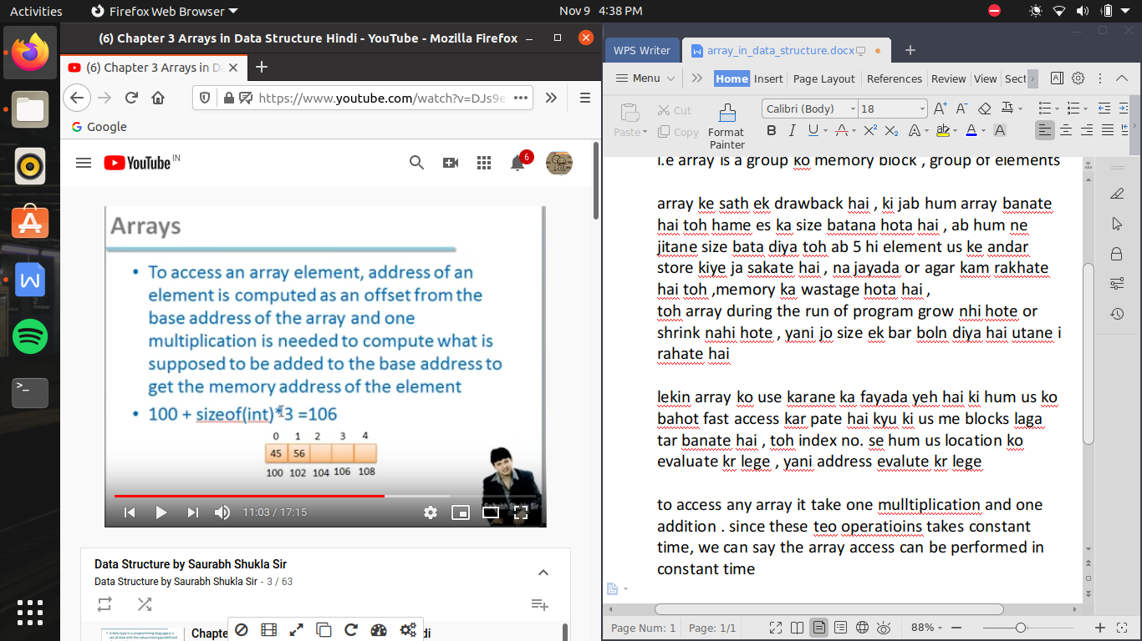

since these two operatioins takes constant time, we can say the array access can be performed in constant time