malloc funtion

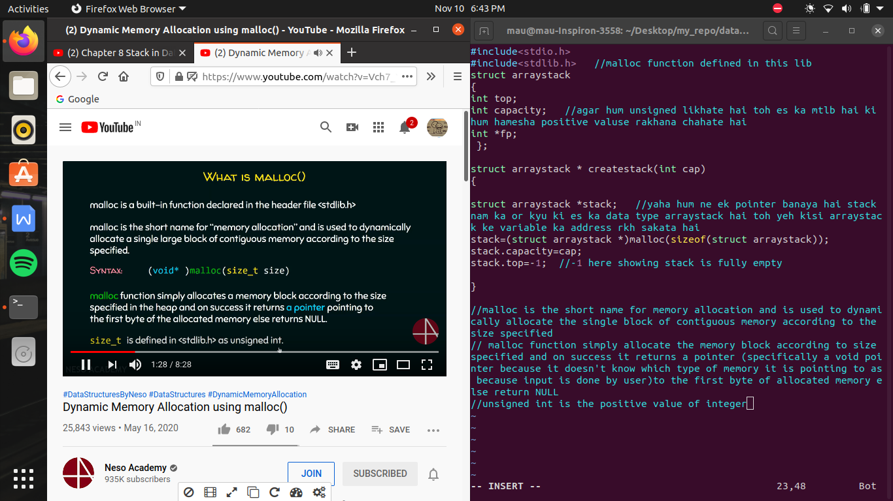

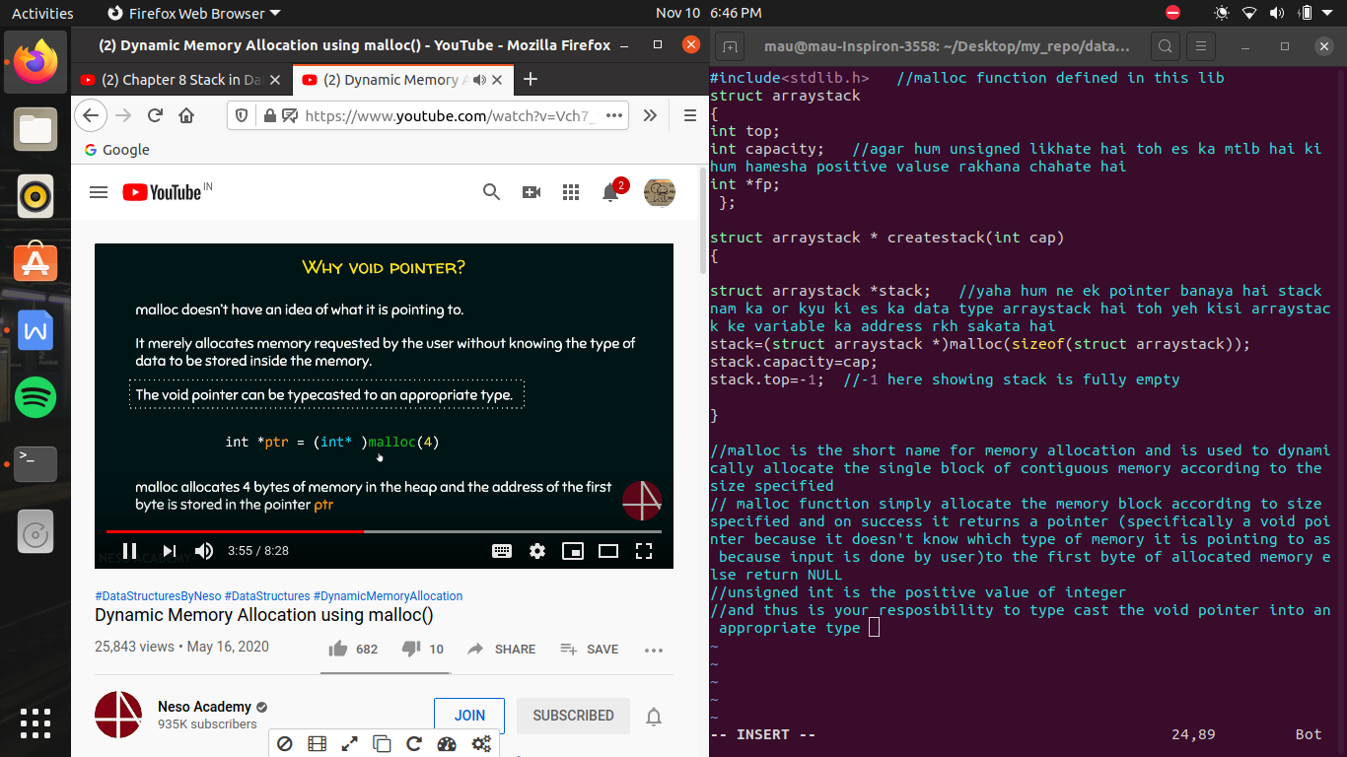

LOG definition ->

hum ek no. ko kitani bar adha kr sakate hai , toh wo log hoti hai

