printing all permutation of a string ->

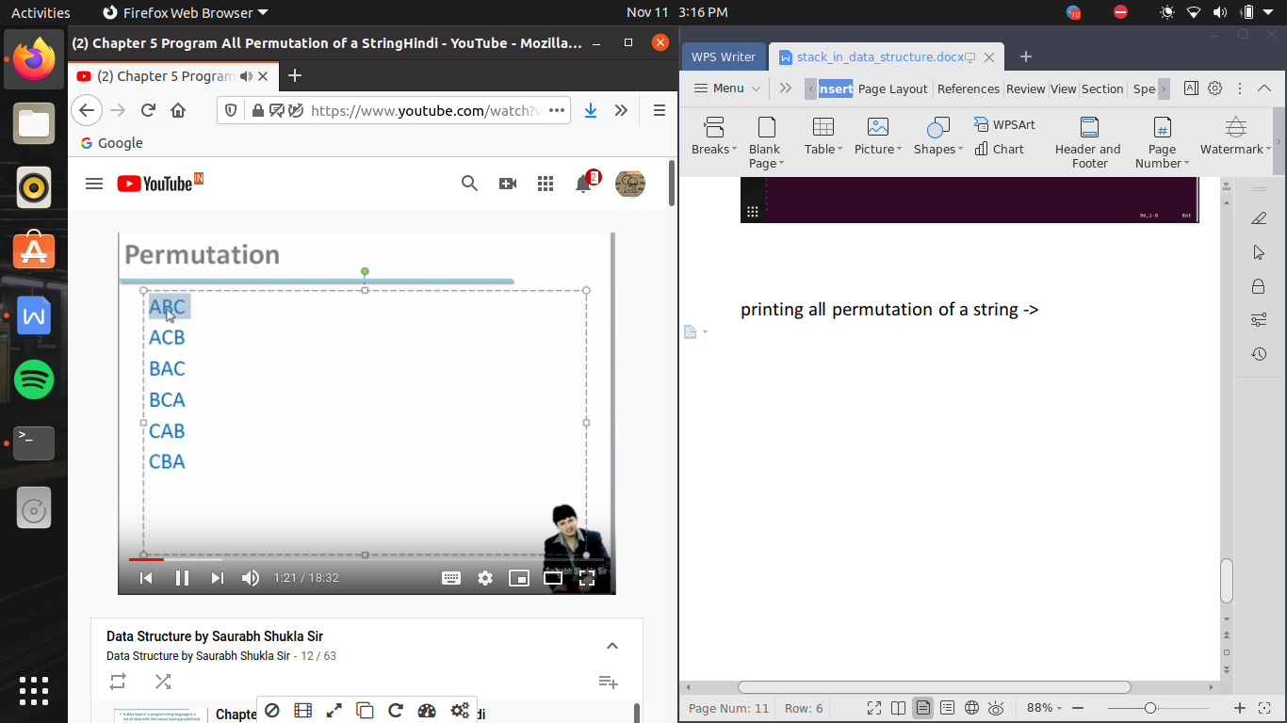

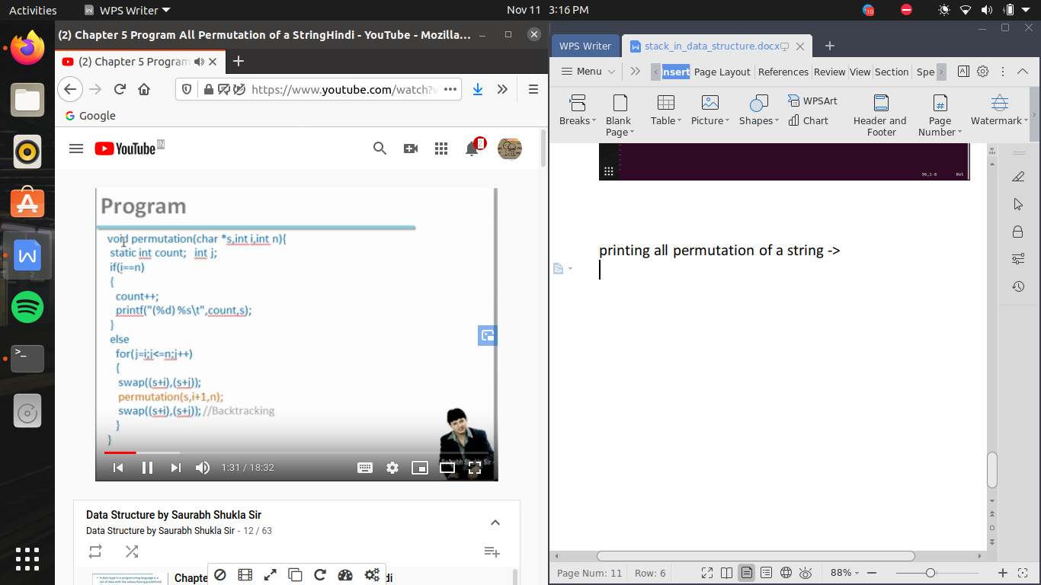

static variable means function ke bar bar call kranane pr bhi yeh variable destroy nhi hoga i.e life is till the the program , or static variable by default 0 se initialize ho jate hai

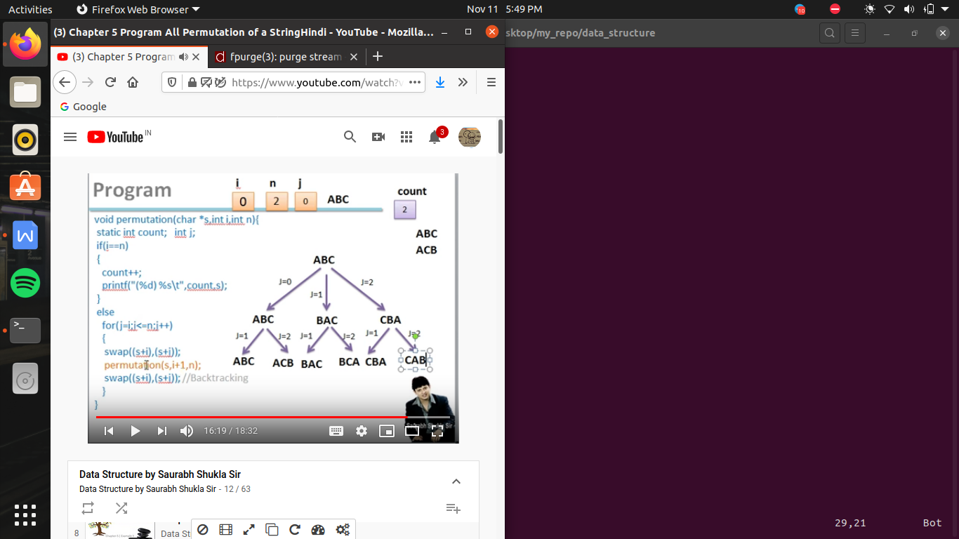

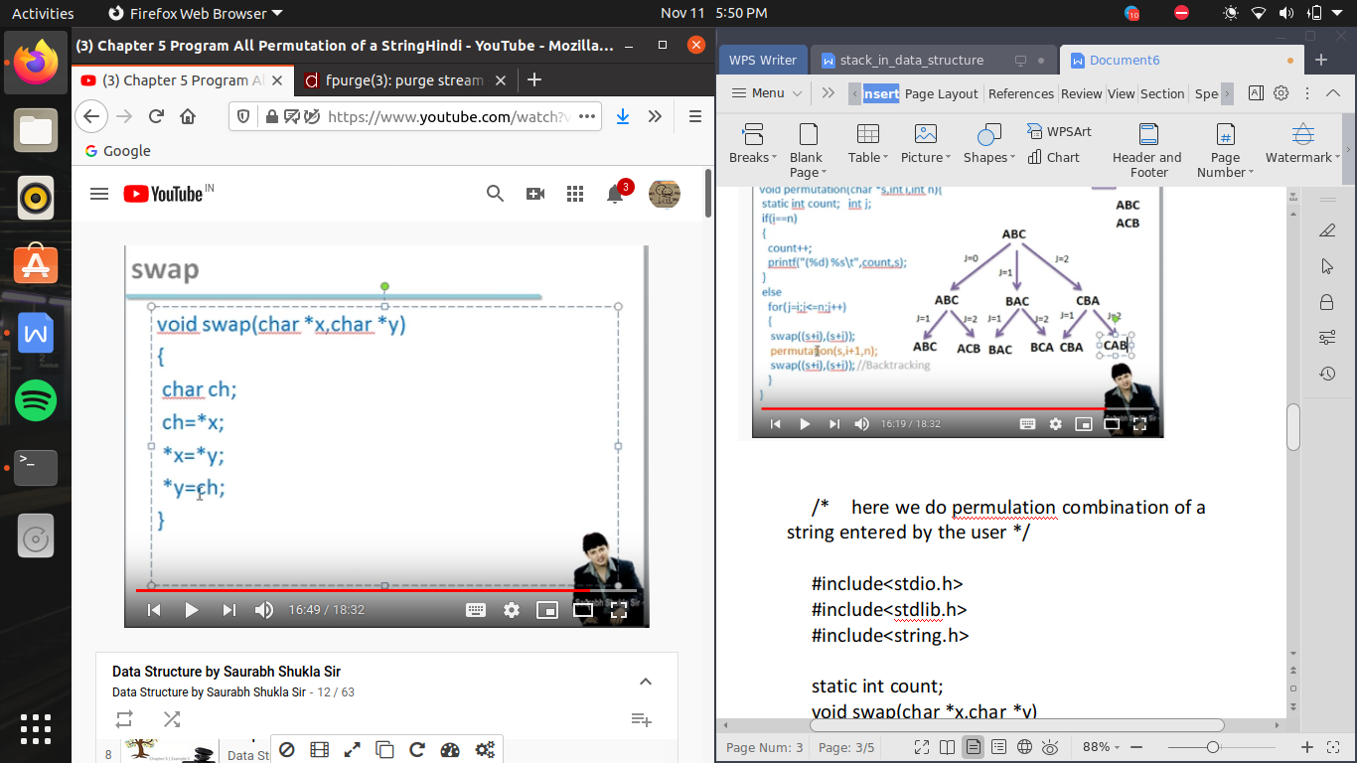

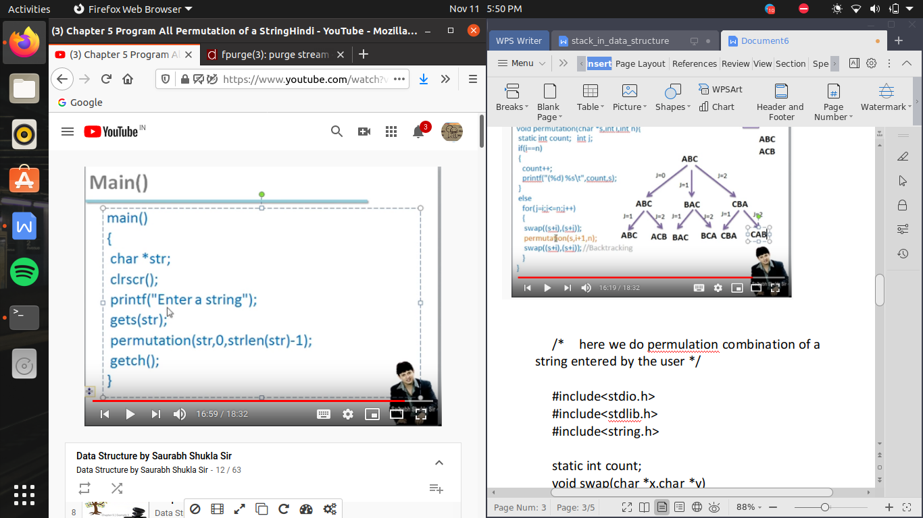

/* here we do permulation combination of a string entered by the user */

#include<stdio.h>

#include<stdlib.h>

#include<string.h>

static int count;

void swap(char *x,char *y)

{

char k;

k=*x;

*x=*y;

*y=k;

}

void permutation(char *s,int i, int n)

{

int j;

if (i==n)

{

count++;

printf("\n (%d) %s \t",count,s);

}

else

{

for(j=i;j<=n;j++)

{

swap((s+i),(s+j));

permutation(s,i+1,n);

}

}

}

void main()

{int size;

printf("enter no of character \n");

scanf("%d",&size);

char *s=(char *)malloc(sizeof(char)*size);

printf("enter string \n");

__fpurge(stdin);

gets(s);

permutation(s,0,strlen(s)-1);

}

