queue

stack ->LIFO (last in first out )

queue ->FIFO (first in first out)

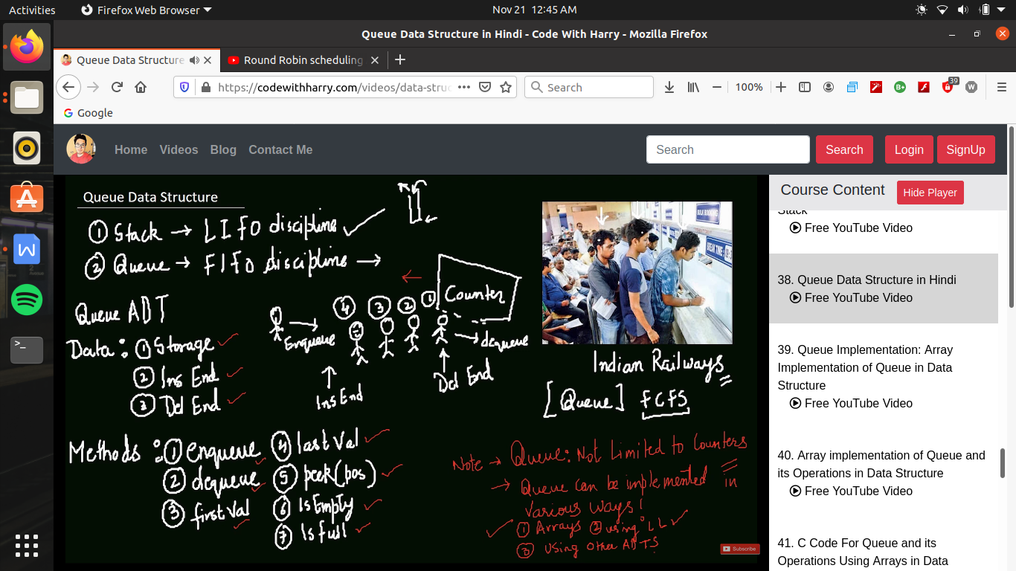

queue using array :-

in queue using array if we have to remove(dequeue) so after removal we have to swift all elements one by one

toh es problem ko sovle karane ke leye hum 2 index lete hai ex-> fornt_index and back_index(es me pahle front end ko age bada dege fir remove karege )

and id front index =back index then it is a queue empty condition

queue full condition when back_index = size -1;

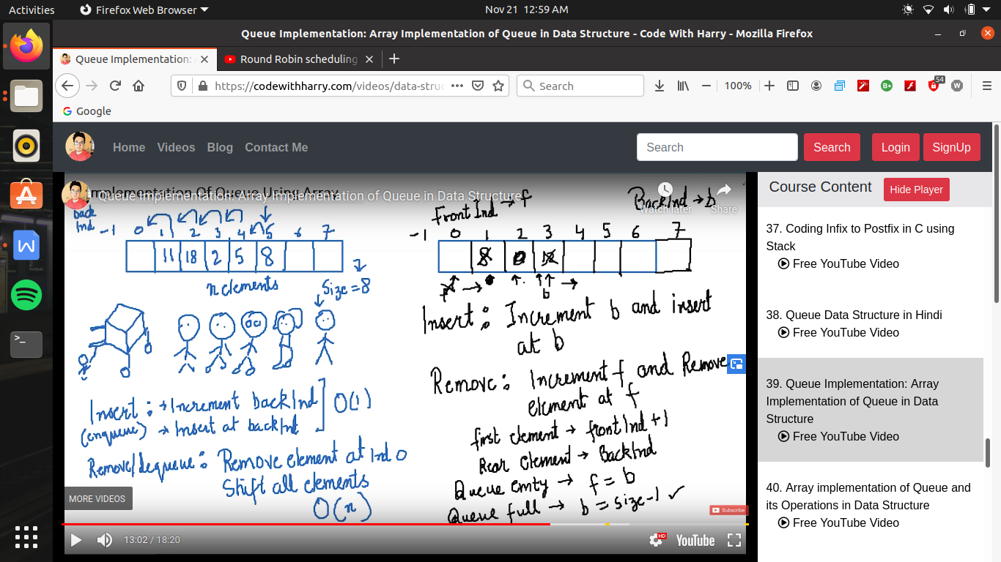

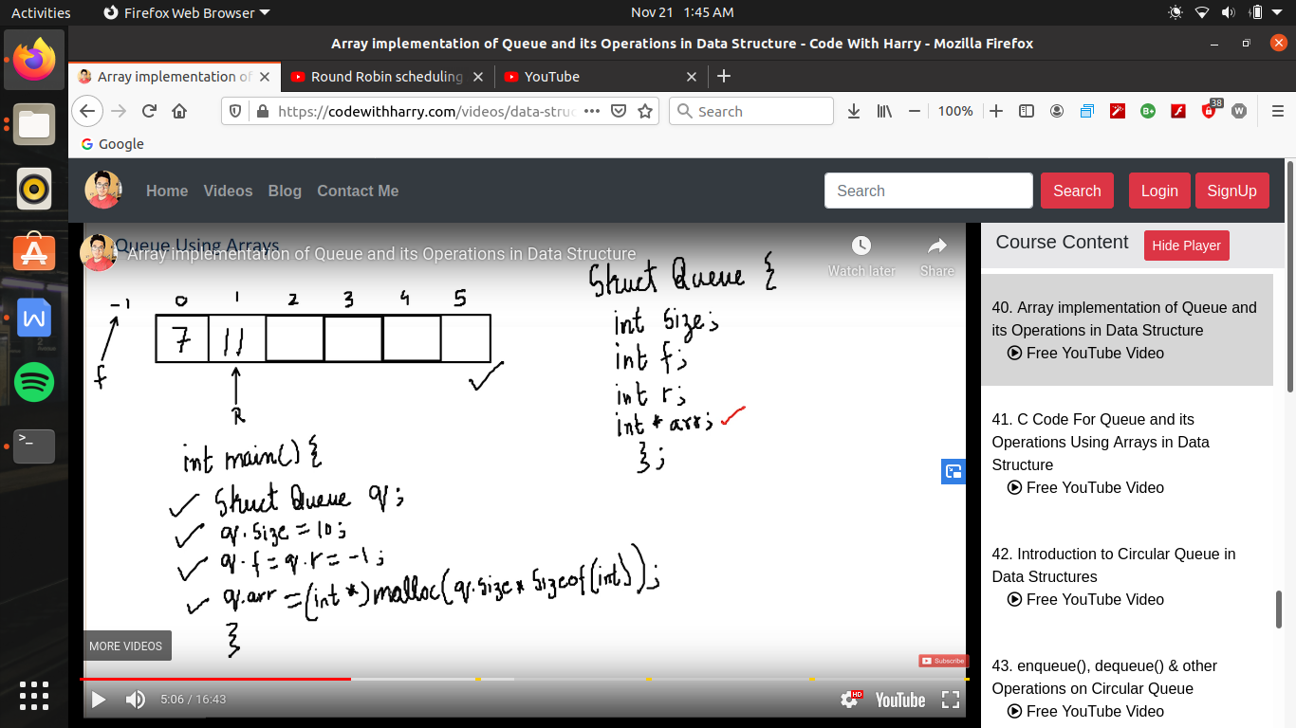

enqueue operation ->

