pointer

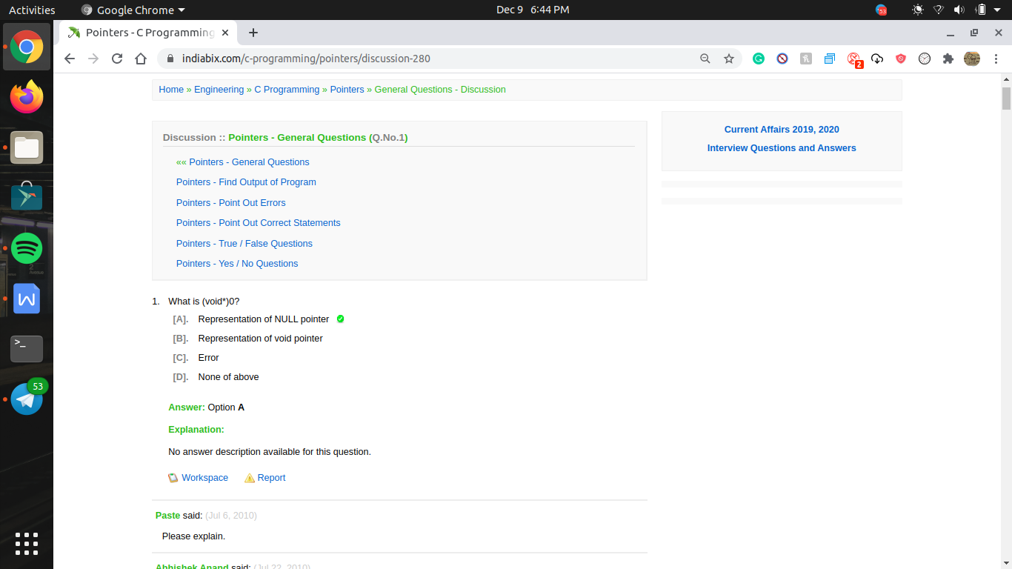

it is Null Pointer because, Pointer stores the addresses of another variable but when variable type is not known then it will be (void) and to store address it is consist(\*) also,so (void \*) and initially it points to 0th address, Means Null

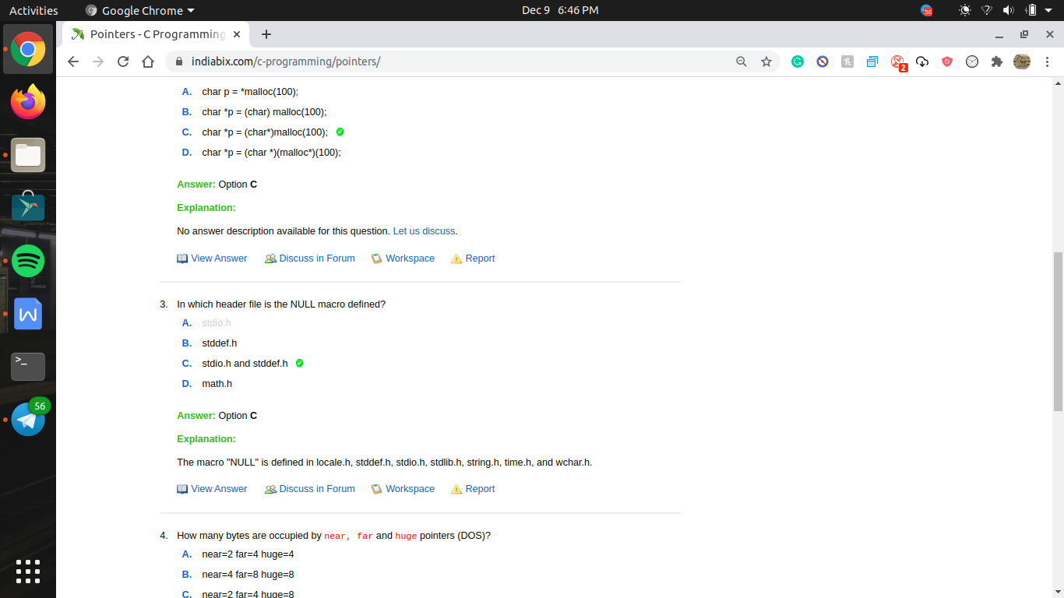



double pointer \*\*ptr (i.e pointer to a pointer ) will contain address of single pointer \*p;

Triple pointer \*\*\*s (pointer which is pointer to a pointer ) will contain address of double pointer \*\*ptr;

and there \*s represent the value stored in ptr;

the \*\*s represnet the value stored in p;

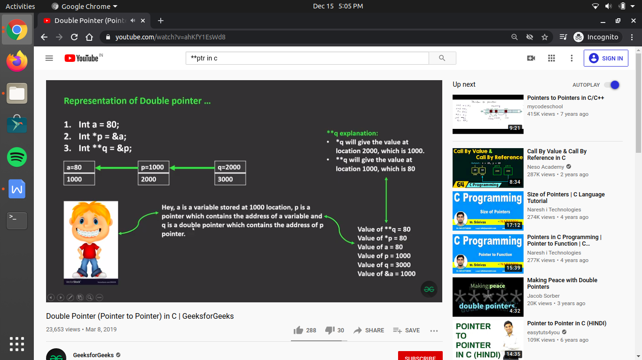

only unary operator (++,--,!,~, sizeof()) , ternary operator (? :)and assignment operator (= , +=, -=, /= ,%=, <<=, >>=) cursor move right to left

and all other operator have associativity left to right

thus

\*\*p+1;

here \* having more priority than + operator

thus first cursor move left to right

\*\*p solve first and then its value increased by 1;

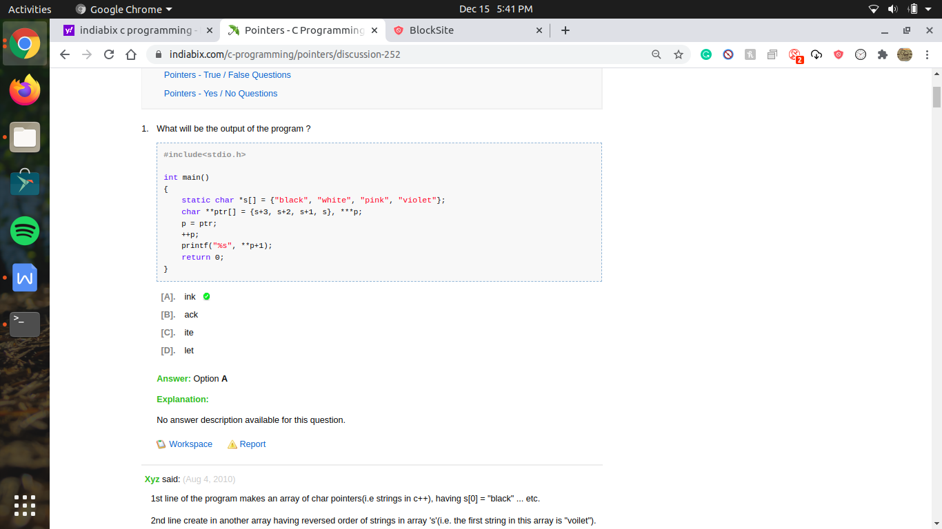

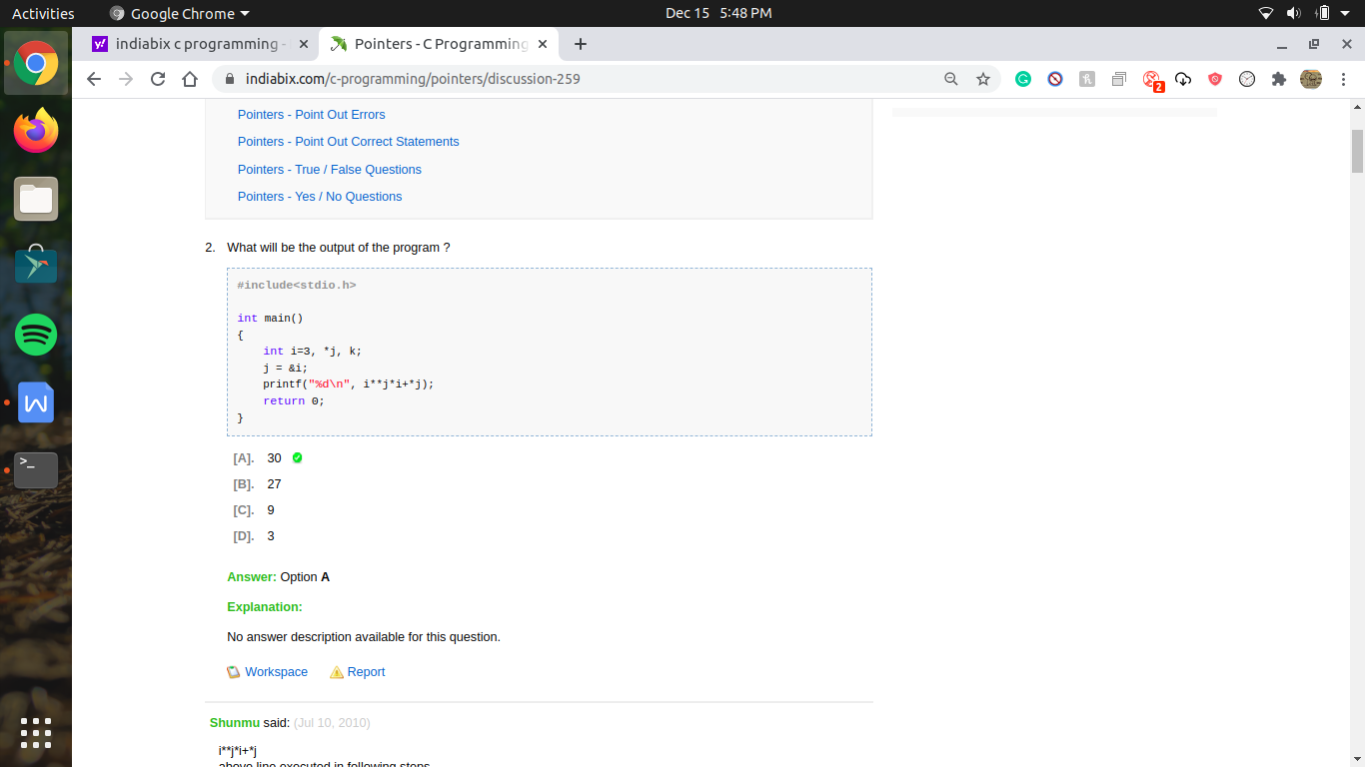

here i\*\*j\*i+\*j

this expression is treated as ,

because \* is a binary operator thus its need 2 operants

such that

i\*(\*j)-> first solve this and result come as 9

now 9 \*i -> 27;

27+\*j -> 30;

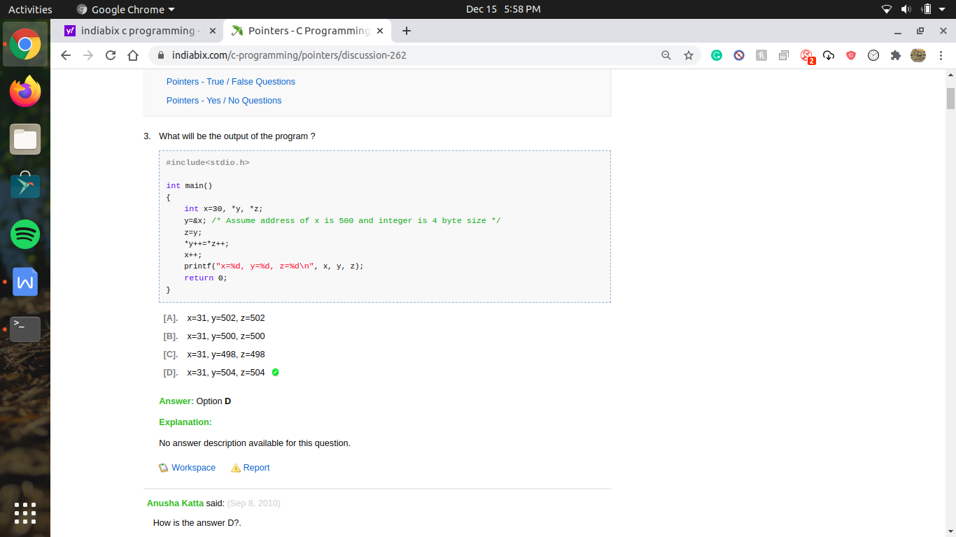

as int block is of 4 bytes thus , by increment in a pointer it will point the address of another block , if it is an array thus the address willl increased by 4 ;

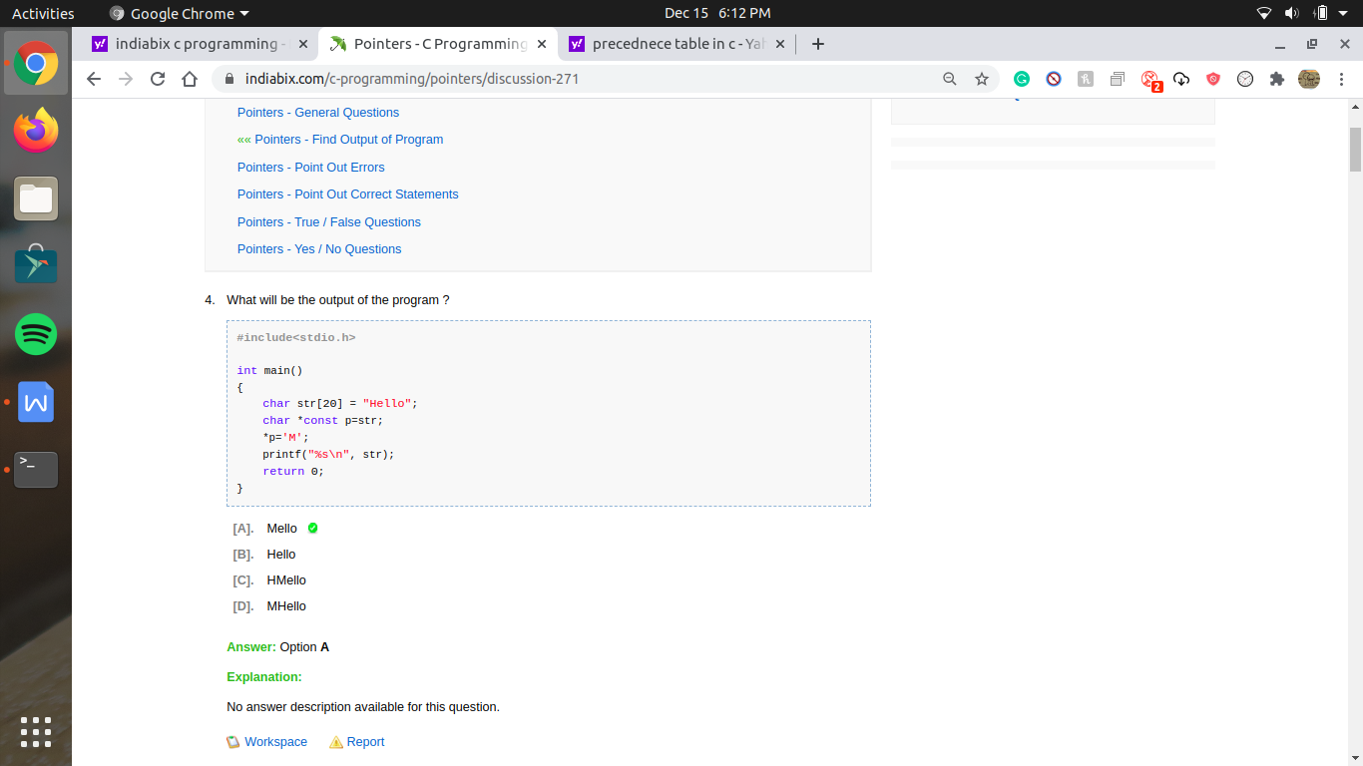

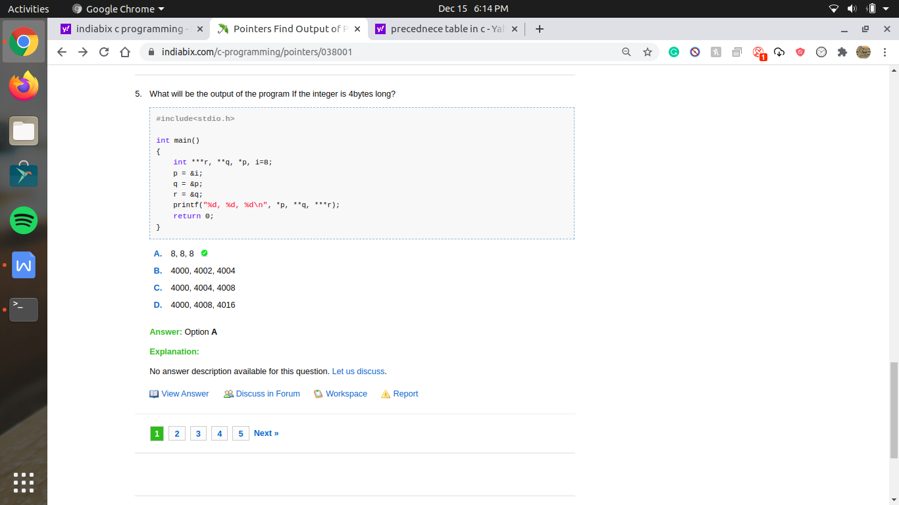

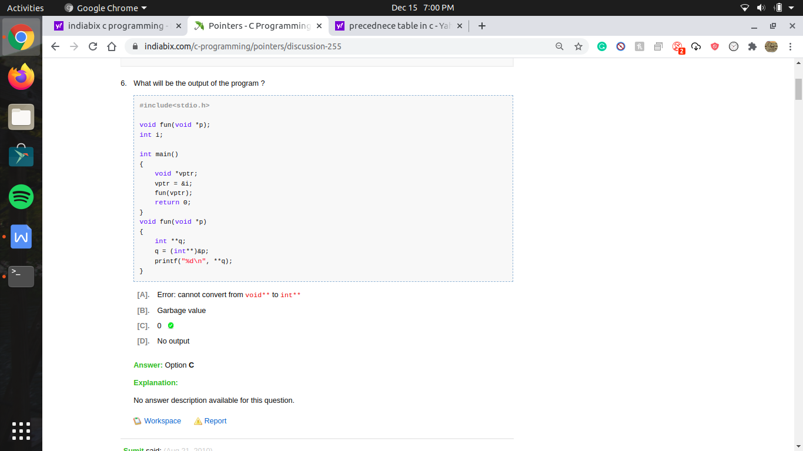

q = (int\*\*) &p;  
in this case q is a memory location (i.e pointer) which stores the memory location of another variable that holds an integer value. OR simply we can say it is a double pointer of integer type. AND p is a void pointer. So, void pointer can not point to any datatype unless and untill it is type-casted to that particular datatype. So, the statement q=(int\*\*)&p is valid.

and as is used as an extern varable thus it contain default value as 0

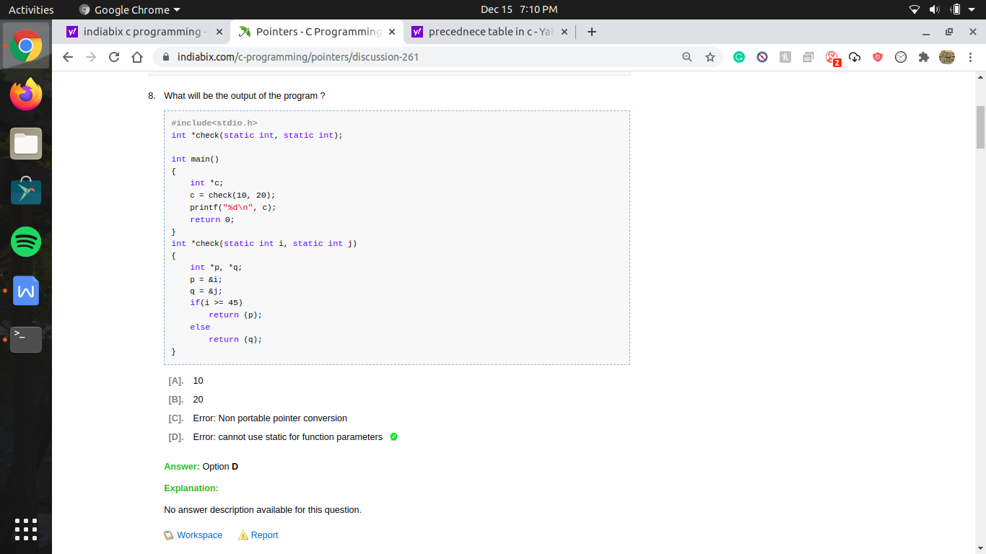

Because we can not pass static variables to the functions.

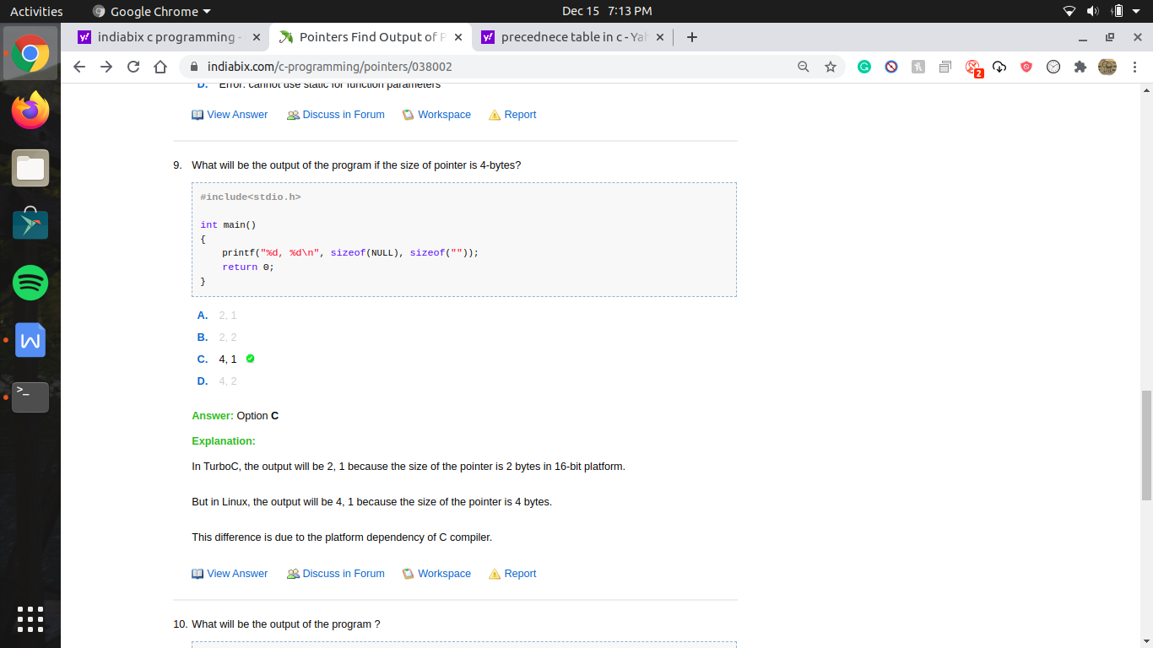

in gcc size of pointer is 8 bytes