Vim editor

Advantage of vim editor is a some havine large size so open the file in some other editor it will take time but if we open it on vim editor it will get open in a fraction of time

Fir we type

“$ vim”

We enter into vim now by pressing (i) we can edit in vim

To save the process

“$ :w”

For the first time to save the file we use

“$ :w <finename.extension>”

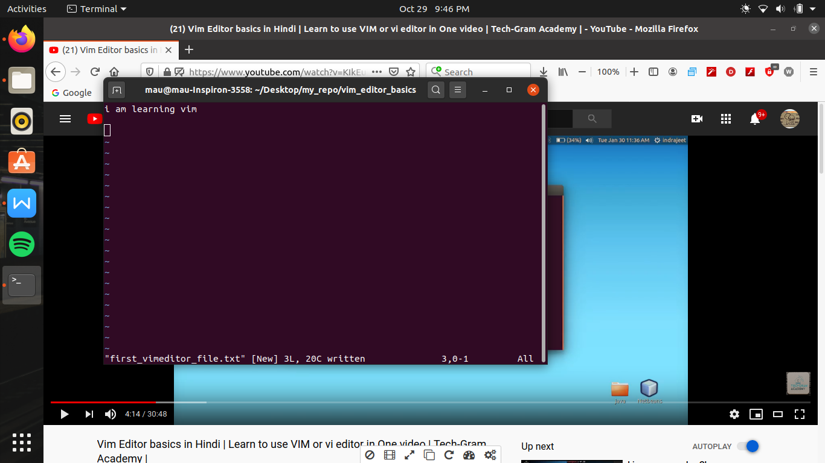

To open a file in a vim editor we use

“$ vim <file name.extension>”

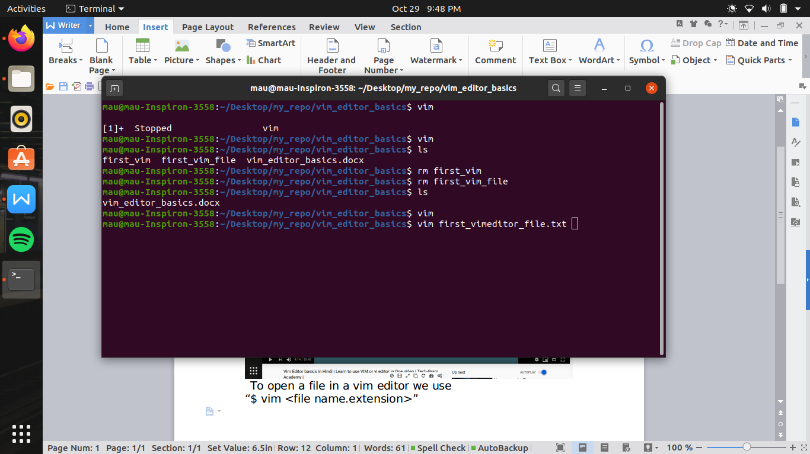

If we have to quit without file saving then we use

“$ :q!”

And if we already save the file and now we have to quit then we use

“$ :q”

And for both work file save and quit simultaneously

“$ :wq”

If we have to move the pointer of the vim editor for that we use (H,J,K,L)

If we press H -> pointer will move left

J -> down

K ->up

L -> right

Note -> this will work only when we are in normal mode

1. e not in insert mode)

Also can be use arrow keys

Now if i want to copy a line to another line

So first we go to normal mode

Then we type (v) i.e visual mode

Then by arrow keys we select the line then press (y) to copy the file ( y -> stand for yanked)

Then automatically came out from the visual mode to normal mode and then move to the line where i have to paste the copied line

Then press (p) by this copy line is pasted at the point where ever pointer is present it can be in the middle of a line or start or end of the line

But if we use

“:put”

Then the copied line is pasted on the next new line

Thus it makes a new line in between

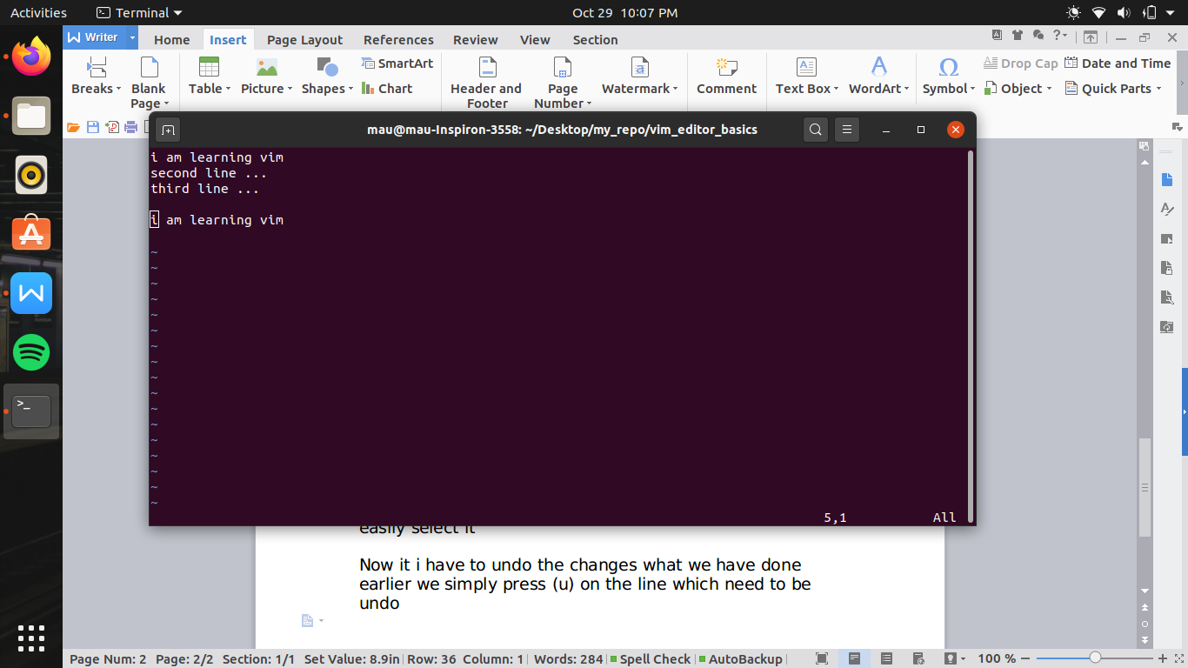

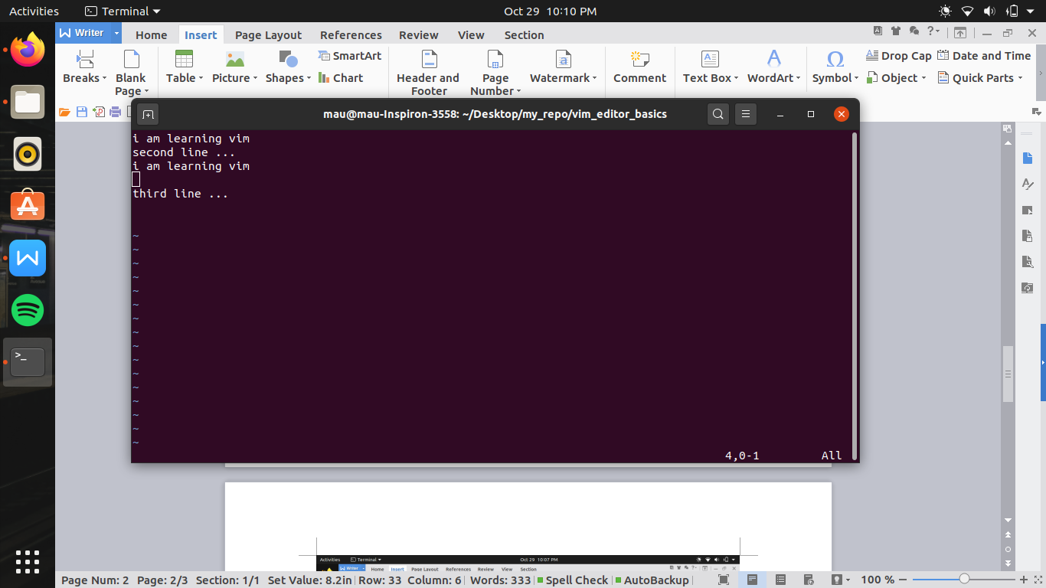

Note ->activate visual mode only when the pointer in on the line which need to copy so that by arrow keys we can easily select it

Now it i have to undo the changes what we have done earlier we simply press (u) on the line which need to be undo

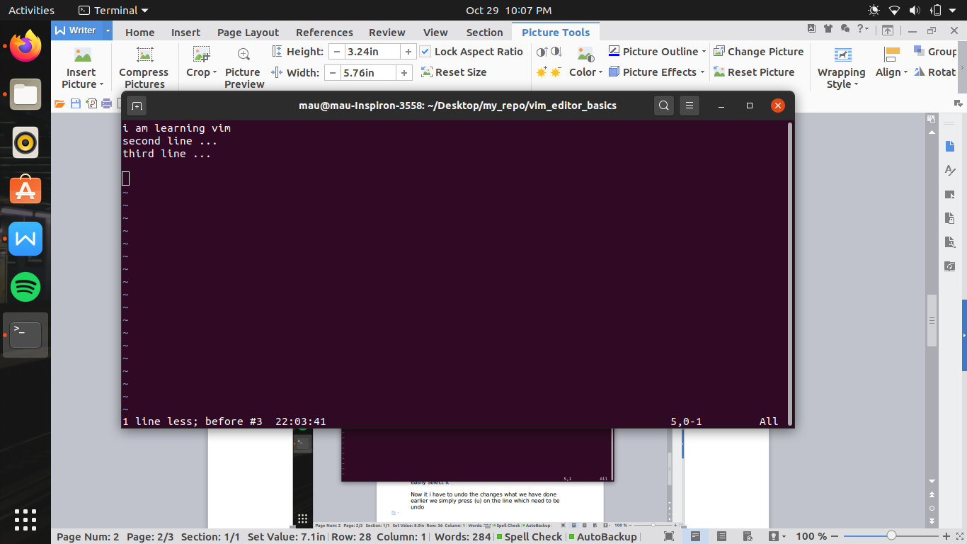

In the vim editor if we have to cut line or delete a line for both their is the same way

For cut or delete the file

We move to the pointer which line need to delete

We press (dd) in the normal mode now file go into buffer mode

And also we can paste it to the new location

For that

“$ :put” or “p”

To paste the file

Now if we have to cut some no. Of line or delete some no. Of line then we use

In the normal made type

(no.of lines to be delete) then (dd)

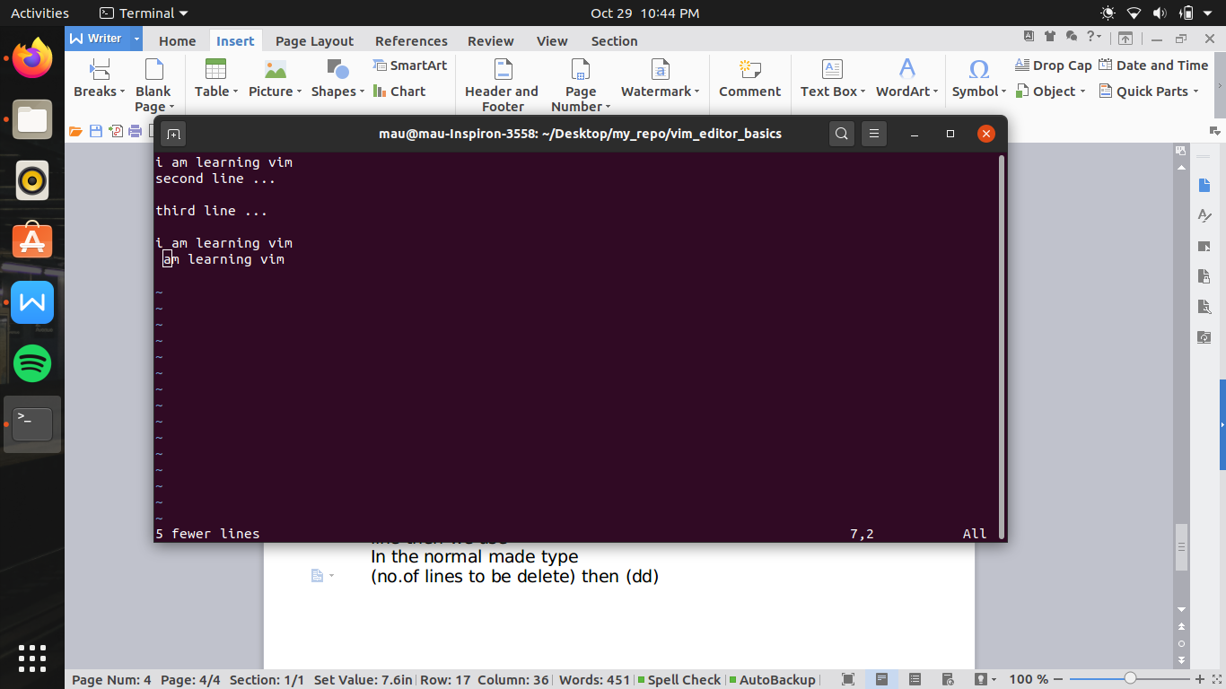

If i have to move at the top line form any any line we use (gg)

And if we have to move to the bottom line then we use

(shift) + (g) i.e capital g (G)

If we have to move at some line from top then we use

(no. Of line)(gg)

Ex- (5gg)

If we have to search something then we use

Forward slash(/) (word which have to search)

Ex- (/am)

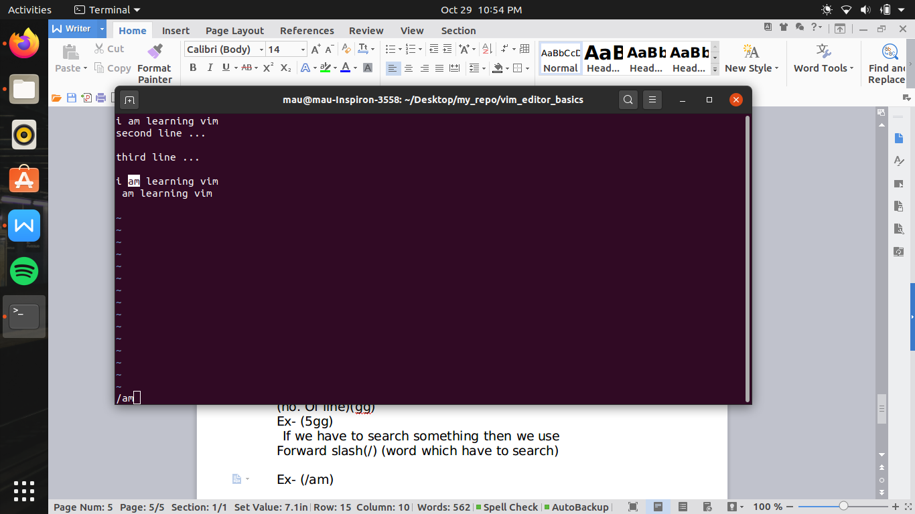

And then if we press (n) then it shows next similar word

Now if i have to search a word form the bottom

Then we use

“?am”

Now in the file if we have to replace some word

So we use

“:%s/<word which has to replace>/<word which replaces>”

Ex “:%s/hello/sangita”

Before

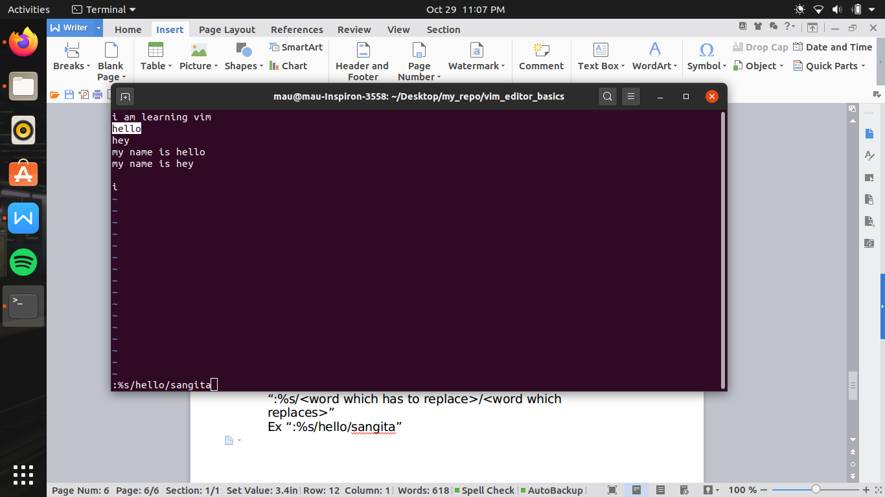

After

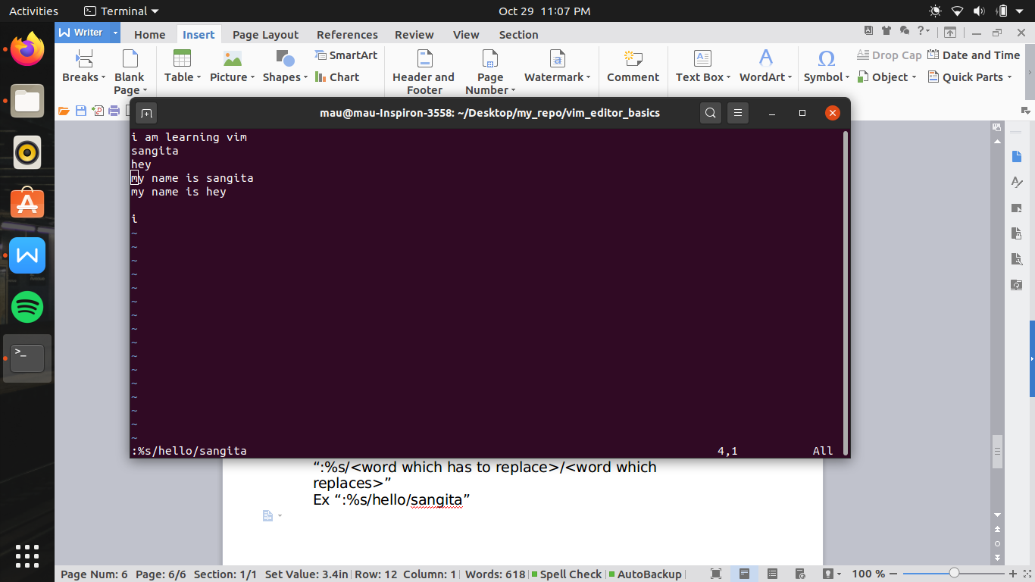

By this simultaneously all file were replaced

Now if i have to check before replace or replace by one by one so we use

“:%s/<file to replace>/<file to replace by>/c”

From this certain commond open

If we press (y) then it replaces

If (n) it does not replace

If (q) it will come to the normal window

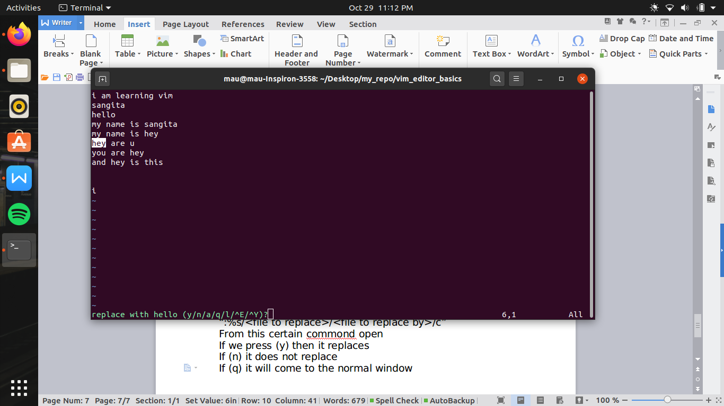

If we have to run two vim simultaneously

By

“ :split <name of file.extension>”

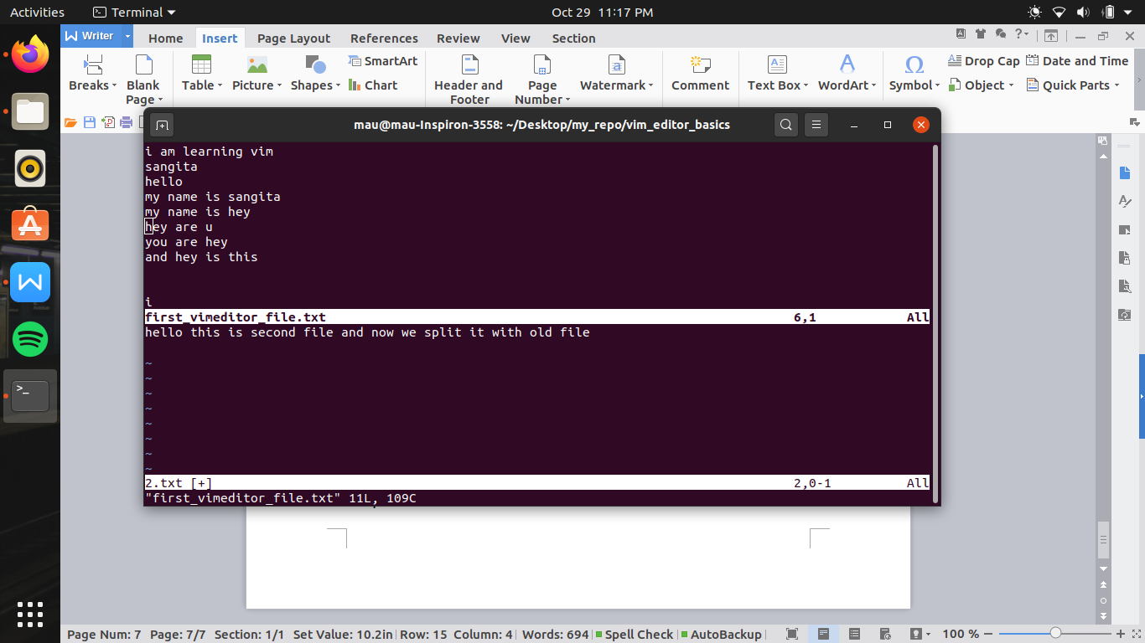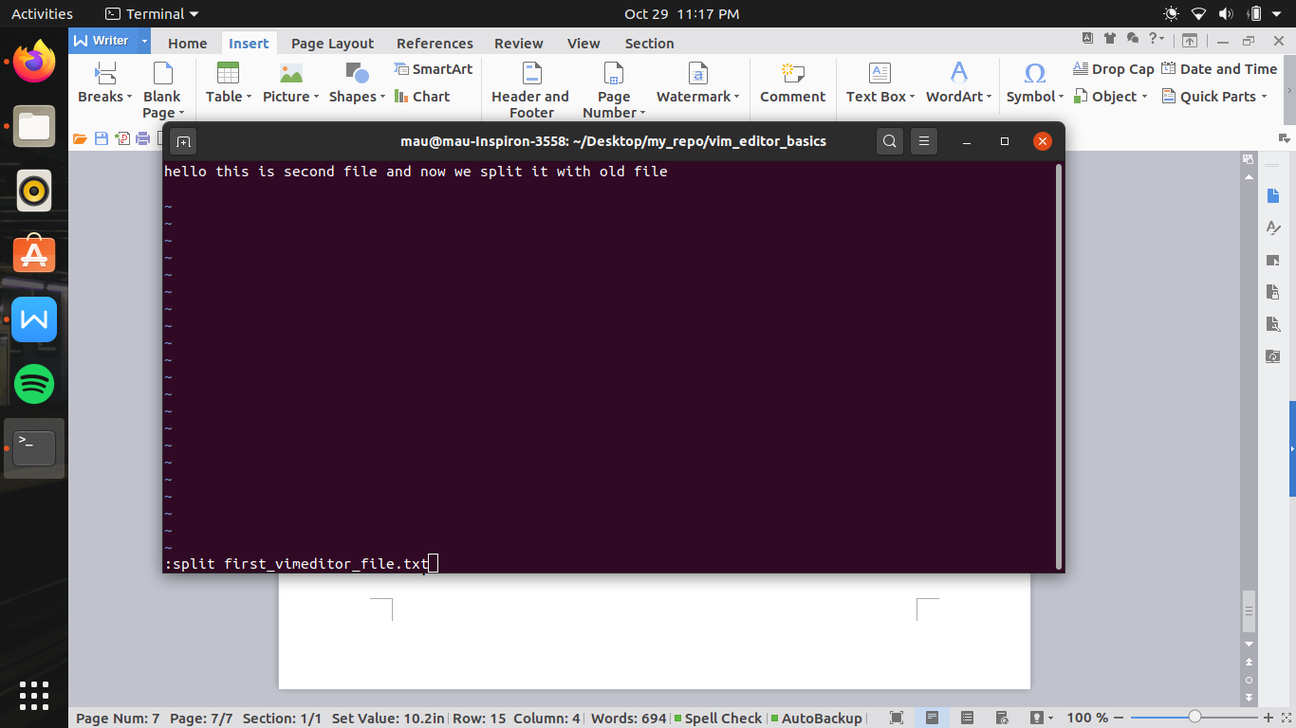

Now if we have to shift from the first file to second file

So first we go to normal mode the by

“control w”

Now we can shift the file from using arrow key

Now if we have to split the file vertically then we use

“:vsplit<filename.extention>”

