# Node js notes

Create package file through :- npm init

Note:- we never upload modules file or folder in the git repository, we can easily download there's file through :- npm install .

Fs => File system

We can easily create file and write some information insert the file through :- fs.writeFileSync()

we can also remove the file through :- fs.unlinkSync()

But in the both condition (create or remove) first we can require(fs) or import the fs.

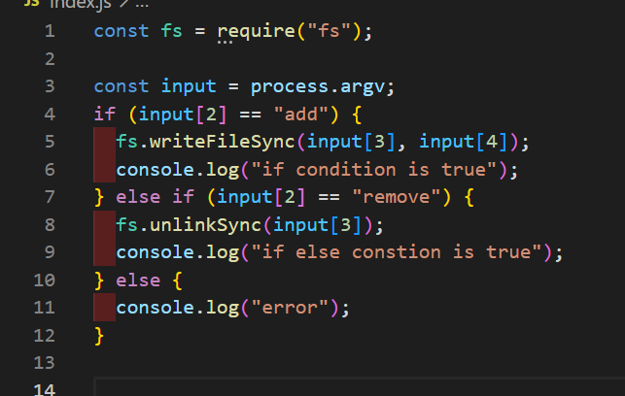

**http server** :-

http is help to create local server and http.createServer is also return the call back function, through :- http.createServer((res, resp)).listen({port no.}4000)

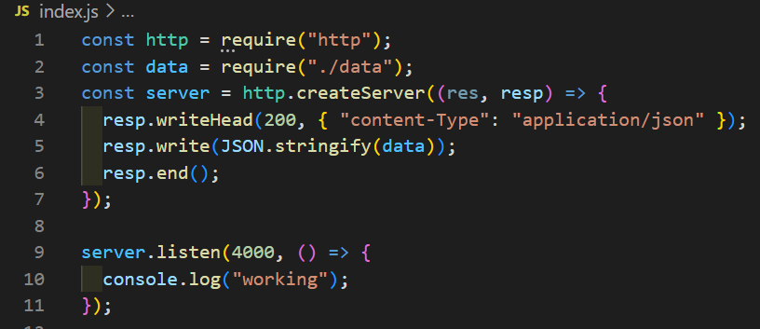

Through JSON.stringify() we can easily return the json data to make a API.

When we want to not update or push the file so, we can make {.gitignore} file and then insert the file name those we not want to not upload.

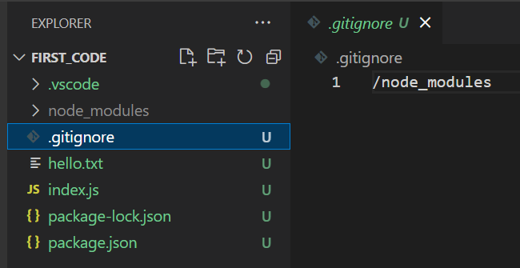

When we want to know about the files location so we can use :- {__dirname} and when we want know about its {__filename}

**Show and create file list in file system**

We can easily find the address of any directory through :- path.join(__dirname, “file_name”); but there is one condition we can only select or find the path of child folder :-

We can create multiple file and write the data inside the file through using for statement and we can also make file inside the folder :-

We can also read or show the file through single line of code, we need to use fs property :-

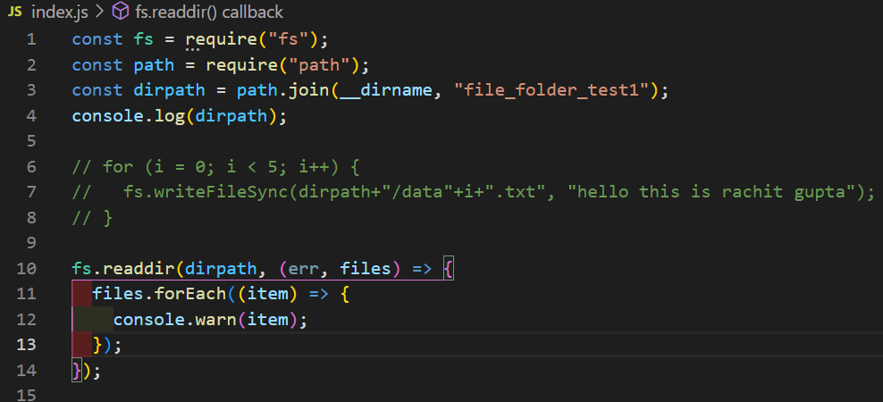

**Crud operation**

**Create** :- we can easily we a file with the help of using fs.writeFileSync(location, data);

**Read** :- we can also read in the information those store inside the file with the help of using :- fs.readFile(location, “it is use to change information beffer to string or text”,(err, data)).

**Update** :- we can easily update the file information with the help of using :- fs.appendfile(location, updated information).

**Rename**:- we can also do file rename through :- fs.rename({location and old filename}, {location and new file name}).

**Delete** :- we can also delete the file through :- fs.unlinkSync(location with file name).

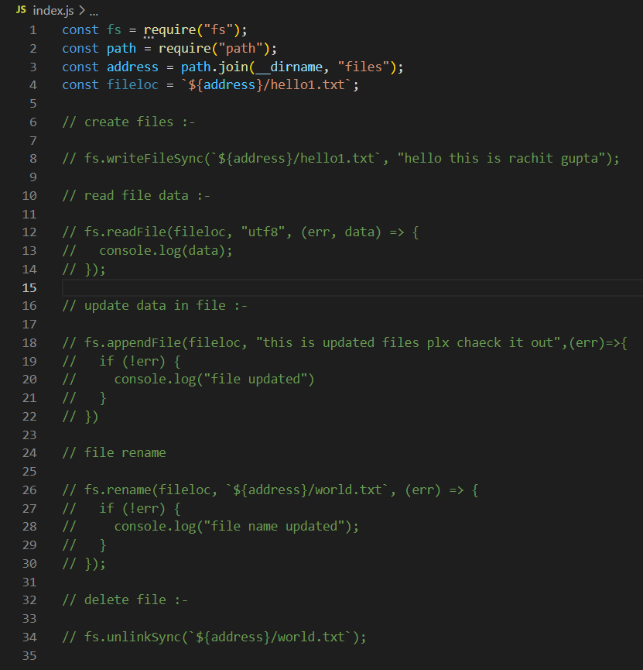

**Asynchronous and Synchronous**

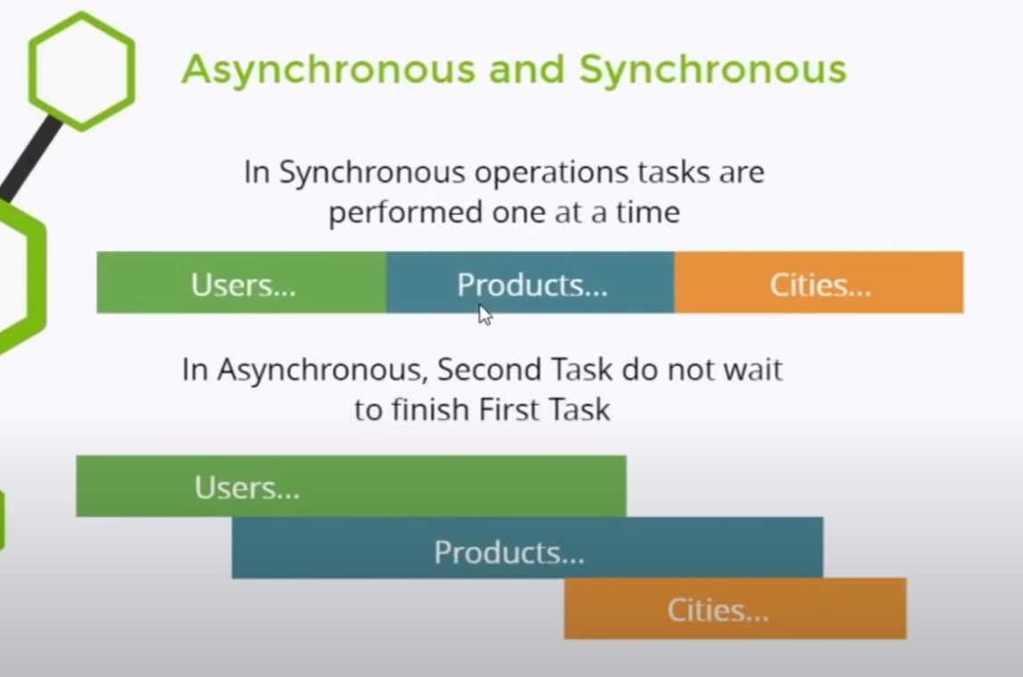

***How to work of node js***

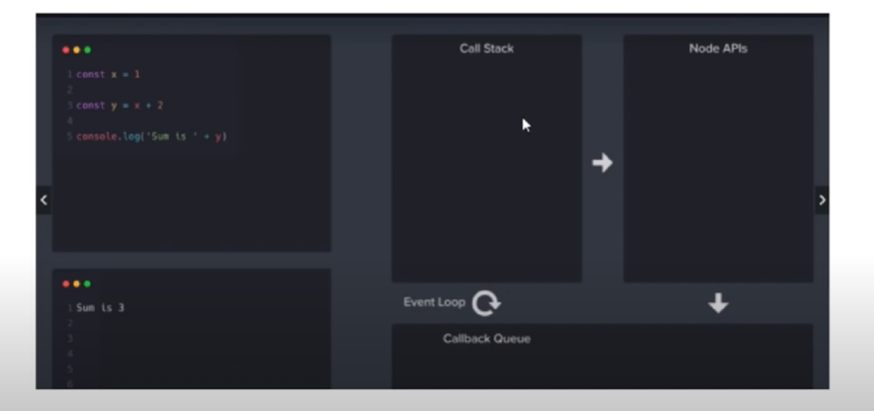

**Bhai ek bar video dekha lena. Url :-** (https://www.youtube.com/watch?v=VrQgmNY96wo&t=8337s)

When java script predefined function executingin call stack but, inherent function or properties use that first goes into the node APIs and move to callback Queue and then, it is for end the main function that store in the call stack after the main function will executing then inherent function or properties move to call stack for executing

***Express js***

With the help of express js we can easily get the data, information and an a html file.

But we need to download and import the express the function.

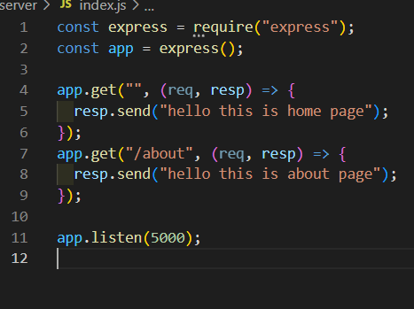

We can also use the listen function to explain the port.

We can also receive the data or information that user request.

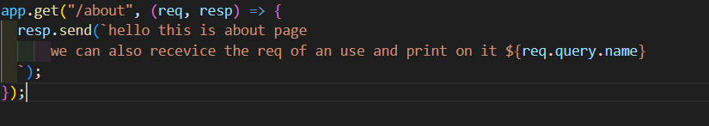

Result :-

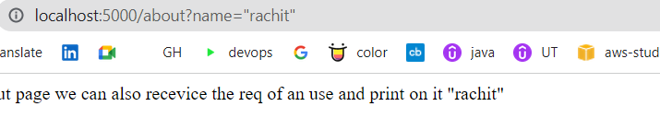

Run html file in node js and express js server but its is static web page and we need to add extension:-

