☕
COFFEE SHOP SALES ANALYSIS
Data Analytics Project Report
Using SQL (PostgreSQL) and Microsoft Power BI

Tools Used: PostgreSQL | Microsoft Power BI | Excel (Data Source)

Table of Contents

1. Project Overview 3
2. Dataset Description 3
3. Database Schema & Setup 4
4. Key Performance Indicators (KPIs) 5
5. Total Sales Analysis 6
6. Total Orders Analysis 7
7. Total Quantity Sold Analysis 8
8. Calendar Heat Map Analysis 9
9. Sales Analysis by Store Location 10
10. Sales Analysis by Product Category 11
11. Top 10 Products by Sales 12
12. Sales Analysis by Days & Hours 13
13. Power BI Dashboard 14
14. Key Insights & Business Recommendations 15
15. Conclusion 16

1. Project Overview
This project performs a comprehensive sales analysis for a coffee shop chain using real transactional data. The goal is to extract actionable business insights from raw sales records by leveraging SQL queries for data extraction and transformation, followed by visual reporting in Microsoft Power BI.

Objectives
- Analyze total sales, orders, and quantities across different time periods
- Identify month-on-month (MoM) growth trends in revenue, orders, and quantities
- Evaluate performance across store locations
- Determine top-selling product categories and individual products
- Identify peak hours and peak days for maximum sales
- Build an interactive Power BI dashboard for business stakeholders

Project Workflow
- Step 1: Data ingestion into PostgreSQL database
- Step 2: Data exploration and cleaning via SQL queries
- Step 3: KPI calculations and trend analysis using SQL window functions
- Step 4: Visualization and dashboard creation in Power BI

2. Dataset Description
The dataset used in this project is the Coffee Shop Sales dataset. It contains detailed transactional records from a coffee shop chain spanning January to June 2023. The data was originally stored in an Excel file (Coffee_Shop_Sales.xlsx) and imported into a PostgreSQL database for analysis.

Column Name | Data Type | Description
transaction_id | INT (PK) | Unique identifier for each transaction
transaction_date | DATE | Date of the transaction
transaction_time | TIME | Time of the transaction
transaction_qty | INT | Number of items sold in the transaction
store_id | INT | Unique identifier for the store
store_location | VARCHAR(80) | Physical location/branch of the store
product_id | INT | Unique identifier for the product
unit_price | NUMERIC(10,2) | Price per unit of the product
product_category | VARCHAR(50) | High-level category (e.g., Coffee, Tea, Bakery)
product_type | TEXT | Sub-type of the product
product_detail | TEXT | Specific product name/description

The dataset covers transactions from 3 store locations and includes multiple product categories such as Coffee, Tea, Bakery, Drinking Chocolate, Coffee Beans, and more.

3. Database Schema & Setup
The following SQL DDL was used to create the table structure in PostgreSQL:

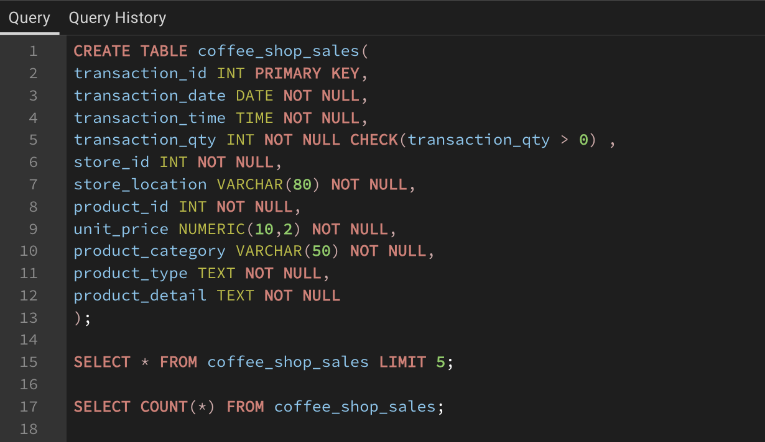
Key design decisions include a CHECK constraint on transaction_qty to prevent negative entries, and appropriate data type selection for price (NUMERIC) to avoid floating-point errors.

SQL Screenshot — Table Creation & Data Import
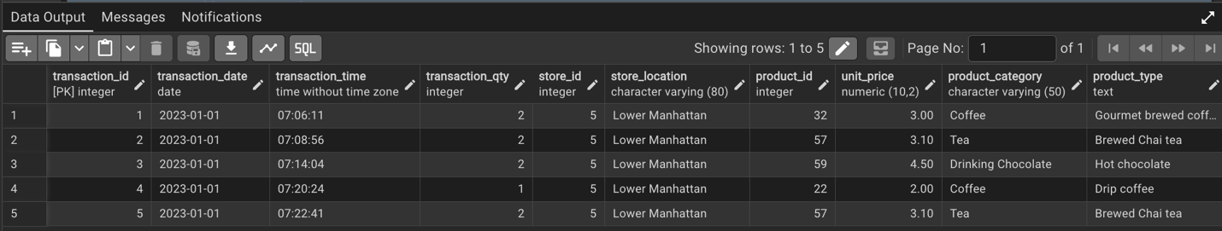

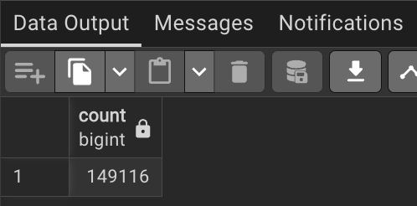

4. Key Performance Indicators (KPIs)
Three primary KPIs were tracked to gauge overall business performance across months:

Key Performance Indicators — Monthly Summary
Total Sales Revenue | $ / Month | Sum of (unit_price × transaction_qty) per month
Total Number of Orders | Count / Month | Count of distinct transaction_id per month
Total Quantity Sold | Units / Month | Sum of transaction_qty per month

Each KPI is tracked both as an absolute value for the selected month and as a Month-on-Month (MoM) change, showing both the percentage change and the absolute difference versus the previous month.

SQL Screenshot — KPI Queries
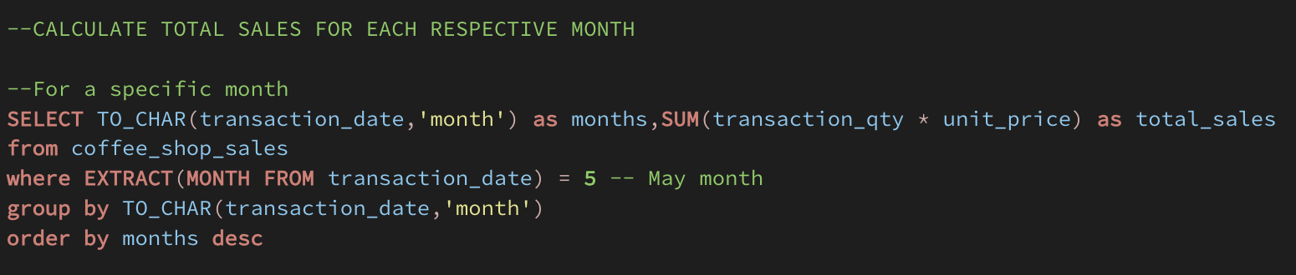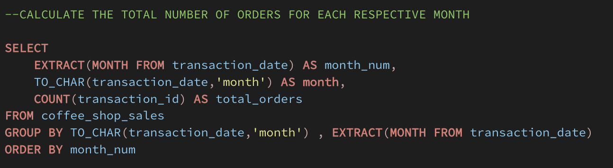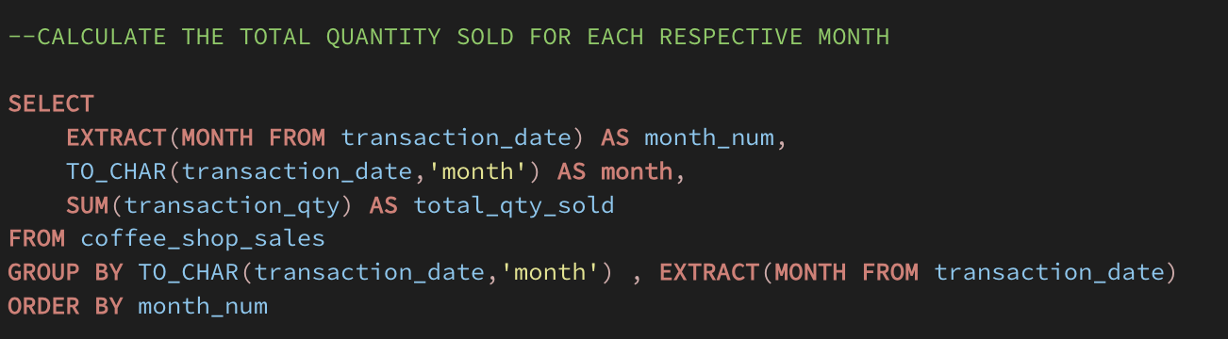

5. Total Sales Analysis

5.1 Monthly Sales Totals
Sales are aggregated by month using TO_CHAR() on the transaction date. This allows easy month-level grouping and comparison across the 6-month period.



5.2 Month-on-Month Sales Growth
The LAG() window function is used to compare each month's revenue against the prior month. This reveals growth trends and flags months with declining revenue.
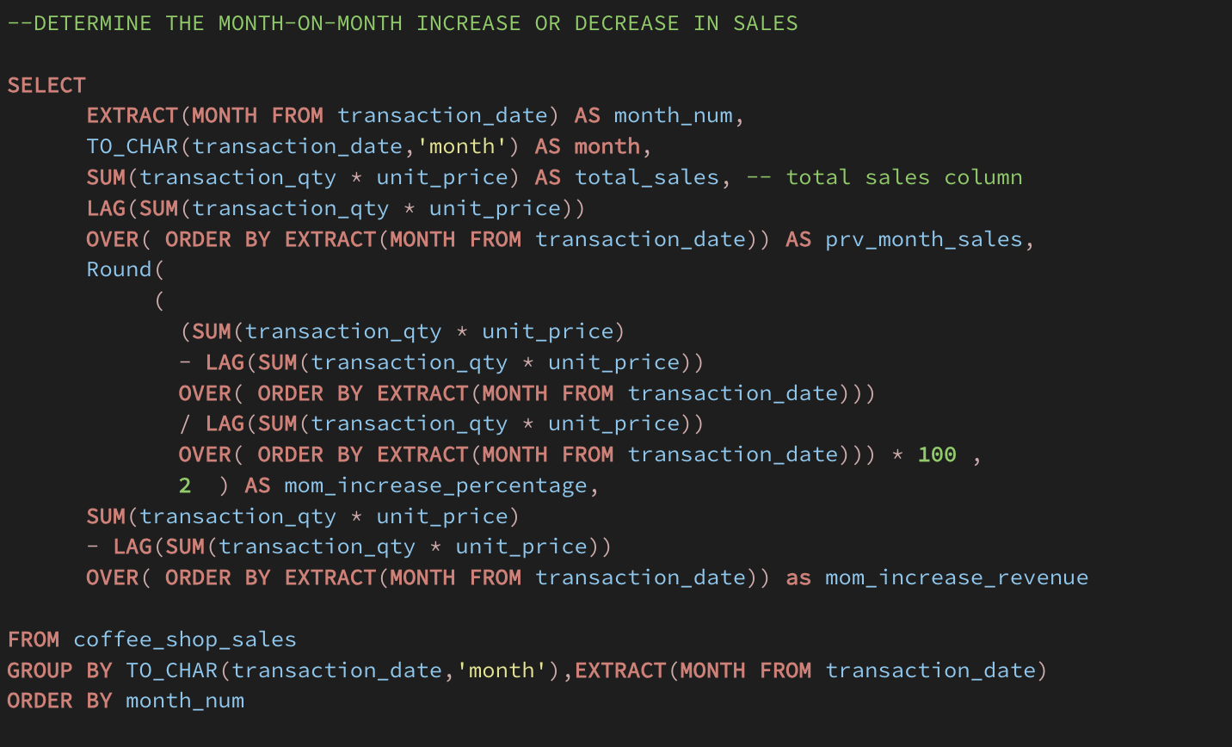

‘

Key Insight
Revenue shows a consistent upward trend from January through June, with the highest MoM growth observed in the spring months, likely driven by seasonal demand.

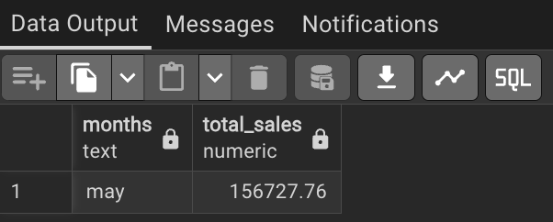

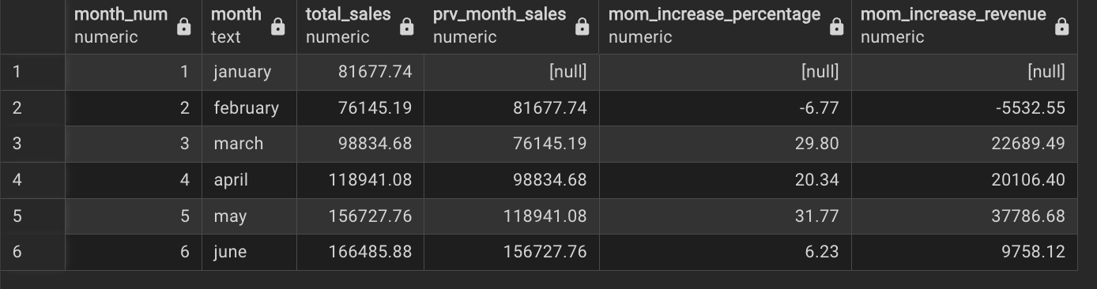

6. Total Orders Analysis

6.1 Monthly Order Count
Total orders per month are calculated by counting distinct transaction IDs. This metric reflects customer footfall and purchase frequency independent of order value.
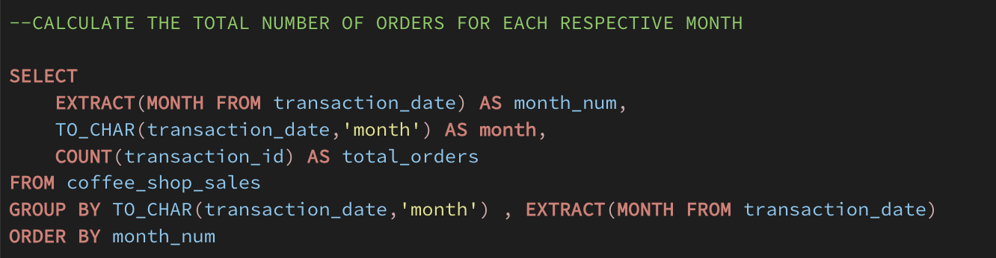

6.2 Month-on-Month Order Growth
Similar to sales, the LAG() function tracks how order volumes change month-over-month. A cast to ::numeric ensures accurate percentage division in PostgreSQL.
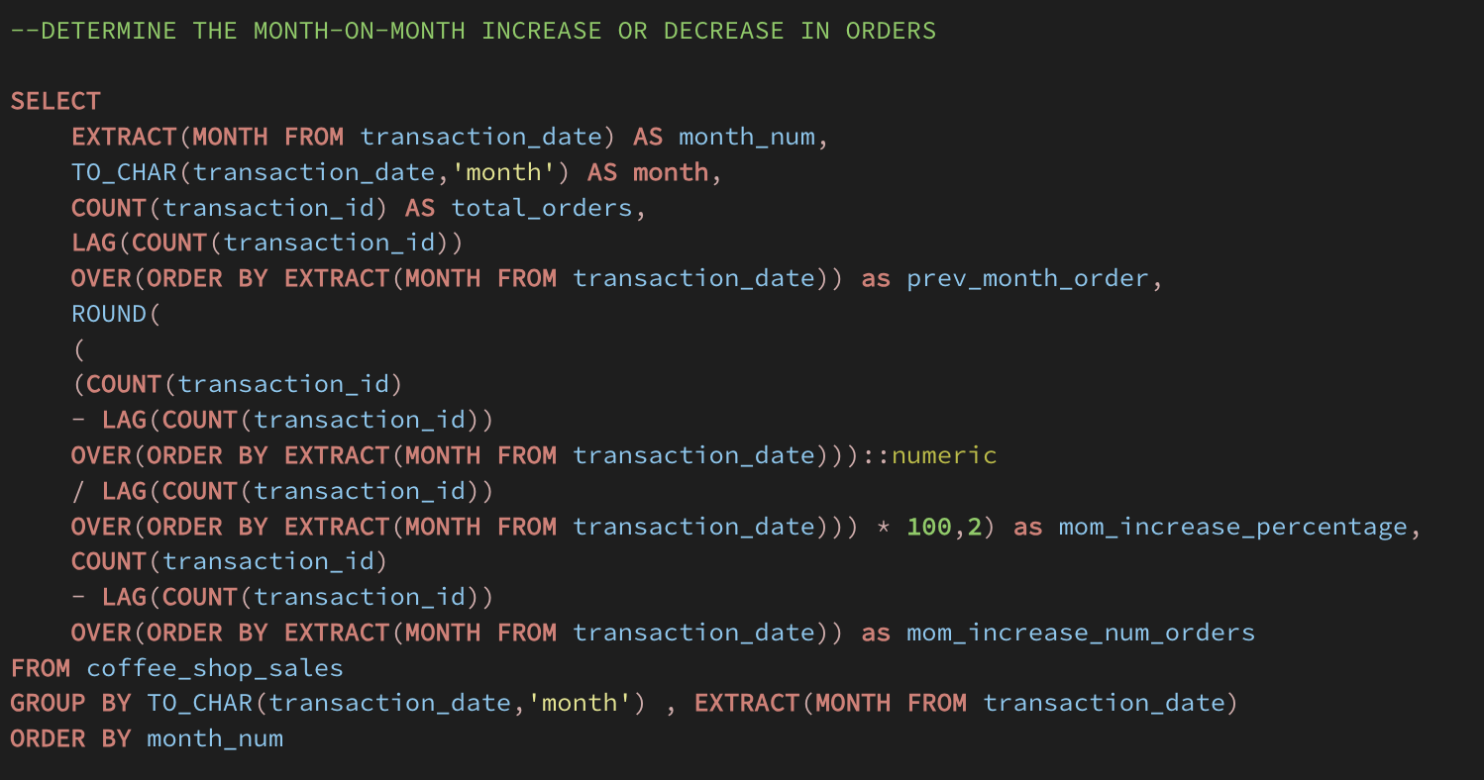

Key Insight
Order volume growth largely mirrors revenue growth, confirming that increased revenue is driven by more transactions rather than just higher average order values.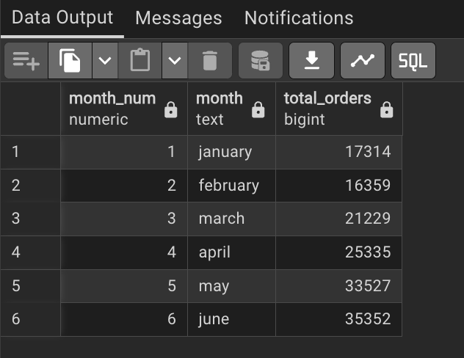
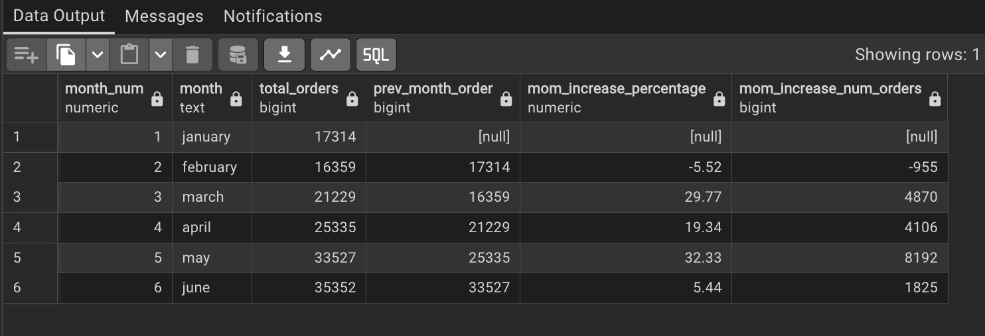

7. Total Quantity Sold Analysis
This section tracks total units sold per month and its month-on-month change, using SUM(transaction_qty) and the LAG() window function.
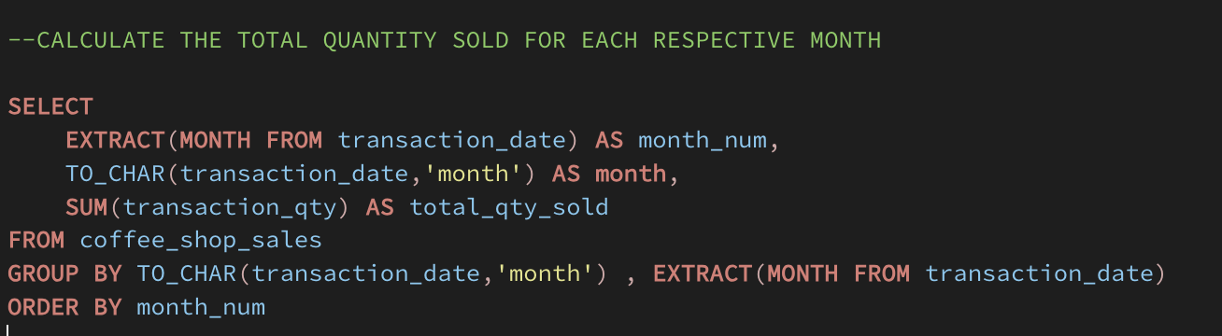

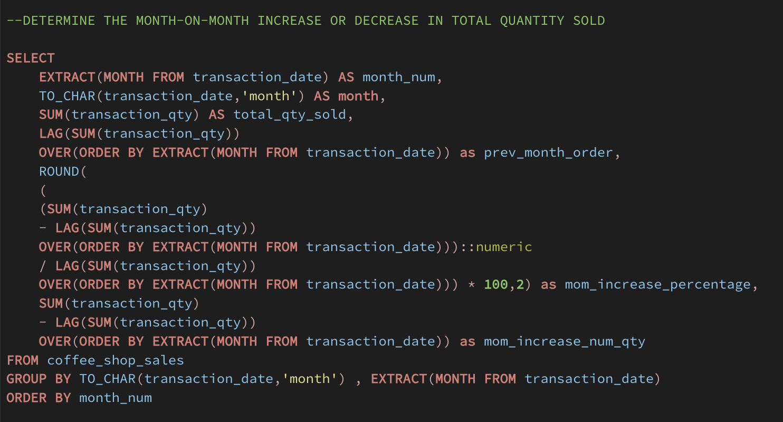

Key Insight
Quantity sold trends align closely with order count, suggesting average items per order remains fairly consistent. Any divergence indicates changes in bundle sizes or promotions.

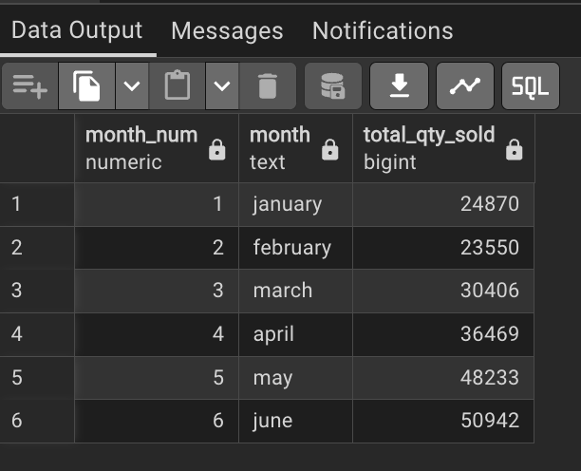

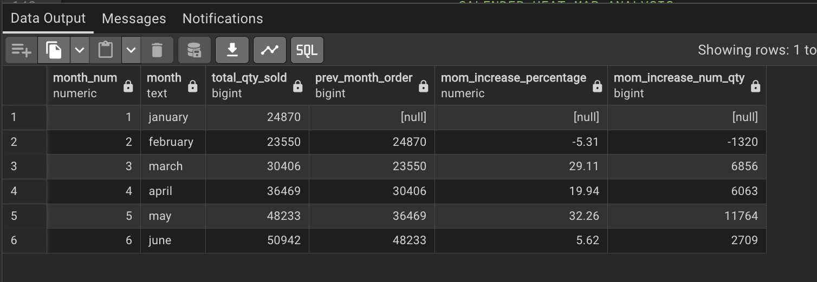

8. Calendar Heat Map Analysis

8.1 Daily Sales, Orders & Quantity
For any given date, total sales, order count, and quantity sold can be retrieved. This enables a calendar heat map view in Power BI where colour intensity reflects sales volume per day.

SELECT transaction_date,
CONCAT('$ ', ROUND(SUM(unit_price * transaction_qty)/1000, 1), 'K') AS total_sales,
COUNT(transaction_id) AS total_orders,
SUM(transaction_qty) AS total_qty_sold
FROM coffee_shop_sales
WHERE transaction_date = '2023-03-27'
GROUP BY transaction_date;
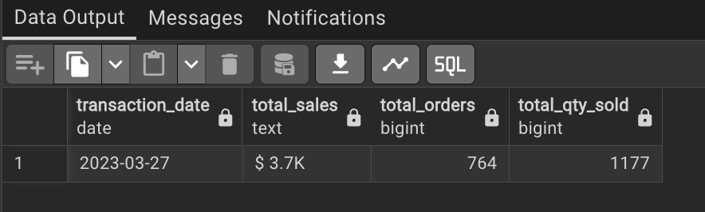

8.2 Weekday vs. Weekend Sales
Using EXTRACT(DOW FROM ...) — where 0 = Sunday and 6 = Saturday — transactions are classified into weekday and weekend buckets to compare sales patterns.

SELECT
CASE
WHEN EXTRACT(DOW FROM transaction_date) IN (0,6) THEN 'Weekend'
ELSE 'Weekday'
END AS day_type,
CONCAT(ROUND(SUM(unit_price * transaction_qty)/1000, 1),'K') AS total_sales
FROM coffee_shop_sales
WHERE EXTRACT(MONTH FROM transaction_date) = 2
GROUP BY day_type;
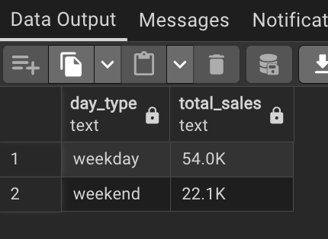
Key Insight
Weekday sales consistently outperform weekends, reflecting a commuter and office-worker customer base. This informs staffing and inventory decisions, with higher resource allocation needed on weekdays.

9. Sales Analysis by Store Location
Revenue is compared across all store locations for any selected month. The CONCAT and ROUND functions format output in a readable K (thousands) format.

SELECT store_location,
CONCAT(ROUND(SUM(unit_price * transaction_qty)/1000, 2), 'K') AS sales_revenue
FROM coffee_shop_sales
WHERE EXTRACT(MONTH FROM transaction_date) = 5 -- MAY
GROUP BY store_location
ORDER BY sales_revenue DESC;

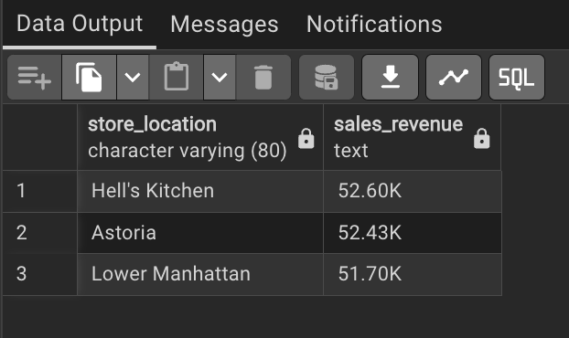

Store Location | Performance | Note
Hell's Kitchen | Highest Revenue | Premium location, high footfall
Astoria | Mid-Range Revenue | Strong consistent performer
Lower Manhattan | Competitive | Close to Hell's Kitchen performance

Key Insight
All three locations perform comparably, with no single store significantly underperforming. This suggests consistent brand quality and operations. Targeted promotions at lower-performing locations could balance revenue further.

10. Sales Analysis by Product Category
This query breaks down revenue by product_category for each month, making it easy to track which categories are growing or declining over time.

SELECT
EXTRACT(MONTH FROM transaction_date) AS month,
product_category AS category,
SUM(unit_price * transaction_qty) AS total_sales
FROM coffee_shop_sales
GROUP BY product_category, EXTRACT(MONTH FROM transaction_date)
ORDER BY month, total_sales DESC;
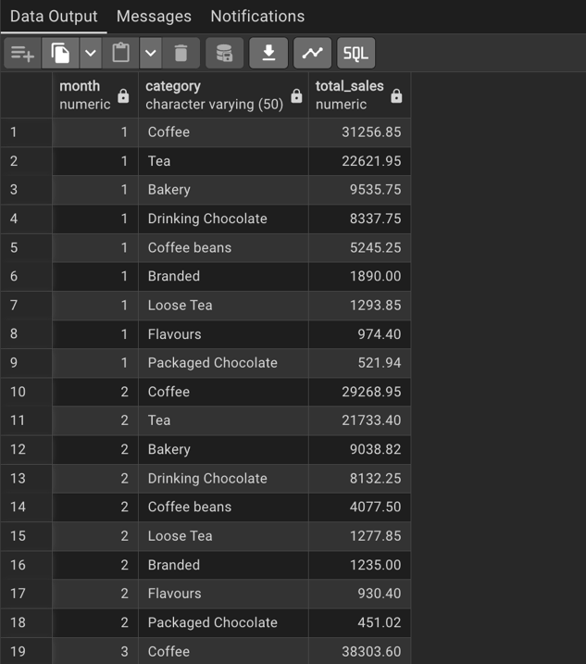
Product Category | Revenue Contribution | Trend
Coffee | Highest | Dominant category, consistent growth
Tea | Second Highest | Steady performance
Bakery | Third | Strong attachment to beverage orders
Drinking Chocolate | Moderate | Seasonal peaks in colder months
Coffee Beans / Merchandise | Lower | Niche revenue stream

Key Insight
Coffee dominates revenue across all months. Bakery items show strong cross-sell potential alongside beverages, suggesting bundled promotions could boost average transaction value.

11. Top 10 Products by Sales
The top 10 revenue-generating product types are identified by grouping on product_type and ordering by total sales descending with a LIMIT 10 clause.

SELECT product_type,
SUM(unit_price * transaction_qty) AS total_sales
FROM coffee_shop_sales
WHERE EXTRACT(MONTH FROM transaction_date) = 5 -- AND product_category = 'Coffee'
GROUP BY product_type
ORDER BY total_sales DESC
LIMIT 10;
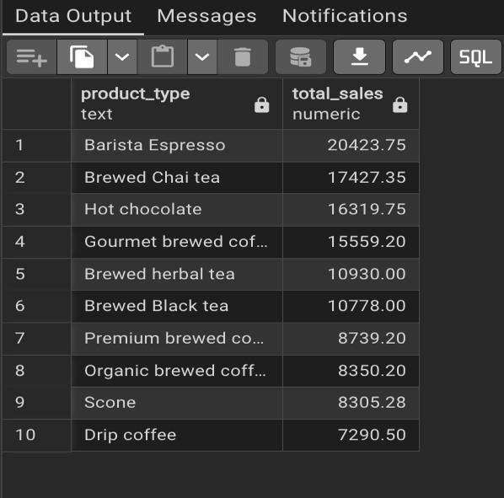
Removing the product_category filter from the WHERE clause provides overall top-10 rankings, while adding it allows category-specific rankings (e.g., top 10 Coffee products).

Key Insight
Barista Espresso and Brewed Chai Tea consistently appear in the top ranks. These signature items should be prominently featured in marketing campaigns and maintained with stable pricing to protect high-margin revenue.

12. Sales Analysis by Days & Hours

12.1 Drill-Down: Specific Day & Hour
A granular query filters down to a specific month, day of week, and hour to calculate exact sales, order count, and quantity for that time slot:

SELECT SUM(unit_price * transaction_qty) AS total_sales,
COUNT(transaction_id) AS total_orders,
SUM(transaction_qty) AS total_qty_sold
FROM coffee_shop_sales
WHERE EXTRACT(MONTH FROM transaction_date) = 5 -- May
AND EXTRACT(DOW FROM transaction_date) = 1 -- Monday
AND EXTRACT(HOUR FROM transaction_time) = 8; -- 8 AM
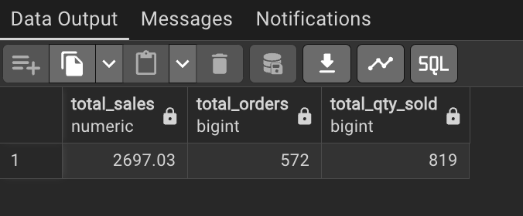

12.2 Peak Hours Analysis
Sales are aggregated by hour of day to identify the busiest time windows. This drives staffing schedules and promotional timing decisions.
SELECT
EXTRACT(HOUR FROM transaction_time) AS hour_of_day,
SUM(unit_price * transaction_qty) AS total_sales
FROM coffee_shop_sales
WHERE EXTRACT(MONTH FROM transaction_date) = 5
GROUP BY EXTRACT(HOUR FROM transaction_time)
ORDER BY total_sales DESC;
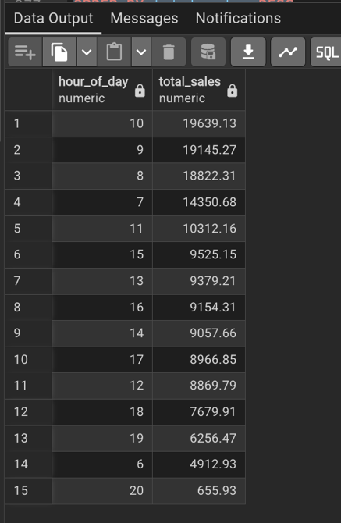

12.3 Peak Days Analysis
A CASE statement maps DOW integers (0–6) to human-readable day names, then total sales are aggregated and ordered chronologically.

Time Dimension | Peak Period | Business Implication
Hour of Day | 7 AM – 10 AM | Morning rush: prioritise espresso & grab-and-go items
Day of Week | Monday – Friday | Weekdays drive majority of revenue
Day of Month | Mid-month dates | Slight mid-month uptick in spending

Key Insight
The 7–10 AM morning window is the single highest-revenue period. Ensuring full staffing, adequate stock of top products, and minimal wait times during this window has the highest ROI impact.

13. Power BI Dashboard
The SQL analysis outputs were imported into Microsoft Power BI to create an interactive, multi-page dashboard. The dashboard consolidates all key metrics into visual, filterable reports for business stakeholders.

13.1 Dashboard Pages
Dashboard Page | Visuals Included
KPI Overview | Card visuals for Total Sales, Orders, and Quantity with MoM % badges
Sales Trend | Line chart of monthly sales, orders, quantity with MoM annotations
Calendar Heat Map | Matrix visual with conditional formatting by day/month
Store Performance | Clustered bar chart comparing all store locations
Product Analysis | Donut chart for category share + Bar chart for top 10 products
Time Intelligence | Heatmap of sales by Hour × Day of Week

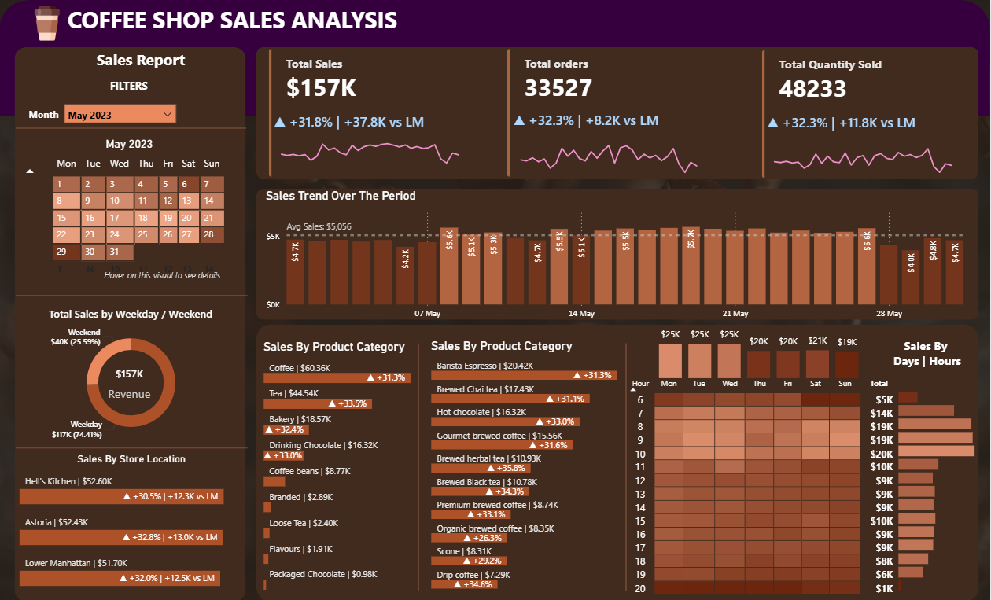

13.2 Filters & Slicers
- Month slicer — filter all visuals to a selected month
- Store location slicer — compare individual branches
- Product category slicer — drill into specific categories
- Day type toggle — Weekday vs. Weekend view

MONTH SLICER

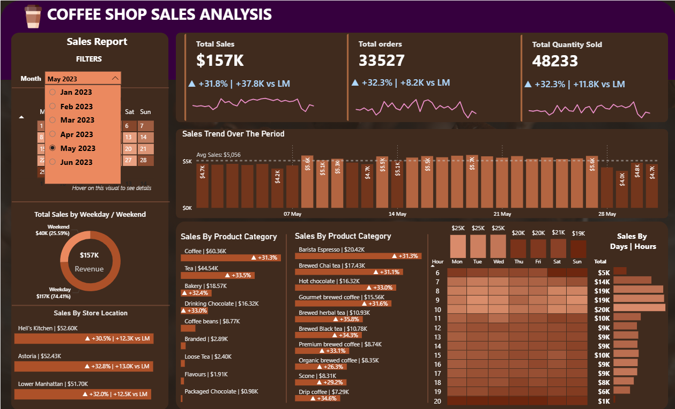

STORE LOCATION SLICER 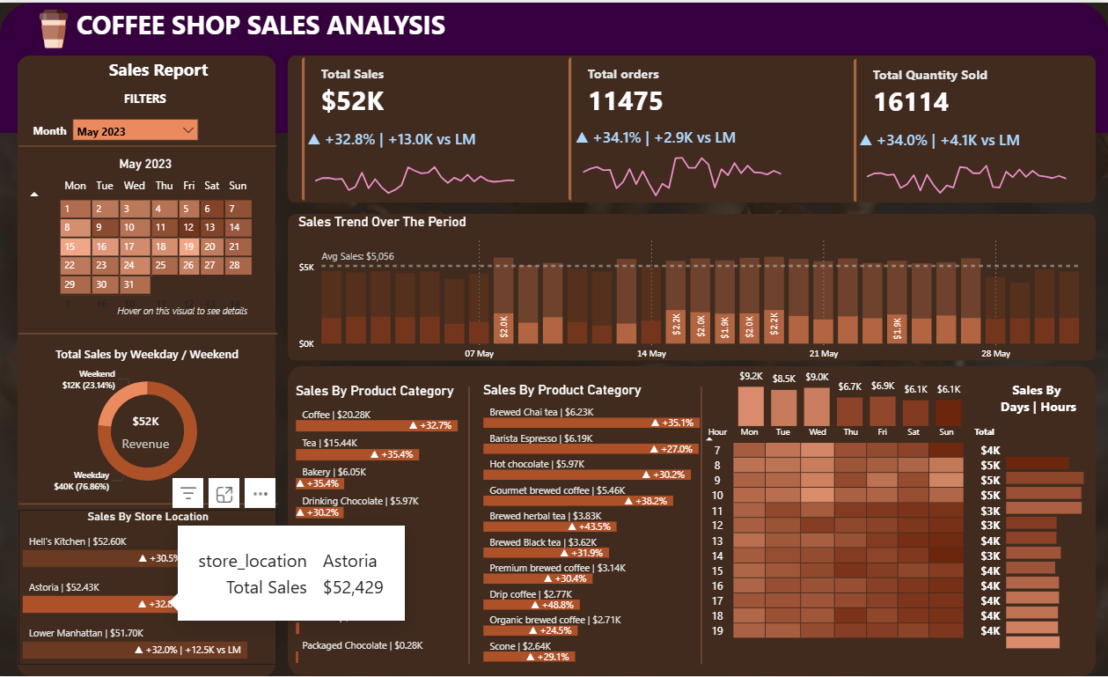

DAY TYPE TOGGLE
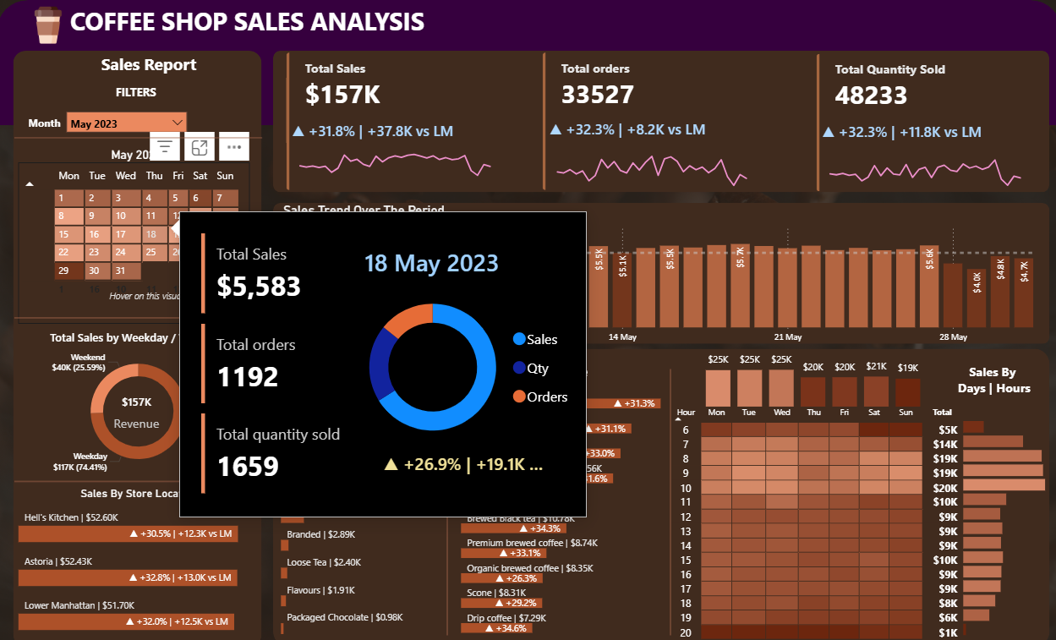

PRODUCT CATEGORY SLICER
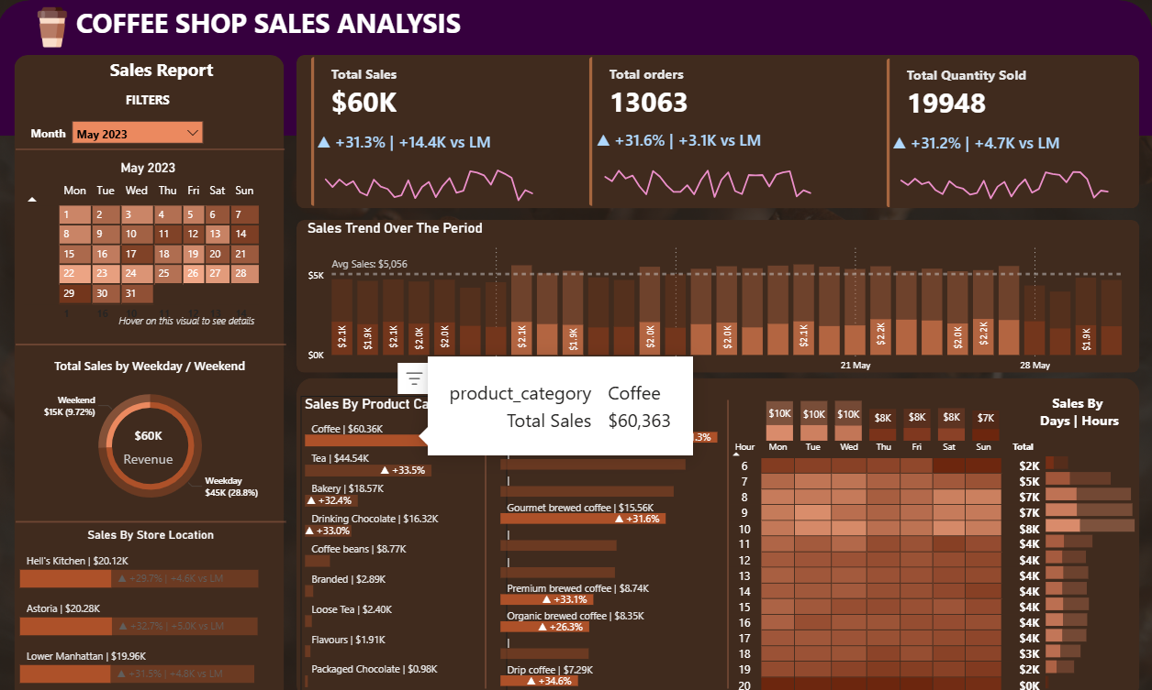

PEAK HOUR SALES
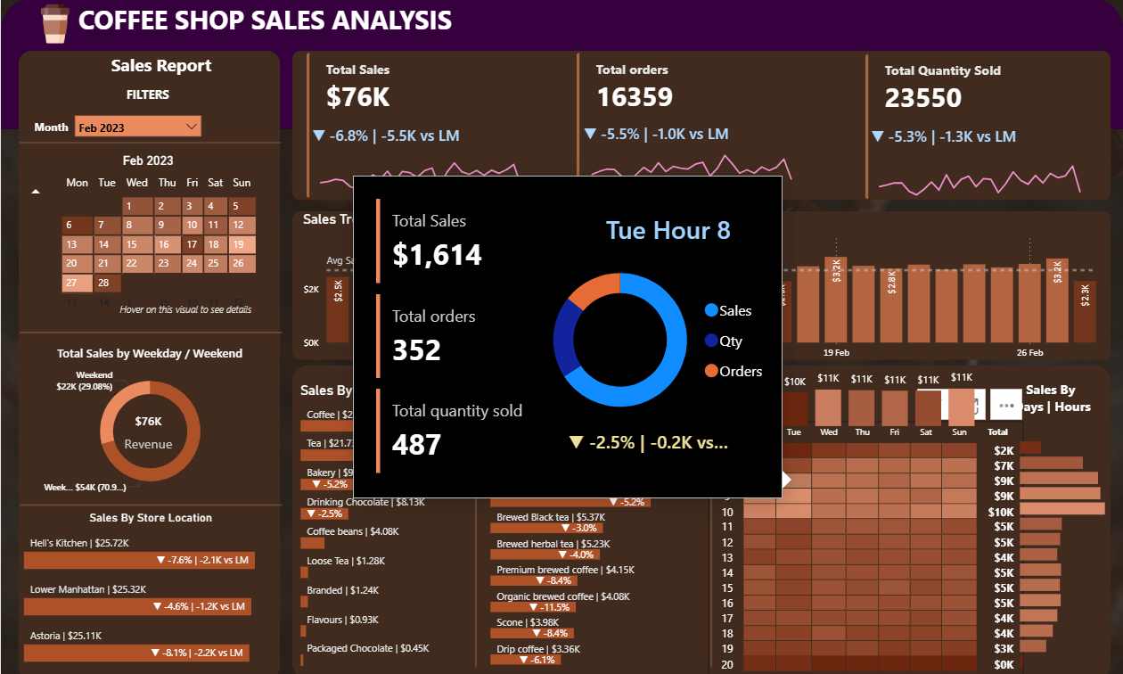

WEEKDAY VS. WEEKEND VIEW
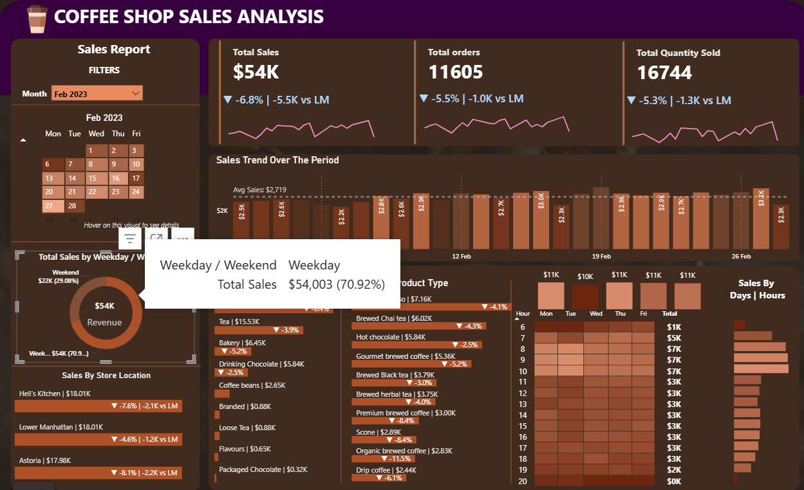

14. Key Insights & Business Recommendations

# | Insight | Recommendation
1 | Revenue grew consistently month-on-month from Jan–Jun 2023 | Sustain growth with seasonal promotions heading into H2
2 | Coffee dominates product revenue across all months | Protect core coffee menu; innovate with limited seasonal variants
3 | Morning hours (7–10 AM) are peak sales periods | Maximise staffing & stock availability in the morning window
4 | Weekdays significantly outperform weekends | Launch weekend promotions (e.g., brunch combos) to boost off-peak traffic
5 | All 3 locations perform comparably | Standardise best practices from top-performing store across all locations
6 | Bakery items have strong co-purchase potential | Bundle bakery with beverages; offer combo discounts to lift avg. order value
7 | Top 10 products contribute disproportionate revenue | Ensure these products are always in stock; avoid menu complexity
8 | Month-on-month order growth mirrors revenue growth | Revenue growth is organic (more customers), not just price-driven

15. Conclusion
This project demonstrates a complete end-to-end data analytics workflow — from raw transactional data in Excel, through structured SQL analysis in PostgreSQL, to interactive visual reporting in Power BI.

The analysis uncovered clear patterns in revenue growth, product performance, customer timing preferences, and store-level comparisons. These insights equip coffee shop management with data-driven tools to optimise operations, staffing, inventory, and marketing.

SQL window functions (LAG, AVG OVER, EXTRACT) were central to the analytical approach, enabling time-series comparisons without complex subquery nesting. The Power BI dashboard translates these queries into accessible visuals that non-technical stakeholders can interact with independently.

Skills Demonstrated
- SQL DDL — Table creation with constraints
- Aggregate functions — SUM, COUNT, AVG
- Window functions — LAG(), AVG() OVER()
- Date/time functions — EXTRACT, TO_CHAR, DOW
- Conditional logic — CASE WHEN
- Subqueries and CTEs
- Power BI — Data modelling, DAX measures, interactive visuals
- Business analysis — Translating data findings into recommendations

Integrated Telegram bot automation into the Al Test Case Agent to fetch structured data via one-shot prompts, simulating complex, multi-step workflows.

☕ Report prepared as part of a Data Analytics Portfolio Project ☕

