**VISVESVARAYA TECHNOLOGICAL UNIVERSITY**

**“JnanaSangama”, Belgaum -590014, Karnataka.**



**LAB REPORT**

**On**

**DATA STRUCTURES (23CS3PCDST)**

**Submitted by**

**Rachit Chandra (1BM23CS255)**

**in partial fulfillment for the award of the degree of**

**BACHELOR OF ENGINEERING**

**in**

**COMPUTER SCIENCE AND ENGINEERING**



**B.M.S. COLLEGE OF ENGINEERING**

**(Autonomous Institution under VTU)**

**BENGALURU-560019**

**September 2024-January 2025**

**B. M. S. College of Engineering,**

**Bull Temple Road, Bangalore 560019**

**(Affiliated To Visvesvaraya Technological University, Belgaum)**

**Department of Computer Science and Engineering**



This is to certify that the Lab work entitled **“DATA STRUCTURES”** carried out by **Rachit Chandra (1BM23CS255)**, who is Bonafide student of **B. M. S. College of Engineering**. It is in partial fulfillment for the award of **Bachelor of Engineering in Computer Science and Engineering** of the Visvesvaraya Technological University, Belgaum during the year 2024-25. The Lab report has been approved as it satisfies the academic requirements in respect of Data structures Lab - **(23CS3PCDST)** work prescribed for the said degree.

**Prof. Lakshmi Neelima M** **Dr. Kavitha Sooda**

Assistant Professor Professor and Head

Department of CSE Department of CSE

BMSCE, Bengaluru BMSCE, Bengaluru

**Index Sheet**

|  |  |  |
| --- | --- | --- |
| **Sl.**  **No.** | **Experiment Title** | **Page No.** |
| 1 | **Stack Implementation using Arrays** | 5 |
| 2 | **Infix Arithmetic Expression to Postfix Expression** | 9 |
| 3 | **Linear Queue using Arrays** | 11 |
|  | **Circular Queue using Arrays** | 14 |
| 4 | **Singly Linked List – Creation, Insertion, Deletion & Display** | 17 |
| 5 | **Singly Linked List – Sorting, Reversal & Concatenation** | 24 |
| 6 | **Stacks using Linked List** | 31 |
|  | **Queue using Linked List** | 35 |
| 7 | **Doubly Linked List -Creation, Insertion, deletion & Display** | 40 |
| 8 | **Binary Search Tree** | 44 |
| 9 | **Breadth First Search** | 47 |
|  | **Depth First Search** | 50 |
| 10 | **Hashing with Linear Probing** | 52 |
| **LeetCode Programs** | | |
| 11 | **Move Zeroes - 283** | 55 |
| 12 | **Majority Element - 169** | 56 |
| 13 | **Game of Two Stacks - HackerRank** | 57 |
| 14 | **Palindrome Linked List - 234** | 58 |
| 15 | **Path Sum - 112** | 59 |

**Course outcomes:**

|  |  |
| --- | --- |
| CO1 | Apply the concept of linear and nonlinear data structures. |
| CO2 | Analyze data structure operations for a given problem |
| CO3 | Design and develop solutions using the operations of linear and nonlinear data structure for a given specification. |
| CO4 | Conduct practical experiments for demonstrating the operations of different data structures. |

**Lab program 1:**

**Write a program to simulate the working of stack using an array with the following: a) Push b) Pop c) Display The program should print appropriate messages for stack overflow, stack underflow**

#include<stdio.h>

#include<stdlib.h>

#define SIZE 5

int stack[SIZE];

int top=-1;

void push(int a)

{

if(top==SIZE-1)

{

printf("\nStack is full,overflow condition");

}

else

{

top++;

stack[top]=a;

printf("\nElement successfully pushed to stack");

}

}

void pop()

{

if(top==-1)

{

printf("\nStack is empty,underflow condition");

}

else

{

int ele = stack[top];

printf("\nElement %d has been successfully popped",ele);

top--;

}

}

void display()

{

if(top==-1)

{

printf("\nstack is empty,underflow condition");

}

else

{

for(int i=top;i>-1;i--)

{

printf("%d ",stack[i]);

}

}

}

void main()

{

int c,e;

while(1)

{

printf("\n\n1.push\n2.pop\n3.display\n4.exit\nEnter :");

scanf("%d",&c);

switch (c)

{

case 1: printf("\nEnter the element to push ");

scanf("%d",&e);

push(e);

break;

case 2: pop();

break;

case 3: display();

break;

case 4: exit(1);

default : printf("\nInvalid input");

}

}

}

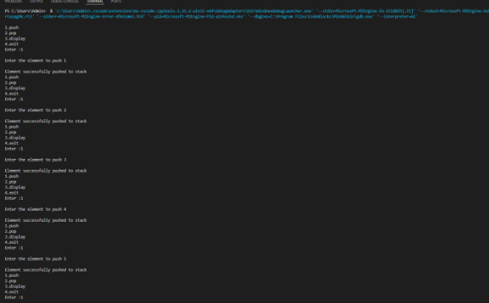

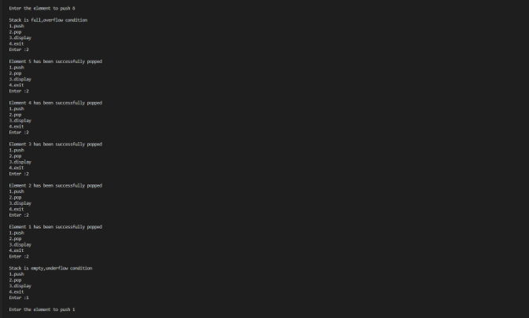

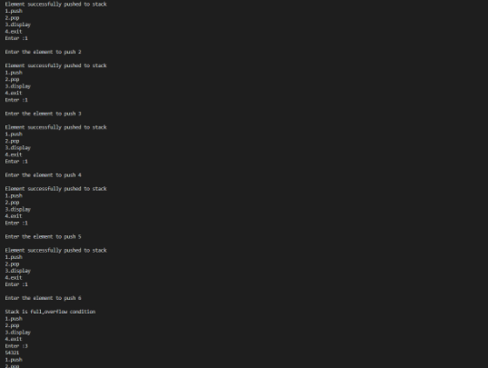

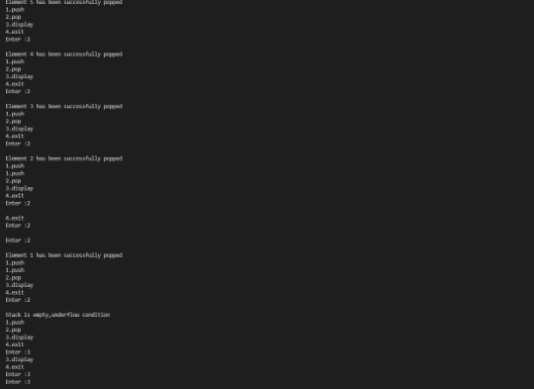

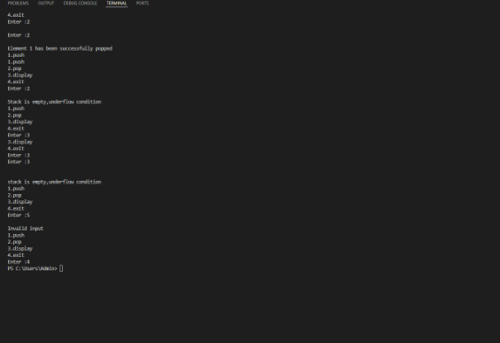

**Lab program 2**

**WAP to convert a given valid parenthesized infix arithmetic expression to postfix expression. The expression consists of single character operands and the binary operators + (plus), - (minus), * (multiply) and / (divide)**

#include <stdio.h>

#include <string.h>

int index1 = 0, pos = 0, top = -1, length;

char symbol, temp, infix[20], postfix[20], stack[20];

void infixToPostfix();

void push(char symbol);

char pop();

int pred(char symbol);

int main() {

printf("Enter infix expression:\n");

scanf("%s", infix);

infixToPostfix();

printf("\nInfix expression: %s", infix);

printf("\nPostfix expression: %s\n", postfix);

return 0;

}

void infixToPostfix() {

length = strlen(infix);

push('#'); // Push an initial dummy character to the stack

while (index1 < length) {

symbol = infix[index1];

switch (symbol) {

case '(':

push(symbol);

break;

case ')':

temp = pop();

while (temp != '(') {

postfix[pos++] = temp;

temp = pop();

}

break;

case '+':

case '-':

case '*':

case '/':

case '^':

while (pred(stack[top]) >= pred(symbol)) {

temp = pop();

postfix[pos++] = temp;

}

push(symbol);

break;

default:

postfix[pos++] = symbol;

}

index1++;

}

while (top > 0) {

temp = pop();

postfix[pos++] = temp;

}

postfix[pos] = '\0';

}

void push(char symbol) {

top = top + 1;

stack[top] = symbol;

}

char pop() {

char symb;

symb = stack[top];

top = top - 1;

return symb;

}

int pred(char symbol) {

int p;

switch (symbol) {

case '^':

p = 3;

break;

case '*':

case '/':

p = 2;

break;

case '+':

case '-':

p = 1;

break;

case '(':

p = 0;

break;

case '#':

p = -1;

break;

default:

p = -1;

}

return p;

}

**Output:**

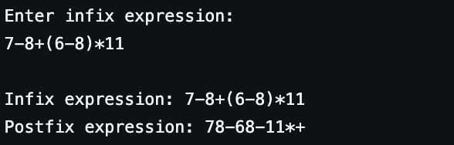

**Lab Program 3**

1. **WAP to simulate the working of a queue of integers using an array. Provide the following operations: Insert, Delete, Display The program should print appropriate messages for queue empty and queue overflow conditions**

#include <stdio.h>

#define SIZE 3

int queue[SIZE];

int front = -1, rear = -1;

int is_full() {

return (rear == SIZE - 1);

}

int is_empty() {

return (front == -1);

}

void insert(int value) {

if (is_full()) {

printf("Queue Overflow\n");

return;

}

if (front == -1)

front = 0;

queue[++rear] = value;

printf("Inserted %d into the queue.\n", value);

}

void delete() {

if (is_empty()) {

printf("Queue Underflow.\n");

return;

}

printf("Deleted %d from the queue.\n", queue[front]);

front++;

if (front > rear) {

front = -1;

rear = -1;

}

}

void display() {

if (is_empty()) {

printf("Queue is empty!\n");

return;

}

printf("Queue elements: ");

for (int i = front; i <= rear; i++) {

printf("%d ", queue[i]);

}

printf("\n");

}

int main() {

int choice, value;

printf("\nQueue Operations:\n");

printf("1. Insert\n");

printf("2. Delete\n");

printf("3. Display\n");

printf("4. Exit\n");

while (1) {

printf("Enter your choice: ");

scanf("%d", &choice);

switch (choice) {

case 1:

printf("Enter the value to insert: ");

scanf("%d", &value);

insert(value);

break;

case 2:

delete();

break;

case 3:

display();

break;

case 4:

printf("Exiting...\n");

return 0;

default:

printf("Invalid choice! Please try again.\n");

}

}

}

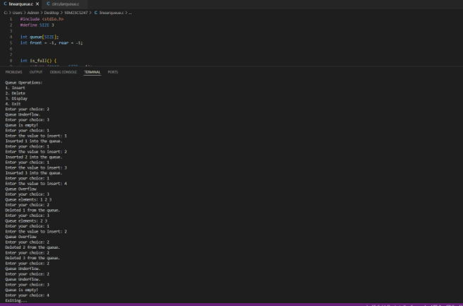

**b) WAP to simulate the working of a circular queue of integers using an array. Provide the following operations: Insert, Delete & Display The program should print appropriate messages for queue empty and queue overflow conditions**

#include <stdio.h>

#define SIZE 3

int queue[SIZE];

int front = -1, rear = -1;

int is_full() {

return (front == (rear + 1) % SIZE);

}

int is_empty() {

return (front == -1);

}

void insert(int n) {

if (is_full()) {

printf("Queue Overflow\n");

return;

}

if (is_empty())

front = 0;

rear = 0;

else

rear = (rear + 1) % SIZE;

queue[rear] = n;

printf("Element %d inserted.\n", n);

}

void delete() {

if (is_empty()) {

printf("Queue Underflow.\n");

return;

}

printf("Element %d deleted\n", queue[front]);

if (front == rear){

front = -1;

rear = -1;

}

else

front = (front + 1) % SIZE;

}

void display() {

if (is_empty()) {

printf("Queue is empty\n");

return;

}

printf("Queue elements: ");

int i = front;

while (1) {

printf("%d ", queue[i]);

if (i == rear)

break;

i = (i + 1) % SIZE;

}

printf("\n");

}

int main() {

int choice, value;

printf("\nCircular Queue Operations:\n");

printf("1. Insert\n");

printf("2. Delete\n");

printf("3. Display\n");

printf("4. Exit\n");

while (1) {

printf("Enter your choice: ");

scanf("%d", &choice);

switch (choice) {

case 1:

printf("Enter the value to insert: ");

scanf("%d", &value);

insert(value);

break;

case 2:

delete();

break;

case 3:

display();

break;

case 4:

printf("Exiting...\n");

return 0;

default:

printf("Invalid choice! Please try again.\n");

}

}

}

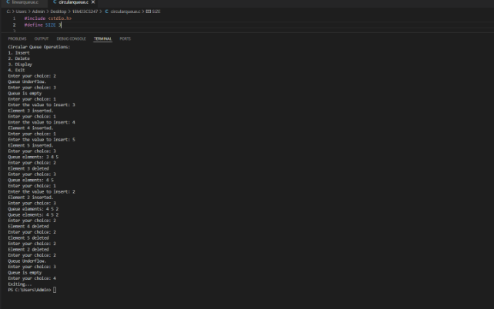

**Lab Program 4**

**WAP to Implement Singly Linked List with following operations**

**a) Create LinkedList.**

**b) Insertion of a node at first position, at any position and at end of list.**

**c) Deletion of first element, specified element and last element in the list.**

**Display the contents of the linked list**.

#include <stdio.h>

#include <stdlib.h>

struct Node {

int data;

struct Node* next;

};

// Create a new node

struct Node* create_node(int data) {

struct Node* new_node = (struct Node*)malloc(sizeof(struct Node));

new_node->data = data;

new_node->next = NULL;

return new_node;

}

// Insert node at the beginning

void insert_at_beginning(struct Node** head, int data) {

struct Node* new_node = create_node(data);

new_node->next = *head;

*head = new_node;

}

// Insert node at the end

void insert_at_end(struct Node** head, int data) {

struct Node* new_node = create_node(data);

if (*head == NULL) {

*head = new_node;

return;

}

struct Node* temp = *head;

while (temp->next != NULL) {

temp = temp->next;

}

temp->next = new_node;

}

// Insert node at a specific position

void insert_at_position(struct Node** head, int data, int position) {

if (position < 0) return; // Invalid position

if (position == 0) {

insert_at_beginning(head, data);

return;

}

struct Node* new_node = create_node(data);

struct Node* temp = *head;

for (int i = 0; i < position - 1; i++) {

if (temp == NULL) return; // Position out of range

temp = temp->next;

}

new_node->next = temp->next;

temp->next = new_node;

}

// Delete node at the beginning

void delete_at_beginning(struct Node** head) {

if (*head != NULL) {

struct Node* temp = *head;

*head = (*head)->next;

free(temp);

}

}

// Delete node at the end

void delete_at_end(struct Node** head) {

if (*head == NULL) return;

if ((*head)->next == NULL) {

free(*head);

*head = NULL;

return;

}

struct Node* temp = *head;

while (temp->next && temp->next->next != NULL) {

temp = temp->next;

}

free(temp->next);

temp->next = NULL;

}

// Delete node with a specific key

void delete_at_key(struct Node** head, int key) {

if (*head == NULL) return;

if ((*head)->data == key) {

struct Node* temp = *head;

*head = (*head)->next;

free(temp);

return;

}

struct Node* temp = *head;

while (temp->next != NULL && temp->next->data != key) {

temp = temp->next;

}

if (temp->next == NULL) return;

struct Node* to_delete = temp->next;

temp->next = temp->next->next;

free(to_delete);

}

// Delete node before the key

void delete_before_key(struct Node** head, int key) {

if (*head == NULL || (*head)->next == NULL) return;

if ((*head)->next->data == key) {

struct Node* temp = *head;

*head = (*head)->next;

free(temp);

return;

}

struct Node* temp = *head;

while (temp->next != NULL && temp->next->next != NULL) {

if (temp->next->next->data == key) {

struct Node* to_delete = temp;

temp = temp->next;

free(to_delete);

return;

}

temp = temp->next;

}

}

// Delete node after the key

void delete_after_key(struct Node** head, int key) {

struct Node* temp = *head;

while (temp != NULL && temp->data != key) {

temp = temp->next;

}

if (temp != NULL && temp->next != NULL) {

struct Node* to_delete = temp->next;

temp->next = temp->next->next;

free(to_delete);

}

}

// Display the list

void display(struct Node* head) {

struct Node* temp = head;

while (temp != NULL) {

printf("%d -> ", temp->data);

temp = temp->next;

}

printf("NULL\n");

}

// Free all nodes to avoid memory leaks

void free_list(struct Node** head) {

struct Node* temp;

while (*head != NULL) {

temp = *head;

*head = (*head)->next;

free(temp);

}

}

int main() {

struct Node* head = NULL;

int data, key;

printf("Choice :\n1.insert_at_beginning\n2.insert_at_end\n3.insert_at_position\n4.delete_at_beginning\n5.delete_at_end\n6.delete_at_key\n7.delete_before_key\n8.delete_after_key\n9.display\n10.exit\n");

int c;

while (1) {

printf("Enter choice: ");

scanf("%d", &c);

switch (c) {

case 1:

printf("Enter the data: ");

scanf("%d", &data);

insert_at_beginning(&head, data);

break;

case 2:

printf("Enter the data: ");

scanf("%d", &data);

insert_at_end(&head, data);

break;

case 3:

printf("Enter the data and position: ");

scanf("%d%d", &data, &key);

insert_at_position(&head, data, key);

break;

case 4:

delete_at_beginning(&head);

break;

case 5:

delete_at_end(&head);

break;

case 6:

printf("Enter the key to delete: ");

scanf("%d", &key);

delete_at_key(&head, key);

break;

case 7:

printf("Enter the key to delete before: ");

scanf("%d", &key);

delete_before_key(&head, key);

break;

case 8:

printf("Enter the key to delete after: ");

scanf("%d", &key);

delete_after_key(&head, key);

break;

case 9:

display(head);

break;

case 10:

exit(0);

default:

printf("Invalid choice...\n");

}

}

return 0;

}

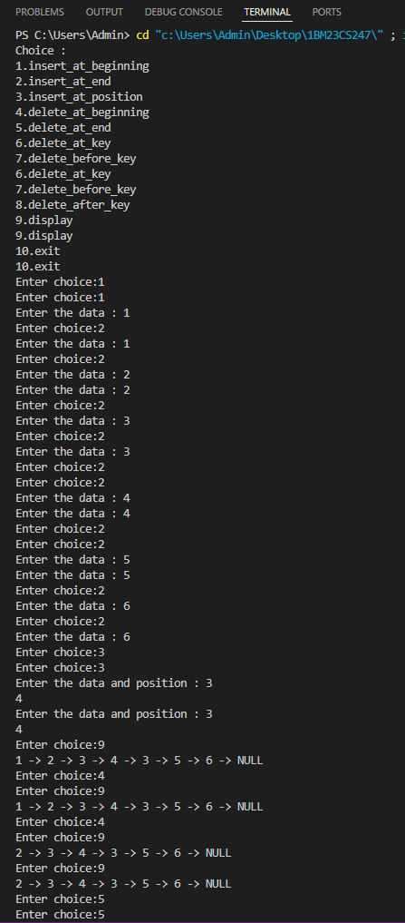

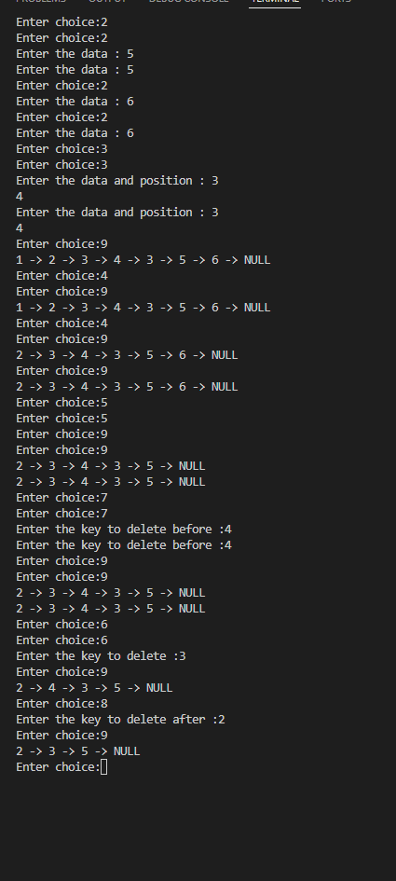

**Lab Program 5**

**WAP to Implement Single Link List with following operations: Sort the linked list, Reverse the linked list, Concatenation of two linked lists.**

#include <stdio.h>

#include <stdlib.h>

struct Node {

int data;

struct Node* next;

};

struct Node* insertAtEnd(struct Node* head, int value) {

struct Node* newNode = (struct Node*)malloc(sizeof(struct Node));

newNode->data = value;

newNode->next = NULL;

if (!head) return newNode;

struct Node* temp = head;

while (temp->next) temp = temp->next;

temp->next = newNode;

return head;

}

void printList(struct Node* head) {

while (head) {

printf("%d -> ", head->data);

head = head->next;

}

printf("NULL\n");

}

struct Node* sortList(struct Node* head) {

if (!head || !head->next) return head;

struct Node* current = head;

while (current) {

struct Node* next = current->next;

while (next) {

if (current->data > next->data) {

int temp = current->data;

current->data = next->data;

next->data = temp;

}

next = next->next;

}

current = current->next;

}

return head;

}

int main() {

struct Node* head = NULL;

int choice, value;

do {

printf("\n1. Insert\n2. Sort\n3. Display\n4. Exit\nEnter your choice: ");

scanf("%d", &choice);

switch (choice) {

case 1:

printf("Enter value to insert: ");

scanf("%d", &value);

head = insertAtEnd(head, value);

break;

case 2:

head = sortList(head);

printf("List sorted.\n");

break;

case 3:

printf("Linked list: ");

printList(head);

break;

case 4:

printf("Exiting program.\n");

break;

default:

printf("Invalid choice. Try again.\n");

}

} while (choice != 4);

return 0;

}

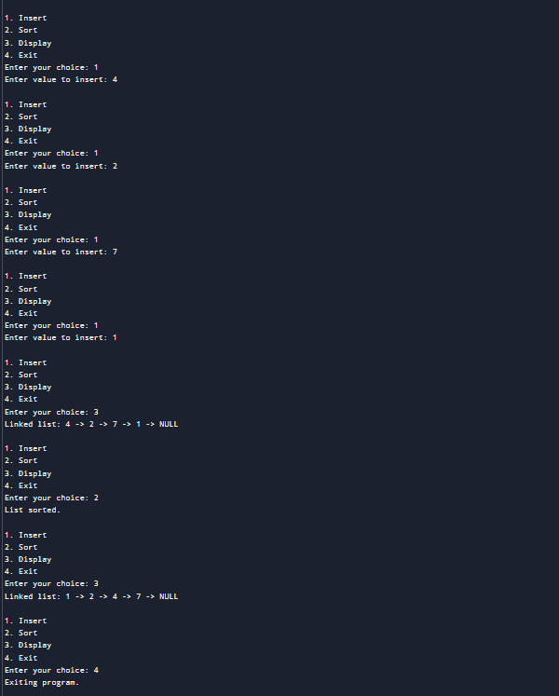

#include <stdio.h>

#include <stdlib.h>

struct Node {

int data;

struct Node* next;

};

struct Node* insertAtEnd(struct Node* head, int value) {

struct Node* newNode = (struct Node*)malloc(sizeof(struct Node));

newNode->data = value;

newNode->next = NULL;

if (!head) return newNode;

struct Node* temp = head;

while (temp->next) temp = temp->next;

temp->next = newNode;

return head;

}

void printList(struct Node* head) {

while (head) {

printf("%d -> ", head->data);

head = head->next;

}

printf("NULL\n");

}

struct Node* reverseList(struct Node* head) {

struct Node* prev = NULL;

struct Node* current = head;

struct Node* next = NULL;

while (current) {

next = current->next;

current->next = prev;

prev = current;

current = next;

}

return prev;

}

int main() {

struct Node* head = NULL;

int value;

printf("Enter values to create a linked list (-1 to stop): ");

do {

scanf("%d", &value);

if (value != -1) head = insertAtEnd(head, value);

} while (value != -1);

printf("Original List: ");

printList(head);

head = reverseList(head);

printf("Reversed List: ");

printList(head);

return 0;

}

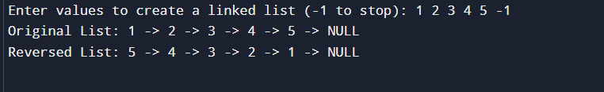

#include <stdio.h>

#include <stdlib.h>

struct Node {

int data;

struct Node* next;

};

struct Node* insertAtEnd(struct Node* head, int value) {

struct Node* newNode = (struct Node*)malloc(sizeof(struct Node));

newNode->data = value;

newNode->next = NULL;

if (!head) return newNode;

struct Node* temp = head;

while (temp->next) temp = temp->next;

temp->next = newNode;

return head;

}

void printList(struct Node* head) {

while (head) {

printf("%d -> ", head->data);

head = head->next;

}

printf("NULL\n");

}

struct Node* concatenateLists(struct Node* head1, struct Node* head2) {

if (!head1) return head2;

if (!head2) return head1;

struct Node* temp = head1;

while (temp->next) temp = temp->next;

temp->next = head2;

return head1;

}

int main() {

struct Node* list1 = NULL;

struct Node* list2 = NULL;

int choice, value;

printf("Creating List 1:\n");

do {

printf("Enter value to insert (-1 to stop): ");

scanf("%d", &value);

if (value != -1) list1 = insertAtEnd(list1, value);

} while (value != -1);

printf("Creating List 2:\n");

do {

printf("Enter value to insert (-1 to stop): ");

scanf("%d", &value);

if (value != -1) list2 = insertAtEnd(list2, value);

} while (value != -1);

printf("List 1: ");

printList(list1);

printf("List 2: ");

printList(list2);

list1 = concatenateLists(list1, list2);

printf("Concatenated List: ");

printList(list1);

return 0;

}

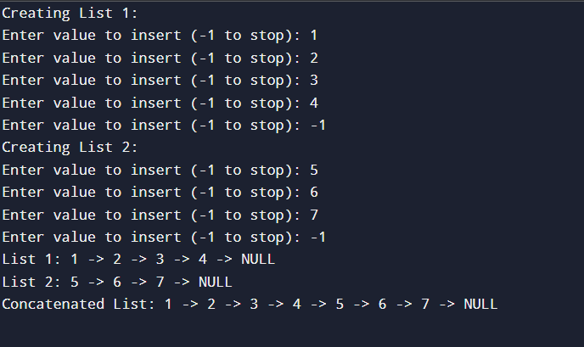

**WAP to Implement Single Link List to simulate Stack & Queue Operations.**

#include <stdio.h>

#include <stdlib.h>

struct Node {

int data;

struct Node* next;

};

struct Queue {

struct Node* front;

struct Node* rear;

};

struct Node* createNode(int data) {

struct Node* node = (struct Node*)malloc(sizeof(struct Node));

node->data = data;

node->next = NULL;

return node;

}

struct Queue* createQueue() {

struct Queue* queue = (struct Queue*)malloc(sizeof(struct Queue));

queue->front = NULL;

queue->rear = NULL;

return queue;

}

int isEmpty(struct Queue* queue) {

return queue->front == NULL;

}

void enqueue(struct Queue* queue, int data) {

struct Node* node = createNode(data);

if (queue->rear == NULL) {

queue->front = queue->rear = node;

return;

}

queue->rear->next = node;

queue->rear = node;

}

int dequeue(struct Queue* queue) {

if (isEmpty(queue)) {

printf("Queue underflow\n");

return NULL;

}

struct Node* temp = queue->front;

int data = temp->data;

queue->front = queue->front->next;

if (queue->front == NULL) queue->rear = NULL;

free(temp);

return data;

}

void display(struct Queue* queue) {

if (isEmpty(queue)) {

printf("Queue is empty\n");

return;

}

struct Node* temp = queue->front;

printf("Queue contents:\n");

while (temp != NULL) {

printf("%d ", temp->data);

temp = temp->next;

}

printf("\n");

}

int main() {

struct Queue* queue = createQueue();

int choice, value;

while (1) {

printf("\nQueue Operations Menu:\n");

printf("1. Enqueue\n");

printf("2. Dequeue\n");

printf("3. Display\n");

printf("4. Exit\n");

printf("Enter your choice: ");

scanf("%d", &choice);

switch (choice) {

case 1:

printf("Enter value to enqueue: ");

scanf("%d", &value);

enqueue(queue, value);

printf("Enqueued: %d\n", value);

break;

case 2:

value = dequeue(queue);

if (value != NULL) {

printf("Dequeued: %d\n", value);

}

break;

case 3:

display(queue);

break;

case 4:

printf("Exiting program.\n");

exit(0);

default:

printf("Invalid choice! Please try again.\n");

}

}

return 0;

}

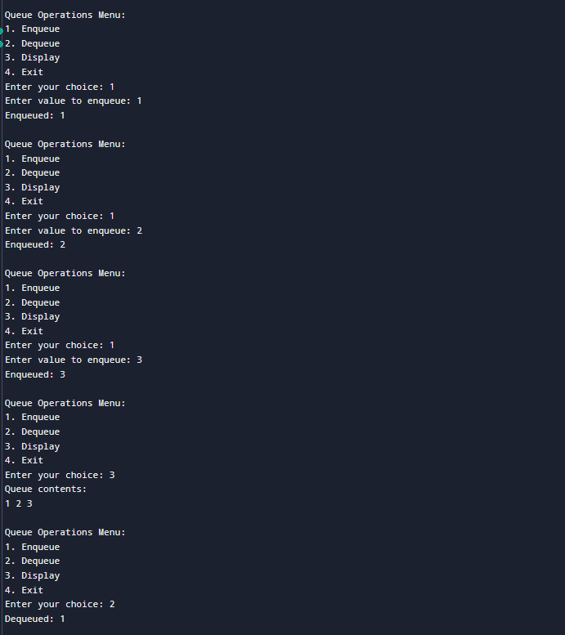

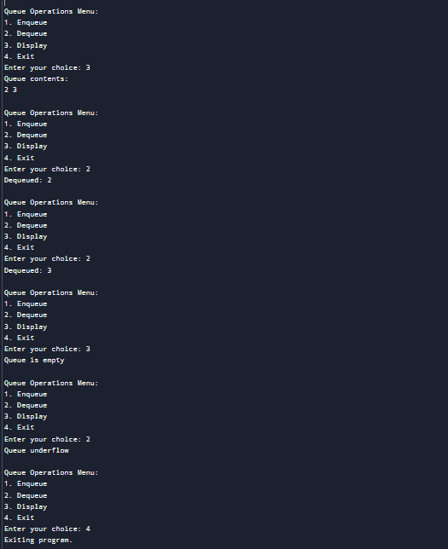\

#include <stdio.h>

#include <stdlib.h>

// Define the Node structure

struct Node {

int data;

struct Node* next;

};

// Function to create a new node

struct Node* createNode(int data) {

struct Node* node = (struct Node*)malloc(sizeof(struct Node));

node->data = data;

node->next = NULL;

return node;

}

// Function to check if the stack is empty

int isEmpty(struct Node* top) {

return top == NULL;

}

// Function to push an element onto the stack

void push(struct Node** top, int data) {

struct Node* node = createNode(data);

node->next = *top;

*top = node;

printf("\nPushed %d onto the stack.", data);

}

// Function to pop an element from the stack

int pop(struct Node** top) {

if (isEmpty(*top)) {

printf("Stack underflow\n");

return -1; // Return -1 to indicate the stack is empty

}

struct Node* temp = *top;

int data = temp->data;

*top = (*top)->next;

free(temp);

return data;

}

// Function to display the elements in the stack

void display(struct Node* top) {

if (isEmpty(top)) {

printf("Stack is empty\n");

return;

}

struct Node* temp = top;

printf("\nStack: ");

while (temp != NULL) {

printf("%d ", temp->data);

temp = temp->next;

}

printf("\n");

}

// Main function with switch-based menu

int main() {

struct Node* stack = NULL;

int choice, value;

while (1) {

printf("\nStack Operations Menu:\n");

printf("1. Push\n");

printf("2. Pop\n");

printf("3. Display\n");

printf("4. Exit\n");

printf("Enter your choice: ");

scanf("%d", &choice);

switch (choice) {

case 1:

printf("Enter value to push: ");

scanf("%d", &value);

push(&stack, value);

break;

case 2:

value = pop(&stack);

if (value != -1) { // Check for valid pop operation

printf("Popped: %d\n", value);

}

break;

case 3:

display(stack);

break;

case 4:

printf("Exiting program.\n");

exit(0);

default:

printf("Invalid choice! Please try again.\n");

}

}

return 0;

}

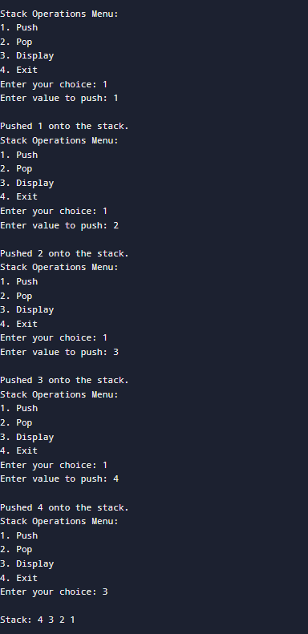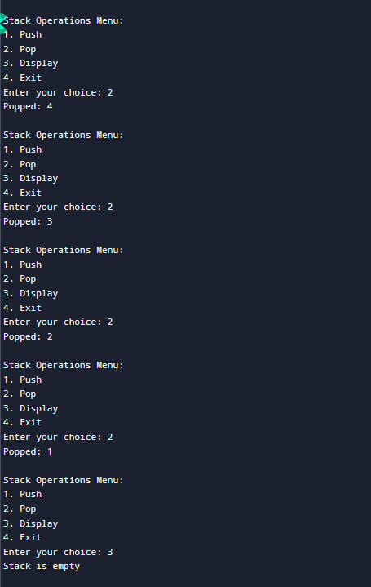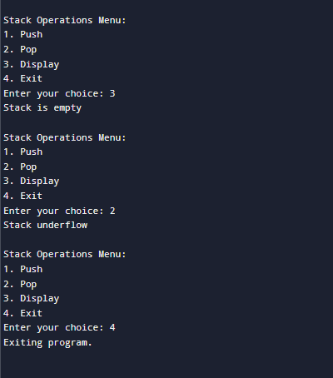

**Lab Program 7**

**WAP to Implement doubly link list with primitive operations**

**a) Create a doubly linked list.**

**b) Insert a new node to the left of the node.**

**c) Delete the node based on a specific value**

**d) Display the contents of the list**

#include <stdio.h>

#include <stdlib.h>

typedef struct node {

struct node* prev;

int data;

struct node* next;

}node;

node* createnode(int data){

node* newnode=(node*)malloc(sizeof(node));

newnode->prev=NULL;

newnode->next=NULL;

newnode->data=data;

return newnode;

}

struct node* createDoublyLinkedList() {

return NULL;

}

int isempty(node* head){

return head==NULL;

}

node* insert_at_beginning(int data, node* head){

node* newnode=createnode(data);

newnode->next=head;

if(head!=NULL)

head->prev=newnode;

head=newnode;

printf("%d has been successfully inserted.\n",data);

return head;

}

node* insert_to_left(int data, int key, node* head) {

node* temp = head;

while (temp != NULL && temp->data != key) {

temp = temp->next;

}

if (temp == NULL) {

printf("Key not found\n");

return head;

}

node* newnode = createnode(data);

newnode->next = temp;

newnode->prev = temp->prev;

if (temp->prev != NULL) {

temp->prev->next = newnode;

} else {

head = newnode;

}

temp->prev = newnode;

printf("%d has been successfully inserted left of %d\n", data, key);

return head;

}

node* deletenode(int key,node* head){

if(isempty(head)){

printf("List is empty hence cannot delete a node\n ");

return head;

}

node* temp=head;

while(temp!=NULL && temp->data!=key){

temp=temp->next;

}

if(temp==NULL){

printf("Key not found\n");

return head;

}

if (temp->prev != NULL) {

temp->prev->next = temp->next;

} else {

head = temp->next;

}

if (temp->next != NULL) {

temp->next->prev = temp->prev;

}

printf("The node has been deleted\n");

free(temp);

return head;

}

void display(node* head){

node* temp=head;

if(isempty(head)){

printf("List is empty\n");

return;

}

printf("List elements : ");

while(temp->next!=NULL){

printf("%d <-> ",temp->data);

temp=temp->next;

}

printf("%d -> NULL\n",temp->data);

}

int main() {

node* head = createDoublyLinkedList();

int choice, value, key;

printf("\nDoubly Linked List Operations:\n");

printf("1. Insert at the beginning\n");

printf("2. Insert to the left of a specific node\n");

printf("3. Delete a node by value\n");

printf("4. Display the list\n");

printf("5. Exit\n");

while (1) {

printf("Enter your choice: ");

scanf("%d", &choice);

switch (choice) {

case 1:

printf("Enter the new value to insert: ");

scanf("%d", &value);

head=insert_at_beginning(value,head);

break;

case 2:

if(!isempty(head)){

printf("Enter the key value: ");

scanf("%d", &key);

printf("Enter the new value to insert: ");

scanf("%d", &value);

head=insert_to_left(value,key,head);

}

else

printf("List is empty hence cannot insert to left.\n");

break;

case 3:

if(!isempty(head)){

printf("Enter the value of the node to delete: ");

scanf("%d", &value);

head=deletenode(value,head);

}

else

printf("List is empty hence cannot delete.\n");

break;

case 4:

display(head);

break;

case 5:

printf("Exiting program.\n");

exit(0);

default:

printf("Invalid choice. Please try again.\n");

}

}

return 0;

}

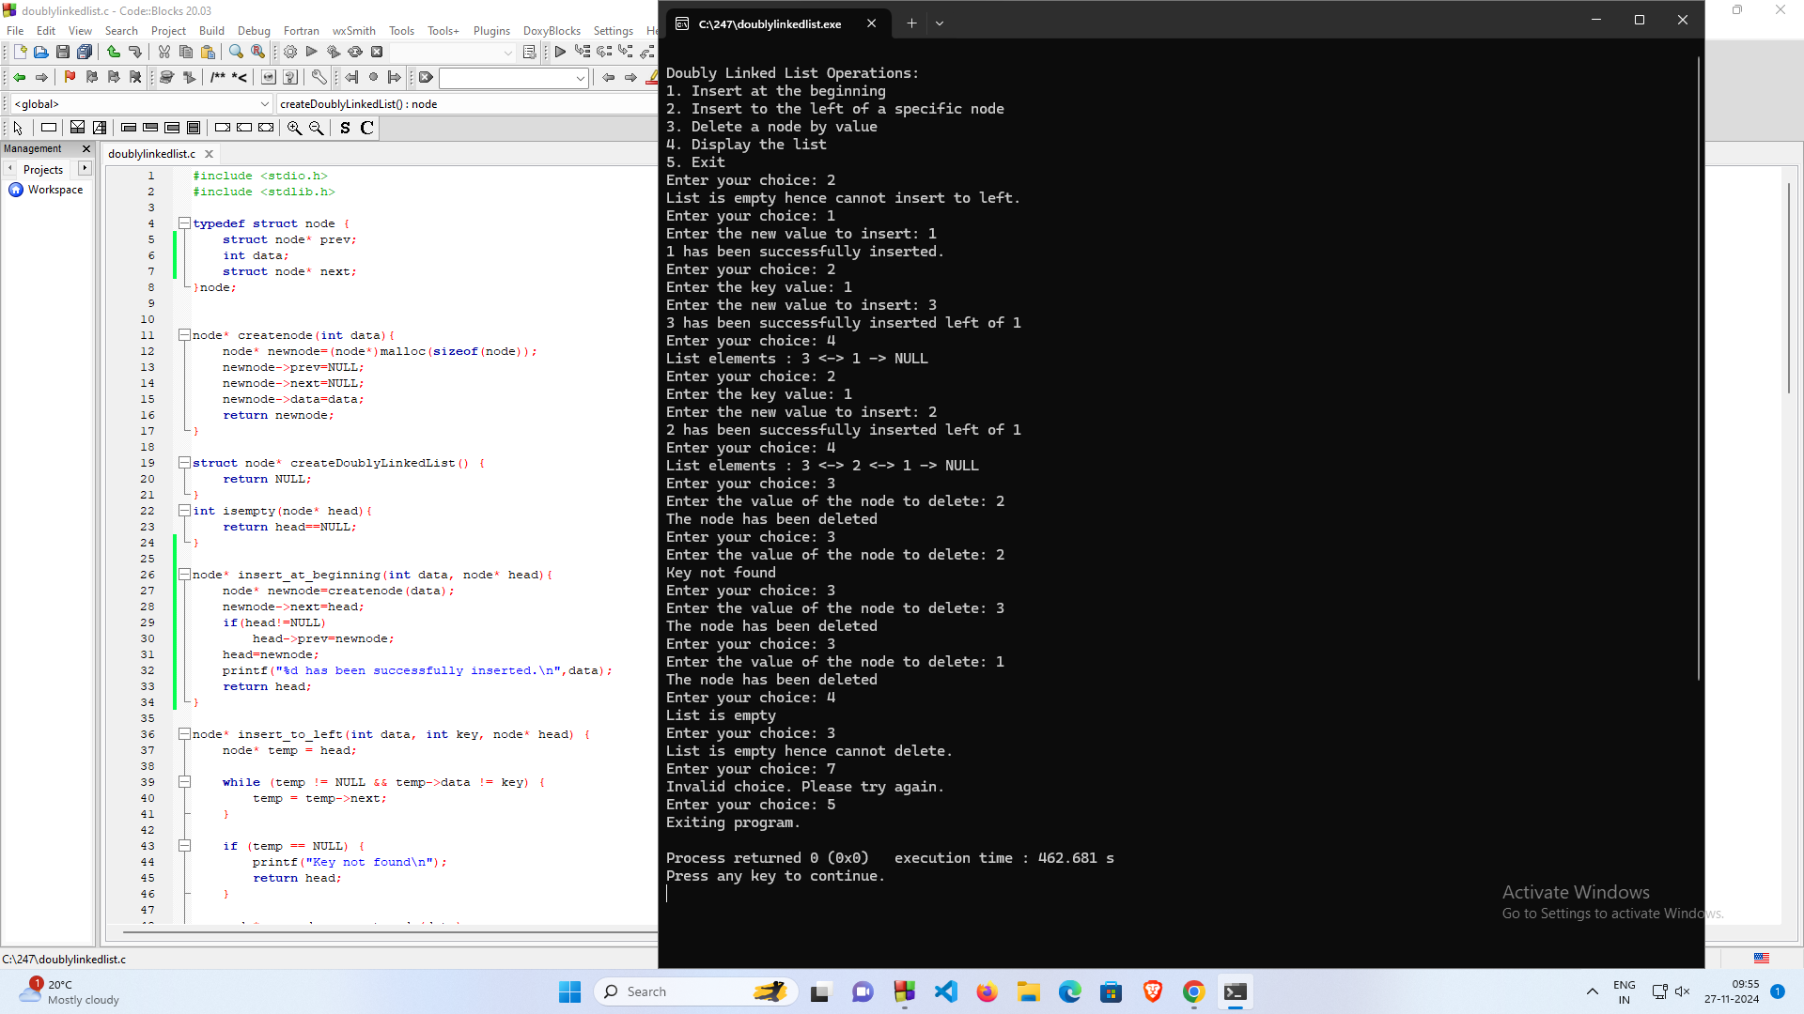

**Lab Program 8**

**Write a program**

**a) To construct a binary Search tree.**

**b) To traverse the tree using all the methods i.e., inorder, preorder and post order**

**c) To display the elements in the tree.**

#include <stdio.h>

#include <stdlib.h>

struct Node {

int data;

struct Node* left;

struct Node* right;

};

struct Node* createNode(int data) {

struct Node* newNode = (struct Node*)malloc(sizeof(struct Node));

newNode->data = data;

newNode->left = newNode->right = NULL;

return newNode;

}

struct Node* insert(struct Node* root, int data) {

if (root == NULL) {

return createNode(data);

}

if (data < root->data) {

root->left = insert(root->left, data);

} else if (data > root->data) {

root->right = insert(root->right, data);

}

return root;

}

void inorderTraversal(struct Node* root) {

if (root == NULL) {

return;

}

inorderTraversal(root->left);

printf("%d ", root->data);

inorderTraversal(root->right);

}

void preorderTraversal(struct Node* root) {

if (root == NULL) {

return;

}

printf("%d ", root->data);

preorderTraversal(root->left);

preorderTraversal(root->right);

}

void postorderTraversal(struct Node* root) {

if (root == NULL) {

return;

}

postorderTraversal(root->left);

postorderTraversal(root->right);

printf("%d ", root->data);

}

int main() {

struct Node* root = NULL;

int choice, data;

while (1) {

printf("\nBinary Search Tree Operations:\n");

printf("1. Insert a node\n");

printf("2. In-order traversal\n");

printf("3. Pre-order traversal\n");

printf("4. Post-order traversal\n");

printf("5. Exit\n");

printf("Enter your choice: ");

scanf("%d", &choice);

switch (choice) {

case 1:

printf("Enter the value to insert: ");

scanf("%d", &data);

root = insert(root, data);

printf("Node %d inserted.\n", data);

break;

case 2:

printf("In-order traversal: ");

inorderTraversal(root);

printf("\n");

break;

case 3:

printf("Pre-order traversal: ");

preorderTraversal(root);

printf("\n");

break;

case 4:

printf("Post-order traversal: ");

postorderTraversal(root);

printf("\n");

break;

case 5:

printf("Exiting...\n");

exit(0);

default:

printf("Invalid choice, please try again.\n");

}

}

return 0;

}

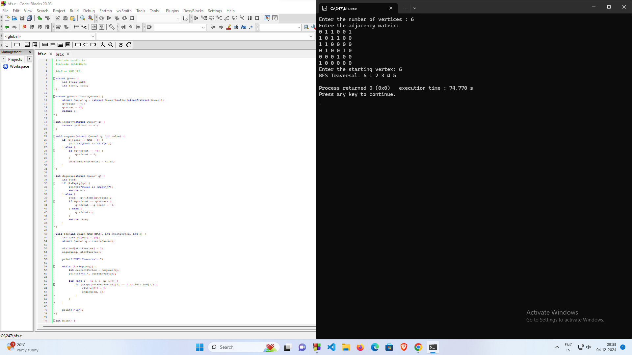

**Lab Program 9**

**Write a program to traverse a graph using BFS method**

#include <stdio.h>

#include <stdlib.h>

#define MAX 100

struct Queue {

int items[MAX];

int front, rear;

};

struct Queue* createQueue() {

struct Queue* q = (struct Queue*)malloc(sizeof(struct Queue));

q->front = -1;

q->rear = -1;

return q;

}

int isEmpty(struct Queue* q) {

return q->front == -1;

}

void enqueue(struct Queue* q, int value) {

if (q->rear == MAX - 1) {

printf("Queue is full\n");

} else {

if (q->front == -1) {

q->front = 0;

}

q->items[++q->rear] = value;

}

}

int dequeue(struct Queue* q) {

int item;

if (isEmpty(q)) {

printf("Queue is empty\n");

return -1;

} else {

item = q->items[q->front];

if (q->front == q->rear) {

q->front = q->rear = -1;

} else {

q->front++;

}

return item;

}

}

void bfs(int graph[MAX][MAX], int startVertex, int n) {

int visited[MAX] = {0};

struct Queue* q = createQueue();

visited[startVertex] = 1;

enqueue(q, startVertex);

printf("BFS Traversal: ");

while (!isEmpty(q)) {

int currentVertex = dequeue(q);

printf("%d ", currentVertex);

for (int i = 1; i <= n; i++) {

if (graph[currentVertex][i] == 1 && !visited[i]) {

visited[i] = 1;

enqueue(q, i);

}

}

}

printf("\n");

}

int main() {

int n, startVertex;

int graph[MAX][MAX];

printf("Enter the number of vertices : ");

scanf("%d", &n);

printf("Enter the adjacency matrix:\n");

for (int i = 1; i <= n; i++) {

for (int j = 1; j <= n; j++) {

scanf("%d", &graph[i][j]);

}

}

printf("Enter the starting vertex: ");

scanf("%d", &startVertex);

bfs(graph, startVertex, n);

return 0;

}

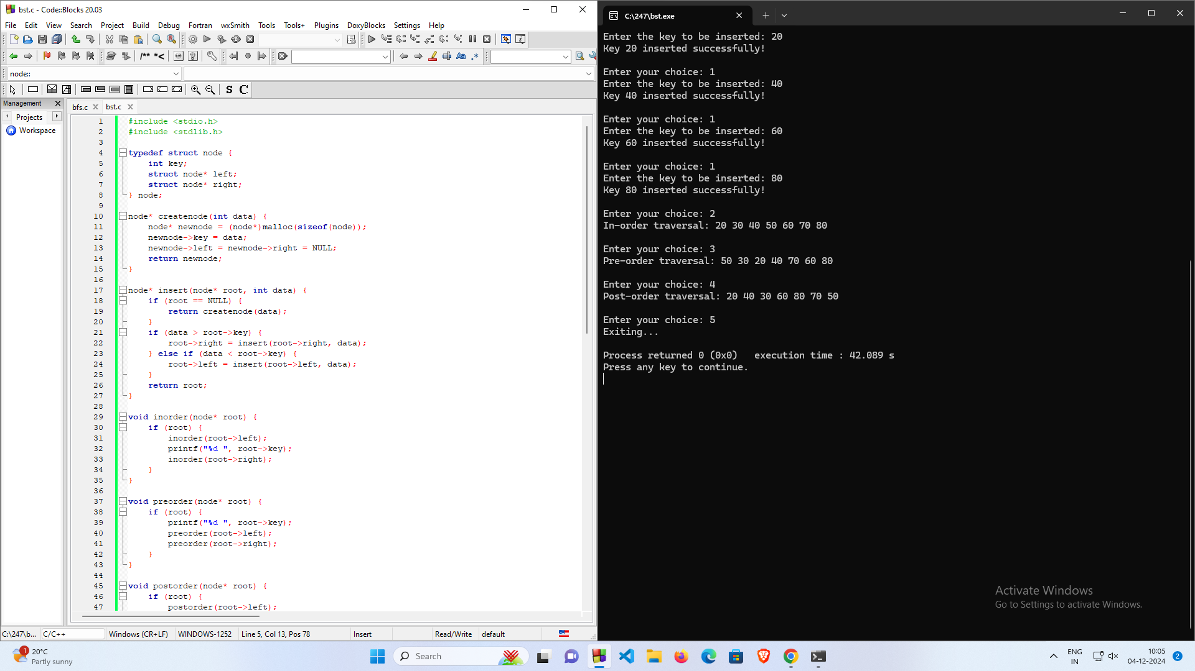

**Lab Program 9**

**Write a program to check whether given graph is connected or not using DFS method.**

#include <stdio.h>

#define MAX_NODES 100

int adjacencyMatrix[MAX_NODES][MAX_NODES];

int visited[MAX_NODES];

int nodes;

// Function for DFS

void DFS(int vertex) {

visited[vertex] = 1;

printf("%d ", vertex); // Print visited node

for (int i = 0; i < nodes; i++) {

if (adjacencyMatrix[vertex][i] == 1 && !visited[i]) {

DFS(i);

}

}

}

// Function to check if the graph is connected

int isConnected() {

// Initialize visited array to 0

for (int i = 0; i < nodes; i++) {

visited[i] = 0;

}

// Start DFS from node 0

DFS(0);

// Check if all nodes are visited

for (int i = 0; i < nodes; i++) {

if (!visited[i]) {

return 0; // Graph is not connected

}

}

return 1; // Graph is connected

}

int main() {

printf("Enter the number of nodes: ");

scanf("%d", &nodes);

printf("Enter the adjacency matrix:\n");

for (int i = 0; i < nodes; i++) {

for (int j = 0; j < nodes; j++) {

scanf("%d", &adjacencyMatrix[i][j]);

}

}

// Check connectivity

if (isConnected()) {

printf("\nThe graph is connected.\n");

} else {

printf("\nThe graph is not connected.\n");

}

return 0;

}

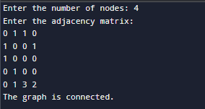

**Lab Program 10**

**Given a File of N employee records with a set K of Keys(4-digit) which uniquely determine the records in file F. Assume that file F is maintained in memory by a Hash Table (HT) of m memory locations with L as the set of memory addresses (2-digit) of locations in HT. Let the keys in K and addresses in L are integers. Design and develop a Program in C that uses Hash function H: K -> L as H(K)=K mod m (remainder method), and implement hashing technique to map a given key K to the address space L. Resolve the collision (if any) using linear probing**

#include <stdio.h>

#include <stdlib.h>

#define MAX_SIZE 100 // Maximum size of the hash table

int hashTable[MAX_SIZE]; // Hash table to store employee keys

int m; // Number of memory locations in the hash table

// Function to initialize the hash table

void initializeHashTable() {

for (int i = 0; i < m; i++) {

hashTable[i] = -1; // Initialize all locations as empty (-1 indicates empty)

}

}

// Hash function: H(K) = K mod m

int hashFunction(int key) {

return key % m;

}

// Function to insert a key into the hash table using linear probing

void insertKey(int key) {

int address = hashFunction(key); // Compute the initial hash address

// Linear probing to resolve collision

int originalAddress = address;

while (hashTable[address] != -1) { // While the location is occupied

printf("Collision detected at address %d for key %d. Probing...\n", address, key);

address = (address + 1) % m; // Move to the next location

if (address == originalAddress) { // If we come back to the start, table is full

printf("Hash table is full! Cannot insert key %d.\n", key);

return;

}

}

hashTable[address] = key; // Place the key at the resolved address

printf("Key %d inserted at address %d.\n", key, address);

}

// Function to display the hash table

void displayHashTable() {

printf("\nHash Table:\n");

for (int i = 0; i < m; i++) {

if (hashTable[i] == -1)

printf("Address %d: EMPTY\n", i);

else

printf("Address %d: %d\n", i, hashTable[i]);

}

}

int main() {

int n; // Number of employee keys

int key;

printf("Enter the number of memory locations in the hash table (m): ");

scanf("%d", &m);

if (m > MAX_SIZE) {

printf("Error: m exceeds the maximum size %d.\n", MAX_SIZE);

return 1;

}

initializeHashTable(); // Initialize the hash table

printf("Enter the number of employee keys (n): ");

scanf("%d", &n);

printf("Enter %d employee keys (4-digit integers):\n", n);

for (int i = 0; i < n; i++) {

scanf("%d", &key);

insertKey(key); // Insert each key into the hash table

}

displayHashTable(); // Display the final hash table

return 0;

}

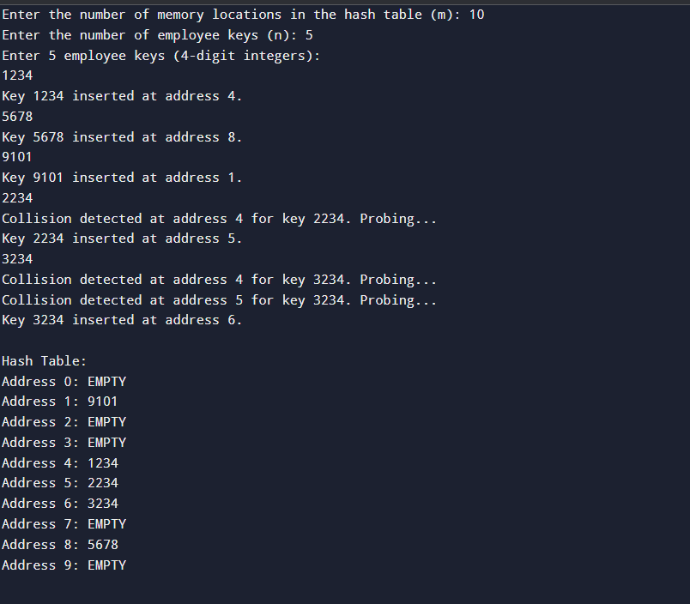

**Leet Code Programs:**

**Move_Zeroes**

void moveZeroes(int* nums, int numsSize) {

int index = 0;

for (int i = 0; i < numsSize; i++) {

if (nums[i] != 0) {

nums[index] = nums[i];

index++;

}

}

while (index < numsSize) {

nums[index] = 0;

index++;

}

}

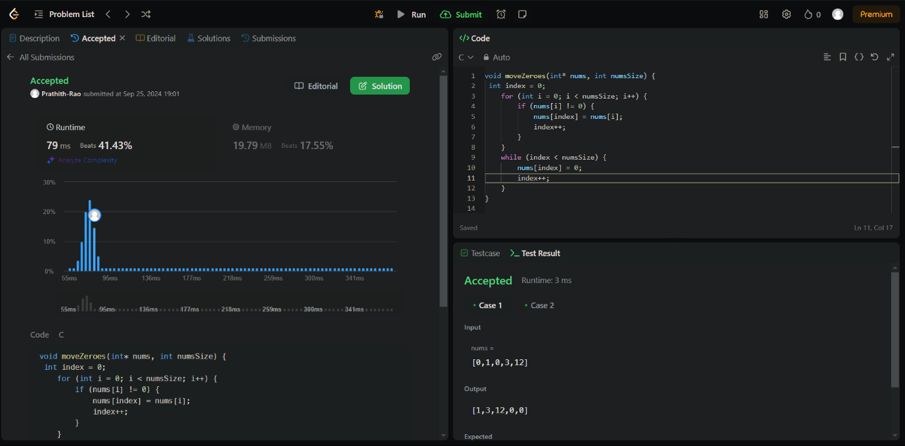

**leetcode_majority_ele**

int majorityElement(int* nums, int numsSize) {

int ele=0;

int c=0;

for(int i=0;i<numsSize;i++)

{

if(c==0)

{

ele=nums[i];

c++;

}

else if(nums[i]==ele)

c++;

else

c--;

}

return ele;

}

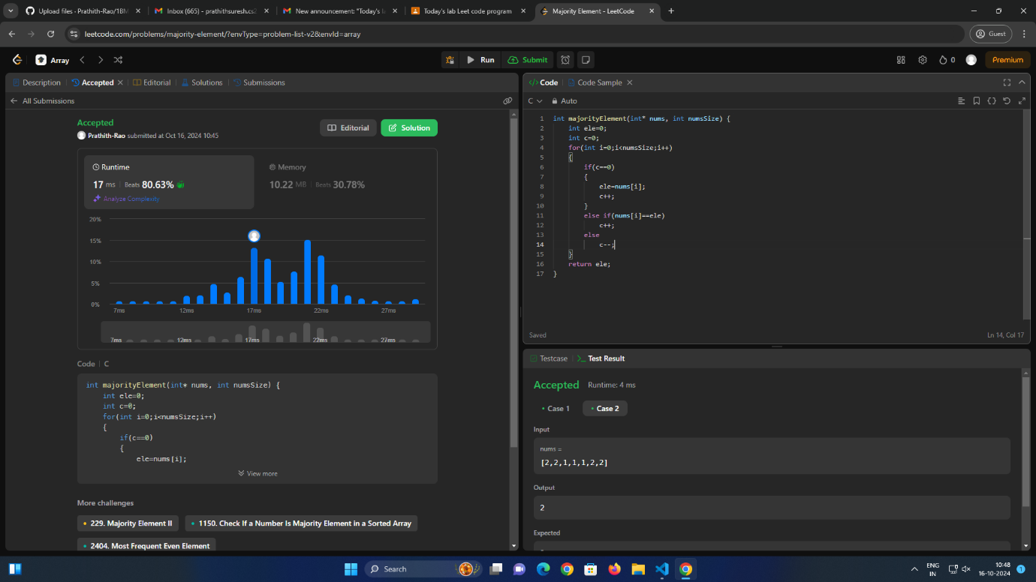

**Game of two stacks**

int twoStacks(int maxSum, int a_count, int* a, int b_count, int* b) {

int sum_a = 0, score_a = 0;

int sum_b = 0, score_b = 0;

int max_score = 0;

for (int i = 0; i < a_count; i++) {

if (sum_a + a[i] > maxSum) break;

sum_a += a[i];

score_a++;

}

max_score = score_a;

for (int j = 0; j < b_count; j++) {

sum_b += b[j];

score_b++;

while (sum_a + sum_b > maxSum && score_a > 0) {

sum_a -= a[score_a - 1];

score_a--;

}

if (sum_a + sum_b <= maxSum) {

int current_score = score_a + score_b;

if (current_score > max_score) {

max_score = current_score;

}

} else {

break;

}

}

return max_score;

}

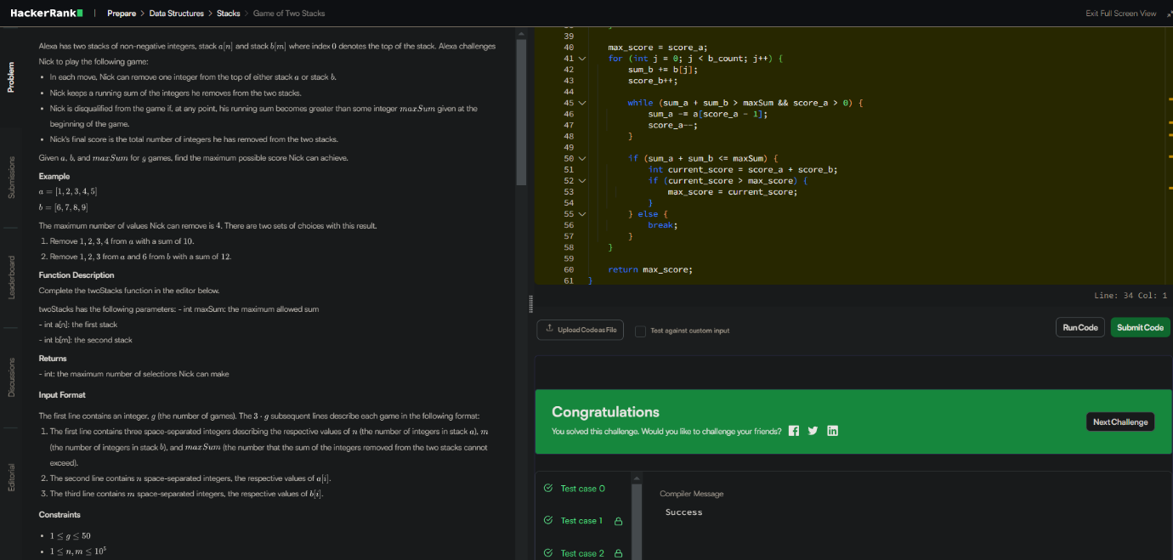

**leetcode-234_palindrome**

bool isPalindrome(struct ListNode* head) {

struct ListNode* temp=head;

if(temp->next==NULL) return true;

struct ListNode *slow = head, *fast = head;

while (fast->next && fast->next->next) {

slow = slow->next;

fast = fast->next->next;

}

temp=slow;

struct ListNode* prev = NULL;

struct ListNode* curr = temp;

struct ListNode* next;

while (curr) {

next = curr->next;

curr->next = prev;

prev = curr;

curr = next;

}

temp=prev;

struct ListNode* n1=head;

struct ListNode* n2=temp;

for(;n1&&n2;n1=n1->next,n2=n2->next)

{

if(n1->val!=n2->val)return false;

}

return true;

}

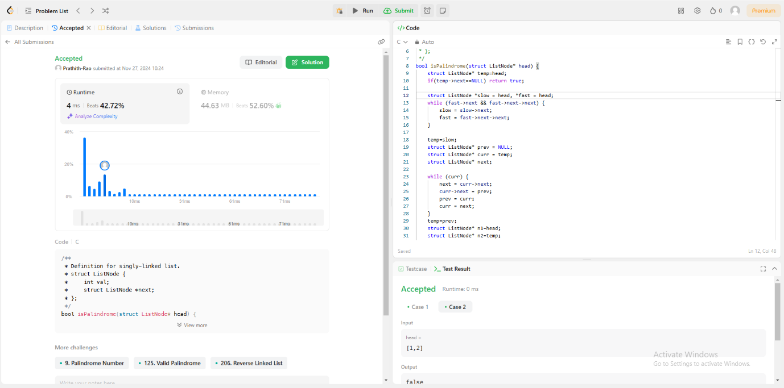

**Path Sum -112**

/**

* Definition for a binary tree node.

* struct TreeNode {

* int val;

* struct TreeNode *left;

* struct TreeNode *right;

* };

*/

bool hasPathSum(struct TreeNode* root, int targetSum) {

if(root==NULL)

return false;

if(root->val==targetSum && root->left==NULL && root->right==NULL)

return true;

else{

return(hasPathSum(root->left,targetSum-root->val) || hasPathSum(root->right,targetSum-root->val));

}

}

