Breast Cancer Prediction Using Machine Learning

Parul  Department of Computer Science & Engineering  Chitkara University, Punjab, India  parul2033.be22@chitkara.edu.in | Rachit Joshi  Department of Computer Science & Engineering  Chitkara University, Punjab, India  rachit2111.be22@chitkara.edu.in | Sukriti  Department of computer  Science & Engineering  Chitkara University, Punjab,  India  sukriti2417.be22@chitkara.edu.in
Dr. Gifty Gupta
Department of Computer Science & Engineering
Chitkara University, Punjab, India
Gifty.gupta@chitkara.edu.in

ABSTRACT
Breast cancer is one of the most commonly diagnosed diseases among women and continues to be a major cause of death worldwide. Detecting it in an early stage is very important, as it can significantly improve survival chances and reduce serious health risks. In this study, a machine-based approach has been used to classify breast tumors as either benign or malignant using Wisconsin Breast Cancer Dataset, which contains 569 samples and 30 features. Various supervised learning techniques were used, including Logistic Regression, Decision Tree, Random Forest, Support Vector Machine (SVM), and K-Nearest Neighbors (KNN). The dataset was first processed using feature scaling and then divided into training and testing sets to ensure better performance of the models. All the models were implemented using Python on the Google Colab platform. Their performance was assessed using metrics such as accuracy, precision, recall, F1-score, and ROC-AUC. The results indicated that SVM performed the best, achieving an accuracy of 98.25% and a perfect recall of 100%, followed by Logistic Regression and Random Forest. This study demonstrates that machine learning can be a fast, reliable, and cost-effective tool for early detection of breast cancer, helping doctors make better and more informed decisions.

Keywords: Breast Cancer, Machine Learning, Wisconsin Breast Cancer Dataset, Early Detection, Logistic Regression, Support Vector Machine.
1. INTRODUCTION
Breast cancer is one of the most commonly diagnosed diseases among women worldwide and continues to be a major public health concern. This happens when abnormal cells in the breast start growing uncontrollably, forming a tumor that can spread to other parts of the body if it is not detected early. Over the years, the number of breast cancer cases has increased significantly, making it one of the leading causes of death among women. Early detection plays a very important role in reducing mortality rates, as it allows timely treatment and increases the chances of recovery.
Traditionally, breast cancer detection relies on medical techniques such as mammography, ultrasound, biopsy, and clinical examinations. While these methods are effective, they often require significant time, cost, and expert interpretation. In some cases, misdiagnosis may occur due to human error or limitations in analyzing complex medical data. Therefore, there is a growing need for intelligent systems that can assist doctors in making faster, more accurate, and reliable decisions.
With the advancement of technology, Machine Learning (ML) has emerged as a powerful tool in the field of healthcare. Machine learning is a branch of artificial intelligence that enables systems to learn from data and make predictions without being explicitly programmed. In the context of breast cancer, ML algorithms can analyze large datasets, identify hidden patterns, and classify tumors as benign or malignant, significantly improving prediction performance in medical datasets [9], [10].
Several machine learning techniques have been successfully applied in breast cancer prediction. Algorithms such as Logistic Regression, Decision Tree, Random Forest, Support Vector Machine (SVM), and K-Nearest Neighbors (KNN) are widely used for classification tasks. Each of these algorithms has its own strengths and works differently. For example, Logistic Regression is simple and interpretable, SVM is effective in handling high-dimensional data, Random Forest improves accuracy by combining multiple decision trees, and KNN classifies data based on similarity. These algorithms are widely used in classification problems due to their effectiveness in handling structured data and high-dimensional features [12], [14].
The main objective of this study is to develop a machine learning-based system that can accurately classify breast tumors and assist in early diagnosis. Multiple supervised learning algorithms are implemented and evaluated using performance metrics such as accuracy, precision, recall, F1-score, and ROC-AUC. By comparing the results of different models, the study identifies the best-performing algorithm for breast cancer prediction.
In conclusion, this research highlights the importance of integrating machine learning techniques into the healthcare system for early and accurate detection of breast cancer. By leveraging data and advanced algorithms, it is possible to develop efficient predictive models that can support medical professionals and ultimately contribute to saving lives.
Machine Learning Algorithms Used in the Study
To develop a reliable breast cancer prediction system, several supervised machine learning algorithms are utilized. Each algorithm contributes to understanding the data from a different perspective and helps in building a robust predictive model.
Logistic Regression
Logistic Regression is a widely used statistical technique for binary classification problems. It estimates the probability of a data point belonging to a particular class using a logistic function. Due to its simplicity and interpretability, it is commonly applied in medical diagnosis where understanding model behavior is important.
Decision Tree
Decision Tree is a rule-based algorithm that represents decisions in a tree-like structure. It splits the dataset based on feature values and forms branches that lead to classification outcomes. It is easy to understand and visualize, making it useful for interpreting how predictions are made.
Random Forest
Random Forest is an ensemble learning method that builds multiple decision trees and combines their outputs to improve prediction accuracy. By reducing overfitting and increasing stability, it provides reliable performance in classification tasks involving structured data.
Support Vector Machine (SVM)
Support Vector Machine is a powerful algorithm that works by finding an optimal boundary (hyperplane) that separates different classes. It is particularly effective in handling high-dimensional data and is widely used in medical applications for classification problems.
K-Nearest Neighbors (KNN)
K-Nearest Neighbors is a straightforward algorithm that classifies data points by looking at the most common class among their closest neighbors. It relies on distance measures and is useful for capturing similarity-based patterns in the data.
2. LITERATURE REVIEW
Machine Learning in Breast Cancer Prediction
Breast cancer prediction has been widely studied using machine learning techniques due to their ability to analyze complex medical data and assist in early diagnosis. Several studies have utilized datasets such as the Wisconsin Breast Cancer Dataset to classify tumors as benign or malignant. William H. Wolberg et al. [1] introduced early machine learning approaches for breast cancer diagnosis, demonstrating the effectiveness of computational methods in medical applications. Later studies showed that machine learning models can identify hidden patterns in clinical data and significantly improve diagnostic accuracy [3], [9], [10].
Supervised Learning Algorithms for Classification
Various supervised learning algorithms have been applied to breast cancer prediction, including Logistic Regression, Decision Tree, Random Forest, Support Vector Machine (SVM), and K-Nearest Neighbors (KNN). Leo Breiman [6] proposed Random Forest, which improves classification accuracy by combining multiple decision trees. Similarly, Corinna Cortes and Vladimir Vapnik [7] developed Support Vector Machines, which are particularly effective for high-dimensional datasets. These algorithms have been widely adopted due to their robustness and ability to handle structured medical data [6], [7].
Role of Data Preprocessing and Feature Engineering
Data preprocessing plays a crucial role in improving the performance of machine learning models. Techniques such as feature scaling, normalization, and feature selection are commonly applied to enhance model accuracy and efficiency. Studies using the Wisconsin dataset [2] highlight that proper preprocessing significantly improves classification performance. Feature engineering also helps in identifying the most relevant attributes, thereby reducing noise and improving model interpretability.
Research Gap
Even though there has been considerable progress in using machine learning for breast cancer prediction, many studies tend to concentrate mainly on analyzing multiple algorithms in depth or making extensive performance comparisons between them. Limited attention has been given to developing a simple, reliable, and practical prediction system that can be easily implemented for real-world use. Additionally, some studies lack proper validation techniques, which may affect the consistency of results [4].
This study addresses these limitations by developing an effective machine learning-based prediction system. Multiple models are implemented to ensure robustness, and the most suitable model is selected based on performance metrics, with the primary focus on building a reliable diagnostic tool rather than conducting an extensive comparative analysis.
3. METHODOLOGY
3.1 Dataset Description
The Wisconsin Breast Cancer Dataset is used, which is widely applied in medical machine learning research. The dataset consists of 569 samples and 30 numerical features that describe the properties of cell nuclei, such as radius, texture, perimeter, area, and smoothness. Below is the description of Selected Features from the Dataset.
Feature Name | Description
Radius | Mean distance from center to boundary points
Texture | Variation in gray-scale intensity
Perimeter | Length of the tumor boundary
Area | Size of the tumor
Smoothness | Variation in radius lengths
Compactness | Measure of shape (perimeter² / area)
Concavity | Depth of concave portions
Symmetry | Symmetry of the cell
Fractal Dimension | Complexity of tumor boundary
The target variable represents the diagnosis of the tumor, where the values are classified into two categories: benign (non-cancerous) and malignant (cancerous). Out of the total samples, 357 are benign and 212 are malignant, making it suitable for classification tasks.
Table 1: Important features of the dataset
3.2 Data Preprocessing
Data preprocessing is an important step to ensure that the dataset is clean and suitable for model training. Initially, the dataset is checked for missing or inconsistent values, and no null values are found.
To improve the performance of machine learning models, feature scaling (standardization) is applied so that all features are brought to a similar range. This is especially important for algorithms like K-Nearest Neighbors (KNN) and Support Vector Machine (SVM), which depend on distance calculations.
After preprocessing, the dataset is divided into two parts: 80% training data (455 samples), 20% testing data (114 samples)
The training data is used to train the models, while the testing data is used to evaluate their performance on unseen data.
3.3 Model Implementation
Several supervised machine learning algorithms are implemented to perform classification. These include Logistic Regression, Decision Tree, Random Forest, Support Vector Machine, K-Nearest Neighbors (KNN).
Each model is trained on the same dataset to ensure a fair comparison. These algorithms are selected because they represent different approaches to classification and are widely used in prediction problems.
3.4 Model Training
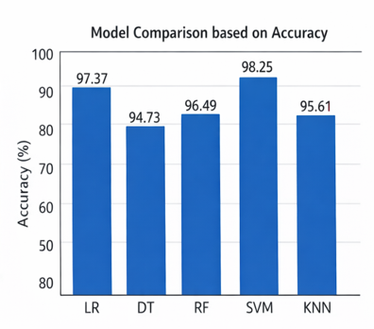
All the selected models are trained using the training dataset (455 samples). During training, the models learn the relationship between input features and the target variable. This helps them to classify the tumors correctly as benign or malignant as shown in figure 1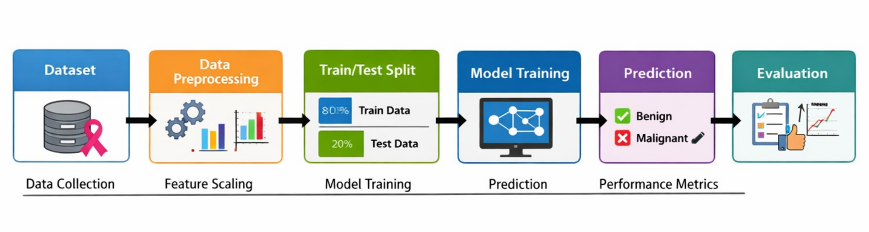Figure 1 Proposed System Architecture for Breast Cancer Prediction
3.5 Performance Evaluation
After training, the models are evaluated using the testing dataset (114 samples). The performance of each model is measured using different evaluation metrics such as: Accuracy, Precision, Recall, F1-score, ROC-AUC score.
Among these, recall is given special importance, as it ensures that malignant cases are correctly identified, which is critical in medical diagnosis.
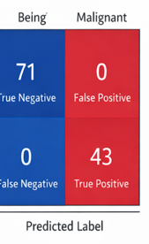
The classification performance of the best model is represented using a confusion matrix in figure2.
Figure 2 Confusion Matrix showing classification results for benign and malignant cases.
3.6 Model Comparison and Selection
All models are compared based on their performance metrics, especially accuracy. This helps in identifying the most suitable model for prediction. The different models are shown using bar graph in figure 3.

Figure 3 Different machine models based on accuracy

Based on the results, the Support Vector Machine (SVM) model performs the best achieving an accuracy of 98.25% and recall of 100% as shown in figure 4. SVM is selected as the best model for breast cancer prediction in this study.

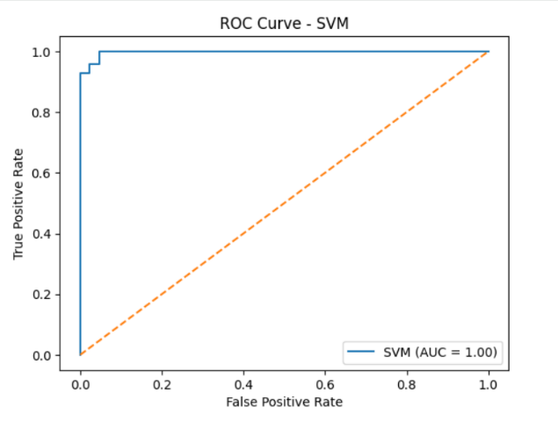
Figure 4 ROC curve of SVM model.
4. RESULT
The performance of the proposed machine learning system was evaluated using standard metrics such as accuracy, precision, recall, F1-score, and ROC-AUC. These metrics provide a comprehensive understanding of the model’s effectiveness in classifying breast cancer cases.
The experimental results demonstrate that the implemented models perform efficiently on the Wisconsin Breast Cancer Dataset. Among the trained models, the Support Vector Machine (SVM) exhibited the most reliable performance, achieving an accuracy of 98.25% along with a recall of 100%, indicating its strong capability in correctly identifying malignant cases. The confusion matrix of the selected model, shown in Fig. 2, illustrates that the number of misclassifications is minimal, further confirming the robustness of the model. Most of the predictions fall into correct categories, highlighting the effectiveness of the trained system.
The ROC curve presented in Fig. 4 demonstrates a high Area Under Curve (AUC) value, indicating excellent classification ability. The curve shows that
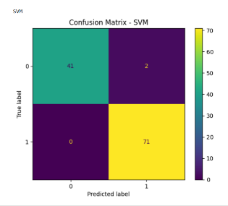
the model maintains a strong balance between true positive rate and false positive rate.
Figure 5 Confusion Matrix SVM

Additionally, cross-validation was performed to ensure the stability and generalization capability of the model. The results indicate that the model performs consistently across different subsets of the dataset.
Overall, the findings suggest that the proposed machine learning approach is effective in analyzing medical data and can serve as a reliable tool for early detection of breast cancer. The system provides accurate predictions and can support healthcare professionals in making informed decisions.
5. Conclusion
In this study, a machine learning-based approach for breast cancer prediction was developed using the Wisconsin Breast Cancer Dataset. Various supervised learning algorithms were implemented to classify tumors as benign or malignant based on medical features.
The results demonstrate that machine learning techniques can achieve high accuracy in predicting breast cancer, with Support Vector Machine (SVM) showing the most reliable performance. The use of preprocessing techniques and proper evaluation metrics contributed to improving the effectiveness of the model.
The proposed system can assist healthcare professionals in making faster and more accurate decisions, thereby supporting early diagnosis and improving patient outcomes. This highlights the potential of integrating machine learning techniques into real-world medical applications.
6. FUTURE SCOPE
In this study, a machine learning-based approach for breast cancer prediction was developed using the Wisconsin Breast Cancer Dataset. Various supervised learning algorithms were implemented to classify tumors as benign or malignant based on medical features.
The results demonstrate that machine learning techniques can achieve high accuracy in predicting breast cancer, with Support Vector Machine (SVM) showing the most reliable performance. The use of preprocessing techniques and proper evaluation metrics contributed to improving the effectiveness of the model.
The proposed system can assist healthcare professionals in making faster and more accurate decisions, thereby supporting early diagnosis and improving patient outcomes. This highlights the potential of integrating machine learning techniques into real-world medical applications.
7. ACKNOWLEDGMENT.
The authors thank the faculty of the Department of Computer Science and Engineering at Chitkara University for their guidance and encouragement throughout this research. Computational experiments were performed on personal equipment.
8. REFERENCES
[1] W. H. Wolberg, W. N. Street, and O. L. Mangasarian,
"Machine Learning Techniques to Diagnose Breast Cancer,"
Proceedings of the IEEE Symposium on Computer-Based Medical Systems, 1995.
[2] M. A. Hall et al., "The WEKA Data Mining Software: An Update," SIGKDD Explorations, vol. 11, no. 1, pp. 10–18, 2009.
[3] D. Dua and C. Graff, "UCI Machine Learning Repository," University of California, Irvine, 2017.
[4] K. Rajesh and S. Anand, "Analysis of Machine Learning Algorithms for Breast Cancer Detection," International Journal of Computer Applications, 2019.
[5] U. M. Fayyad, G. Piatetsky-Shapiro, and P. Smyth, "From Data Mining to Knowledge Discovery in Databases," AI Magazine, vol. 17, no. 3, pp. 37–54, 1996.
[6] L. Breiman, "Random Forests," Machine Learning, vol. 45, no. 1, pp. 5–32, 2001.
[7] C. Cortes and V. Vapnik, "Support-Vector Networks," Machine Learning, vol. 20, no. 3, pp. 273–297, 1995.
[8] T. Cover and P. Hart, "Nearest Neighbor Pattern Classification," IEEE Transactions on Information Theory, vol. 13, no. 1, pp. 21–27, 1967.
[9] A. Asri, A. Mousannif, H. Al Moatassime, and T. Noel, "Using Machine Learning Algorithms for Breast Cancer Risk Prediction," Procedia Computer Science, vol. 83, pp. 1064–1069, 2016.
[10] M. A. Khan, M. Sharif, T. Akram, and V. H. C. de Albuquerque, "A Novel Approach for Classification of Breast Cancer Using Machine Learning," IEEE Access, vol. 8, pp. 122–133, 2020.
[11] J. Han, M. Kamber, and J. Pei, "Data Mining: Concepts and Techniques," 3rd ed., Morgan Kaufmann, 2011.
[12] S. B. Kotsiantis, "Supervised Machine Learning: A Review of Classification Techniques," Informatica, vol. 31, pp. 249–268, 2007.
[13] O. L. Mangasarian, W. N. Street, and W. H. Wolberg, "Breast Cancer Diagnosis and Prognosis via Linear Programming," Operations Research, vol. 43, no. 4, pp. 570–577, 1995.
[14] N. Cristianini and J. Shawe-Taylor, "An Introduction to Support Vector Machines," Cambridge University Press, 2000.

